**A SHOE SHOP**

**LIBRARIES/MODULES USED:**

* Flask -> Flask, render_template, flash, redirect, url_for, request, session
* Flaskext -> mysql. MySQL
* flask_bcrypt -> Bcrypt
* flask_login -> UserMixin, login_user, logout_user, LoginManager, current_user, login_required
* flask_wtf ->FlaskForm, file.FileField, file.FileAllowed
* wtforms -> StringField, PasswordField, SubmitField, BooleanField, fields. FloatField, validators.DataRequired, validators.length, validators.EqualTo , validators.ValidationError
* os
* pymysql

**REQUIRMENTS:**

* MySQL server and Workbench
* Python
* Internet

**SETUP**

* Create user in mysql with username and password as root
* In mysql workbench execute queries in sqlQueries.sql file
* Create new python environment
* Open command prompt in the project folder and execute commend “pip install -r eeq.txt”
* Then execute commend “python server.py”
* Go to <http://127.0.0.1:5000/> to see webpage

**SCREENSHOTS**

**HOME**

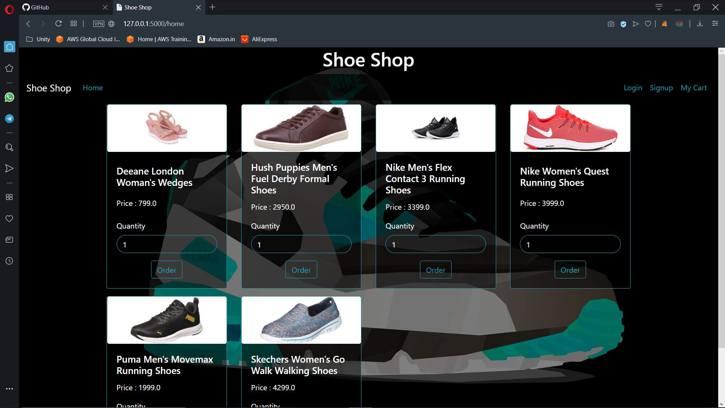

**LOGIN**

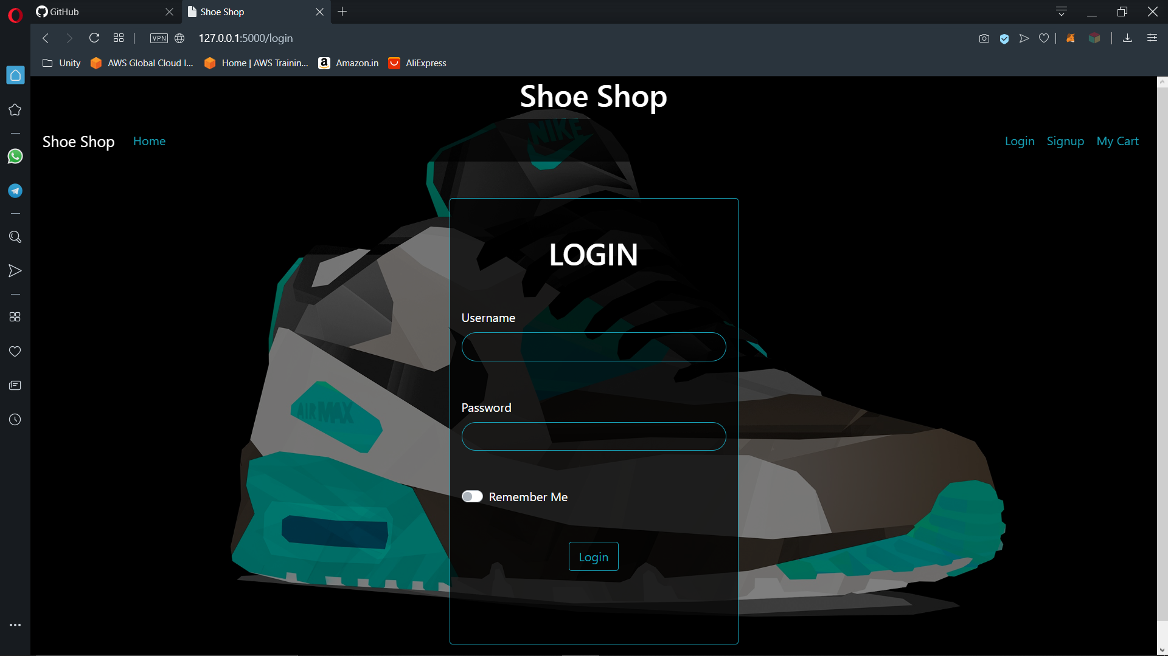

**SIGN UP**

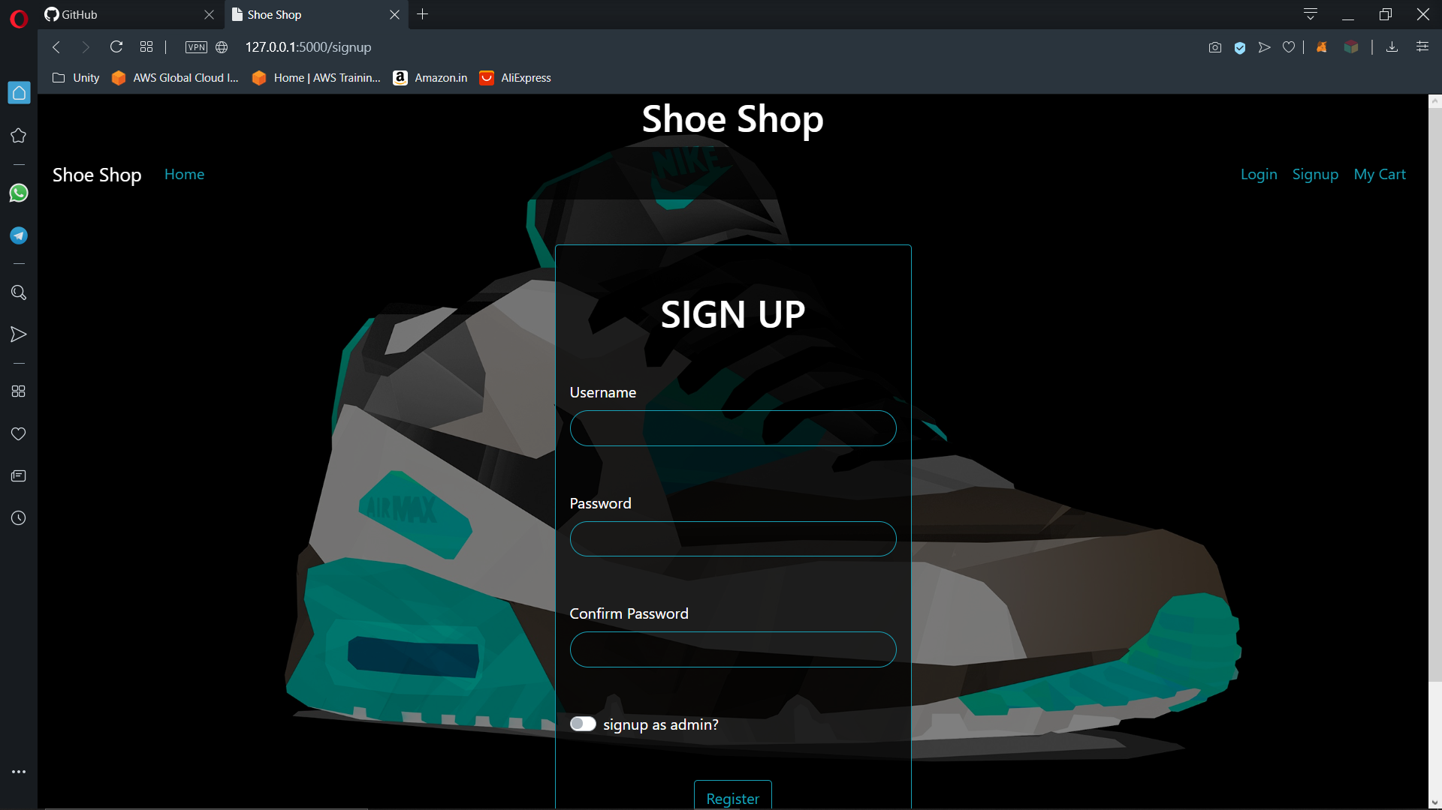

**USER’S CART**

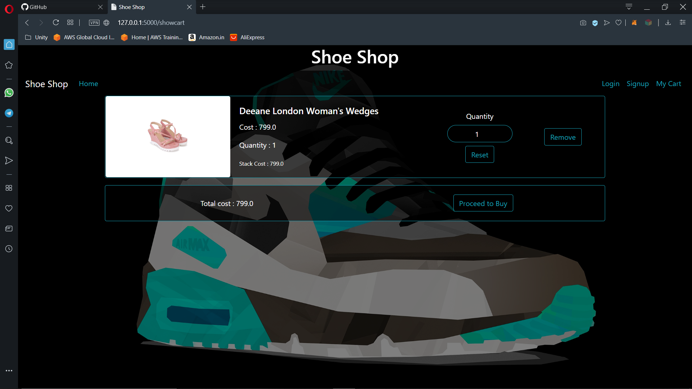

**USER’S HISTORY**

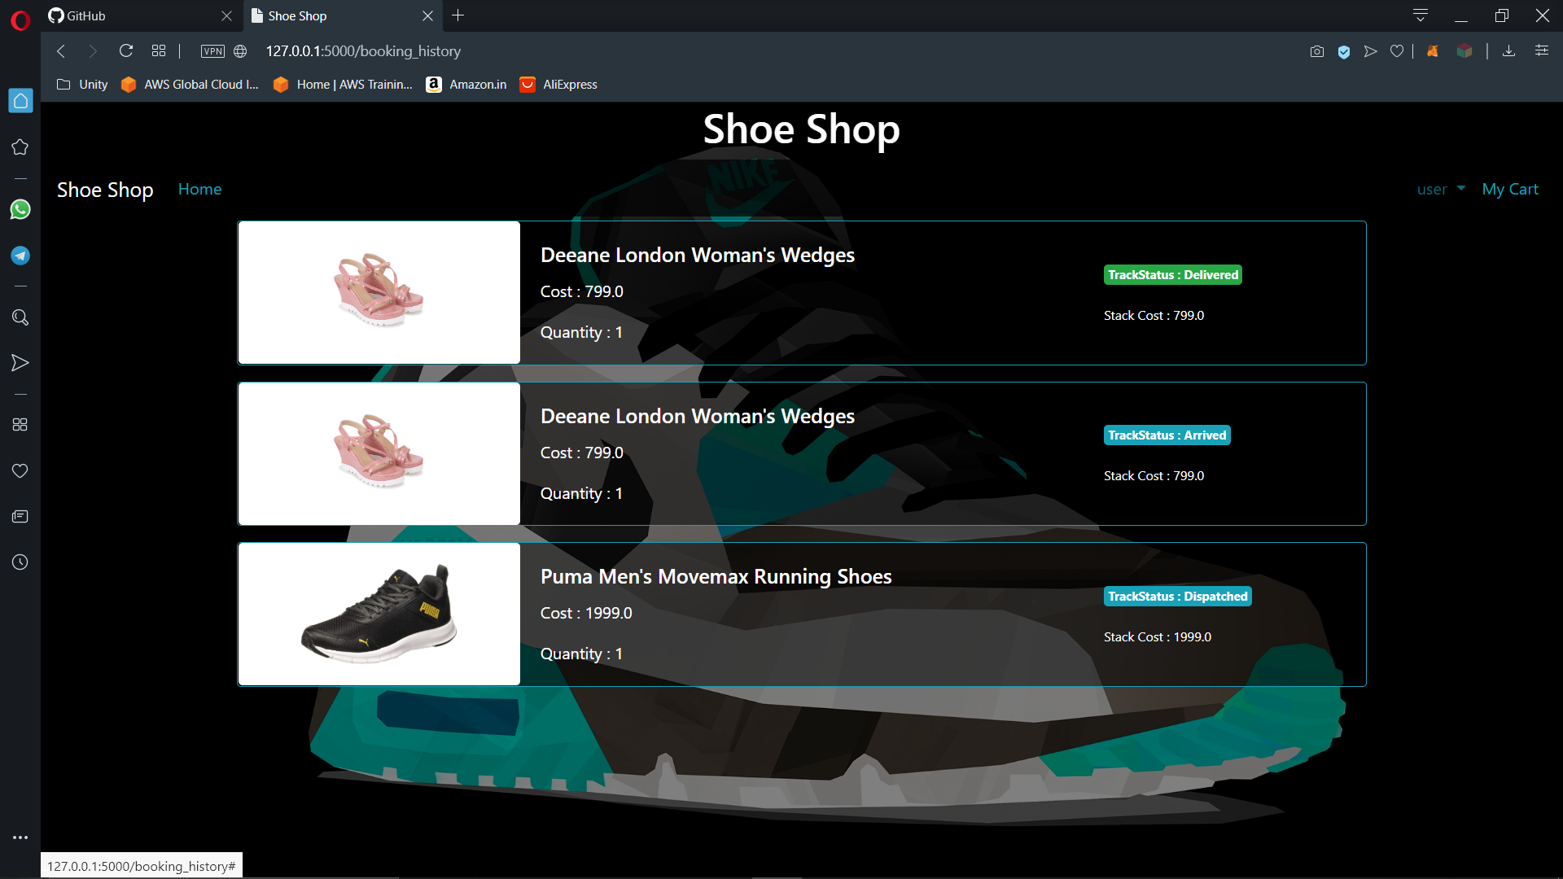

**ADMIN’S ADD NEW PRODUCT SCREEN**

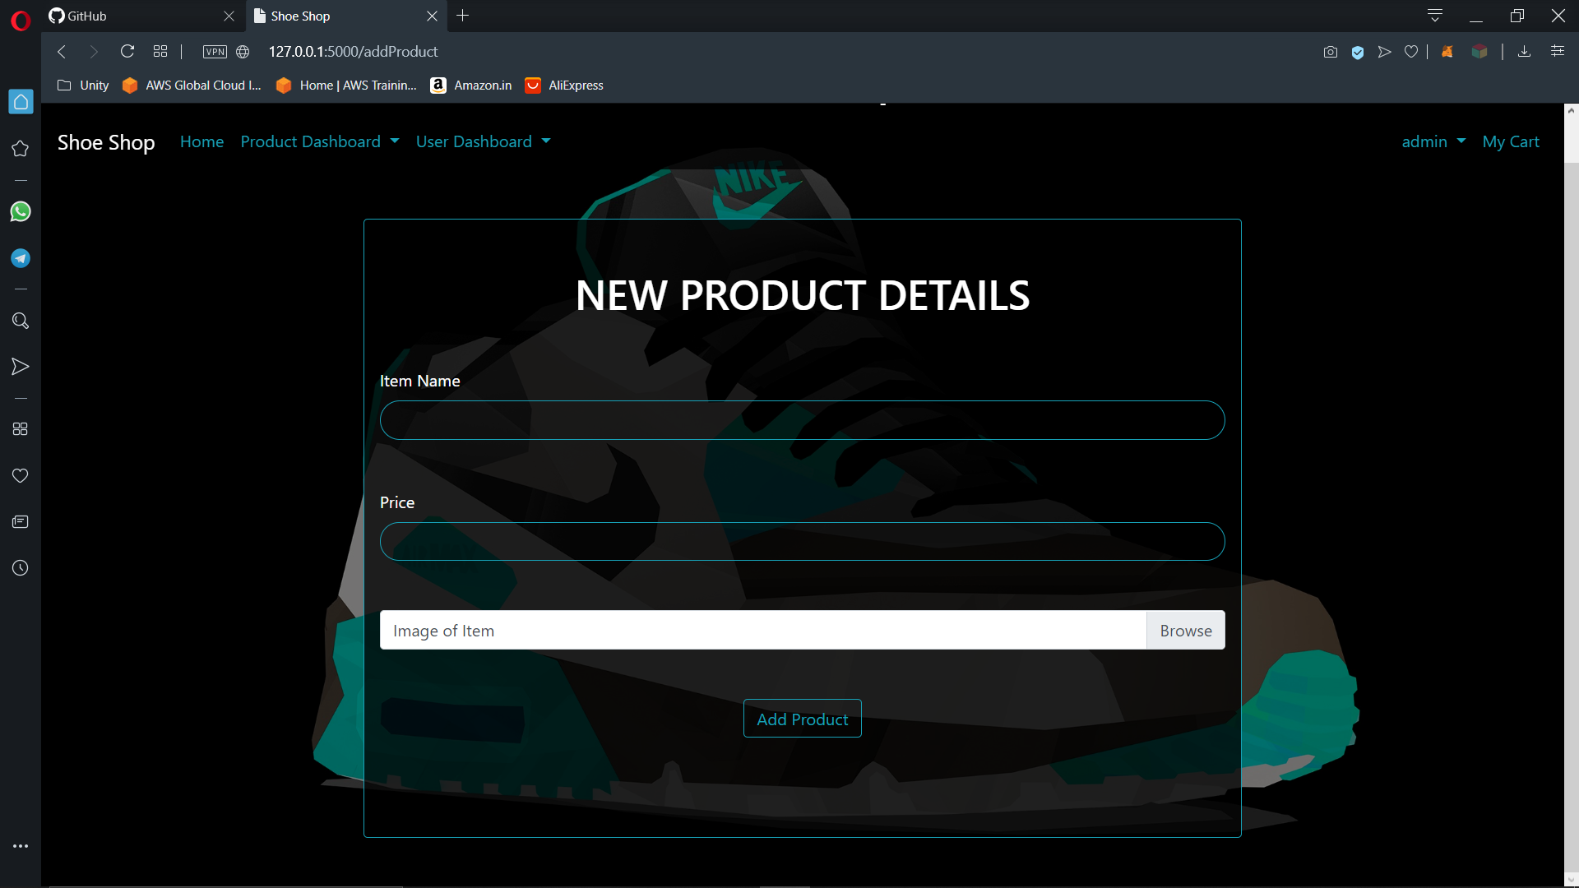

**ADMIN’S VIEW USER SCREEN**

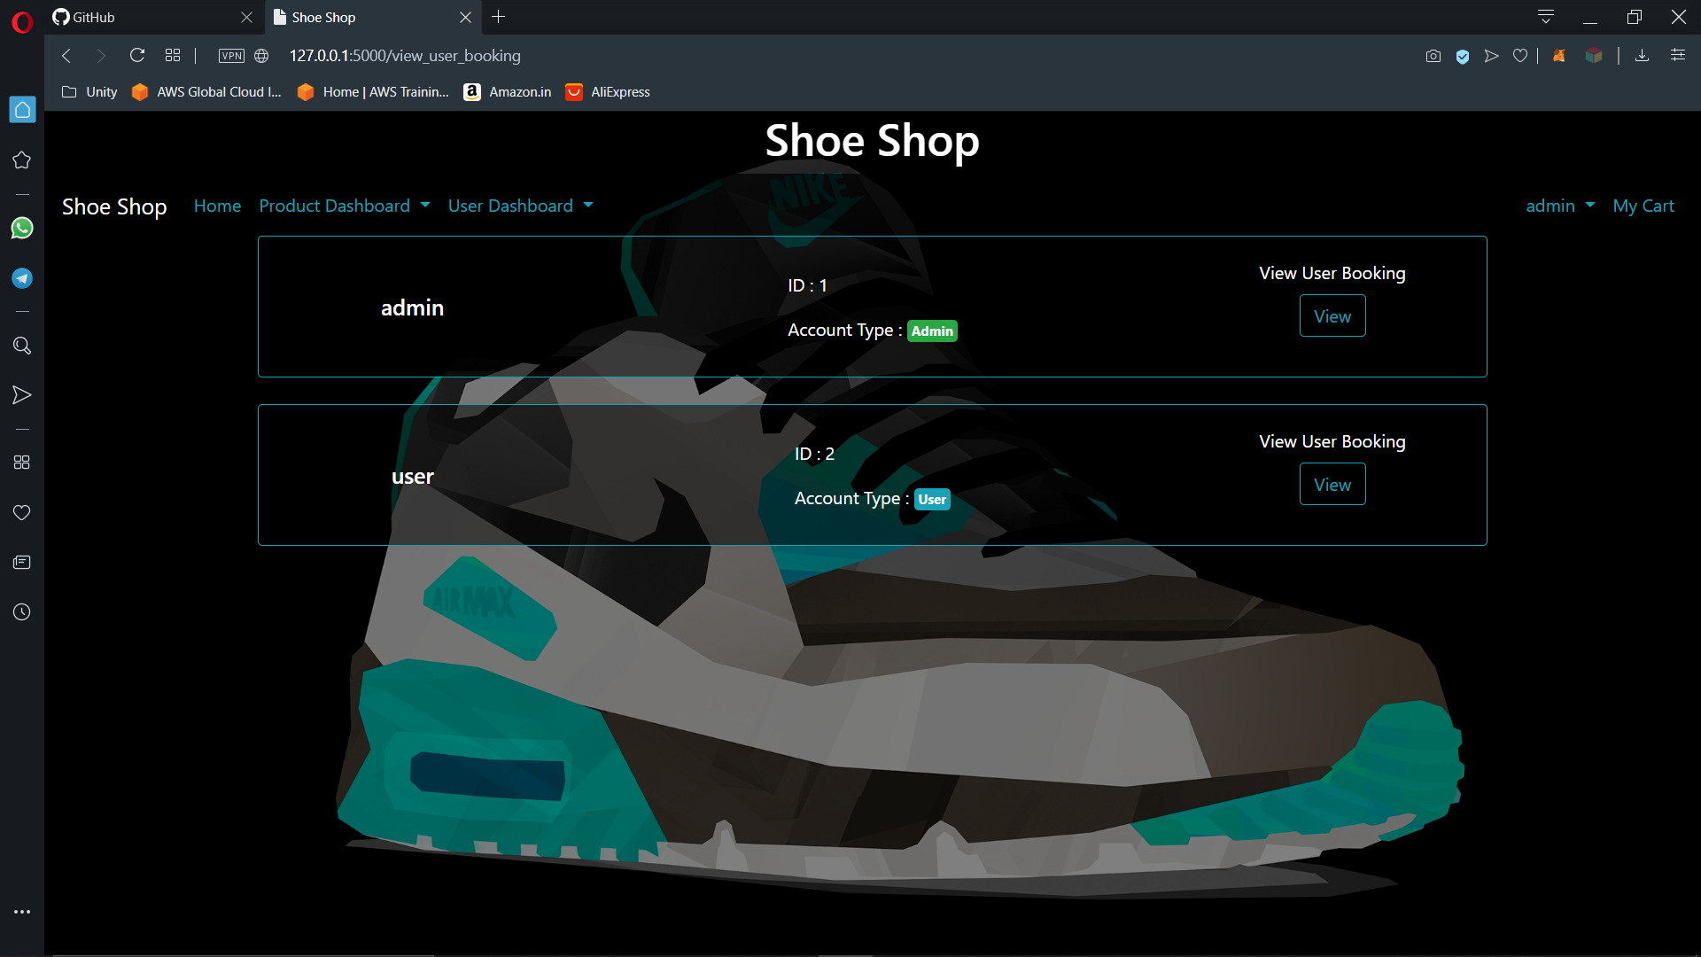

**ADMIN’S VIEW USER HISTORY SCREEN**

