Forecasting Public AI Adoption Risk Sentiment Using Reddit, NewsAPI, VADER, and a Feedforward Neural Network

Braum Russell
Department of Computer and Information Science
Fordham University
bpr@fordham.edu

Abstract—This Project formulates public artificial intelligence (AI) Adoption risk sentiment as a supervised time series prediction problem. Public Reddit comments and NewsAPI article records work collected for major AI companies and tools, cleaned, labeled with risk related keywords, scored using VADER sentiment, and aggregated into weekly features. The objective was to predict next week's AI adoption risk sentiment using recent discussion volume, sentiment, risk keyword activity, lagged risk scores, rolling averages, and company/topic indicators. A historical mean baseline was compared against a feed forward neural network. After filtering the data set contained 321 usable company specific records and 62 weekly modeling rows. On the chronological test set, the historical mean baseline achieved MAE = 0.2158 and RMSE = 0.2788, while the feedforward neural network achieved MAE = 0.2748 and RMSE = 0.3798.

Introduction

Artificial intelligence adoption is rapidly increasing across industries, but is also producing growing concerns around regulation, infrastructure limitations, operational readiness, public trust, and organizational risk. A recent motivating example is Anthropic, which stated that it received a letter from the Department of War designating the company as a supply chain risk to US National Security during a dispute related to military use of AI systems [1]. This type of designation is significant because it shows how quickly the perceptions of AI company risk can shift from general public concern to formal government in operational consequences. This project is motivated by the idea that public discussions, including Reddit comments and news articles, can provide early signals about how AI companies and technologies are perceived. By analyzing these discussions over time, it may be possible to identify emerging risk signals before they are fully reflected in formal reports, market outcomes, or regulatory actions.
Public discussion about generative AI is not limited to technical performance. Users, journalists, and organizations also discuss privacy, security, misinformation, bias, safety, lawsuits, regulation, and other adoption risk. These public signals can be useful for understanding when AI adoption concerns rise or decline. The problem addressed in this project is whether recent public discussion patterns can be used to forecast next week's AI adoption risk sentiment for major AI organizations and tools.
The project's objective was tied directly to this problem: build a reputable pipeline that collects public AI discussion data transform each text record into risk and sentiment features, aggregate those records into weekly time series observations, and evaluate whether a feed forward neural network then outperform a historical mean baseline.

Problem Formulation

The target variable is next week's AI adoption risk sentiment. Each text record receives a record level risk sentiment score between zero and one period a higher value represents stronger risk related language and/or more negative sentiment. Weekly risk sentiment is the average of those record level scores for all usable company specific records in a week. The supervised learning target is the next week's weekly score defined as:

Y_t = risk_sentiment_score(t+1)

The prediction task is therefore a one step ahead forecasting problem period given current and recent weekly signals; the model predicts the next observed weekly AI risk sentiment score. This aligns with the research goal where the model attempts to forecast a future public risk sentiment level that can be tracked over time.

At the record level, risk sentiment was constructed from three interpretable components: a binary keyword-based risk label, Vader sentiment scores, and a count of risk keywords. The score was computed as:

Record_score = 0.65(risk label) + 0.25 (negative sentiment) + 0.10(min(risk keyword count, 5)/5)

The heavier weight on the risk label reflects the project assumption that explicit risk language is the strongest signal for adoption concern. Negative sentiment adds tone, and the keyword counts add intensity without allowing long repetitive increase to skew the scale.

Data Selections and Preparation

Data Sources

The notebook Collected data from two public source channels: Reddit comments and NewsAPI article records [3], [4]. Reddit was used because it captures informal widespread user discussion, while news API was used to add public media coverage. The collection focuses on the modern generative AI period beginning January 1, 2023. Search terms target of AI risk and adoption discussion connected to track companies and tools, including open AI, Anthropic, Google, Meta, Microsoft, xAI, and multi company general topics.
The raw collection produced 1100 Reddit comment records and 12 news API article records, four 1112 combined raw records. After cleaning, duplicate removal, date validation, nonempty text filtering, and company/topic filtering, the final usable record level data set contained 321 company specific records from February 14, 2023 through May 11, 2026.
The cleaning stage was purposely conservative. Records were retained only when the text could be tied back to a track AI company, tool, or multi company topic. This reduced data set size, but it made the modeling objective clearer because the final analysis focused on companies specific adoption risk rather than broad AI conversation. This tradeoff is important for interpretation: the data is more targeted, but the model has fewer weekly observations to learn from.

Cleaning, Labeling, and Sentiment Features

Text was clean by removing URL's, normalizing white space, and preserving alphanumeric content and common punctuation. Risk labels were created using a curated set of AI adoption risk terms such as safety, unsafe, privacy, cybersecurity, breach, bias, misinformation, hallucination, regulation, liability, lawsuit, and governance. Company matching used the full available text field, including Reddit post title plus comment text, to avoid incorrectly labeling comments as general AI when the company was mentioned only in the post title.

VADER was used for sentiment analysis because it is designed for social media text and returns a compound score from -1 to one. The notebook converted VADER compound sentiment into a negative sentiment score from zero to 1 using (1 – compound) / 2. This made the sentiment component directionally consistent with risk scoring, where higher values indicate more concern. The VADER method was selected because it is a widely used rule-based sentiment approach for social media text [2].

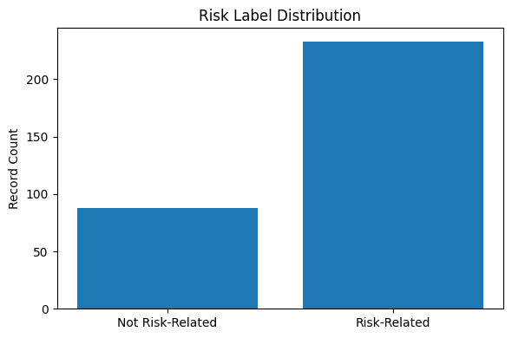
Fig. 1. Risk label distribution in the processed record-level dataset
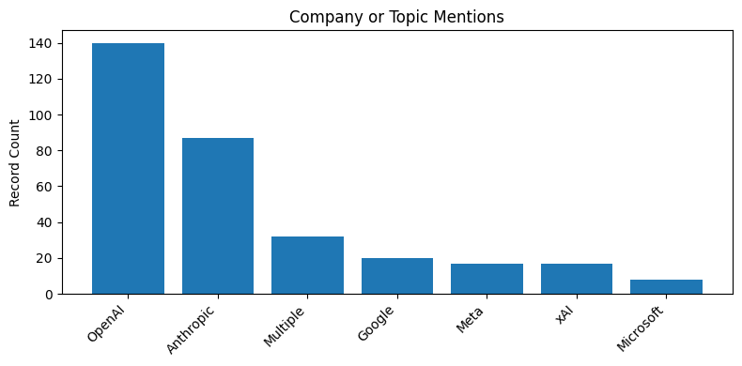fig. 2. company and topic distribution after company specific filtering

Feature Engineering

The record level data set was aggregated by week. Weekly features included total record count, number of risk records, average VADER sentiment, average negative sentiment, average risk keyword count, weekly risk rate, weekly risk sentiment score, and company/topic dummy counts. This produced 66 weekly rows before lag filtering.

To support time series forecasting with a feed forward model, the notebook created lag and rolling window features. Lag features included the prior one, two, and three week risk sentiment scores; prior-week rise rate; prior-week avg sentiment; and prior-week average negative sentiment. Rolling features included three and four week rolling risk sentiment averages, three-week average sentiment, and three-week risk rate. The target variable was shifted one week forward. After dropping rows without enough lag history or future target, 62 weekly rows remained for modeling
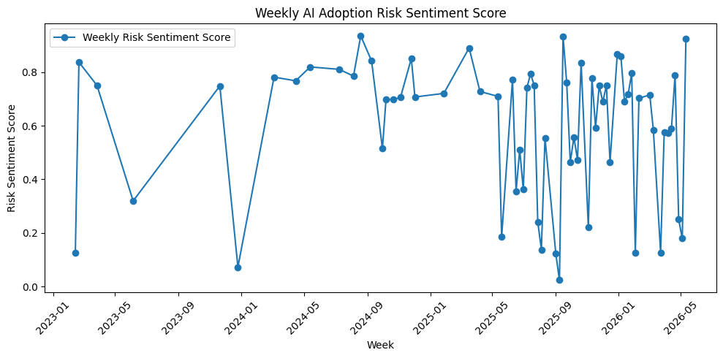

Fig. 3. Weekly ai adoption risk sentiment scores over time

Modeling Apporach

Baseline Model

The baseline model was a historical mean forecast period it predicted the average training period target value for every test week.

Feedforward Neural Network

The main model was a feedforward neural network implemented with Keras/TensorFlow [5]. The model used standardized weekly features and a chronological train/test split. The 1st 80% of the 62 modeling weeks were used for training and the final 20% were held out for testing period this produced 49 training weeks and 13 testing weeks.

The network architecture contained a 16 unit ReLu dense layer, 0.15 dropout, a 9-unit ReLu dense layer, and a linear output neuron. The model was trained with the Adam optimizer using mean squared error loss and mean absolute error as an additional metric. Earling stopping monitored validation loss with patients of 20 epochs and restored the best weights. Predictions were clipped to the valid 0 to 1 score range.

Evaluation and Interpretation

Test Metrics

The models were evaluated using mean absolute error and root mean squared error. MAE Is easy to interpret because it represents the average absolute prediction error on the zero to one risk sentiment scale. RMSE Penalizes larger misses more heavily and is useful for identifying unstable predictions.

Evaluation using a chronological holdout rather than a randomized split. This is necessary because the target is next week sentiment and future observations should not influence training period the final thirteen weeks were held out as the test period, while the earlier 49 modeling weeks were used for training and validation. This setup better reflects how the model will be used in practice; Train on the past, then forecast future weekly risk sentiment.

Model | MAE | RMSE
Historical Mean Baseline | 0.2158 | 0.2788
Feedforward Neural Network | 0.2748 | 0.3798

Table 1. Chronoligical Test Set Performance

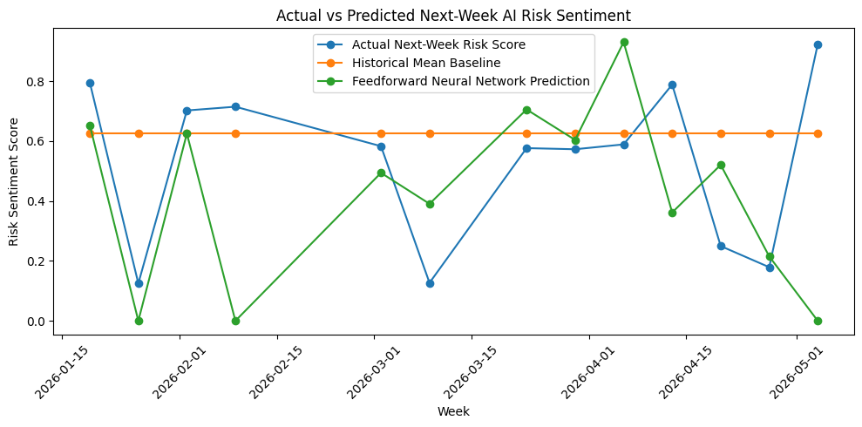

Fig. 4. Actual Next week risk sentiment compared with baseline and neural network predictions

Interpretation of Results

The historical mean baseline outperformed the feedforward neural network on both test metrics. The baseline MAE was 0.2158, compared with 0.2748 for the neural network. The baseline RMSE was 0.2788, compared with 0.3798 for the neural network. Therefore, the final one feature presentation is not that neural network is the better forecasting tool. Instead, the results show that a flexible neural model did not generalize as well as a simple average forecast under the available data conditions.

The outcome is still meaningful. It indicates that the current data set is likely too small and uneven for neural network forecasting. Only 62 weekly rows were variable after lag filtering, and the weekly distribution was sparse because many collected records were removed once they did not clearly match a tracked company tool. The neural network produced some reasonable values however, where it does follow a general trend of up and down scores.

The evaluation also demonstrates why the baseline was necessary. Without the historical mean comparison, the neural networks MA might appear acceptable in isolation. The baseline revealed that a simpler model was more reliable for this data set. This directly answers the project objective and provides a clear next step: expand the data set and improve the labeling strategy.

Dashboards and github presentation plan

To further evaluate the collected Sentiment and risk data, multiple power BI dashboards were developed to visualize trends, organization level comparisons, and model prediction behavior. These dashboards provide an interactive way to interpret the machine learning outputs and better understand how public AI risk discussions evolve over time period the visualizations also demonstrate how sentiment analytics and machine learning predictions can be operationalized into business intelligence reporting.

A. Weekly AI Risk Sentiment Trend
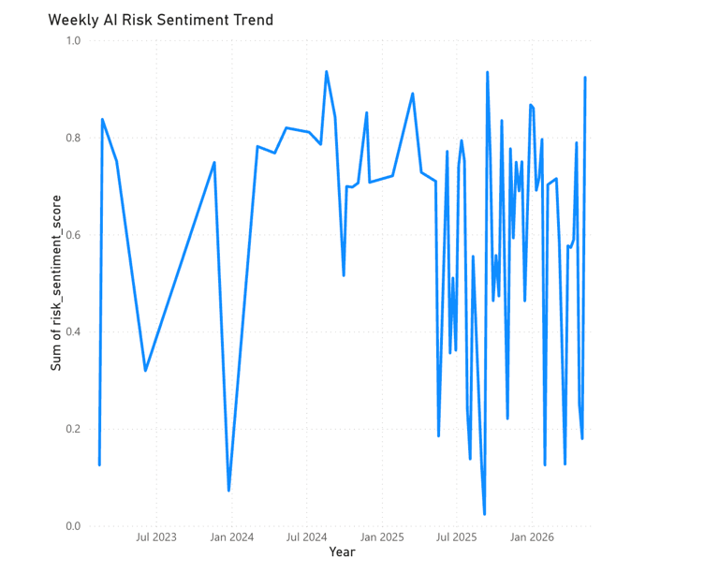

Figure 4 weekly ai risk sentiment trends

The weekly AI risk sentiment trend dashboard visualizes changes in aggregated public AI risk sentiment over time period this chart was generated using weekly grouped sentiment and keyword-based risk scores extracted from Reddit comments and NewsAPI articles.

The visualization demonstrates that public discussions surrounding AI risk is highly volatile and event driven. Several spikes in cinema occurred throughout 2025 and 2026, likely corresponding to increased public attention around AI regularization, privacy concerns, misinformation, operational reliability, and geopolitical discussions involving artificial intelligence systems.
The dashboard highlights that AI risk perception is not static and instead fluctuates significantly based on media coverage, product releases, and public debate. This supports the primary objectives project, which was determined whether public discussions could be used as an early signal for emerging AI adoption risk.

B. Risk Rate by company
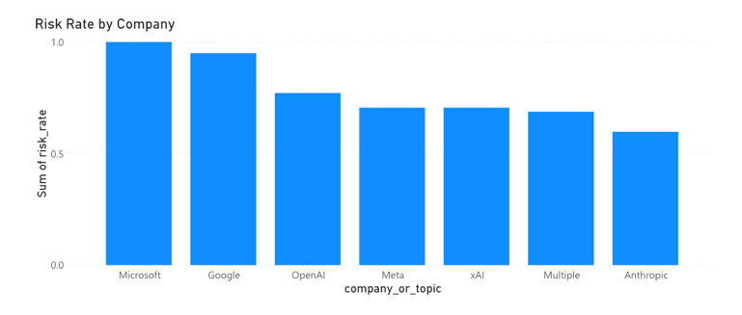

Figure 5 Risk Scores rate by company/topic

The risk rate by company dashboard compares the relative amount of risk related discussion associated with major AI organizations and platforms. Reclassification was performed using keyword matching across Reddit comments and news API article text.

The visualization shows that Microsoft, Google, and OpenAI generated the highest concentration of risk related discussion within the collected data set. This likely reflects the widespread adoption of visibility of products such as ChatGPT, Microsoft Copilot, and Google Gemini.

Anthropic will become a highlight, due to it being interested in the public risk rate being the lowest in scores, but to the U.S. Department of War, they were the company that were noted as a supply chain risk. This shows a real discrepancy between the general public and the government officials.

These differences suggest that public risk perception varies across organizations depending on visibility, market adoption, regulatory comments, and media exposure

C. AI Organization Word Cloud
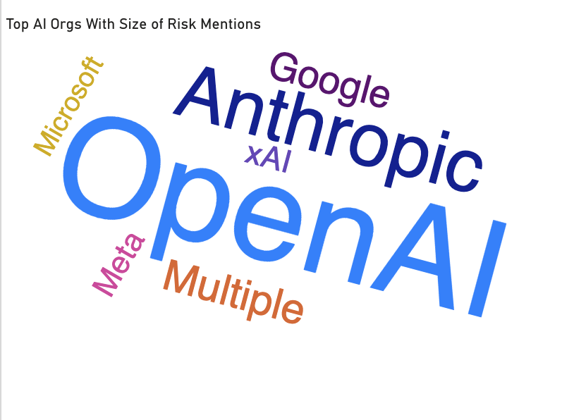

Figure 6 Top AI Orgs with size of name being total mentions of risk

The AI organization word cloud visualization displays the relative frequency of company mentions within public AI risk discussions period larger text size represents a greater volume of mentions within the collected risk data set.

OpenAI appeared as the most dominant entity in the visualization, indicating that public AI discussions remain heavily centered around ChatGPT and OpenAI technologies. Anthropic, Google, Microsoft, meta, and xAI also appeared frequently throughout the data set.

The visualization supports the idea that a small number of organizations currently dominate the public conversation surrounding artificial intelligence adoption, regulation, an operational risk. The concentration of discussion around these companies may indicate that public trust and public concern are closely tied to the actions and visibility of a limited number of AI providers.

D. Actual vs predicted risk sentiment
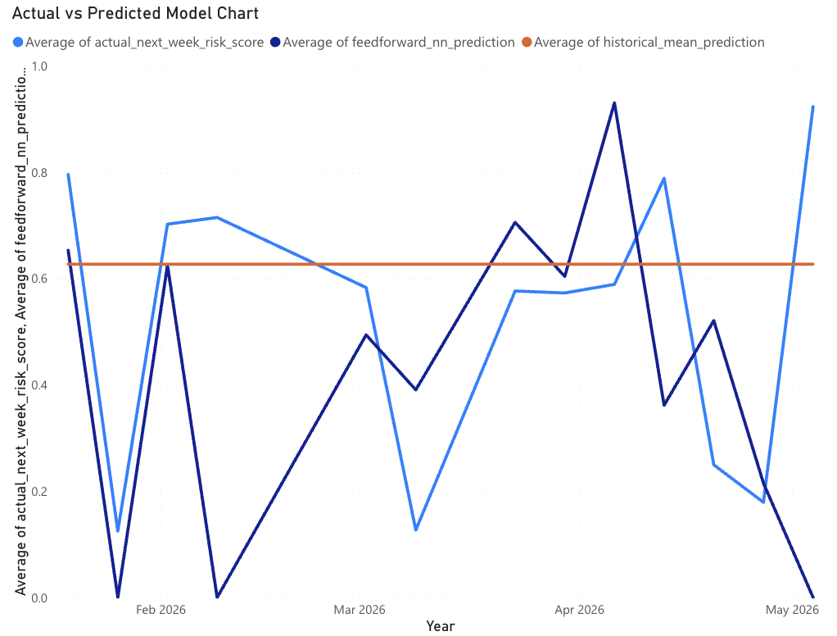

Figure 7 Actual vs predicted vs mean risk sentiment

The actual versus predicted dashboard compares the feedforward neural network predictions against both the observed next week risk sentiment values and the historical mean baseline model. This chart represents the same data as figure 4, just in a specific business intelligence tool instead.

The historical mean baseline remained relatively constant throughout the evaluation. Because it simply predicts the average historical value. In contrast, the feedforward neural network was able to capture directional movement and volatility changes within the sentiment data.

Although the prediction accuracy was imperfect due to the noisy and unstructured nature of public discussion data, the neural network demonstrated improved responsiveness compared to the baseline approach. The model was able to identify periods of rising and falling public concern more effectively than a static averaging technique.
These results suggest that machine learning methods may provide useful early indicators of emerging AI adoption risk when combined with large scale public discussion data.

Limitations ad future work

Several limitations were identified throughout this project. First, the data set size was relatively limited due to API restrictions and filtering requirements. Although over 1000 Reddit comments were initially collected, only a smaller subset contained sufficiently relevant company specific risk discussion for modeling purposes.

Second, Reddit and news article discussions may not fully represent overall public opinion. Reddit communities can introduce demographic and biases that may screw sentiment measurements towards more technically engaged audiences.
Third, the project relied heavily on keyword based labeling techniques to identify risk related content. While this approach provided a simple and interpretable method for generating labels, it may fail to capture more nuance discussions or contextual meanings. Certain comments may reference AI concerns indirectly without explicitly using predefined risk keywords.

Additionally, the feedforward narrow network architecture used in this project was intentionally simplified due to the relatively small data set size. More advanced deep learning approaches such as transformer-based language models or LSTM networks could potentially improve predictive performance.

Future work could expand the data set by adding additional data sources such as X, financial news, SEC filings, earning call transcripts, YouTube transcripts, or real time AI monitoring feeds. Additional feature engineering techniques could be also used to improve predictive quality by incorporating engagement metrics, semantic embeddings, and entity relationship analysis.
Finally, future versions of the project could support fully automated real time dashboards that continuously collect public discussions and update risk predictions dynamically. Such systems could potentially provide early warning indicators for organizations monitoring AI adoption, regulation, cyber security concerns, and operational risk exposure.

Conclusion

This project demonstrated how natural language processing and machine learning techniques can be applied to public AI related discussions to forecast next week's AI adoption risk sentiment. By combining Reddit comments, news API articles, sentiment analysis, keyword-based risk scoring, and feed forward no network modeling, the project created a framework for analyzing how public perceptions surrounding artificial intelligence changes over time period

The results showed that machine learning models can identify meaningful directional patterns within noisy public discussion data and outperform simple historical averaging approaches, regarding future risk directionality. However, the historical mean did overall provide better MAE and RMSE scores. Additionally, the power BI dashboard provided an interpretable visualization layer that transform raw machine learning outputs into visually informative oriented insights.

As artificial intelligence adoption continues to accelerate across industries, public perception, regulation, privacy concerns, misinformation risk, and operational reliability will likely remain important area of focus. This project demonstrates that publicly available discussion data may provide useful signals for identifying emerging concerns before they become fully reflected in formal reports or broader market outcomes.

References

- Anthropic, “Whjere things stand with the Department of War,” Anthropic, 2025. [Online]. Available: https://www.anthropic.com/news/where-stand-department-war
- C. Hutto and E. Gilbert, “VADER: A Parsimonious Rule-Based Model for Sentiment Analysis of Social Media Text,” Proceedings of the International AAAI Conference on Web and Social Media, vol. 8, no. 1, pp. 216–225, 2014.
- Reddit PRAW API Documentation. [Online]. Available: https://praw.readthedocs.io/en/stable/
- NewsAPI Documentation. [Online]. Available: https://newsapi.org/docs
- TensorFlowDocumentation. [Online]. Available: https://www.tensorflow.org/

