A Descriptive Analysis of Holiday Travel Experiences Using Sentiment and Market Features From AirBNB Reviews

Braum Russell
Department of Computer and Information Science
Fordham University
New York City, New York
bpr2@fordham.edu

Abstract—Online accommodation platforms generate large volumes of user-generated reviews that reflect traveler’s subjective experiences as well as underlying market dynamics. Understanding how these experiences vary across cities and holidays remain a challenge descriptive data mining problem. This study applies unsupervised clustering to characterize holiday-specific Airbnb city profiles by combining sentiment polarity, emotional composition, and market-related features derived from Airbnb reviews and listings. Using data from the Inside Airbnb project, cities are clustered independently for five major holidays: Christmas, Easter, Halloween, New Year’s and Valentine’s Day. Results show that cities consistently separate into distinct holiday experience profiles that reflect differences in emotional intensity and market behavior rather than simple sentiment rankings. These findings demonstrate the value of multidimensional sentiment representations for descriptive urban and tourism analytics.

Introduction
Holiday travel is commonly associated with heightened emotional expectations, distinctive activities, and changes in accommodation demand. Online platforms such as Airbnb capture these experiences through millions of user-generated reviews that reflect not only satisfaction or dissatisfactions, but also emotional tone, anticipation, and trust. While there is a heavy concentration of previous work on Airbnb data focusing on pricing dynamics or predictive modeling tasks, less attention has been given to understand how cities are experienced during holidays from a descriptive perspective.
This project adopts a descriptive data mining approach to explore whether cities exhibit recurring holiday experience profiles when considering both emotional sentiment expressed in reviews and structural characteristics of the Airbnb market. Because there are no predefined labels for concepts such as “holiday experience type”, unsupervised learning is a natural choice. Rather than predicting outcomes or ranking destinations, the goal is to uncover unrevealed structure in holiday-related travel experiences.
The work follows a outline of:
- Construction of a city-holiday representation that integrates sentiment polarity, emotional composition, and market features derived from Airbnb data.
- A demonstration that sentiment alone is insufficient to capture meaningful holiday experience structure.
- Identification and interpretation of consistent holiday experience clusters across meaningful holidays using unsupervised clustering.

Background

Airbnb Reviews as Experience Data
Airbnb reviews provide a rich source of experiential data because they are voluntarily written, publicly available, and contain detailed emotional and contextual information. Unlike numerical ratings alone, review text captures subjective impressions of stays, expectations, and perceived value. At the same time, reviews are subject to platform-specific biases and may not represent all travelers equally depending on their choice of booking. Despite this, Airbnb reviews are widely used in tourism analytics and urban data science as resources for travel experience.

Sentiment and Emotion Analysis
Sentiment analysis is commonly used to quantify the polarity of text along a positive-negative spectrum. In this work, I use the VADER sentiment analyzer, which is used for short, informal text and produces a compound sentiment score reflecting overall polarity. To move beyond scalar sentiment, emotion features are also extracted using the NRC emotion lexicon, which assigns words to emotion categories such as joy, trust, anticipation, anger, fear, and sadness. Together, sentiment and emotion features provide complementary views of how holiday experiences are expressed.

Data and feature Contruction

Data Source
The data used in this project comes from the InsideAirbnb repository, which provides publicly available snapshots of Airbnb listings and reviews for cities worldwide. Twenty major cities were selected, ten cities in the United States cities and ten cities internationally, with sufficient review volume. Two primary data sources were used: a listing dataset containing market attributes (e.g., price, availability, room type), and a reviews dataset containing text reviews and timestamps. The combined created dataframe for reviews contained a total of 1,678,542 reviews. The combined created dataframe for listings had a total of 477,433 listings.
TABLE 1: Cities Analyzed
Austin, TX | Los Angeles, CA | Seattle, WA | Berlin, Germany | Paris, France
Boston, MA | New Orleans, LA | Washington D.C. | London, United Kingdom | Rome, Italy
Chicago, IL | New York City, NY | Amsterdam, Netherlands | Madrid, Spain | Sydney, Australia
Dallas, TX | San Francisco, CA | Barcelona, Spain | Munich, Germany | Toronto, Canada

Holiday Definition
Five holidays were analyzed, Christmas, New Year’s, Valentine’s Day, Halloween, and Easter. Fixed-date holidays were defined using narrow calendar windows designed to capture core holiday activity (Christmas: Dec 20 – Dec 27; New Year’s: Dec 28 – Jan 3; Valentine’s Day: Feb 10 – Feb 17; Halloween: Oct 25 - Nov 2). Easter, as a movable holiday, was aggregated across a fixed ten-year window (2015-2025). Fixed-date holidays were aggregated across all available years. Because clustering is performed independent for each holiday, differing temporal aggregation strategies do not affect clustering validity.

Feature Engineering
Features were constructed at the city-holiday level and grouped into three categories:
- Sentiment Features: Mean and standard deviation of the VADER compound sentiment score, proportions of positive, neutral, and negative reviews, and average review length.
- Emotional Features: Mean values of NRC emotion categories, including joy, trust, anticipation, sadness, anger, and fear.
- Market Features: Average nightly price, price variability, average minimum stay, average availability, total number of listings, and proportion of entire home listings.
All features were standardized prior to clustering.

TABLE 2: Feature Summary Table
City | Holiday | Mean_Compound | Std_Compound
Pct_positive | Pct_negative | Pct_neutral | Avg_Review_length
Joy | Sadness | Fear | Trust
Anticipation | Review_Count | Avg_Price | Price_Std
Avg_Min_Nights | Avg_Availaibility | Listing_Count | Pct_Entire_Home

Experimental Methodology

Clustering Setup
Clustering was performed separately for each holiday using the k-means algorithm. All features were standardized to zero mean and unit variance. Clustering cities independently for each holiday avoids mixing up differences between holidays with differences between cities.

Baseline vs. Rich Feature Sets
To assess whether clustering results were non-trivial, two
feature sets were evaluated. A baseline feature set included only mean sentiment polarity, A rich feature set included sentiment, emotion and market features. This comparison allows us to evaluate whether additional emotional and market dimensions provide meaningful structure beyond sentiment alone.

Parameter Selection and Validation
The number of clusters k was varied from 2 to 6. Internal validation metrics, including silhouette score and Davies-Bouldin indexes, were used to evaluate clustering quality. For each holiday, the value of k that maximized silhouette score while maintaining interpretability was selected.

Visualization
Principal Component Analysis (PCA) was applied solely for visualization purposes to project high-dimensional feature vectors into two dimensions. PCA was not used during clustering. PCA plots are used to visually confirm separation between clusters and help with interpretation.

Results and Analysis

Baseline Clustering Results
Clustering using only mean sentiment polarity produced very high silhouette scores across all holidays, with values exceeding 0.70 in several cases. This outcome is expected, as clustering on a single scalar variable is inherently simple and yields compact clusters. However, despite high internal validation scores, these clusters provide limited insight, effectively partitioning cities along a one-dimensional sentiment without capturing meaningful emotional and market expression.

TABLE 3: Baseline Clustering Performance

Rich Feature Clustering Results
When sentiment, emotion, and market features were combined, silhouette scores were lower than those obtained using sentiment alone. This reduction reflects the increased dimensionality and complexity of the feature spaces rather than inferior clustering. Importantly, the resulting clusters were far more interpretable, stable across holidays, and aligned with meaningful differences in both emotional expression and market characteristics. These results highlight the limitation of relying solely on compactness metrics when performing descriptive clustering.
As seen below, here are the final selected clusters meeting the best internal validation metrics showing recommended “k” clusters for rich features.

TABLE 4: CLUSTERS AND VAL METRIC

Christmas Case Study: Cluster Structure
Christmas is used as a representative case study to illustrate the structure and interpretation of the resulting clusters. A two-cluster solution provided the most interpretable structure for the rich feature set.

TABLE 5: Christmas Cluster Centroids
(Cluster 0 highlighted in grey)

Examination of cluster centroids reveals two distinct holiday experience profiles. The first cluster is characterized by very high positive sentiment (mean compound sentiment approximately 0.77), a high proportion of positive reviews (over 90%), and strong emotional expression in joy, trust, and anticipation. Market characteristics for this cluster include high average price and extremely large price variability, along with lower average availability. These features suggest that this cluster represent emotional intense holiday experiences occurring in highly differentiated and premium market.
The second cluster shows more moderate sentiment levels (mean compound sentiment around 0.48), a lower proportion of positive reviews, and weaker emotional expression across all NRC categories. Market features indicate lower average prices, substantially lower price variability, and higher availability, pointing to more stable and routine holiday markets.

City Membership for Christmas
To make the clustering results concrete, we examine which cities belong to each cluster during Christmas.
TABLE 6: City Membership by Christmas Cluster
Cities in the high-intensity cluster tend to be large, internationally recognized tourist destinations, whereas cities in moderate cluster are generally characterized by more stable and less volatile holiday demand.

PCA Visualization
FIGURE 1: PCA Visualization of Christmas Clusters
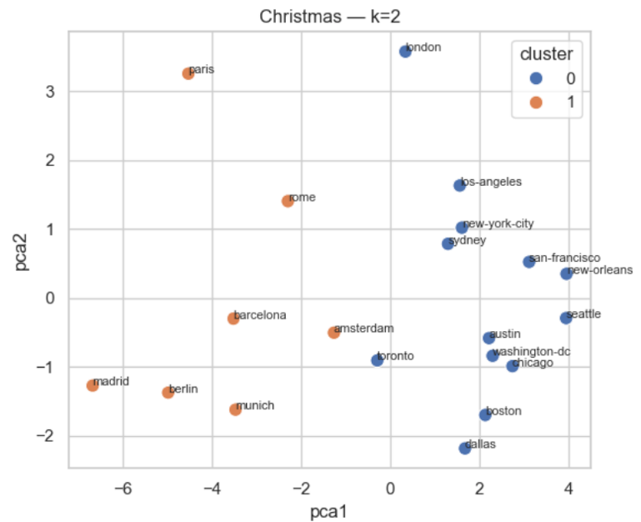
The PCA projection shows clear separation between clusters, supporting the qualitative interpretation of distinct holiday experience profiles.

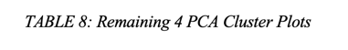
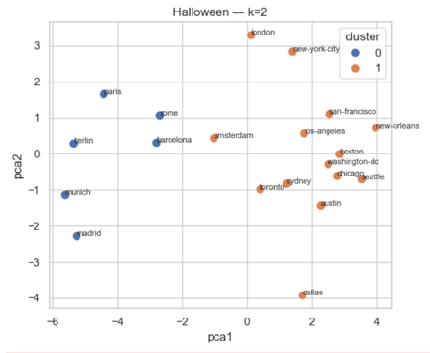
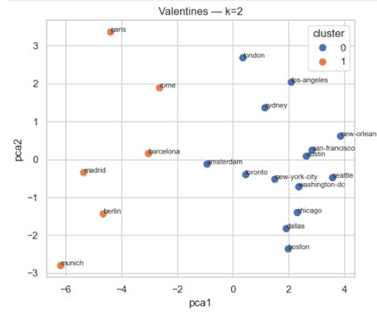
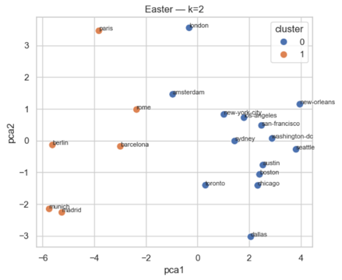

Comparison Across Holidays
While Christmas is presented as a detailed case study, similar clustering patterns were observed across the remaining holidays: Easter, Halloween, New Year’s, and Valentine’s Day. For each holiday, cities consistently separated into two primary clusters when using the rich feature set that combines sentiment, emotion, and market characteristics.
Across all holidays, on cluster was characterized by higher average sentiment, a larger proportion of positive reviews, and stronger emotional signals, particularly in joy, trust, anticipation. These cities also tended to exhibit average prices and greater price variability, suggesting increased demand and more differentiated holiday markets. The second cluster consistently showed more moderate sentiment levels, weaker emotional intensity, lower prices, and higher availability, reflecting more stable and less emotionally charged holiday experiences.
Although the dominant emotional signals varied by holiday, the overall structure of the clusters remained consistent. For example, Valentine’s Day clusters were distinguished primarily by elevated expressions of joy and trust, while Halloween clusters showed comparatively higher levels of fear and anticipation. Easter and New Year’s exhibited intermediate emotional profiles but followed the same general pattern of separation between high-intensity and moderate holiday markets.
Importantly, the consistency of this two-cluster structure across all five holidays suggests that the identified holiday experience profiles are not artifacts of a single holiday but represent recurring patterns in how cities are experienced during peak travel periods. This cross-holiday stability supports the interpretation that cities exhibit persistent experiential characteristics that manifest differently depending on the emotional context of the holiday.

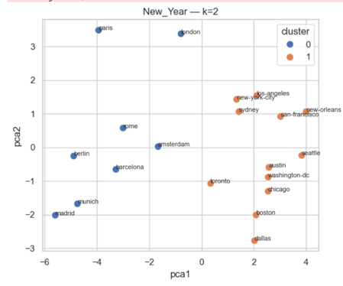

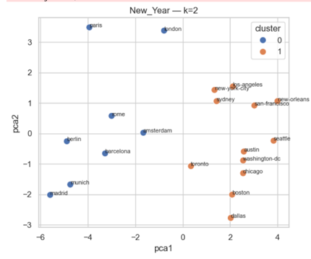

Related Work
Sentiment analysis of user-generated reviews has been widely studied in the context of online platforms, particularly for short text such as social media posts and consumer reviews. Lexicon-based sentiment approaches remain popular in applied data mining because they are interpretable and computationally efficient. The VADER sentiment model is specifically designed for short text and has been shown to perform competitively on social media and review-style data, making it suitable for large-scale analysis of Airbnb reviews [1]. While polarity-based sentiment provides a useful summary of overall opinion, prior work has shown that higher-dimensional emotional representations can better capture subjective experiences. Emotion lexicon that associate words with discrete emotional categories such as joy, trust, fear, and sadness enable more nuanced characterization of affective content and have been successfully applied in multiple text mining domains [2].
Airbnb has emerged as a common application domain for data mining and urban analytics due to the availability of large-scale, publicly accessible datasets. The inside Airbnb project provides standardized listings, reviews, and calendar data for cities worldwide, supporting reproducible cross-city analysis and comparative studies [3]. Prior research using Airbnb data has examined pricing dynamics, availability patterns, and geographic variation. However, relatively less work has focused on aggregating review-level sentiment into city-level representation for comparative analysis across specific temporal contexts such as holidays.
For descriptive analysis without labeled outcomes, clustering remains a fundamental unsupervised learning approach. K-means clustering is frequently used as a baseline due to its simplicity, scalability, and interpretability when the number of entities is modest, such as city-level aggregates [4]. Because unsupervised learning lacks real truth labels, internal validation metrics are employed to assess clustering quality. The silhouette coefficient measures how well instances fit within their assigned clusters compared to neighboring clusters an dis widely used to guide selection of the number of clusters [5]. Complementary to silhouette, the Davies-Bouldin index evaluates clustering quality by quantifying average similarity between clusters, with lower values indicating better separation and compactness [6]. Using multiple internal metrics provides a more robust assessment of clustering structure in exploratory data mining settings.
High-dimensional feature spaces often complicate interpretation of clustering results. Dimensionality reduction techniques such as Principal Component Analysis (PCA) are frequently used to project clustered data into two dimensions for visualization and interpretability, even when PCA is not used directly for clustering [7]. PCA enables qualitative assessment of cluster separation and supports communication of results to non-technical audiences. Finally, scikit-learn provides standardized implementations of preprocessing, clustering, dimensionality reductions, and evaluation metrics, facilitating reproducible experimentation and consistent methodological choices in applied data mining research [8].

Conclusion
This study explored whether holiday-specific Airbnb experiences across major global cities exhibit systematic patterns when analyzed through sentiment, emotional tone, and market features. By applying unsupervised clustering to city-level holiday aggregates, the analysis revealed a consistent two-cluster structure across five major holidays. These clusters correspond to distinct experiential profiles rather than just simple sentiment rankings, with one cluster characterized by higher emotional intensity, stronger positive sentiment and more premium market conditions.
Using Christmas as a representative case, the analysis demonstrated that cities can be meaningfully grouped into holiday experience types that align with both guest sentiment and market behavior. Importantly, similar patterns were observed for Easter, Halloween, New Year’s, and Valentine’s Day, suggesting that these experience types are stable and recurring rather than holiday-specific anomalies.
Some limitations should be acknowledged. First, the number of cities per holiday is relatively small, which constrains separation measured by internal validation metrics such as silhouette score. Secondly, aggregating reviews at the city level necessarily differs within city variation among neighborhoods and individual listings. Future work could address these by expanding geographic scope to include additional cities, or preforming clustering at finer detailed city views, such as neighborhoods in cities.
Overall, this work demonstrates that combining sentiment analysis with market features provides a viable system for uncovering latent experiential pattens in large-scale traveling data.

References
- C. Hutto and E. Gilbert, “VADER: a Parsimonious Rule-Based Model for Sentiment Analysis of Social Media Text,” Proceedings of the International AAAI Conference on Web and Social Media, vol. 8, no. 1, May 2014, doi: https://doi.org/10.1609/icwsm.v8i1.14550.
- S. M. Mohammad and P. D. Turney, “Crowdsourcing a Word-Emotion Association Lexicon,” arXiv:1308.6297 [cs], Aug. 2013, Available: https://arxiv.org/abs/1308.6297
- Inside Airbnb, “Get the Data,” insideairbnb.com, 2024. https://insideairbnb.com/get-the-data/
- J. MacQueen, “Some methods for classification and analysis of multivariate observations,” Proceedings of the Fifth Berkeley Symposium on Mathematical Statistics and Probability, Volume 1: Statistics, vol. 5.1, pp.281–298, Jan. 1967, Available: https://projecteuclid.org/ebooks/berkeley-symposium-on-mathematical-statistics-and-probability/Proceedings-of-the-Fifth-Berkeley-Symposium-on-Mathematical-Statistics-and/chapter/Some-methods-for-classification-and-analysis-of-multivariate-observations/bsmsp/1200512992
- P. J. Rousseeuw, “Silhouettes: a Graphical Aid to the Interpretation and Validation of Cluster Analysis,” Journal of Computational and Applied Mathematics, vol. 20, no. 0377–0427, pp. 53–65, Nov. 1987, doi: https://doi.org/10.1016/0377-0427(87)90125-7.
- ‌“2.3.Clustering,” scikit-learn.https://scikit-learn.org/stable/modules/clustering.html#davies-bouldin-index
- ‌J. Shlens, “A Tutorial on Principal Component Analysis,” Dec. 2005. Available: https://www.cs.cmu.edu/~elaw/papers/pca.pdf
- ‌F. Pedregosa et al., “Scikit-learn: Machine Learning in Python,” Journal of Machine Learning Research, vol. 12, no. 85, pp. 2825–2830, 2011, Available: https://jmlr.org/papers/v12/pedregosa11a.html

