Summary Table of MAPE
 | Moving Average | Arima | Smoothing |  | Best Method
gdp_usd_bn | 2.22% | 6.13% | 8.79% |  | MA
Rice_production | 2.29 % | 4.15 % | 5.85 |  | MA
Sugarcane_production | 3.14 % | 8.79 % | 8.79 % |  | MA
Maize_production | 3.91 % | 7 % | 8.51 % |  | MA

gdp_usd_tr
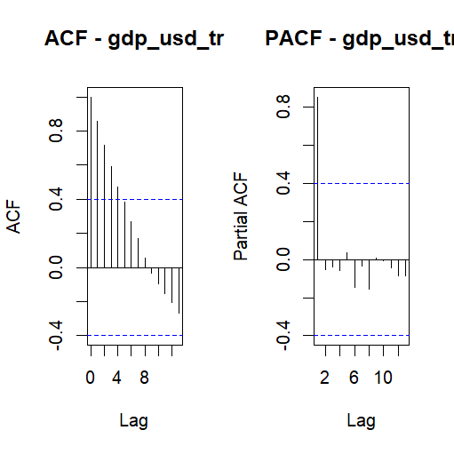
- It tells about the sum of value of total goods produced in the country from 2001 to 2024
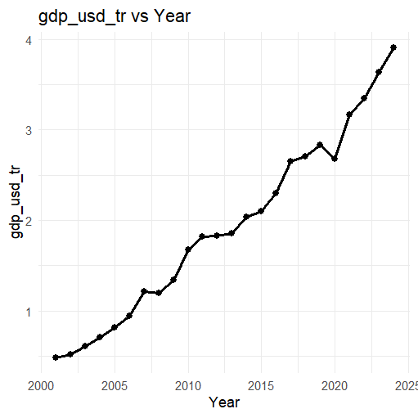

Moving Average
- Window vs MAPE
- Window MAPE
- 1 2 2.220121
- 2 3 2.960161
- 3 4 3.660827
- 4 5 4.093562
- 5 6 4.621548
- 6 7 4.987216
- 7 8 5.318731
therefore, window size = 2 has least percentage error

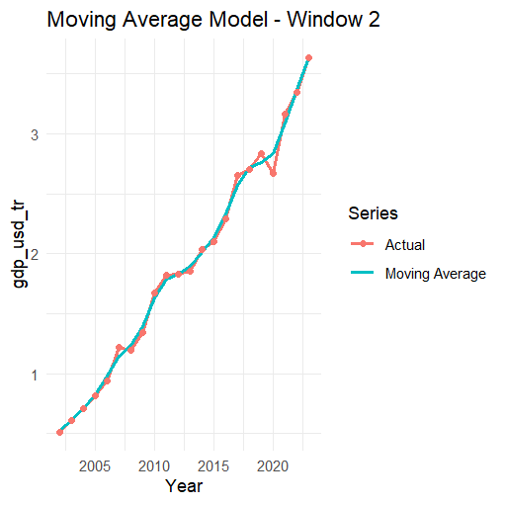
Single Exponential Smoothening
Smoothing parameters:
alpha = 0.9999
Initial states:
l = 0.4958
sigma: 0.2087
AIC AICc BIC
4.984700 6.184700 8.518862

Accuracy of SES model:
ME RMSE MAE MPE MAPE MASE ACF1
Training set 0.1422712 0.1998518 0.1580849 7.975547 8.78763 0.9611294 -0.1411096

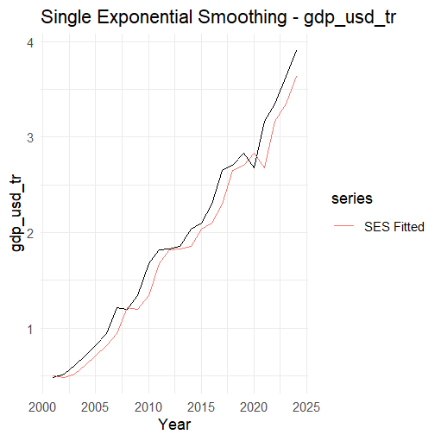
ARIMA
ARIMA(0,1,0) with drift
Coefficients:
drift
0.1489
s.e. 0.0291
sigma^2 = 0.02038: log likelihood = 12.65
AIC=-21.3 AICc=-20.7 BIC=-19.02
p=0 , d=1, q=0

Accuracy of ARIMA model:
ME RMSE MAE MPE MAPE MASE ACF1
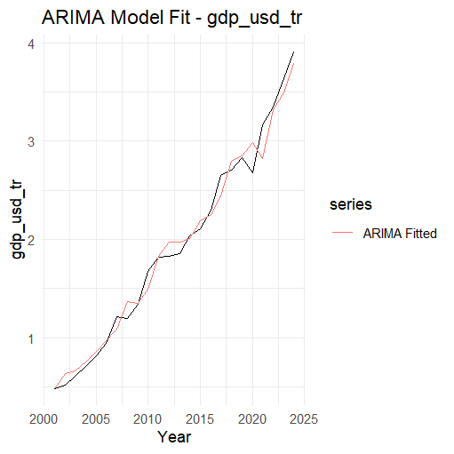
Training set: 1.4003e-05 0.136 0.1029 -1.8189 6.1288 0.62569 -0.18978

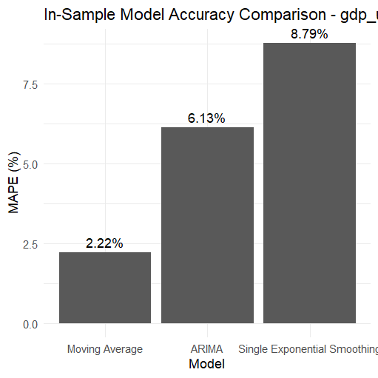
Least Percentage error for gdp is from moving average model

Rice_production
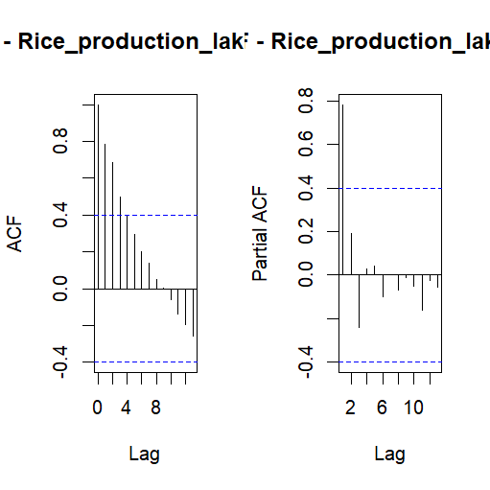
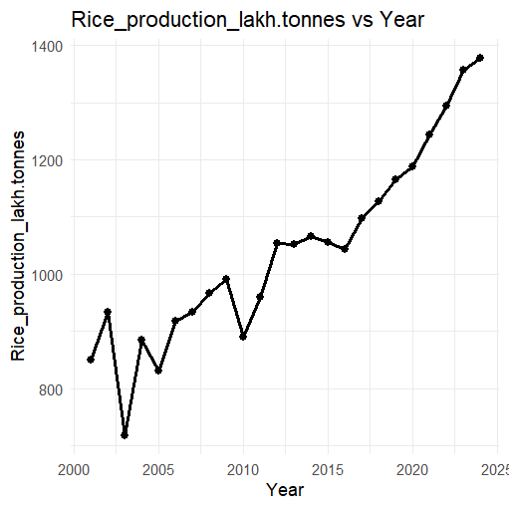

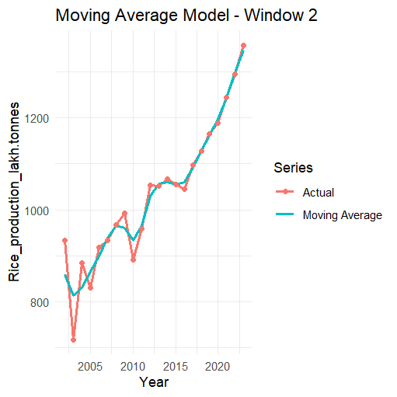
Moving average
Window MAPE
1 2 2.290598
2 3 3.054130
3 4 2.799404
4 5 2.921363
5 6 2.635787
6 7 2.924483
7 8 3.319667

SES
Smoothing parameters:
alpha = 0.7105

Initial states:
l = 859.8458

sigma: 72.9504

AIC AICc BIC
286.0944 287.2944 289.6286

ME RMSE MAE MPE MAPE MASE ACF1
Training set 29.640 69.844 57.21209 2.331188 5.85251 1.000744 -0.3400813
Arima
P= 0, d=1 , q=1

ME RMSE MAE MPE MAPE MASE ACF1
Training set -3.197246 58.25914 39.48473 -0.9513636 4.153336 0.69066 -0.02646264
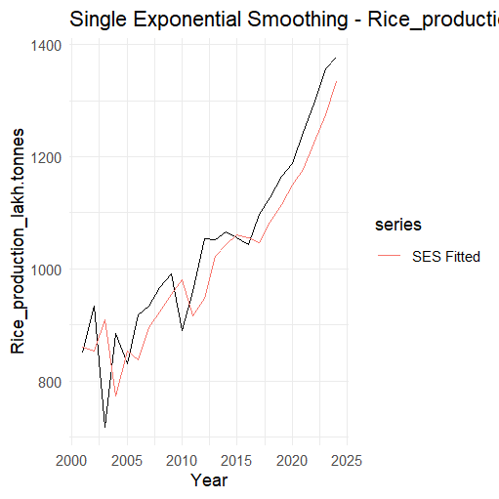
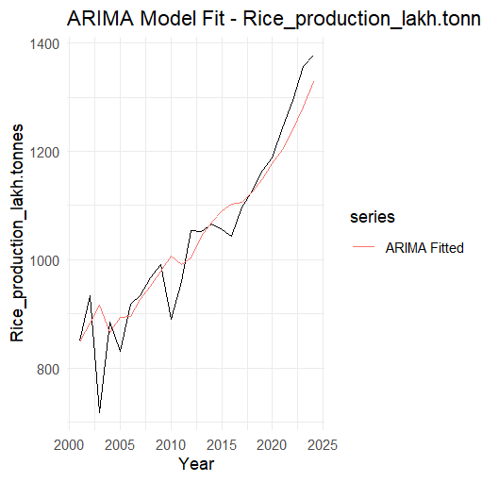
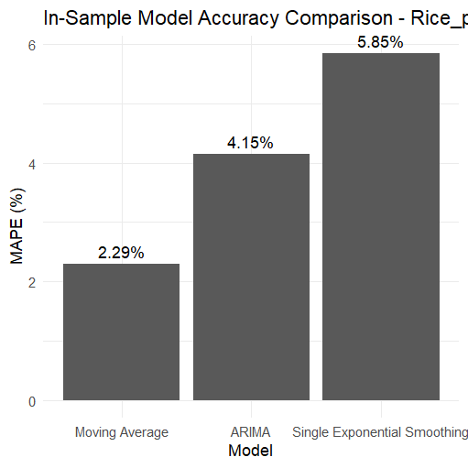

e praduc
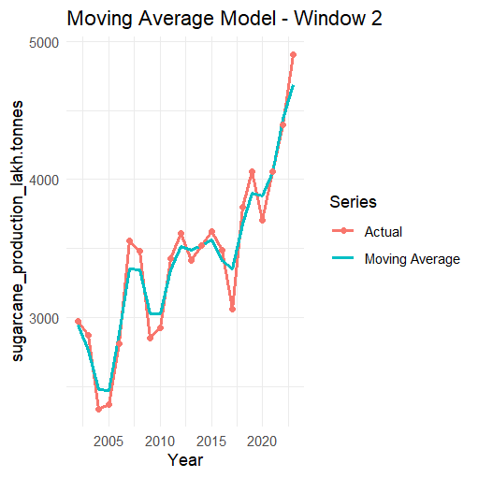
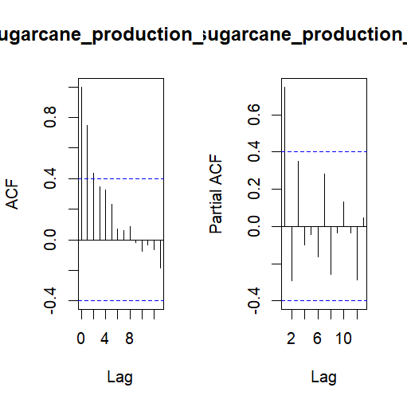
Sugarcane Production

Best Moving Average Window: 2 (for moving avg)

Smoothing parameters:
alpha = 0.9999

for ARiMA , p=0 , d=1, q=0

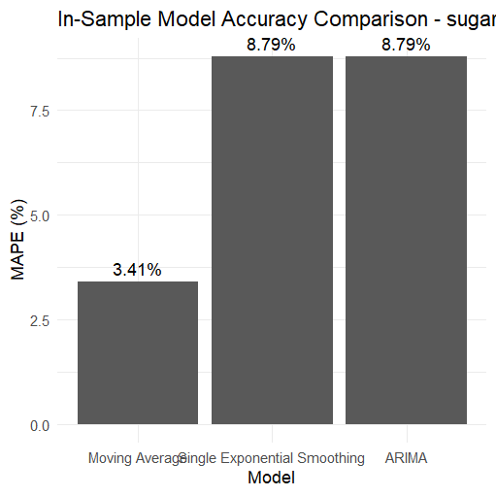

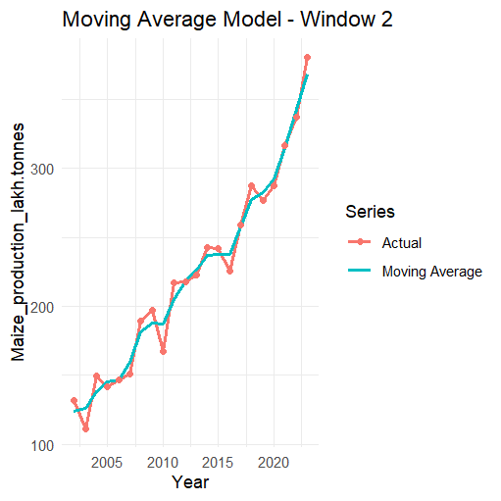
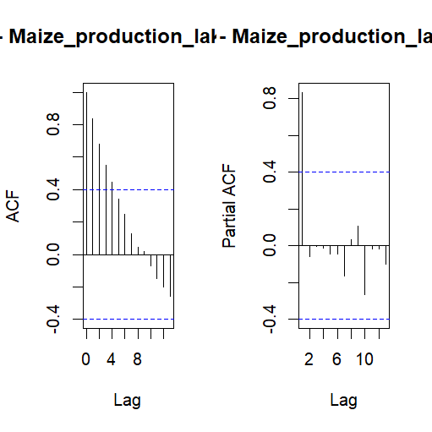
Maize_production
Moving Average MAPE: 3.91 % (window = 2)

Smoothing parameters:
alpha = 0.9425

Initial states:
l = 121.0287

sigma: 24.331

AIC AICc BIC
233.3891 234.5891 236.9233

Arima
P = 0, d=1, q=1

