- Make a copy of “lab-4” directory and name it as gba
- Copy contracts and scripts folders to gba
- In another terminal, compile the contract, run the command under the gba directory
$ hh compile
- Deploy the contract to goerli, run the command under the gba directory
$ hh run --network goerli scripts/deploy.js
- Go to https://goerli.etherscan.io/ and use your account address to search for the transaction
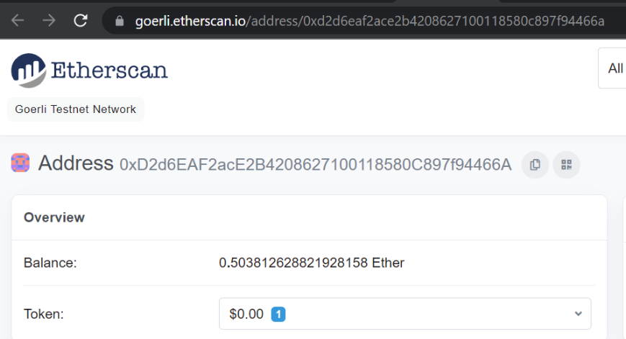

https://goerli.etherscan.io/address/0x8e4fb3e962bc36b44e26e9cf8357ff7223879941

Locate the transaction for the contract creation. “Contract Creation” is indicated under the To column.
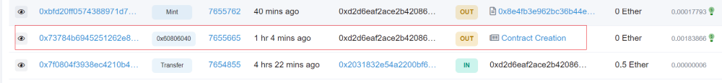
- Open the transaction for contract creation, copy the contract address 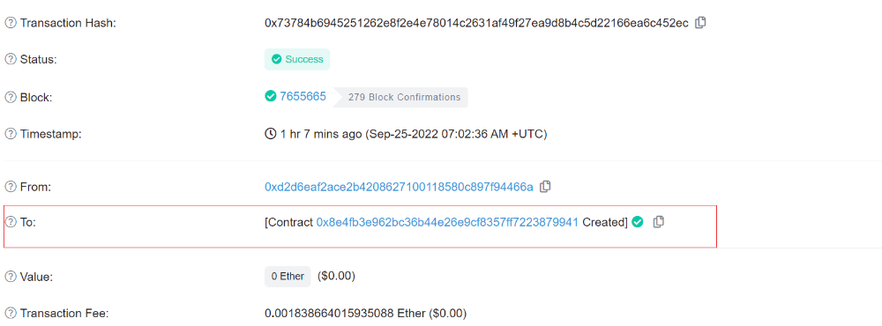
https://goerli.etherscan.io/tx/0x73784b6945251262e8f2e4e78014c2631af49f27ea9d8b4c5d22166ea6c452ec

The contents of the contract can also be browsed using the contract address.
https://goerli.etherscan.io/address/0x8e4fb3e962bc36b44e26e9cf8357ff7223879941

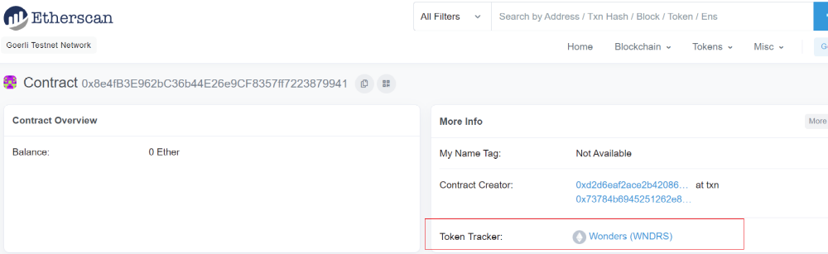

- Use scripts/mint.js and scripts/transfer.js to mint more tokens and transfer them to another address

run the command under the gba directory
$ hh run --network goerli scripts/mint.js (or scripts/transfer.js)

- These transactions can be found via https://goerli.etherscan.io/ using the contract address

https://goerli.etherscan.io/address/0x8e4fb3e962bc36b44e26e9cf8357ff7223879941

