## THE VOLVO LIFE JOURNAL

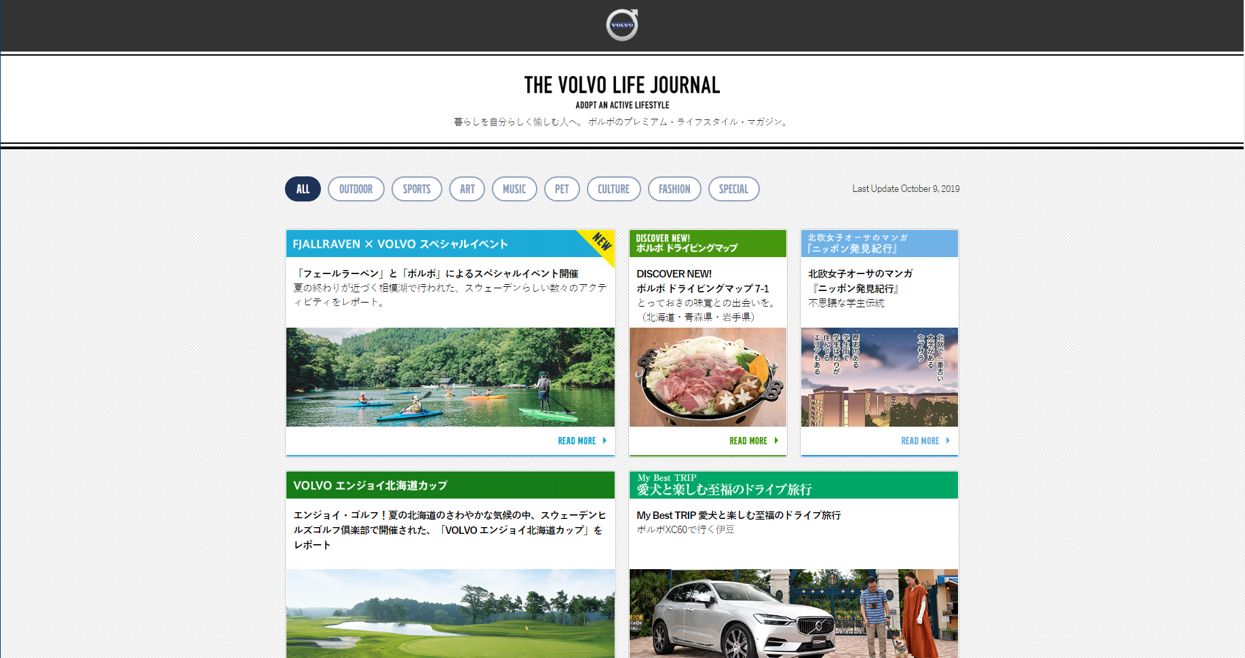

URL: https://v-for-life.jp/

Language: HTML, jQuery

Description:

* Static HTML pages
* Responsive design

## 451039

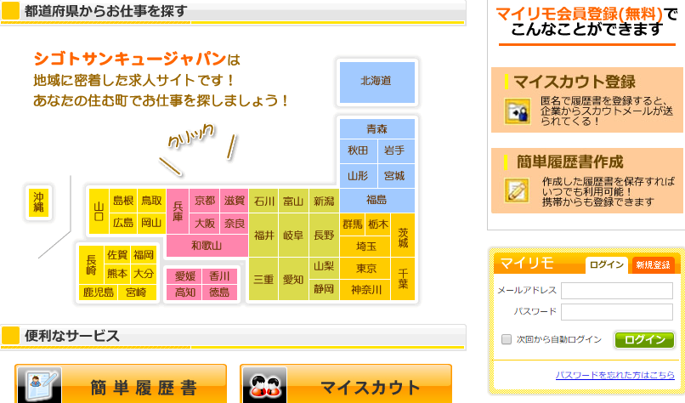

URL: <http://451039.jp/>

Language: PHP

Framework: Symfony

Description:

A part-time job searching site built on Symfony framework

## OCHER.CLUB

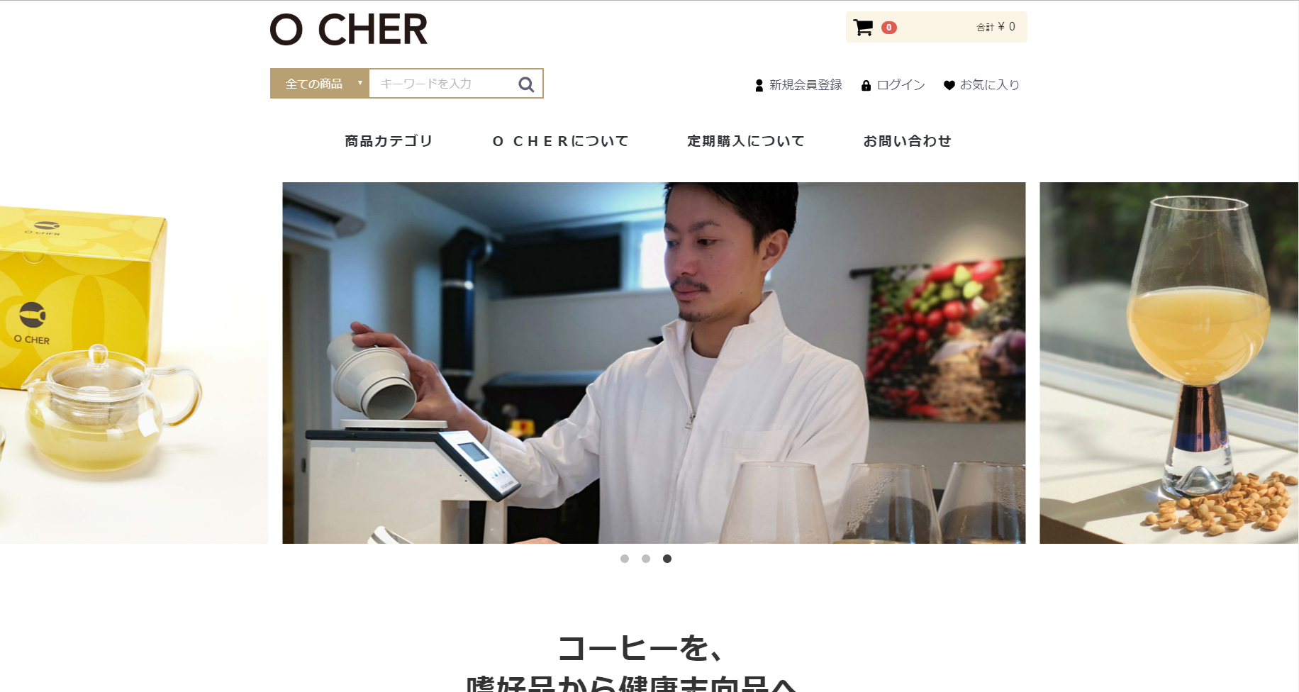

URL: <https://ocher.club>

Language: PHP

Framework: EC-CUBE

Description:

We added following features to EC-CUBE framework:

* Subscription order management
* GMO Payment Gateway manual bulk payment

## THE HEADLINE

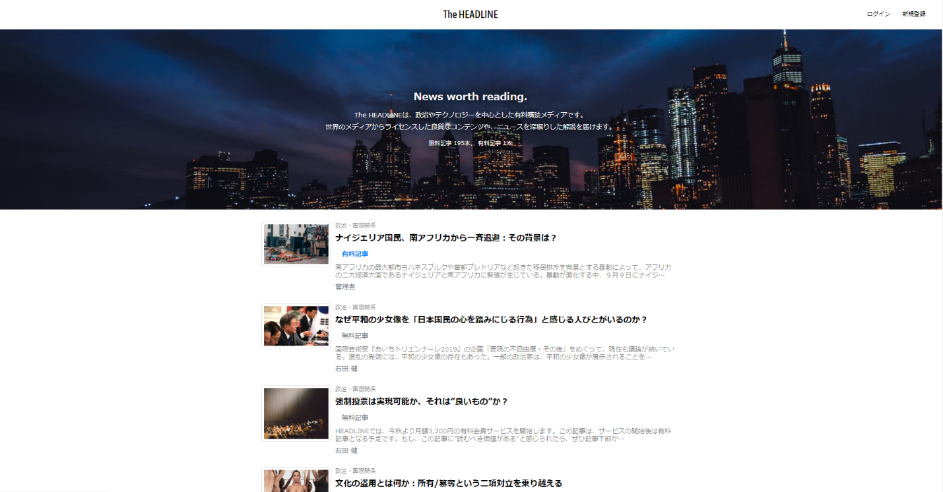

URL: <https://theheadline.jp>

Language: Ruby

Framework: Ruby on Rails

Description:

Rails CMS built from scratch.

* Stripe payment system
* Twitter, Facbook login using OmniAuth
* Automatically share contents to Twitter.

## ITINERARY

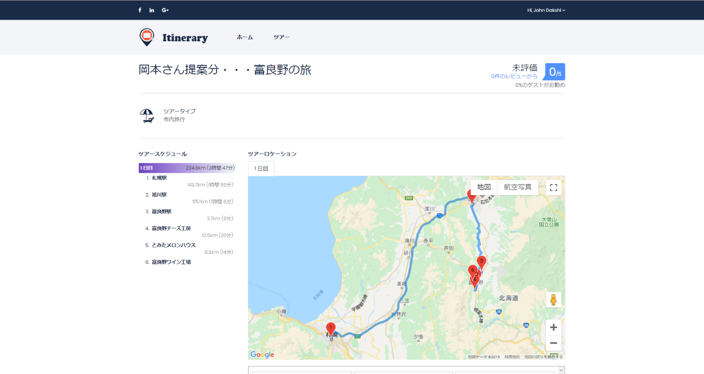

Langauge: PHP

Framework: Laravel

Description:

We added following features to Booking Core system:

* Google map search and direction service
* Multiple-day and mutlple-spot tour feature
* Live video & voice call, chatting service
* Co-Browsing

## BRIGHT PAY SYSTEM

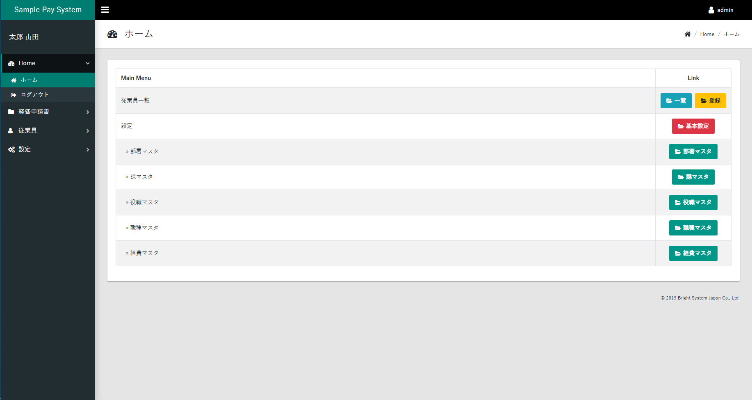

Langauge: PHP

Framework: CakePHP

Description:

Finance management system built on CakePHP framework.

* Export massive data to CSV & PDF format.
* Solved non-ANSI languages garbling problem in TCPDF and opening downloaded csv file in Excel.

## KETCHUP

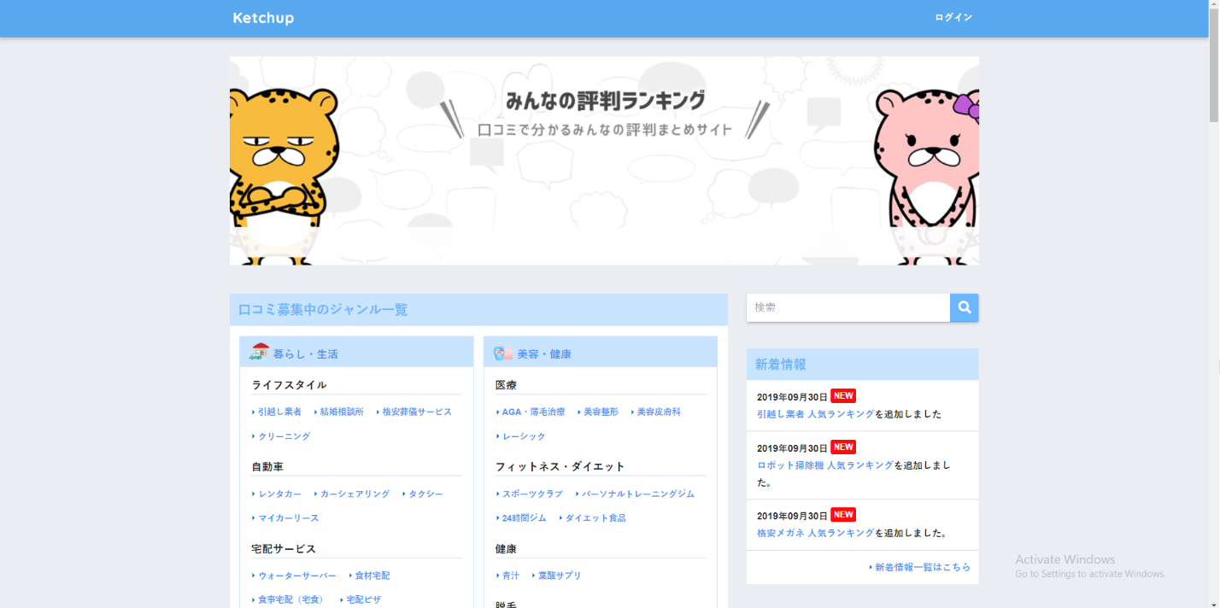

Language: PHP

Framework: WordPress

Description:

We customized designs and features of WordPress framework.

* Ranking posts by reviews
* Social share & SEO support

## MAKUSURU

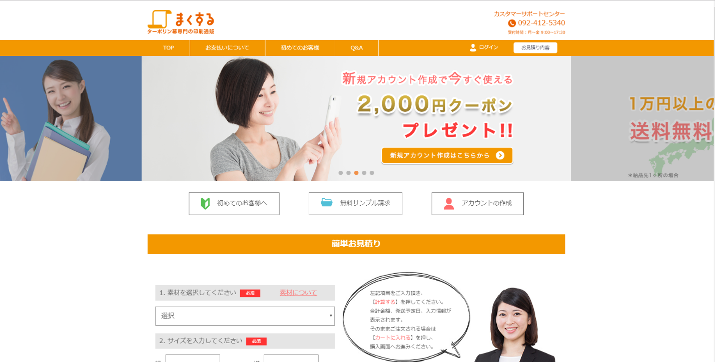

Language: PHP

Framework: EC-CUBE

Description:

We added following features to EC-CUBE framework:

* Product size-based pricing option.
* Fixed plugin inconsistency problem that happens when reorder saved orders and estimations.