STUDENT RECORD MANAGEMENT SYSTEM
PROJECT DOCUMENTATION
A Python Console-Based Application
━━━━━━━━━━━━━━━━━━━━━━━━━━━━━━━━━━━━━━

Student Name | ________________________________________
Student ID | ________________________________________
Course/Module | ________________________________________
Lecturer | ________________________________________
Institution | ________________________________________
Submission Date | ________________________________________
Prepared as part of a structured programming project

TABLE OF CONTENTS
Section | Title | Page
1.0 | Introduction | 3
2.0 | System Analysis | 4
3.0 | System Design | 5
4.0 | System Implementation | 7
5.0 | System Testing | 8
6.0 | Limitations and Recommendations | 9
7.0 | Conclusion | 10
Appendix A | Original Python Source Code | 11

This documentation explains the purpose, structure, operation, testing and limitations of the Student Record Management System developed in Python.

1.0 INTRODUCTION

1.1 Background of the Project
Educational institutions keep important information about students and lecturers, including names, identification numbers, contact details and parent or guardian telephone numbers. When records are handled manually, searching for a particular record can be slow and errors can occur. This project demonstrates how Python dictionaries, functions, loops, conditional statements and exception handling can be used to build a simple console-based record lookup system.

1.2 Problem Statement
Manual record searching may take unnecessary time, especially when a user must inspect many entries before finding the correct student or lecturer. There is also a risk of entering an invalid identification number or using a name that does not match the selected record. A small automated system is therefore required to validate user input, search stored records and return the correct information.

1.3 Aim of the Project
The aim of the project is to develop a Python-based Student Record Management System that allows a user to enter a student ID and name to retrieve student information, and optionally use a lecturer login panel to retrieve lecturer information.

1.4 Objectives
- Store student and lecturer records using Python dictionaries.
- Allow users to search for a student by ID and name.
- Validate identification numbers so that only integers are accepted.
- Validate names so that numeric-only entries are rejected.
- Provide a separate lecturer login panel.
- Display clear success or failure messages.
- Demonstrate the use of functions, loops, conditions and exception handling.

1.5 Scope of the System
The current system is a local console application. It contains predefined records for eleven students and five lecturers. It does not use a database, graphical interface, password authentication, file storage or network connection. Its main purpose is to demonstrate fundamental structured programming concepts.

2.0 SYSTEM ANALYSIS

2.1 Proposed Solution
The proposed solution is an interactive Python program that displays a student section first. The user enters a student ID and a student name. The program checks the stored dictionary and displays the student name, parent telephone number and email address when the details match. After the student section, the system asks whether the user is a lecturer. A lecturer who answers “yes” enters an ID and name, and the system displays the corresponding telephone number.

2.2 System Users
User | Purpose | Main Actions
Student/User | Searches for an existing student record. | Enter student ID and name; view contact information.
Lecturer | Uses the lecturer login panel. | Answer yes; enter lecturer ID and name; view lecturer record.
Developer/Administrator | Maintains the source code and records. | Add, edit or remove dictionary entries and improve validation.

2.3 Functional Requirements
- The system shall display a clear program heading.
- The system shall accept a student ID as an integer.
- The system shall accept a student name as text.
- The system shall search the student record dictionary.
- The system shall display student contact information when a record matches.
- The system shall ask whether the user is a lecturer.
- The system shall accept lecturer ID and name when the response is yes.
- The system shall display a suitable message when a record is not found.

2.4 Non-Functional Requirements
Requirement | Description
Usability | Prompts and messages should be easy to understand.
Reliability | Valid records should return the correct stored information.
Performance | Dictionary lookup should complete immediately for the small dataset.
Maintainability | Records and functions should be easy to update.
Portability | The application should run on any computer with a compatible Python interpreter.
Security | Future versions should protect sensitive contact details and require proper authentication.

3.0 SYSTEM DESIGN

3.1 Program Structure
The program follows a procedural design. Two main functions are defined: one for student record lookup and one for lecturer record lookup. The main program then uses loops to collect and validate inputs before calling the appropriate function.
Component | Responsibility
student_info(student_id, student_name) | Stores student records, checks the supplied student ID and name, and returns student contact details.
lecturer_access(lecturer_id, lecturer_name) | Stores lecturer records, checks the supplied lecturer ID and name, and returns lecturer details.
Student input loops | Validate the student ID and name before searching.
Lecturer response loop | Accept only yes or no.
Lecturer input loops | Validate lecturer ID and name before searching.

3.2 Data Structure
Python dictionaries are used because they provide a direct relationship between a unique ID and the information connected to that ID. Each outer dictionary key is an integer ID. The value is another dictionary containing named fields.
111: {
"name": "Christian Effiong",
"parent_phonenumber": "075900747",
"email": "chriseffi@gmail.com"
}

3.3 Input–Process–Output Design
Stage | Student Section | Lecturer Section
Input | Student ID and student name | Yes/no response, lecturer ID and lecturer name
Process | Validate data; search attendance_info; compare ID and name | Validate data; search lecturer_info; compare ID and name
Output | Student name, parent phone number and email, or an error message | Lecturer name, ID and phone number, or an error message

3.4 System Flowchart
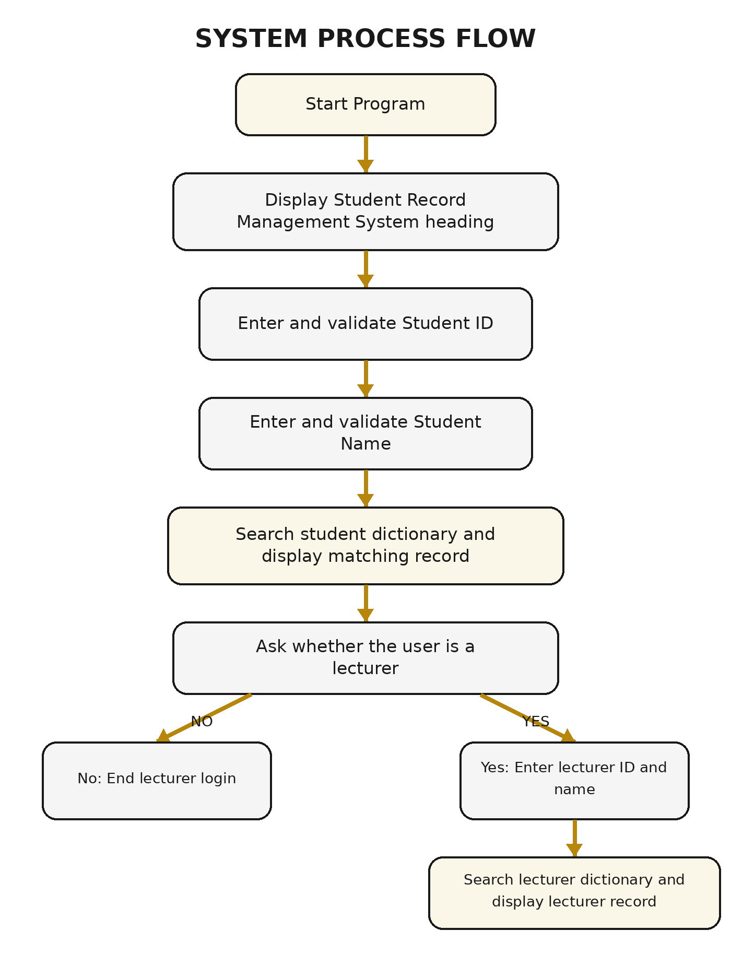
Figure 1: Overall process flow of the Student Record Management System

4.0 SYSTEM IMPLEMENTATION

4.1 Development Technology
Item | Details
Programming Language | Python 3
Interface | Command-line / console
Storage Method | Hard-coded nested dictionaries
Main Concepts | Functions, dictionaries, loops, conditionals, input, exception handling and formatted strings
Recommended Editor | Visual Studio Code, IDLE or any Python-compatible editor

4.2 Explanation of the Student Function
The student_info function receives student_id and student_name as parameters. It creates the attendance_info dictionary, checks whether the supplied ID exists, obtains the stored name, telephone number and email address, and then returns a formatted result. The function is intended to verify that both the ID and name identify the same student.

4.3 Explanation of the Lecturer Function
The lecturer_access function performs a similar operation for lecturers. It accepts a lecturer ID and lecturer name, checks the lecturer_info dictionary and returns the lecturer name, ID and telephone number when the supplied information matches.

4.4 Input Validation
- Student and lecturer IDs are converted with int(). A ValueError is caught when the user enters non-numeric data.
- Student names are collected as strings and converted to title case for consistent comparison.
- The lecturer question accepts only yes or no and repeats when another value is entered.
- Loops keep the user at the same input stage until acceptable data is provided.

4.5 How to Run the Program
- Install Python 3 on the computer.
- Copy the source code into a file named student_record.py.
- Open Command Prompt, PowerShell or a terminal in the folder containing the file.
- Run the command: python student_record.py
- Enter a valid student ID and name.
- Answer the lecturer question and continue when required.

4.6 Example Record Search
Enter your student ID: 111
Enter your name: Christian Effiong
student: Christian Effiong
parent phonenumber: 075900747
email: chriseffi@gmail.com

5.0 SYSTEM TESTING

5.1 Testing Approach
Black-box testing can be used to test the application. Each test supplies an input and checks whether the displayed output matches the expected result. Both valid and invalid inputs should be tested.
ID | Input | Expected Result | Purpose
TC01 | 111 / Christian Effiong | Existing student record is displayed. | Valid student lookup
TC02 | 111 / Wrong Name | A no-information message is displayed. | Name mismatch
TC03 | abc as student ID | “Id Should be integer” is displayed and input repeats. | Invalid ID type
TC04 | Blank student name | The prompt repeats. | Empty name
TC05 | yes / 121 / Effiong John | Lecturer record is displayed. | Valid lecturer lookup
TC06 | maybe | The user is told to answer yes or no. | Invalid lecturer response
TC07 | abc as lecturer ID | “String data type not allowed” is displayed. | Invalid lecturer ID
TC08 | no | Lecturer login should be skipped and the program should end safely. | No lecturer access
TC09 | Unknown student ID | A clear record-not-found message should appear. | ID does not exist
TC10 | Unknown lecturer ID | A clear lecturer-not-found message should appear. | ID does not exist

5.2 Expected Results
The system should return the correct record only when the supplied ID and name belong to the same person. Invalid data should not terminate the program unexpectedly. The user should receive a clear message and be allowed to try again where appropriate.

5.3 Acceptance Criteria
- All valid student records can be retrieved.
- All valid lecturer records can be retrieved.
- Non-integer IDs are rejected without crashing the program.
- Invalid yes/no answers are rejected.
- Choosing no for lecturer access ends the lecturer section safely.
- Unknown IDs and mismatched names produce clear messages.

6.0 LIMITATIONS AND RECOMMENDATIONS

6.1 Limitations in the Current Version
Area | Limitation
Record matching logic | The for-loops inside both lookup functions return during the first iteration. The loop variables are not needed because the program already retrieved the record using the ID.
Lecturer “no” option | The lecturer_access function is called after the yes/no section even when the user selects no. In that situation, lecturer_id and lecturer_name may not exist, which can cause a NameError.
Unknown ID handling | When an ID is not found in the dictionary, the functions do not return a clear message, so None may be printed.
Name validation | input() always returns a string. The lecturer-name isinstance check does not properly detect numeric text, and the related try/except block cannot catch a ValueError there.
Data persistence | Records are hard-coded and disappear when the source code is replaced. Users cannot add or edit records through the application.
Security | Contact details are displayed without a password or role-based permission.
Scalability | The console interface and hard-coded dictionaries are suitable only for a small demonstration system.

6.2 Recommended Corrections
- Compare the supplied name directly with the name stored under the selected ID.
- Add an else branch that returns a clear “ID not found” message.
- Call lecturer_access only inside the if ask == "yes" block.
- Use student_name.isalpha() or another suitable rule when checking names.
- Move the dictionaries outside the functions so they are created once and can be shared.
- Separate data storage, validation and user-interface logic into different functions.
- Use a database such as SQLite or MySQL for a larger version.
- Add passwords, access roles and audit logging before storing real personal information.

6.3 Future Enhancements
Enhancement | Benefit
Add, update and delete records | Allows the system to perform full record management rather than lookup only.
Database integration | Stores records permanently and supports many users.
Graphical user interface | Makes the system easier to use.
Authentication and roles | Protects private records and separates student, lecturer and administrator access.
Attendance and grades | Expands the system into a complete student management application.
Report generation | Allows printing or exporting student records to PDF.
Search by partial name | Improves record discovery when the exact ID is unknown.

7.0 CONCLUSION
The Student Record Management System demonstrates how basic Python programming concepts can be combined to solve a real record-searching problem. The program uses nested dictionaries to store information, functions to organize operations, loops to repeat invalid input, conditionals to make decisions and exception handling to prevent some input errors. It provides separate student and lecturer sections and can display records when the correct details are supplied.
Although the current version is suitable as a structured programming project, several corrections are required to make every program path safe and reliable. The most important improvements are to simplify the matching logic, handle unknown IDs, prevent the lecturer function from being called when the user selects no, and improve name validation. With database storage, authentication and a graphical interface, the project can later be expanded into a practical school management system.

7.1 Summary of Learning Outcomes
- Creating and accessing nested dictionaries.
- Defining functions with parameters and return values.
- Using while loops for repeated input.
- Using if, elif and else for decision-making.
- Handling invalid integer conversion with try and except.
- Formatting output with f-strings.
- Identifying and documenting software limitations.

APPENDIX A: ORIGINAL PYTHON SOURCE CODE
print("*"*70)
print("STUDENT RECORD MANAGEMENT SYSTEM")
print("*"*70)

def student_info(student_id, student_name):
attendance_info={
111:{"name": "Christian Effiong", "parent_phonenumber":"075900747", "email" : "chriseffi@gmail.com"},
222:{"name": "Sallieu Mansaray", "parent_phonenumber":"099856734", "email" : "sallieu@gmail.com"},
333:{"name": "Angela Yankuba", "parent_phonenumber":"07360897", "email" : "angiebaby@gmail.com"},
444:{"name": "Alfred Vandy", "parent_phonenumber":"088905634", "email" : "vandy@gmail.com"},
555:{"name": "Caper Chino", "parent_phonenumber":"09999887", "email" : "chino@gmail.com"},
666:{"name": "George Ngolo", "parent_phonenumber":"07923435", "email" : "ngolo@gmail.com"},
777:{"name": "Haja Sombie", "parent_phonenumber":"075778098", "email" : "sombie@gmail.com"},
888:{"name": "French Genius", "parent_phonenumber":"099900747", "email" : "chriseffi@gmail.com"},
999:{"name": "Mamta John ", "parent_phonenumber":"0675900747", "email" : "mamta@gmail.com"},
110:{"name": "Christian Kamara", "parent_phonenumber":"07597875", "email" : "kamara@gmail.com"},
211:{"name": "Tan Seri", "parent_phonenumber":"08884909", "email" : "serTan@gmail.com"},
}
if student_id in attendance_info:
name=attendance_info[student_id]["name"]
phonenumber=attendance_info[student_id]["parent_phonenumber"]
email=attendance_info[student_id]["email"]
for pid, student in attendance_info.items():
if name == student_name:
return f"student: {name} \nparent phonenumber: {phonenumber} \nemail: {email}"
else:
return f"No information found for student name: {student_name}\nstudent_id: {student_id}"

def lecturer_access(lecturer_id, lecturer_name):
lecturer_info={
121:{"name": "Effiong John", "phone_number":"075900747"},
122:{"name": "Effiong Fatu", "phone_number":"099708086"},
123:{"name": "Kamara Conteh", "phone_number":"075780098"},
124:{"name": "Amadu Kamara", "phone_number":"09995612"},
125:{"name": "Elijah Fullah", "phone_number":"099960747"}
}
if lecturer_id in lecturer_info:
lect_name=lecturer_info[lecturer_id]["name"]
lect_phone=lecturer_info[lecturer_id]["phone_number"]
for id, name in lecturer_info.items():
if lect_name==lecturer_name:
return f"lecturer name: {lecturer_name} \nlecturer id: {lecturer_id}\n lecturer phonenumber: {lect_phone}"
else:
return f"No data found for lecturer name: {lecturer_name} and lecturer id: {lecturer_id}"

student_name={}
student_id=0
while True:
try:
student_id=int(input("Enter your student ID: "))
break
except ValueError:
print("Id Should be integer ")
continue

while True:
student_name=input("Enter your name: ").title()
if student_name:
try:
student_name=int(student_name)
if isinstance(student_name, int):
print("name should be string")
continue
else:
break
except ValueError:
now=student_info(student_id, student_name)
print(now)
break

print("#"*100)
print("LECTURER LOGIN PANEL")
print("*"* 100)

while True:
ask=input("Please answer with yes or no\nAre you a lecturer yes or no: ").lower()
if ask:
try:
ask=int(ask)
if isinstance(ask, int):
print("please no number is allowed only use yes or no")
continue
else:
break
except ValueError:
if ask=="yes":
break
elif ask== "no":
break
else:
print("not stop messing around ")
continue

if ask =="yes":
while True:
try:
lecturer_id=int(input("Enter your Lecturer ID: "))
break
except ValueError:
print("String data type not allowed")
continue

while True:
lecturer_name=input("Enter your Name: ").title()
if lecturer_name:
try:
if isinstance(lecturer_name, int):
print("Please no number allowed")
continue
else:
break
except ValueError:
break

call=lecturer_access(lecturer_id, lecturer_name)
print(call)

