Lab 5 – Prolog Fundamentals

Group #: 3
Joey Issa - 300219818
Garrett Winslow - 300149981
Yannick Vaillancourt – 300226628

Task A report
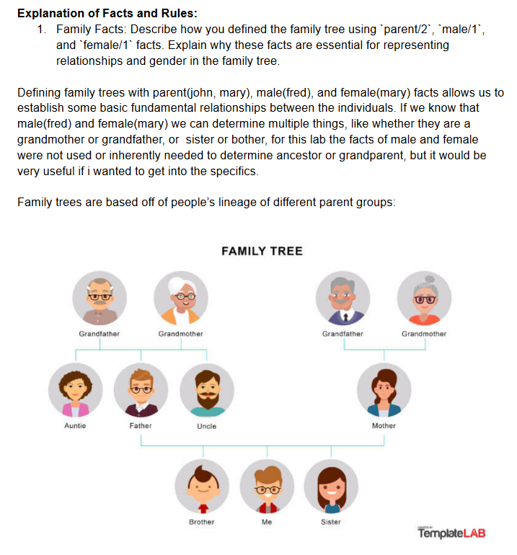
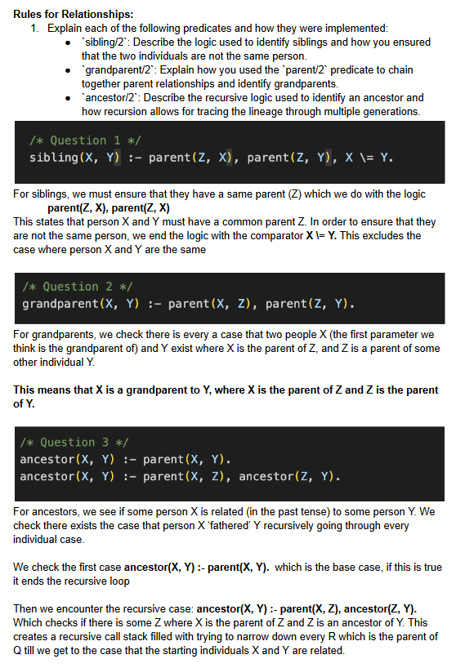
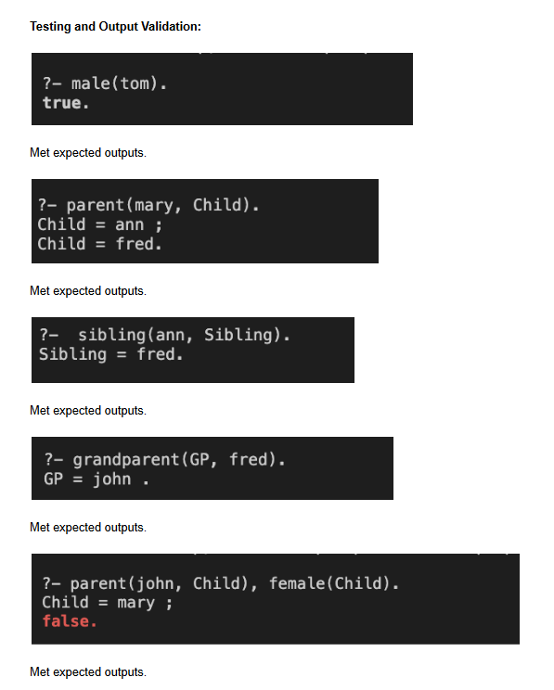
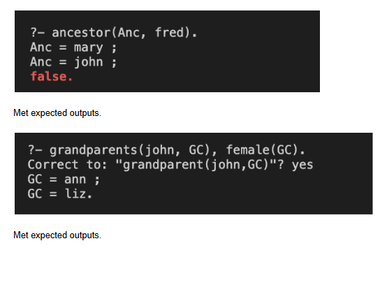

Task B report
1. The base case just says "when the list is empty stop recursing", without it prolog will continue to waste everyone's time taking the sum of an empty list.
2. When head is an odd number then the first section fails (0 is NOT Head mod 2). That means we branch to the next possible true (the other side of the or) which takes the sum counting the head.
3. If the number is even then we don't branch and we simply recurs, not counting the head.
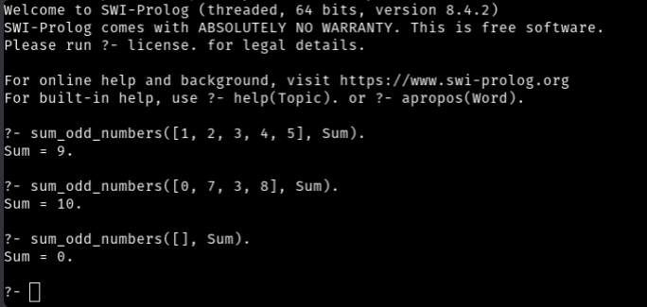

Task C report
Permutation:
I used the built-in ‘permutation/2’ predicate. It has two arguments: the first is a list of all 4 house colors, representing what items the lists should generate permutations of, and the destination list that these permutations get stored as, providing the ‘Houses’ list for any permutation that succeeds.
Helper predicates:
‘next_to/3’ checks if the first 2 arguments are found back-to-back in the list, while ‘not_next_to/3’ checks for this to not be the case. The base cases for next_to are: ‘we’ve reached the end of the list and have no more elements’, indicating they were not found back-to-back (in the order 1st element -> 2nd element), and ‘1st element is the head of the list, and the 2nd element is the head of the tail of the list’, meaning they were found, with the recursive step simply trying again with the tail of the list. ‘not_next_to/3’ simply checks if the negation of next_to is true (returning the opposite of next_to).
Valid solutions:
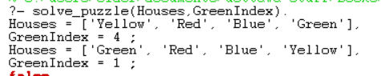
These solutions are valid because all clues have been met. Red is always to the left of Blue (taking advantage of the fact that ‘next_to’ technically only checks if the sequence […,X,Y,…] exists in the list and not the other way around). The second clue effectively finds the index of ‘Green’ since the treasure is always in the green house, and thus will never have a mismatch. The third clue ensured ‘Yellow’ and ‘Green’ were never side by side (in either direction, thus requiring both ‘not_next_to’s). Lastly the fourth clue ensures the ‘Green’ house is not second from the left, but all other outcomes are acceptable.
The fourth clue is actually unneeded, because if ‘Red’ is always next to ‘Blue’, but ‘Green’ cannot be next to ‘Yellow’, then they must be split, with ‘Red’ & ‘Blue’ taking up the middle 2 spots. This therefore prevents ‘Green’ from being the 2nd house entirely, and the remaining permutations simply require getting the index of the ‘Green’ house to obtain the treasure.

