Report Requirements
In addition to submitting your code, include a brief report covering the following:
- Game Logic and Dynamic Predicates: Explain how you set up the 6x6 grid, assigned mines, and used dynamic predicates to track game state.
- Game Logic and Dynamic Predicates: In order to represent the state of each tile (hidden, flagged, revealed), I have 3 different dynamic predicates, 1 per state. So when players perform an action (revealing, flagging or unflagging), it firstly checks whether that tile is in an appropriate state to perform such an action, and then transfers it to another predicate. At the start of the game, initialized with the predicate ‘new_game/0’, 6 randomly chosen numbers from 1 to 36, and then converted to (x,y) coordinates, are used to determine mine placement. Then, all 36 tiles are deemed hidden, and as such asserts each tile’s coordinates into grid.
2. Recursive Logic and Neighbouring Count Calculation: Describe how you implemented recursive checks to calculate adjacent mines and handled player moves.
- Recursive Logic and Neighbouring Count Calculation: To determine the amount of adjacent mines, I check each tile within a +-1,+-1 radius, and increment the accumulator by 1 for each mine found this way. More specifically, given the coordinates of the tile to be revealed, I apply the relative coordinates (between -1 and 1 on both axis) to them, and for each combination (example: (2,1) tests (3,2), (3,1), (3,0), (2,2), (2,1), (2,0), (1,2), (1,1), (1,0))), checks if a mine predicate at those coordinates exist.
3. Game Interaction and Display: Explain how you managed user commands and displayed the game board for each move.
- Game Interaction and Display: Each player commands acts with a whitelist approach, where only explicitly permitted actions can be performed. Because each command requires the tile to be a specific state (and thus doesn’t exist in any other state), if that is not the case for any reason (such as the coordinates being in a different state or the coordinates themselves being invalid), then that command is terminated immediately. The game board is displayed after each successful action. To accomplish this, for each coordinate combination within 1 & 6 is checked, and the corresponding value is added to a list depending on its state (‘?’ for hidden, ‘F’ for flagged, and the revealed value for revealed tiles). After this list is constructed, 6 values are printed at a time, repeating until none are left (which always displays correctly because the grid is always 6x6).
4. Testing and Results: Provide test cases and the results of playing through various game scenarios. Include screenshots or console outputs to demonstrate key game interactions.
Key interactions:
new_game:
Even after a previous game has finished, new_game clears all the dynamic predicates, sets all the tile states to grid (meaning they’re hidden), randomly chooses new mine locations, and lastly prints the new initial board
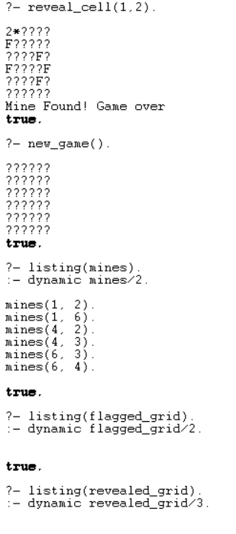
reveal_cell:
Standard operations:
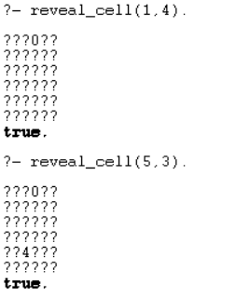
The standard behavior reveals the amount of adjacent mines.
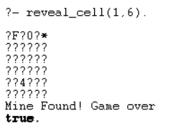
If a mine was revealed this way, the game is said to be over, and must be restarted with new_game(). While the play can still perform actions, because the victory condition requires flagging all the mines, which is only permitted to do on cells that haven’t been revealed, this victory is no longer achievable.
Error handling:
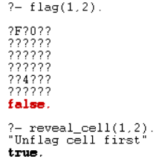
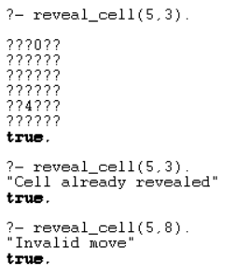

flag
Standard operations:
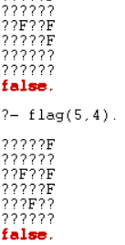
Victory determined after flagging
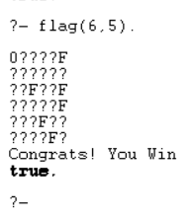
The win condition is that all and only the mines are flagged. As such that state can be reached after flagging the last mine.
Error handling:
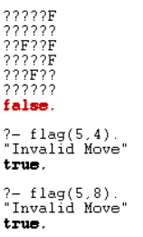
unflag
Standard operations:
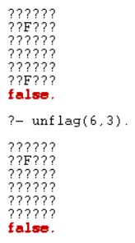
Win
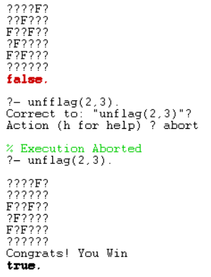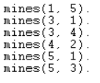
Error handling:
