小米开放平台
https://dev.mi.com/console/man/

消息推送管理后台
http://admin.xmpush.xiaomi.com/v2/app/nav

推送官方文档
https://dev.mi.com/doc/?p=544

创建一个工程，包名为com.ggggcexx.xiaomipushtest
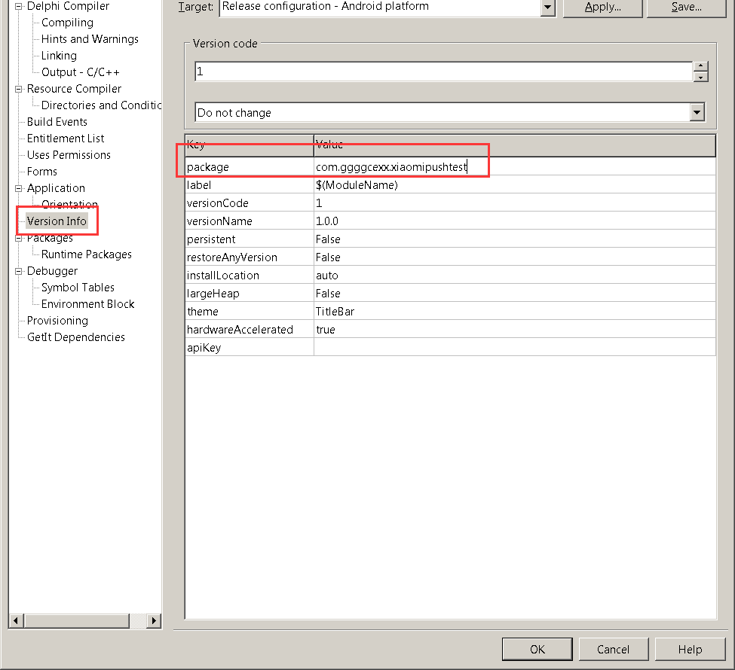

在小米开放平台，https://dev.mi.com/console/man/
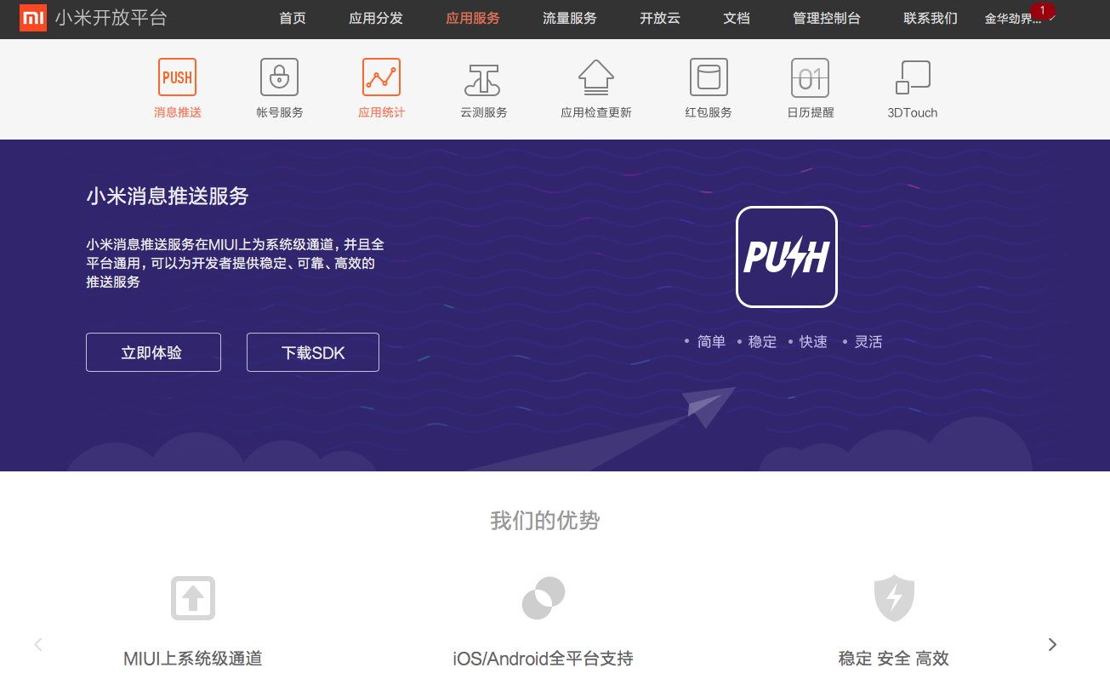
创建一个应用，
包名为com.ggggcexx.xiaomipushtest
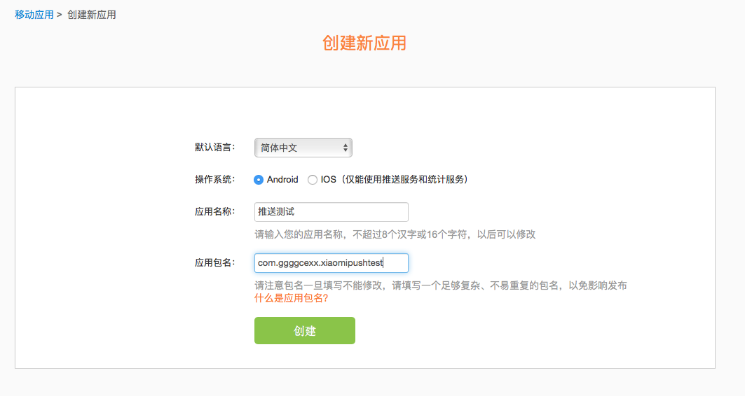
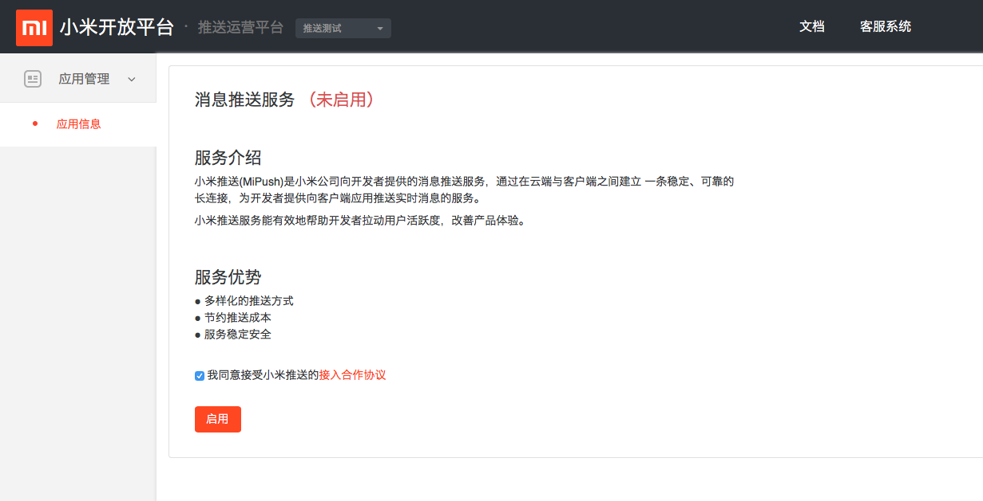
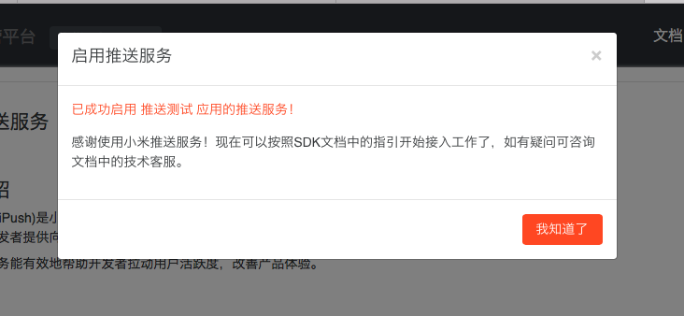
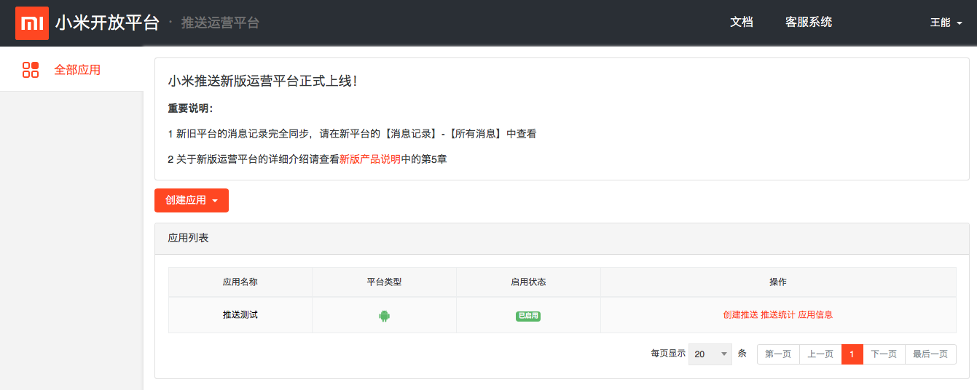
获取到应用的APPID和APPKey
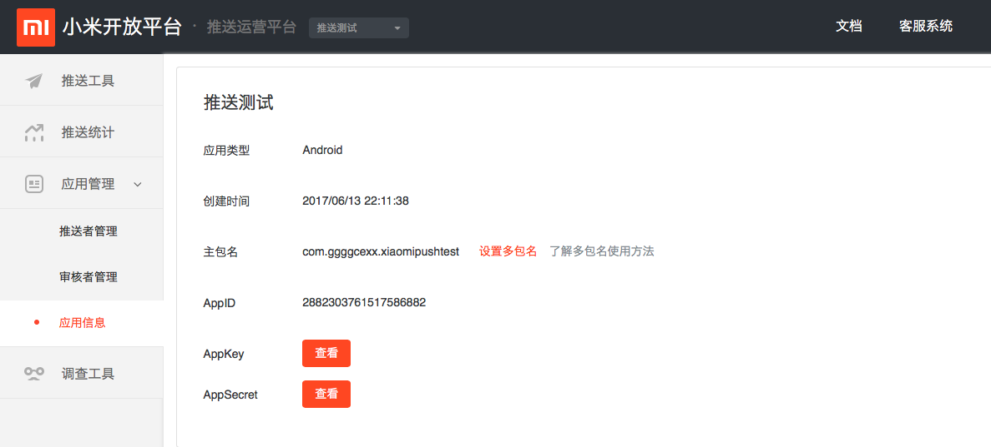

下载小米推送SDK
https://dev.mi.com/mipush/downpage/

配置XML
加入以下权限
<uses-permission android:name="android.permission.INTERNET" />
<uses-permission android:name="android.permission.ACCESS_NETWORK_STATE" />
<uses-permission android:name="android.permission.ACCESS_WIFI_STATE" />
<uses-permission android:name="android.permission.READ_PHONE_STATE" />
<uses-permission android:name="android.permission.GET_TASKS" />
<uses-permission android:name="android.permission.VIBRATE"/>
<permission android:name="com.xiaomi.mipushdemo.permission.MIPUSH_RECEIVE" android:protectionLevel="signature" />
<!--这里com.xiaomi.mipushdemo改成app的包名-->
<uses-permission android:name="com.xiaomi.mipushdemo.permission.MIPUSH_RECEIVE" />
<!--这里com.xiaomi.mipushdemo改成app的包名-->
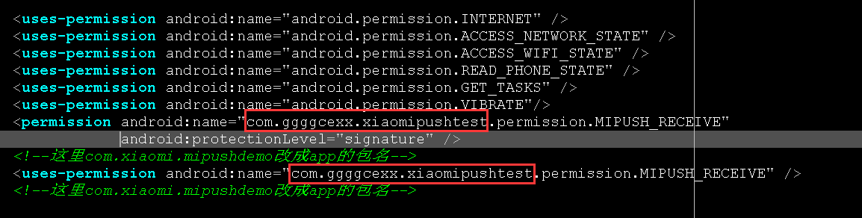

加入:
<service
android:enabled="true"
android:process=":pushservice"
android:name="com.xiaomi.push.service.XMPushService"/>
<service
android:name="com.xiaomi.push.service.XMJobService"
android:enabled="true"
android:exported="false"
android:permission="android.permission.BIND_JOB_SERVICE"
android:process=":pushservice" />
<!--注：此service必须在3.0.1版本以后（包括3.0.1版本）加入-->
<service
android:enabled="true"
android:exported="true"
android:name="com.xiaomi.mipush.sdk.PushMessageHandler" />
<service android:enabled="true"
android:name="com.xiaomi.mipush.sdk.MessageHandleService" />
<!--注：此service必须在2.2.5版本以后（包括2.2.5版本）加入-->
<receiver
android:exported="true"
android:name="com.xiaomi.push.service.receivers.NetworkStatusReceiver" >
<intent-filter>
<action android:name="android.net.conn.CONNECTIVITY_CHANGE" />
<category android:name="android.intent.category.DEFAULT" />
</intent-filter>
</receiver>
<receiver
android:exported="false"
android:process=":pushservice"
android:name="com.xiaomi.push.service.receivers.PingReceiver" >
<intent-filter>
<action android:name="com.xiaomi.push.PING_TIMER" />
</intent-filter>
</receiver>

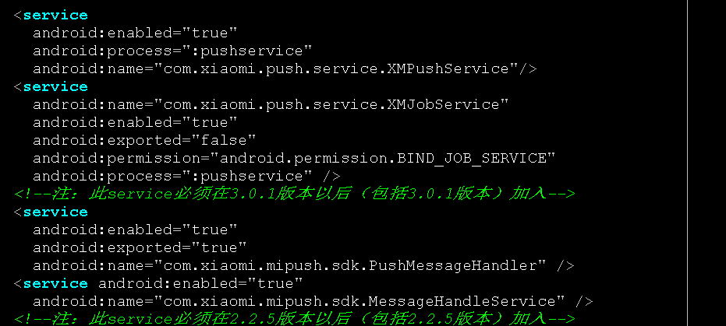
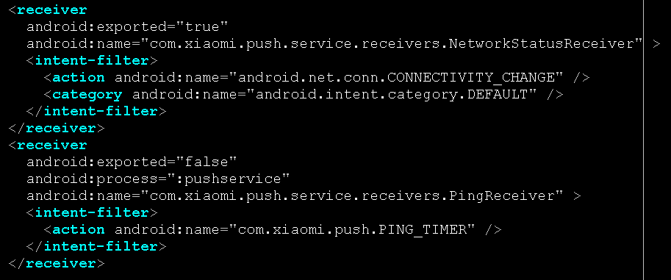

自定义一个BroadcastReceiver类
将自定义的BroadcastReceiver注册到AndroidManifest.xml文件中

<receiver
android:name="com.ggggcexx.xiaomipushreceiver.MyPushMessageReceiver"
android:exported="true">
<intent-filter>
<action android:name="com.xiaomi.mipush.RECEIVE_MESSAGE" />
</intent-filter>
<intent-filter>
<action android:name="com.xiaomi.mipush.MESSAGE_ARRIVED" />
</intent-filter>
<intent-filter>
<action android:name="com.xiaomi.mipush.ERROR" />
</intent-filter>
</receiver>
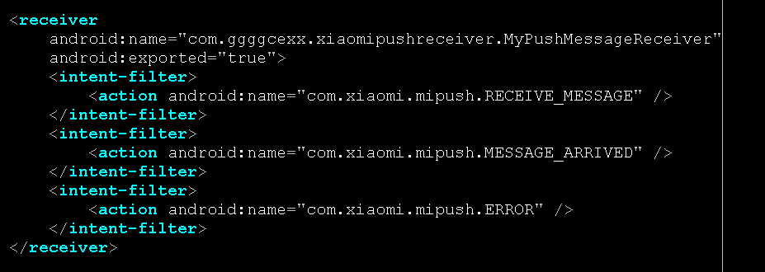

添加Jar
