Description: cid:CB87A374-D5A5-478E-AC29-46AF9F321BCA

QBA

**Deployment instruction**

09/03/2014

Prepared by:

Vladimir Kisel

**Table of Contents**

1 Version history 3

2 Overview 3

2.1 Common information 3

3 Instruction 4

3.1 TeamCity build 4

3.2 Octopus deploy 4

3.3 Database schema deployment 5

3.4 QBA dummy course configuration in BrainHoney 6

4 Environment information 10

4.1 Server information 10

4.2 Database information 10

4.3 Dummy course ids information 11

# Version history

|  |  |  |  |  |  |
| --- | --- | --- | --- | --- | --- |
| **Version #** | **Implemented**  **By** | **Revision**  **Date** | **Approved**  **By** | **Approval**  **Date** | **Reason** |
| 1.0 | Vladimir Kisel | 9/3/2014 |  |  | Project close out documentation |
|  |  |  |  |  |  |

# Overview

## Common information

* QBA source code is located in GitHub repo: <https://github.com/macmillanhighered/PXQuestionBankAdmin>
* QBA DB scripts: <https://github.com/macmillanhighered/PXQuestionBankAdmin/tree/develop/PXQBA/SQLQueries/DatabaseSchema>
* QBA version information: [https://github.com/macmillanhighered/PXQuestionBankAdmin/tree/develop/PXQBA/Web/Macmillan.PXQBA.Web/Properties/ProductInfo.cs](https://github.com/macmillanhighered/PXQuestionBankAdmin/tree/develop/PXQBA/SQLQueries/DatabaseSchema)
* Dummy course CSS configuration: [https://github.com/macmillanhighered/PXQuestionBankAdmin/tree/develop/PXQBA/Web/Macmillan.PXQBA.Web/Content/qba-dummy-course-overrides.css](https://github.com/macmillanhighered/PXQuestionBankAdmin/tree/develop/PXQBA/SQLQueries/DatabaseSchema)

# Instruction

## TeamCity build

1. Go to <http://build.macmillanusa.com/>
2. Check QBA is successfully built
3. TeamCity should automatically build after any changes in develop branch, but if not or if it necessary, manual building could be executed by pressing Run button



## Octopus deploy

1. Go to <http://deploy.macmillanusa.com/>
2. Chose Projects -> PX Question Bank Admin

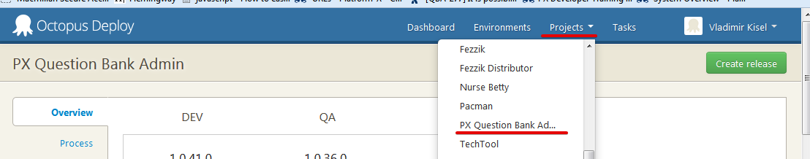

1. Press Create Release button
2. Enter version and press Save
3. Find new created release in Releases tab, then press Deploy this Release button

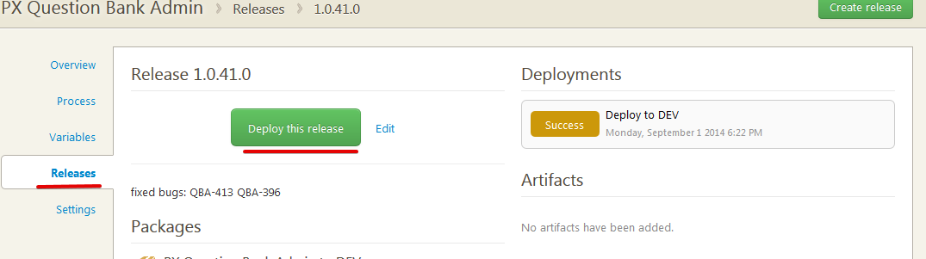

1. Choose environment where release should be deployed to and press Deploy Release button
2. Wait for the deploy process to complete

## Database schema deployment

Database scripts should be applied to PxData2(SQL servers info could be found in 4.2) if there are any new scripts for the release. Database scripts could be found on GitHub repo: <https://github.com/macmillanhighered/PXQuestionBankAdmin/tree/develop/PXQBA/SQLQueries/DatabaseSchema>

Or in the attach:



In order user to see Titles in the list, the user should be added to PxData2. PxWebUserRights table with

PxWebRightId = (SELECT TOP 1 PxWebRightId FROM PxWebRights WHERE PxWebRightType = 'QuestionBank').

After that is done, super admin can grant the user with the role for a particular title on User Management page

## QBA dummy course configuration in BrainHoney

This block should be executed only once at initial deployment or if there are any changes for course overrides.

1. Go to BrainHoney Administration for corresponding environment (for Dev it is <http://root.dev.brainhoney.bfwpub.com/BrainHoney/Frame/Component/AdminDomainDetail?domainid=1>)

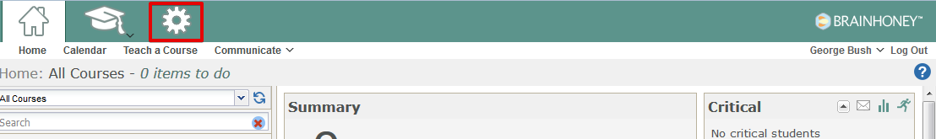

1. Choose Find Course, enter Qba Dummy Course Id and check “Search all domains” (list of env corresponding id’s could be found in 4.3

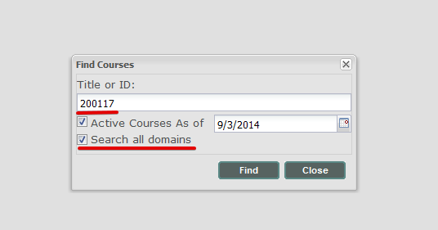

1. Open the course and open syllabus for it 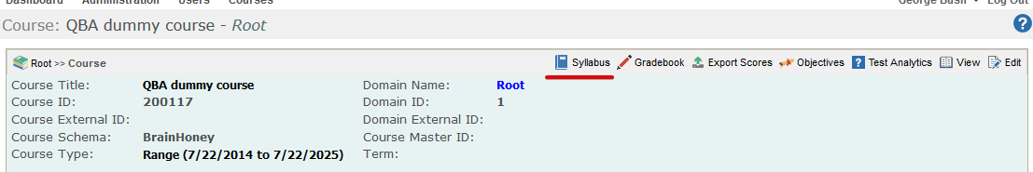
2. Add qba-dummy-course-overrides.css to the course resources and then choose course settings

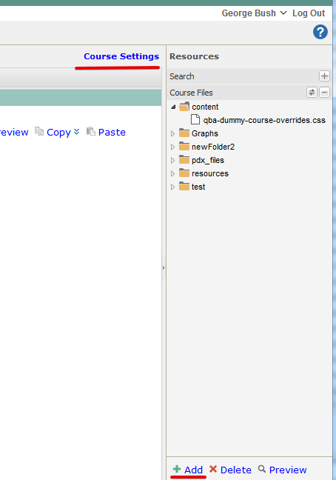

1. Choose added CSS and press Done

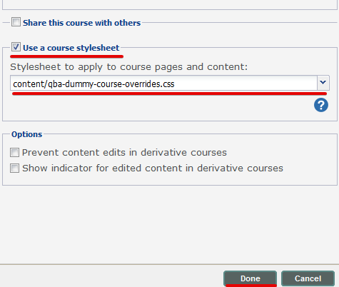

# Environment information

## Server information

|  |  |
| --- | --- |
| **Tier** | **Server Name With Corresponding IP** |
| Development | HBAPPDEV01 |
| QA | HBAPPQA01 |
| Stage | N/A |
| Pristine | HBAPPPR01 |
| Production | HBAPP01 |

## Database information

|  |  |
| --- | --- |
| **Tier** | **Database Name With Corresponding IP** |
| Development | SPXDBDEV01.web.hbpub.net\SQL2008R2: 192.168.78.95 |
| Integration | N/A |
| QA / Stage | 192.168.223.152 |
| Pristine | 10.9.211.29 |
| Production | 192.168.223.152 |

## Dummy course ids information

|  |  |
| --- | --- |
| **Tier** | **QBA Dummy course Id** |
| Development | 200117 |
| Integration | N/A |
| QA | 213956 |
| Pristine | 102154 |
| Production | 449318 |