|  |
| --- |
| Macmillan USA |
| Platform-X Admin Portal |
| Functional Specification |
|  |
| **David Newman** |
| **8/24/2011** |

|  |
| --- |
| Functional specification of the Platform-X Admin Portal |

Contents

System Environment 3

Login 3

Page Header 5

Processing Dialog 5

Implementation 5

Dashboard 6

Logs 7

Log Summary Widget 8

Log Search 9

Metadata 11

Search 11

Settings 14

Environments 14

Creating an Environment 16

Editing an Environment 17

Users 18

Editing Users 19

Creating Users 20

Delete User 21

Setup and Configuration 22

Platform-X Admin Portal

The Platform-X Admin Portal is an application designed to support monitoring, deployment, and configuration of the Platform-X Learning Management System. The Platform-X Admin Portal (PX-AP) is a wholly separate application from the Platform-X Learning Management System (PX-LMS).

# System Environment

The PX-AP is built on the following platform:

.NET Framework version 4.0

ASP.NET MVC 3

IIS7

Microsoft SQL Server 2008R2

# Login

Unlike the PX-LMS which uses the Novell/RA/DLAP authentication system, the PX-AP application will use the standard ASP.NET authentication provider. To simplify security the initial implementation of PX-AP will only have one type of user, Administrators. Administrators are able to view and modify all data accessible by the system once they've authenticated.

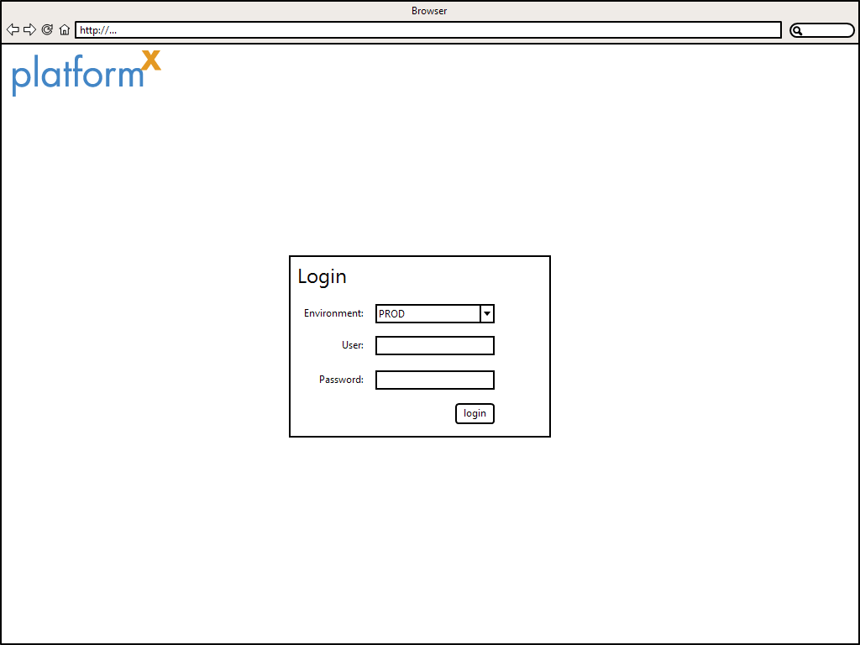

**Figure 1: Login Screen**

Figure 1 shows the PX-AP login page. This page is displayed for all unauthenticated users, and is where users are redirected to when they log out. If an unauthenticated user attempts to directly access any page, they will be redirected here.

To get past the login page, the user must enter their username and password and hit the "login" button. If the credentials are valid, the user will be redirected. The location to which the user is directed upon successful login depends on how they accessed the login page. If a user originally requested a specific PX-AP page and was redirected to the login page, then that user should be taken to the page they originally requested after authenticating. Otherwise, the user will be taken to their dashboard page.

Since the PX-AP application acts as a centralized portal for all of the environments in which PX-LMS is deployed users must select an environment when they log in. If no environments exist (e.g. when the PX-AP is first deployed) then the environment dropdown should not appear.

# Page Header

Every authenticated page in PX-AP shows the same header. The header shows the currently logged in user, a logout link, as well as links to commonly used documentation. Users can switch between environments by using the dropdown box located next to their username. Switching environments will take the user to the dashboard for that environment.



**Figure 2: Page Header**

# Processing Dialog

There is a generic “Processing” dialog that is displayed anytime a long running action is occurring. This is especially important for asynchronous operations such as updating metadata values on large sets of items.

The following Image shows the generic “Processing” dialog.

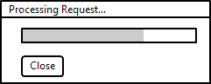

This dialog will be updated periodically to show the current status of the pending operation. In conjunction with showing the “Processing” dialog, the screen should be blocked so that the user can not perform further actions.

Once the pending operation is completed, the progress bar will turn into a message and will stay on the screen until the user clicks the “Close” button. It is important to note that if the user presses the “Close” button while the operation is still pending, it does not cancel the operation, it simply closes the dialog. The following image shows the “Processing” dialog in its “Completed” state.

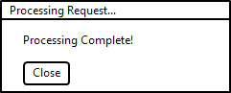

## Implementation

In order to implement the “Processing” dialog we need to support a simply server-side interface. When an operation is started that requires progress updates, a record will be written to a table. The unique ID of this record will be returned back to the UI layer so that progress updates can be checked for using a simple polling technique.

The following table shows the structure of the database table used to store progress of long running operations.

|  |  |  |
| --- | --- | --- |
| Column Name | Type | Description |
| id | bigint | Auto-incrementing primary key |
| percent_complete | int | From zero to one-hundred, tracks current progress value |
| status | varchar | Either “processing” or “complete” |

The user interface should take advantage of the jQuery UI Progressbar component to display the progress bar portion of the UI. Likewise, the user interface can simply use the jQuery UI Dialog component to render itself and perform the necessary blocking.

There dialog itself should be wrapped as a jQuery plugin so that it can be invoked easily by various parts of the application.

# Dashboard

Upon logging in, users are taken to the dashboard page by default. The PX-AP dashboard displays the primary navigation as well as a set of widgets. The widgets displayed vary in terms of what they show, but in general represent aggregated data such as statistics about errors and logging. Using the widgets users can get a sense of what is happening in PX-LMS and drill down for more detail.

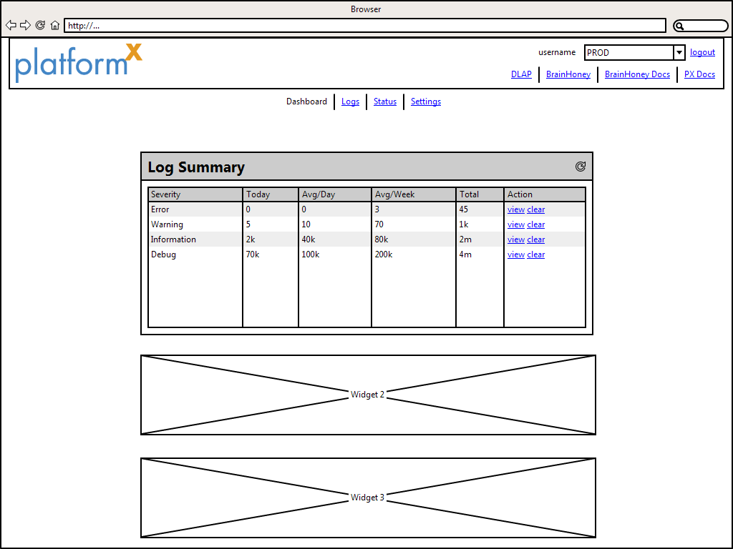

**Figure 3: Dashboard Page**

As shown in Figure 3, the PX-AP dashboard shows the standard page header along with a primary navigation and a set of widgets. The primary navigation provides links to each of PX-AP's major sections including Logs, Status, and Settings. Selecting the Dashboard item will return the user to the dashboard page.

Some widgets only display if there is an environment selected. For example, the Log Summary widget cannot populate itself if no environment has been selected. In such cases, the widget should not display at all until the user selects and environment.

# Logs

The Logs section of PX-AP provides visibility into all errors, warnings, and messages logged by PX-LMS. The log messages can be filtered, searched, and viewed in full detail.

## Log Summary Widget

The Log Summary widget is displayed on the PX-AP dashboard and shows statistics about the number of messages logged by PX-LMS grouped by severity. This allows users to get a general sense of PX-LMS health, e.g. if an abnormal number of errors occurring.

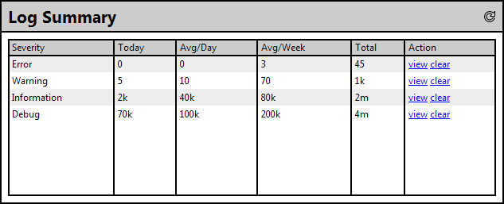

**Figure 4: Log Summary widget**

The Log Summary widget displays the following columns:

|  |  |
| --- | --- |
| **Column** | **Description** |
| Severity | The severity level of the log messages. |
| Today | Number of messages logged for that severity today. |
| Avg/Day | Average number of errors seen per day, excluding errors logged today. |
| Avg/Week | Average number of errors seen per week, excluding errors logged today. |
| Total | Total number of errors logged. |
| Action | Links that perform functionality. |

The Action column contains links that perform functions based on the row they are in. The "view" action takes the user to a page that displays a listing of all log messages that the row represents. The "clear" action will delete all log message from the row and reset all of the statistics. This will not prevent future messages from being logged.

The "reload" icon in the upper right hand corner of the Log Summary widget's header will refresh all of the statistics each time it is pressed. When pressed, the "reload" icon changes to a "loading" icon, which prevents the user from clicking it multiple times in rapid succession.

## Log Search

The Log Search page is the landing page for the Logs section of PX-AP. Users that click on the "Logs" navigation item will be taken to this page. The Log Search page allows users to filter through the existing log messages using one or more of the following criteria.

|  |  |  |  |
| --- | --- | --- | --- |
| **Criteria** | **Description** | **Values** | **Validation** |
| Severity | Severity level specified when the message was logged. | All, Error, Warning, Information, Debug | None |
| Category | Category message was tagged with when logged. | Loaded from the logging database. Works as a drop down that supports auto-complete as user types. | Alphanumeric |
| Source | Where the message was logged. Typically the name of a server. | Loaded from the logging database. | None. |
| Between | Constrains result set to messaged logged between the dates specified. | Valid DateTime | DateTime. Start must be greater than end. |
| Message | Performs a text search against the Message field of the log message. | N/A | Valid SQL 2008 full-text search. |

As shown in Figure 5 below, the user must click the "search" button to initiate the search. Results are displayed in a table below the search form and supports paging through the data. The data returned by all searches is by default ordered by the Time column descending so that the most recent messages are at the top of the table. To change the ordering, the user can click on a column header.

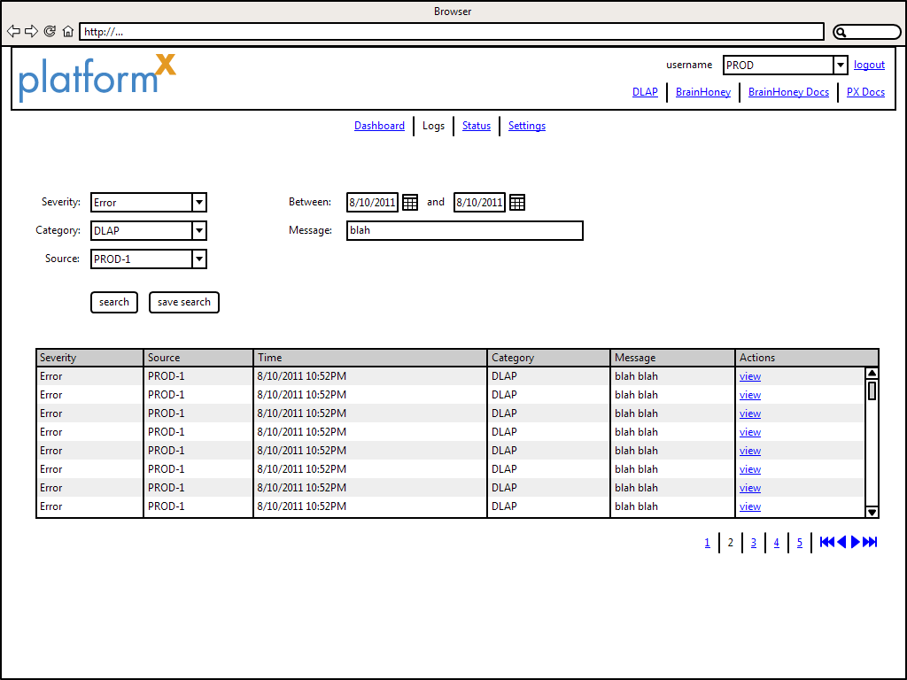

**Figure 5: Log Search**

If a user wishes to see the full detail of a specific log message, they can click the "view" link in the Actions column. Doing so will open an overlay with the details, as depicted in Figure 6. The default tab shown in the overlay is the "Message" tab which just shows the log message body. The "Full Detail" tab contains all information included in the message. The "Properties" tab shows any extended properties extracted from the message and stored in the logging database. Clicking the "X" icon in the upper right of the overlay will close the overlay. If there are no sources defined for the current environment, display a warning and provide a link to environments page, so that user can add sources.

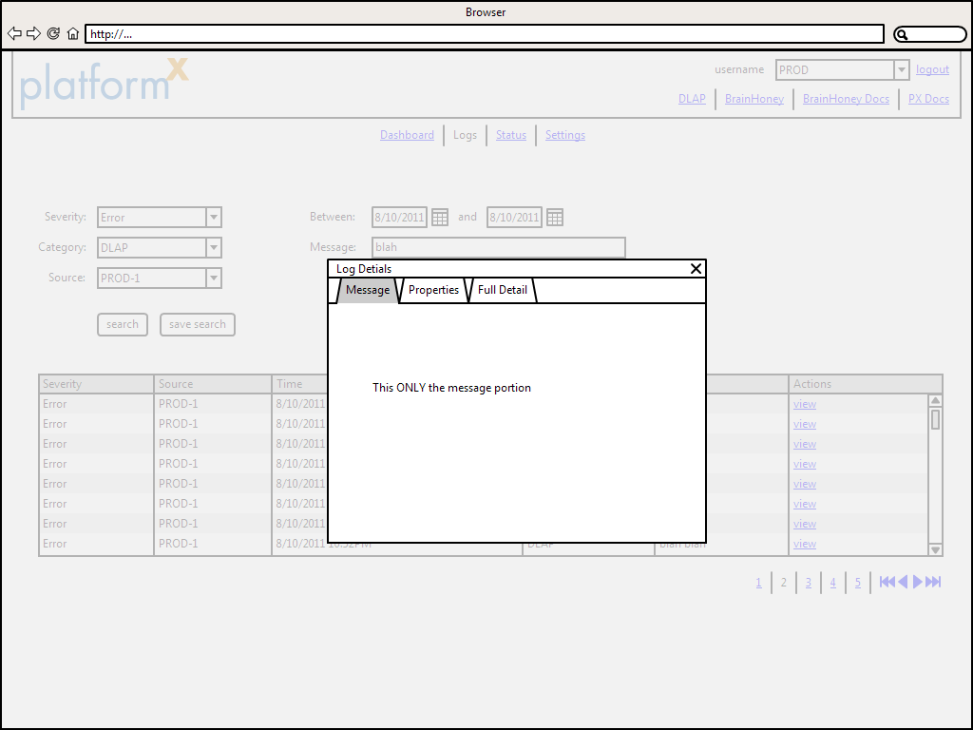

**Figure 6: Log message details**

# Metadata

The metadata section allows users to add specific metadata fields to items in DLAP. The following sections describe each type of metadata that can be added and how those subsections of the Admin Portal should function.

## Search

The Search subsection allows users to apply the metadata necessary to enable searching on items. The following image shows the entry form used to specify the metadata for the items.

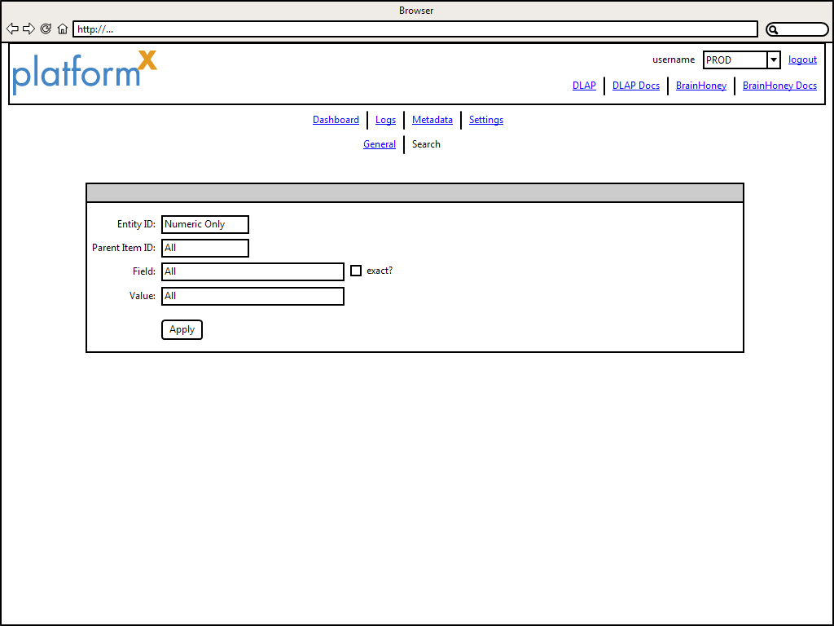

In the above wireframe, the user must enter the following fields:

Entity ID – This is the ID of the course that contains the items the metadata is being applied to

Parent Item ID – This is the ID of the item whose children will be recursively modified

Field – This is the name of the XML element in the items that will be added or modified

exact? – Checking this box will result in the attribute ‘dlap_type=”exact”’ being added to the element

Value – This is the value of the metadata specified by Field

Once these values are entered by the user, the user presses the “Apply” button. The “Apply” button performs the following logic:

1. Loads item specified by “Parent Item ID” and all of its child items
2. For each item, check whether “Field” already exists.
   1. If “Field” already exists, update the value to match “Value” and “exact?”
   2. If “Field” does not exist, add “Field” and set “Value” and “exact?” as necessary
3. For each item, add it to a flattened list of items that have been modified
4. At this point, setup the necessary interactions with the generic “Progress” component
5. Break the total list of items into groups of twenty or less and then use the PutItems command to store the items back to DLAP. For each group, update the “Progress” component.

The following image shows the Search metadata screen once the “Apply” button has been pressed.

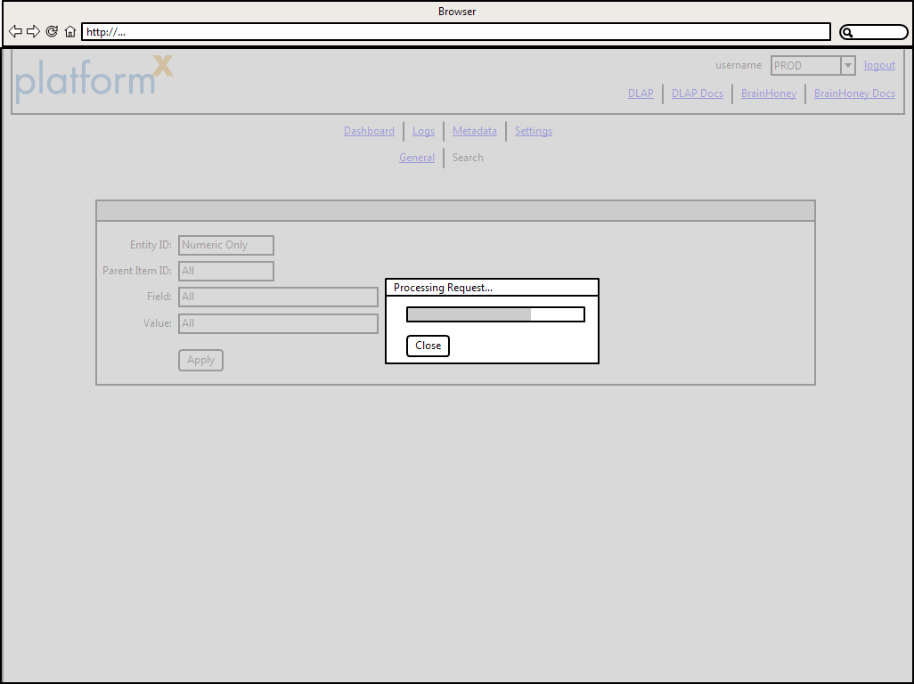

The following shows the Search metadata screen once the processing of all items is completed.

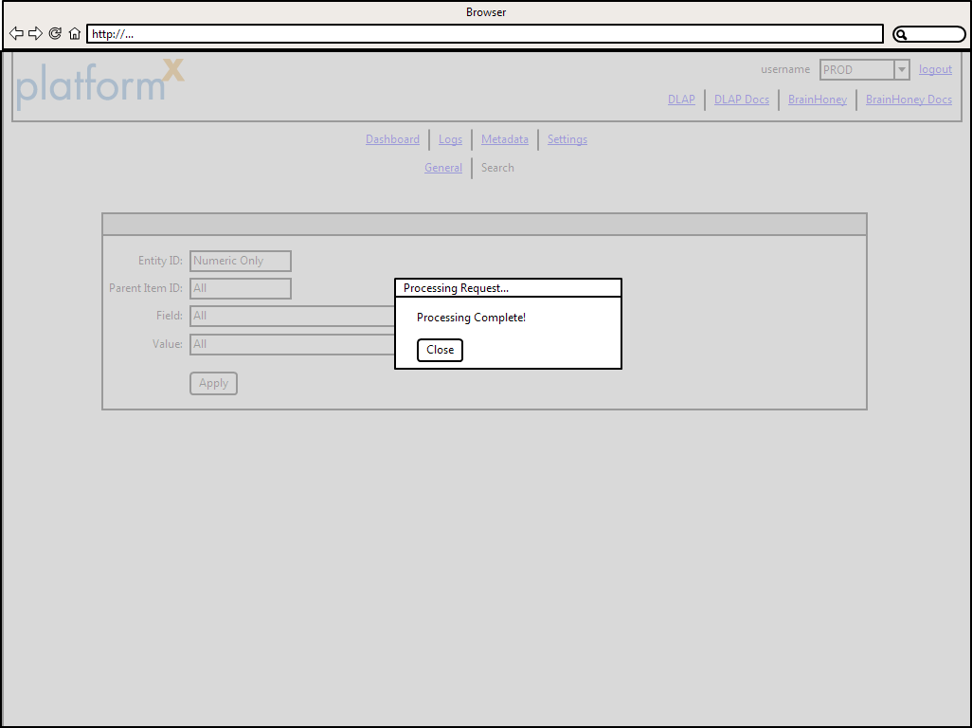

When the user clicks the “Close” button, the “Processing” component goes away and the screen unblocks to show the underlying page.

# Settings

The settings page provides a secondary navigation allowing access to configure different parts of the site.

## Environments

The environments section allows the user to create and edit environments. Each environment represents a specific ecosystem in which PX-LMS is deployed. An environment includes information about the DLAP, BrainHoney, and PX-LMS servers and is used to determine what is displayed throughout the PX-AP application. The following table shows all of the properties of an environment.

|  |  |  |
| --- | --- | --- |
| **Property** | **Description** | **Validation** |
| Title | The title of the environment. | Required. Alphanumeric, allow - and _ |
| Description | Description of the environment. | Alphanumeric, allow -,_!. |
| DLAP Server | URL to the DLAP server. | Valid URL |
| BrainHoney Server | URL to the BrainHoney server. | Valid URL |
| PX Docs | URL to the PX-LMS documentation | Valid URL |
| Sources | List of all "source" values the environment logs messages from. | Alphanumeric, allow -_. |

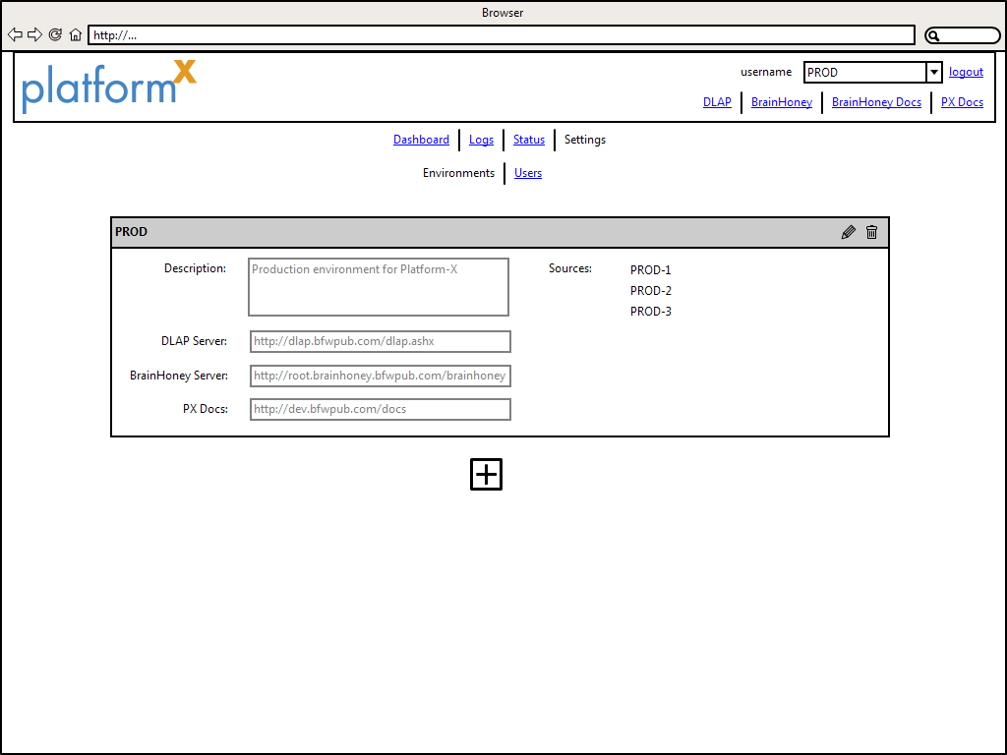

**Figure 7: Environments page**

### Creating an Environment

The first time the environments section is accessed there may not be any environments defined. For example, Figure 8 shows what a user will see when they access the environments page after installing PX-AP.

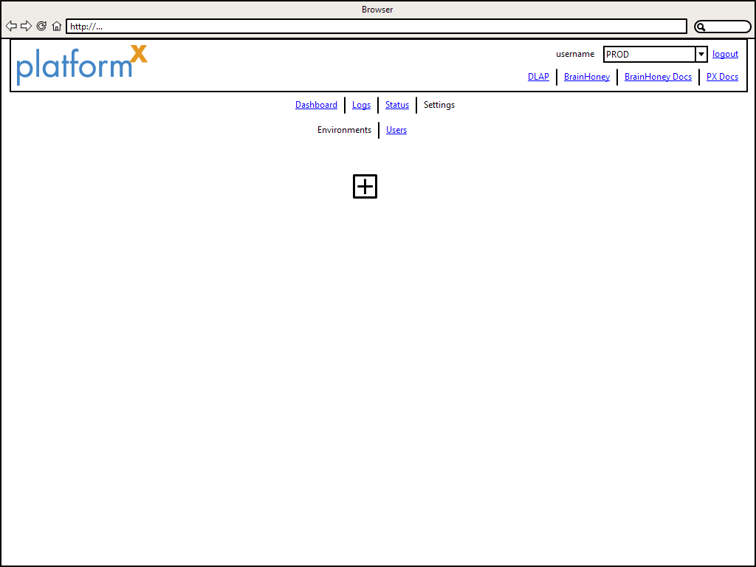

**Figure 9: Empty Environments page**

To create an environment, the user must click the "add" button. After doing so they will be presented with a UI for entering the environment details described in the table above. Figure 10 shows the creation of a new environment.

The user must enter a title for the environment, and then optionally any of the other details as defined in the table above. Once the user is satisfied with their entry, they hit the "save" button in the upper right hand corner of the entry form. If all validation pass, then the environment is created. If the user decides to cancel creation of the environment they can click the "cancel" button. Once the environment has been saved, the environments screen will look like what was previously shown in Figure 7.

When the is not environment selected, a warning should be displayed on all pages, and no widget should be displayed across the site.

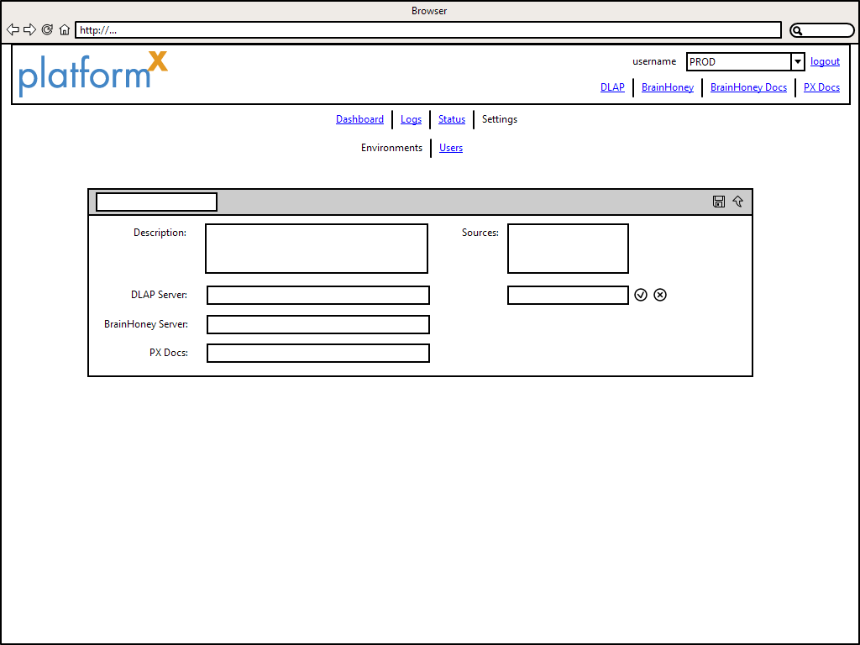

**Figure 10: Creating an environment**

### Editing an Environment

Existing environments can be edited by clicking the "edit" icon. Changes to the environment can be saved by clicking the "save" icon, or cancelled by clicking the "cancel" icon. If the user wishes to delete an environment they can click the "delete" icon. Note that deleting an environment will not delete any data, such as log messages, that may be related to it.

If the user currently has the environment being edited active, then the top menu URLs should be updated to reflect the changes. All environment changes should occur without reloading the page. If the user deletes the currently active environment, user is redirected to index page with no environment selected.

When a user edits and environment, they should see something similar to Figure 11.

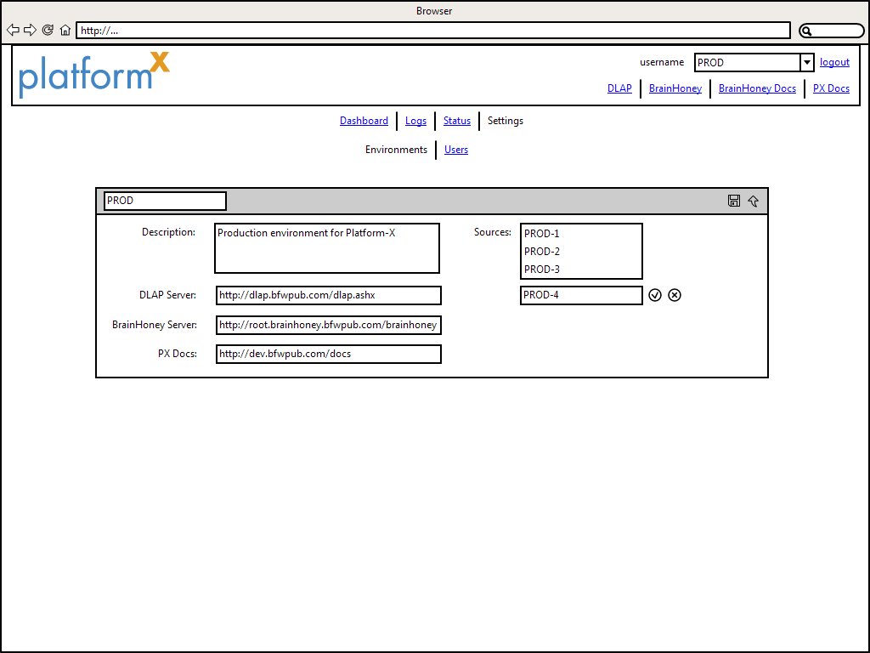

**Figure 11: Editing an environment**

## Users

The users section allows the user to create, edit, and delete user accounts. The main view of the users section lists all existing system users and is shown in Figure 12.

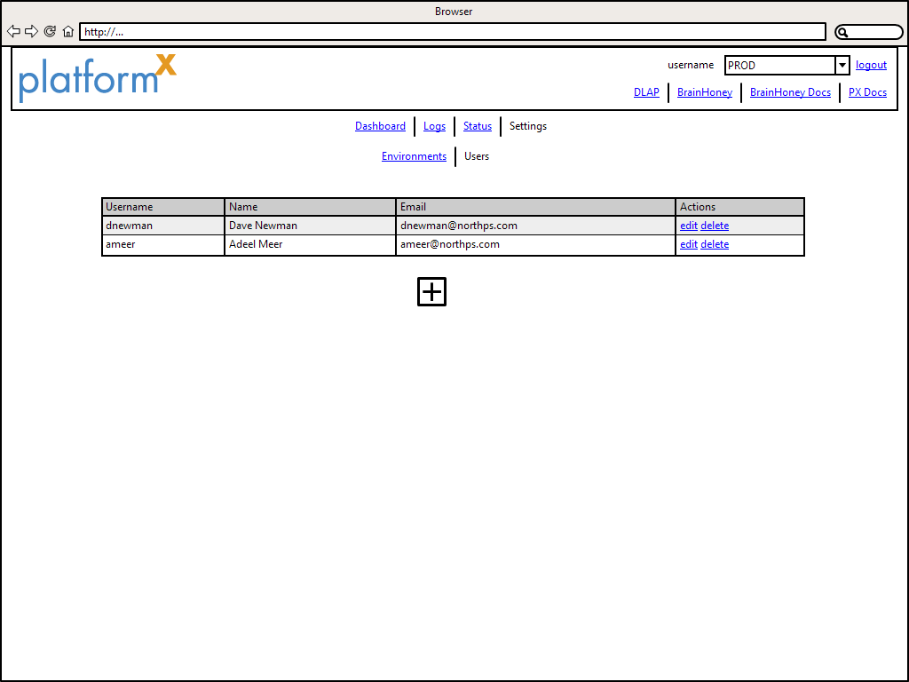

**Figure 12: Users landing page**

### Editing Users

Existing users can have all of their details changed except their username. To edit a user's details simply click the "edit" link in the "Actions" column. Clicking the "edit" link will display a dialog like the one shown in Figure 13. Clicking the "save" button will save the new information whereas clicking the "cancel" button will disregard all changes and close the dialog. Edit screen will have password fields blank, if no password is entered, then password of the user will remain same and other information will be updated. If the password is provided, then password will be changed to new password.

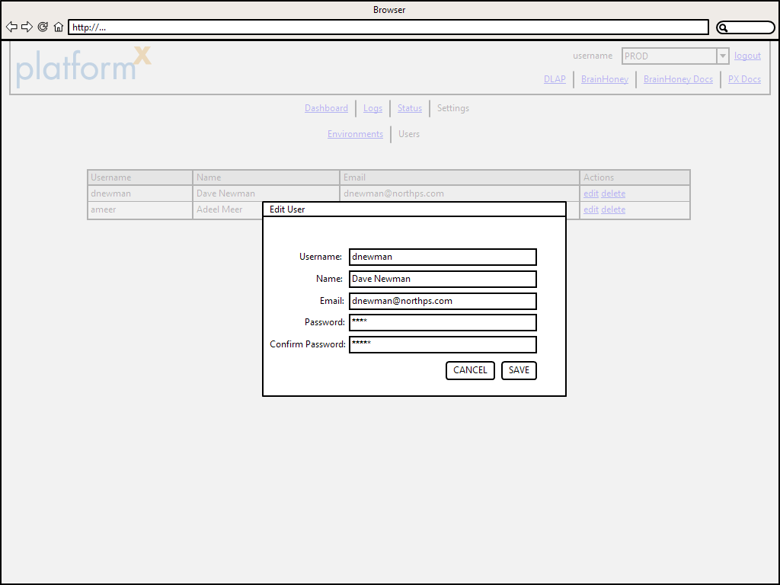

**Figure 13: Editing a user**

### Creating Users

New user accounts can be created by clicking the large plus icon below the list of users. Clicking the icon will open a modal window that accepts all input necessary to create a user. To save the new user, click the "save" button. Clicking the "cancel" button will disregard all input and close the dialog. Figure 14 shows the dialog that creates the user.



**Figure 14: Create User Dialog**

### Delete User

Users can be deleted by clicking the "delete" link in the "Actions" column. Deleting a user will prevent the user from accessing the system and will delete and data stored for that user. When the "delete" link is clicked the user will be prompted to confirm the deletion. Clicking the "confirm" button will permanently delete the user while clicking the "cancel" button will keep the user and its information. Figure 15 shows the delete user confirmation dialog.

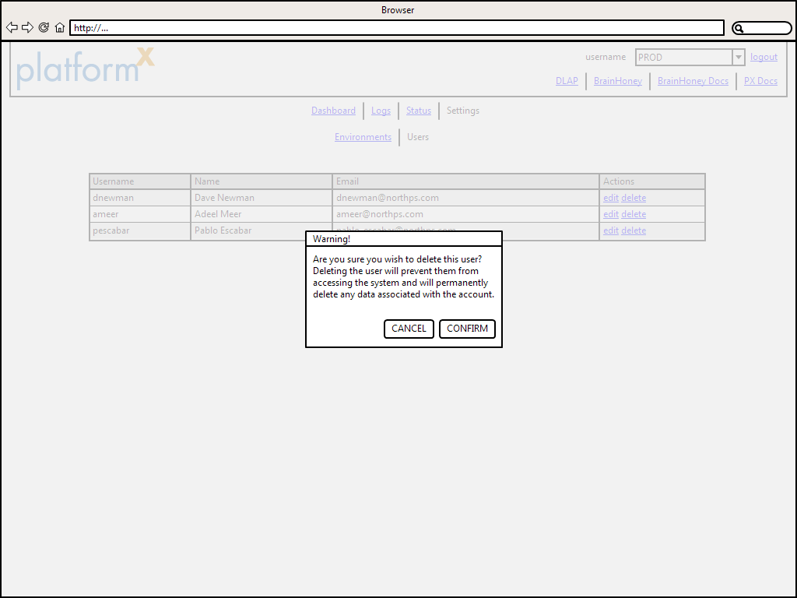

**Figure 15: Delete user confirmation dialog**

# Setup and Configuration

This section describes the details of getting code for PAPX and setting it up to be functional. The svn location of PAPX is **svn://svn.bfwpub.com/PX/PXAP/trunk**. There are few steps which must completed before we can run PAPX. First step is to define the following connection strings in the web.config file:-

1. ApplicationServices – This is the database which holds data related to PAPX like users and environments. Microsoft utility aspnet_regsql has to be run on this database to create authentication schema.
2. PXData – This is the database which has the logging information from PX.

Next step is to run database scripts. Within the PAPX folder there is a folder called DbScripts. This folder has two folders which contains the master scripts for the two databases. Running these scripts on these databases will ensure that all necessary database objects have been created.

Since this is the fresh install, an initial user has to be created which can be done by visiting the following url <http://[DomainName]/Account/register>