X. Arteinvest Online Web User Administration

When a user fills out the business partner registration form, shown in exhibit 1 below (requesting broker-access to sell art) on the Arteinvest website two things happen:
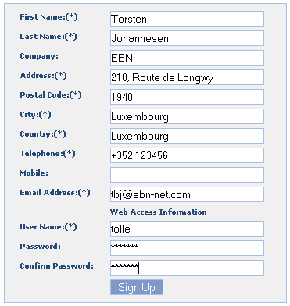
Exhibit 1- Web business partner registration form

- An email will be send to webadmin@ebn-net.com. This is a distribution list and is administrated from within Windows / Exchange server locally here at EBN. Current members, as of this writing, are Georgette Weisen and Torsten Johannesen. The mail simply serves as a remainder that a new user via the Arteinvest web has requested access.
- The data the user entered on the website will be stored in a database (you will more or less see the same data in the email you receive under 1).

You access the website user administration tool in Policy Manager from the main menu under |Websites|Art€Invest|User Management|.
The interface for user administration is shown in exhibit 2 below. The table in the upper part contains the new user request from web, i.e. users that have filled out the webform above.
You have two buttons to the right – Delete will delete the user request, Edit will bring up the user edit form. Hint – double clicking on a row in the table will also bring up the user edit form.

