COS60006– Introduction to Programming

Learning Summary Report

Lakshmi Saketh Chebrolu (101734216)

Tutorial Day: Saturday

Tutorial Time: 8:30-10:30

Tutor: Sharon Stratsianis

Self-Assessment Details

The following checklists provide an overview of my self-assessment for this unit.

|  |  |  |  |  |
| --- | --- | --- | --- | --- |
|  | Pass (D) | Credit (C) | Distinction (B) | High Distinction (A) |
| Self-Assessment (please tick) |  |  |  | Checkmark |

*Self-assessment Statement*

|  |  |
| --- | --- |
|  | Included (please tick) |
| Learning Summary Report | Checkmark |
| Test 1 and Test 2 are Compete in Doubtfire | Checkmark |
| Pascal programs that demonstrate coverage of core concepts | Checkmark |
| C programs that demonstrate coverage of core concepts | Checkmark |

*Minimum Pass Checklist*

|  |  |
| --- | --- |
|  | Included (please tick) |
| All Credit Tasks are Complete on Doubtfire | Checkmark |

*Minimum Credit Checklist, in addition to Pass Checklist*

|  |  |
| --- | --- |
|  | Included (please tick) |
| Distinction tasks (other than Custom Program) are Complete | Checkmark |
| Custom program meets Distinction criteria & Interview booked | Checkmark |
| Design report has structure chart and screenshots of program | Checkmark |

*Minimum Distinction Checklist, in addition to Credit Checklist*

|  |  |
| --- | --- |
|  | Included (please tick) |
| HD Project included | Checkmark |
| Custom project meets HD requirements | Checkmark |

*Minimum High Distinction Checklist, in addition to Distinction Checklist*

# Declaration

I declare that this portfolio is my individual work. I have not copied from any other student’s work or from any other source except where due acknowledgment is made explicitly in the text, nor has any part of this submission been written for me by another person.

Signature: **Lakshmi Saketh Chebrolu**

# Portfolio Overview

This portfolio included with all my work that help to demonstrate the progress that I have achieved in all Unit Learning Outcomes for COS60006 Introduction to programming to a (75-77) Distinction Level.

I think I deserve this mark because I have maintained the consistency and quality in submission of my work. I have completed the given tasks with in time and uploaded them to the doubt fire.

As I was aiming to get a Distinction grade, I have completed all tutorial, pass, credit and all the distinction tasks. I have done a TicTacToe game using SwinGame libraries for the custom code project. I have completed the GUI music player successfully till the high distinction in that it will show the indication for the song playing. I have completed the Text music player using pascal in High distinction in this my program will update the file name and also, we can update the album name in file using this. I also used the external music player to play the songs.

SwinGame API’s are very useful in implementing the required functionalities but if more sources are available for the understanding of API’s it would be more helpful for me. It took long time for me to analyse and understand the API’s in swinGame, but it was fun in creating the applications using it. I enjoyed writing code for Textmusic player as I was new to pascal that program has helped me to understand the concepts clearly and this has helped me in solving the other programs easily.

# Reflection

## The most important things I learnt:

When I joined this college, I have already done my programming in c in my UG and I want to take exemption from this subject. On the first day of lecture class, when Matthew has showed us the games done by some of students, I was amazed we can do these with pascal and I felt like I want to do this subject and I changed my decision and took this.

In this subject I like the swingame library, through which we can create the graphical user interfaces which is very interesting. I had created a GUI music player in which user can load his file and play the songs in the albums list and also, I have created a TicTacToe game, in this we have two players and it is interesting to play.

When I am working on the GUI music player it consumed lot of time for me. The programming in C has confused me and it also consumed my time in converting the generic value in the album data, at last I have done that. I felt like I require more examples for the swingame API’s for better understand and faster analysation of it.

## The things that helped me most were:

My tutor Sharon has helped me in all the aspects for the better understanding of this programming language. She has corrected me in following the coding standards for writing the programs. The helpdesk and basic tutorials in the Swinburne site has helped me in understanding the concepts easily. I went to helpdesk regarding for the help on GUI music player really, I felt it is very helpful.

## I found the following topics particularly challenging:

Coming from the electronics background, moving into the IT field is a challenging task. Even I had overcome this challenge by the help of the Swinburne resources. I utilized the library and Swinburne online materials it has solved many questions. The book available in the Swinburne programming unit is not useful for me. The HD level tasks in the text music player are very challenging and tasks in GUI music player like identifying which track is playing currently is also a hard task.

## I found the following topics particularly interesting:

I had never seen creating games using the pascal language, I felt SWINGAME is very interesting area for me to work and explore

## I feel I learnt these topics, concepts, and/or tools really well:

I had learn a new programming language and also it helped me to improve my problem solving abilities. In this I got experience in using the SwinGame API’s. All the tasks show about learning abilities and my analysations in the programming. My programming in swingame library is the proof for my learning..

The tasks which are proves my learning are: Programming concepts, GUI music player, Text Music player.

## I still need to work on the following areas:

As of now I am confident on my learning areas, I need to work on the animations, sprites using the swinGame library. Even I had done that, but it is taking lot of time for me to complete that. I need to focus on this area to improve my standards in this subject.

## My progress in this unit was …:

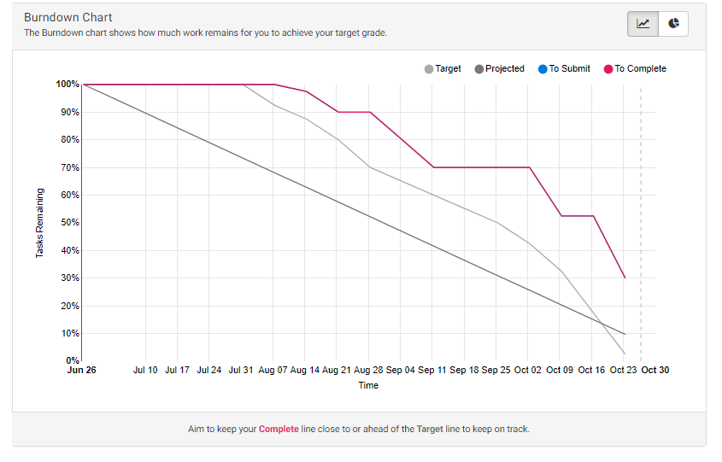

This chart always helps me to track my tasks and helped me to submit them with in time.

## This unit will help me in the future:

For the next semester I am planning to take OOPS, this language help me to understand the coding standards we need to follow and also helped to improve my problem solving abilities and also it helped me to use a new API and how to access them.

## If I did this unit again I would do the following things differently:

If I do this subject again, I will focus on the swingame library and focus on achieving the HD Band 2 grade in this subject. I want to work on a research project I always feel that I lack creativity, I need questions so that I will work and achieve the output. I create a sample programs using the swinGame library classes for my understanding and create a document for the future use.