**Certificate No. : Cert_No**



**CERTIFICATE**

**This is to certify that**

**below mentioned person has successfully completed the Training Course for T_Course.**

**:**

1. **Trainee Name T_Name**

**:**

1. **Company Name C_Name**

**:**

1. **Trained Period T_Period**

**:**

1. **Trained Subject T_Subject**

**:**

1. **Trained Course T_Course**

**(Validity for the Certificate : Until V_Date)**

|  |
| --- |
|  |



Sincerely yours,

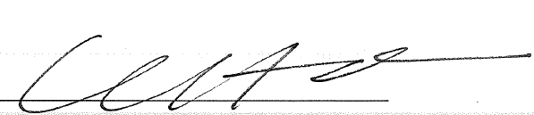

President of GLOBAL ACADEMY,

HYUNDAI GLOBAL SERVICE