**Certificate No. HGA - -**



**CERTIFICATE**

**This is to certify that**

**below mentioned person has successfully completed the Training Course for T_Course.**

1. **Trainee Name : T_Name**
2. **Company Name: C_Name**
3. **Trained Period : T_Period**
4. **Trained Subject: T_Subject**
5. **Trained Course: T_Course**

**(Validity for the Certificate : Until V_Date)**

|  |
| --- |
|  |



Sincerely yours,

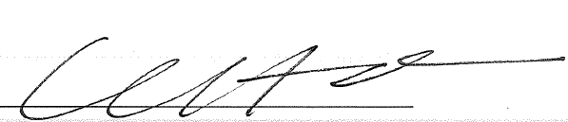

President of GLOBAL ACADEMY,

HYUNDAI GLOBAL SERVICE