1. Introduction to “Hydrognomon”, a time series processing software package

The time series processing system “Hydrognomon”, is an independent software application for Microsoft Windows 2000 and later versions (XP, Vista, Windows 7 etc.). This version of the manual refers to the 4th version of the software package. Hydrognomon is developed at the N.T.U.A. during the last decade for the purpose of covering various scientific needs. This new version is a FLOS (Free Libre Open Source) Software and it is distributed under a GPLv3 license ([http://www.gnu.org/licenses/gpl.html, GPLv3](http://www.gnu.org/licenses/gpl.html,%20GPLv3)) with some exceptions, a copy of which is available at the end of this manual. Version 4 is based on earlier versions and was developed during the following research projects: "Modernization of Athens water resource system supervision and management, 1999-2003" and "Integrated Water Systems Management in Conjunction with an Advanced Information System (ODYSSEUS), 2003-2006". More information about these projects is available at the ITIA’s site (<http://itia.ntua.gr/>).

The current version (4) covers the needs of the “National Bank of Hydrological and Meteorological Information” hydro-meteorological data processing (<http://www.hydroscope.gr/>).

The official site of Hydrognomon is: <http://hydrognomon.org/>. New versions are available on-site. Hydrognomon’s documentation is also available on the ITIA’s site. *Openmeteo* (<http://openmeteo.org/>) is used for the software development concerning the source code and the malfunction recording system (bugs) (<http://openmeteo.org/code/>).

The main differences between the current version (4) and the previous ones are the following:

* The part of communication with the database and the geographical data management (of the database) are removed. In previous versions, Hydrognomon was a software package of data management and processing. In the current version the management part is removed, because it is considered to be an independent software application as web interface, called “Enhydris” (<http://openmeteo.org/enhydris/>) , while data processing is kept.
* The user interface is rebuilt, floating toolbars are used, etc., the application is Unicode and can be used in multilingual environments; and it is possible to display titles in different languages at the same time. Time series are regarded as documents which means that the choices save/save as… are enabled, as well as opening from the operational system (file type *.hts), general integration to the operational system, drag’n drop possibilities etc.
* The previous version could support specific time steps. At the current version any time step, which is a multiplier of minutes or months, can be set. So, it is possible to use a 20 minutes time step, 3 hourly time step, 3 monthly time step, etc. Moreover, new concepts are introduced like “Nominal Offset” (start time subdivisions) and “Actual Offset” (time shifting – time position). Finally, a new type of “save as” is implemented (“hts version 2”, or “openmeteo.org”, “Hydrognomon 4” file type).
* New aggregation routines etc. compatible to the new time step implementation of time series.
* Application of hydro-measurements registration and calculations.
* Implementation of discharge – sediment discharge curves.
* Enrichment with functions such as general – nonlinear time series operations disaggregation, etc.
* Multiple time series regression with various optimization options and monthly changing solution search, variance chart plotting etc.
* Improved statistical operations, potential evapotranspiration calculation, etc.
* Area rainfall integration, rain level calculation, etc.
* Various bug fixes of previous versions.

The methodologies and the algorithms that are used for the data management and data processing are presented in this manual; and provide the scientific documentation of the package. Moreover, data plotting standardization is defined. This manual is mostly based on the corresponding manual of the ODYSSEY program, with number id=676 at ITIA’s web site (<http://www.itia.ntua.gr/el/docinfo/676/>). The user’s manual, which presents the analysis of the program procedures and functions, will be available separately from the FAQ list and the demonstration videos (see <http://www.youtube.com/hydrognomon>/).

In general, the system’s development was based on:

* The ITIA team experience (<http://www.itia.ntua.gr/>)
* Experience gained from the development of previous versions (Christofides, 1998, Christofides and Kozanis, 2004, Kozanis et al. 2005), as well as from the development of trial versions (Kozanis et al., 2005)
* The database design, that contains time series data; as well as experience and knowledge gained from the previous design. (Christofides, et al., 2005;

Papakostas, 2004)

* Market research on competing software systems
* Feedback and malfunctions reports (bugs) by past versions users
* Hydrology and Computer Science bibliographical research.

This system does not implement advanced processes, like synthetic time series production (this function is provided by the Castalia software, which is also available at the ITIA’s site), but simple (typical hydrological) processes, that operate auxiliary. The most important functions provided by the system, are the following:

* Time series transformation to one with a regular time step (it is well known that raw time series have some irregularity. However, disruptions come up often and have to be eliminated before further processing.)
* Time series integration to larger time step (aggregation), e.g. “ten minutes” to “hourly” time step, “hourly” to “daily” time step, “daily” to “monthly” time step.
* Standard consistency tests like homogeneity test, extreme values test and time consistency test.
* Linear regression between time series, multiple regression, organic correlation and autocorrelation.
* Water balances: lumped rainfall –runoff model (This subsystem is known as Zygos.)
* Estimation of missing values by means of linear regression, option to introduce a random term in order to maintain the statistical properties. Time series expansion.
* Linear operations between time series.
* Stage – discharge curve estimation by means of statistical methods and expansion curves using hydraulic equations.
* Export discharge time series from stage time series, as well as volume and area time series from stage time series of reservoirs and lakes.
* Evapotranspiration and potential evapotranspiration calculation using analytical or semi – empirical methods.
* Expansion of evapotranspiration samples.
* Time series sampling, statistical property estimation, statistical parameter adjustment, statistical predictions, statistical tests and confidence interval estimation. (This subsystem is known as Pythia.)
* Time series analysis of special rainfalls – Intensity - Duration - Frequency (IDF) curve estimation by means of consistent methodologies. (This subsystem is known as Omvros.).

## Basic software’s structure

Software structural element is the time series object, which are in the computer’s memory. They are uploaded from a file or they are created after data processing or data transfer from some other software package (e.g. with Copy – Paste command from a Spreadsheet application such as Microsoft *Excel*). The time series files are plain text files and they can be read by any text processor like Microsoft Windows Notepad and Wordpad, vi, emacs, etc. The file specifications are included in a separate appendix at the end of this document.

Each time series is displayed on a grid consisted of columns of dates and values. Several time series can be represented using multiple columns. Time series can be saved into a file and retrieved later or transferred to another computer or uploaded to a database.

Times series processing requires the use of an open Hydrognomon time series. Moreover, every time series can be copied and transferred to another software application. The data visualization could be made easier by using various tools such as filters, color, tabulation, flagging, graphs.

The following figure shows the multiple depictions of three time series. In another tab is shown the tabulation by month/ hydrological year, color marking of some values and graphs of two time series.

**CAUTION**

**Hydrognomon is nothing more than a computing tool for time - consuming calculations, which means that the experienced and critical thinking experts should never be substituted. In many cases, Hydrognomon users came up with false results and conclusions because the data and the applied methodology and assumptions were not taken seriously into account. It should be given special emphasis to the fact that the presented software package is quite friendly to the user. This can be a dangerous trap. If the user is not quite familiar with it, this documentation should always be consulted and the meaning of each used term, like time series, parameters, etc. should be double checked.**

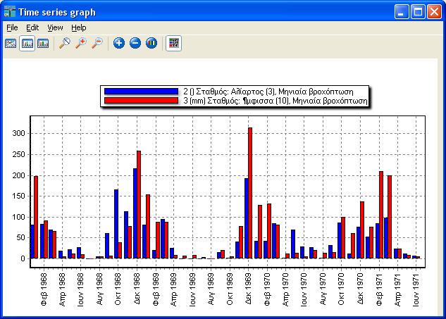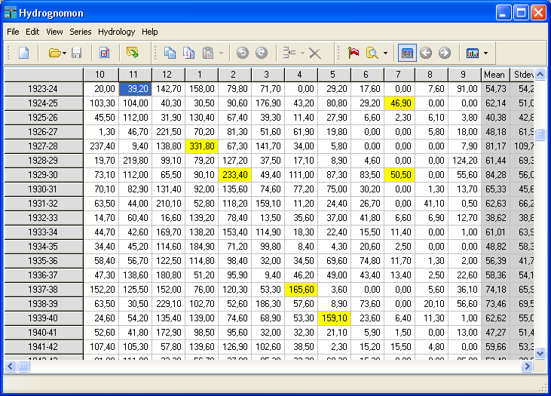 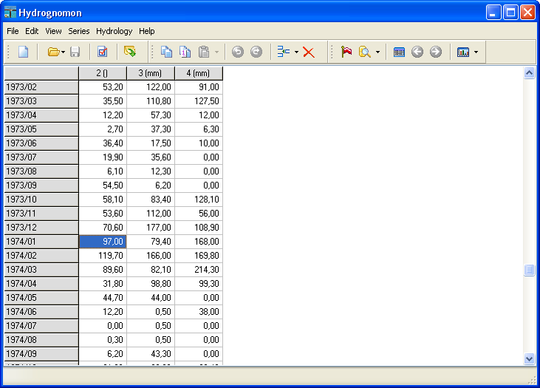

Figure 1.1: Typical software screen

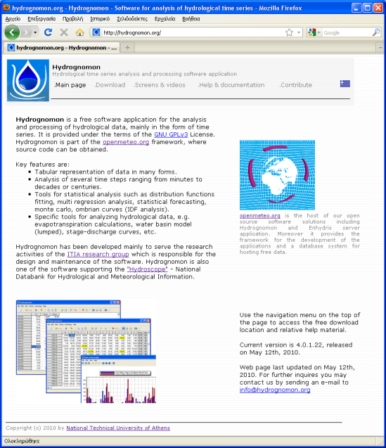

Figure 1.2: site <http://hydrognomon.org/>

1. Time series data standardization
   1. **Introduction**

Time series data standardization is implemented in order to cover every possible need like raw data measurement and storage, export of processed data and climatic characteristics, generation of synthetic time series, water balance formation etc. The most important standardization characteristic is time series time step, which is also called observation time scale. There are also some other important standardization characteristics presented in this documentation such as: the parameter’s type and special time step’s characteristics, like the timestamp start time and various offsets. Finally, there is a flag option that can be used in order to mark special time series values.

The main time series data types, according to their origin (raw, processed and synthetic), are presented in Table 2.1. In previous software package’s versions, raw data management was held by Hydrognomon while processed data management was mainly held by Hydrognomon. On the other hand, synthetic data management was held by Castalia application. Synthetic data was used in management scenarios of Hydronomeas[1] application and could generate multiple predictions for the same time series. The current Hydrognomon version cannot manage synthetic data of multiple predictions. However, data can be transferred to Hydrognomon using Castalia application and copy – paste command.

Raw data may contain errors and need reductions, additions, etc. Raw data should be stored to separate files or data bases and protected in order to be always available to possible check or re-processing. Processed data, based on raw data may have the same or derivative time scale.

The stored time series of the new Hydrognomon version (version4) are called version 2 time series. The used standard is defined by [openmeteo.org](http://openmeteo.org/) and it can be found at: <http://openmeteo.org/doc/timeseries.html#timeseries-objects> (see also the appendix at the end of this documentation)

Table 2.1: Time series data types

|  |  |
| --- | --- |
| **Data type** | **Description** |
| Raw | Intact (not processed in any way) measurements taken using conventional methods or telemetrically – totally automated. Raw data are subjected to consistency control. Before any other process, they are also subjected to reduction to constant time step time series. |
| Processed | Results of raw data processing, e.g. aggregated time series, mean values, time series subjected to infilling of missing values and homogeneity restoration, etc. or time series generated from complex procedures such as evapotranspiration estimation models or water balances. |
| Synthetic | Synthetic data refer to prediction time series (i.e. values of sizes at periods that there are no measurements, e.g. using the Castalia application) or composition time series e.g. that derive from integration of various stations samples to a single sample. |

* 1. **Time scale (time step)**

### Timestamps

The basic time series component is the timestamp.

Every single value of any time series, either a measurement or a processing result, is registered at a certain instance – identity, which is called time stamp. The time stamp, according to time series nature, can refer either to a unique instance or a timespan. If the records are instances (e.g. the observation of a river’s stage: the stage is recorded in unique time instances) then instantaneous variables are used and the time stamp of any value reflects the unique instance of the recording.

In case of processed variables or value measuring that is accumulated during a period of time (e.g. daily measurement of a pluviometer that accumulated the rain during a whole day), the time stamp does not correspond to a certain instance but to an integration time period. So as far as the previous example is concerned, the pluviometer’s time stamp is equal to a time period of 24 hours or 1440 minutes (The integration time period is usually as long as the observation time scale). For monthly values (mean maximum temperatures of a month, or total monthly rainfall), timestamps correspond to monthly periods. The timestamps that refer to the values of annual runoff, are whole years etc.

It is assumed that: timestamps mark the end of the measuring / integral period for accumulating variables of time scales up to a day. The natural meaning of this assumption is given through an example: if rainfall value is recorded as well as relevant date and hour, this value refers to the relevant value of the preceding period.

As far as variables of monthly time scale (or longer ones) are concerned, timestamp is sifted by introducing a suitable offset variable (which is called actual offset) of the same length as the time scale, that finally marks the begging of the interval. For example the total annual rainfall of the year 2009 is recorded in 1-1-2009, not in 1-1-2010 in order to avoid misunderstandings. In this case, the measurement refers to a whole year of observation (from 1-1-2009 to 31-12-2009). Actual offsets can be also used in daily time scales or even shorter, depending on the user’s judgment.

**Time stamps presentation**

The international standard ISO 8601 is used for time stamps presentation (<http://en.wikipedia.org/wiki/ISO_8601>). According to this standard, the presentation follows an order from the largest time unit to the briefest, e.g. from years to minutes. For example, the registration of a complete time stamp will have the following form: 2010-06-18T14:40 (a gap can be used instead of T). In case of monthly time scale, only the year and the month are used (e.g. 2010/06). On annual basis, only the year is used (e.g. 2010) or the hydrological year (e.g. 2009-2010).

* + 1. **Actual Offset**

As mentioned above, time stamps of time series usually refer to the end of the preceding time interval. It is possible to shift time stamps (offset) e.g. in order not to refer to the end of the preceding time interval but to the end of the following one. The offset registration is e.g. (0,1) where the first number refers to minutes and the second to months. For daily time series (0,1) is used automatically, for 3month time series (0,3), for annual time series (0,12) etc. These values can be modified by the user. Moreover, in case of daily time step or briefer, the value (0,0) is used automatically. For daily time series, the actual offset value (1440,0) could be used, because 1440 minutes are equal to a day. In this case, the time stamp refers to the following day. This value (1440 minutes) can be really useful in the case of daily time series which have values that refer to the current day and not to the previous one. Special attention should be paid to the fact that the default value is (0,0). This means that in daily time series with time stamps at 00:00, the registered values of each day refer to the preceding time interval.

Actual offsets make sense when they are used for time series offset of constant time step (not variable) and even more for time series referring to a period of time (not instantaneous). However, even if it is forbidden to use actual offset for variable time series offset, it is permitted to use actual offset for instantaneous ones.

* + 1. **Observation time step –time scale**

Time series time step is the most fundamental standardization characteristic and defines the distance between time stamps of time series successive values. The time step can be any multiple of minutes or months. Time steps that are multiples of minutes have constant length, while the multiples of months vary because month’s duration varies (28 - 31 days), year’s duration varies(365 or 366 days) etc.

In earlier Hydrognomon versions six standard time steps were defined (5minutes, 10minutes, hourly, daily, monthly and annual). They are represented in Table 2.2. as well as their possible uses. In the new version, these time steps are kept as preset steps in order to ensure compatibility with files created by earlier versions, and they are represented in a special page as the most common used time steps. However, there are many other preset options like 15, 20, 30 minutes, 2, 3, 4, 6, 8, 12 hours, 2, 3, 4, 6 months, 2, 5, 10 years. New ones can also be defined by multiplying the time basis (minute or hour).

Table 2.2: Standard time series time steps, possible use

|  |  |  |
| --- | --- | --- |
| **Term** | **Multiplier / time basis** | **Use** |
| Unknown ή Unspecified | - | No time step. |
| Five-minute | 5 x minutes | Raw data from telemetric stations or from scanned films of recording equipment. |
| Ten-minute | 10 x minutes |
| Hourly | 60 x minutes | Raw data from recording devices or even aggregated data e.g. 10 minutes. Used for detailed models e.g. flood routing. |
| Daily | 1440 x minutes | Raw data recorded usually by means of conventional methods (e.g. pluviometers) or processed or even synthetic time series. Used for detailed water balances, evapotranspiration models etc. |
| Monthly | 1 x month | Processed or synthetic time series. Standard time step for water balance plot, water needs estimation, water resources management in general and climatic properties estimation. |
| Yearly ή Annual | 12 x month | Processed or synthetic time series. Used for water resources management, statistical time series processing, climatic trends investigation (like the hydrological persistence – Hurst phenomenon). |
| Variable | - | Raw, sporadic measurements or results of some processes (see discharge export from level measurements – unit 5.4) |

Data resulted from seasonal aggregation can be represented using annual time series (e.g. October – March rainfall). Monthly and annual time steps vary because the duration of the month or the year varies. So, for time series of annual time step, the timespan can be either 365 days or 366 days if the year is leap. Similarly, for monthly time series, the time interval can be 28, 29, 30 or 31 days, depending on the month and the year (for leap years). Consequently, for processes that generate aggregated time series, this variance is taken into account.

* + 1. **Timestamp integer time subdivisions start time – timestamp “Nominal Offset”**

Since a specific time step is defined (not a variable one), time stamps have some integer time subdivisions e.g. 5 minutes, 10 minutes, months, years, etc. The start time of the integer subdivision is defined by Nominal offset option, only if the time step is strict (see below). Nominal Offset is a (0,1)vector. The first value represents the minutes of an hour and the second one the month (like actual offset) and by definition one of the two values is zero. The nonzero element should be less than the current time subdivision. For 10 minutes time series, the Nominal Offset can be from (0,0) to (9,0). (0,0) marks time stamps 00:00, 00:10, 00:20, etc. (9,0) marks time stamps 00:09, 00:19, 00:29, etc. For hourly time series, it can take values from (0,0) to (59,0) e.g. 00:00, 01:00, 02:00 or 00:59, 01:59, etc. Daily time series with Nominal Offset= (480,0), refer to time stamps 2010-06-18T08:00, 2010-06-19T08:00, etc. For monthly time series, the Nominal Offset can be only (0,0), while for annual time series can be (0,0) or even e.g. (0,9) which refers to the hydrological year that begins in October (βλ. παρακάτω). For 2, 3, 4 or 6 month time scales as well as for over year time scales, the offset begins in the 1st of January of 1900. In this way, 3 month periods e.g. January – March or February - April etc. can be represented. Nominal Offset is calculated and used automatically by the program for every time series, except for annual ones, because of the difference between the year and the hydrological year. No special settings are required. The value is set automatically. Being familiar with this parameter can be helpful in case of aggregation functions usage.

* + 1. **Use of hydrological year - seasonal aggregations**

A complete cycle of periodic hydrological fluctuations lasts a period of time, which is called hydrological year. (Koutsoyiannis, 1997, p. 87). Its application is fundamental in order to achieve the best statistical independency among annual values. As far as Greece is concerned, the hydrological year begins in October 1 and ends on September 30 of the next year. For example 1987-88 refers to the hydrological year that begins in October 1, 1987 and ends on September 30, 1988. The timestamp is recorded the first day of the hydrological year. (e.g. 1/10/1987 00:00, see Table 2.4)

In the current Hydrognomon version, any month could be defined as the start time of the hydrological year. October 1 is quite common as start time of the hydrological year internationally. July 1 follows. The hydrological year’s start time is defined by setting a value from 0 to 11 months to Nominal Offset e.g. for October Nominal Offset is equal to (0,9), while for July Nominal Offset is (0,6).

Moreover, it is possible to adjust Hydrognomon’s environment in order to display calendar tables, results, etc., according to the used hydrological year. The 1st of October has been set as default value for start time of the hydrological year. However, the settings can be altered according to user’s will.

Annual rates may have resulted from aggregation. Using aggregation to calculate seasonal rates means that only some months of a year are used (e.g. March – August – seasonal aggregation). In this case, the annual representation is just informative and the values refer to a time period shorter than a year.

* + 1. **Time step strict**

Data processing demands time series of stable time step. In order to convert time series of irregular time step to time series of stable time step (by removing time irregularities), a special process is used, which is represented in unit 4.2. However, irregular – unpredictable time shifts should not be confused with stable ones like Actual Offset. By definition, time series of monthly or longer time step have strict time step.

In past Hydrognomon versions, it was possible to set strict time step. In the current version, there is strict time step only when Nominal Offset is set. In this case, time stamps can be exclusively integer time subdivisions and the time step is strict. Consequently, for time series of monthly (or longer) time step, Nominal Offset must have a specified value.

In case of non-strict time step (Nominal Offset is not set), the time step can be considered to be a more informative term. So, daily rates can be successively: 2010-06-18T08:00, 2010-06-19T10:00, 2010-06-20T08:00, 2010-06-21T08:00. The second value is not recorded at 08:00 but at 10:00 a.m. This could happen for example because the observer was 2 hours late but was conscientious enough to mention it. This is an unpredictable time irregularity. Applying an appropriate method, that usually uses some kind of linear interpolation, these time irregularities can be removed (see 4.2).

For time series that have strict time step by definition, the use of a time subdivision that is not multiple of the Nominal Offset, is prevented by the system. Having in mind that Nominal Offset is calculated automatically, the first registration is defined automatically by Nominal Offset (except for annual time series) and the subsequent registrations should be multiples of it.

* 1. **Variables standardization**

Table 2.3: Time series variable types

|  |  |
| --- | --- |
| **Name** | **Use** |
| Unknown | The variable type is not defined |
| Instantaneous | The rates refer to instant measurements, e.g. reservoir’s stage, wind speed, etc. |
| Average | The rates refer to averages of time periods, e.g. average temperature 24h from hourly measured temperatures |
| Cumulative or SUM | The rates are the sum of individual periods e.g. aggregated month rainfall that results from daily rainfall measurements. |
| Maximum | Maximum rates e.g. the maximum hourly temperature for a period of 24h. |
| Minimum | Minimum rates e.g. the minimum hourly temperature for a period of 24h. |

Table 2.3 represents the variable types of processed data time series that may result from aggregation (see unit 4.3). In addition, aggregated variables refer to raw data (like rainfall, sunshine duration etc.)

Table 2.4 represents various timestamp examples for time series data. The saving methodology is modified according to the variable type (i.e. differs if the variable is instantaneous or not)

Table 2.4: Timestamps – variables’ time reference for some typical occasions

|  |  |  |  |  |  |
| --- | --- | --- | --- | --- | --- |
| **Variable type** | **Time step** | **Nominal**  **Offset** | **Actual**  **Offset** | **Duration** | **Example** |
| Instantaneous  (refers to a specific instance) | Every time step | 0 | **-**  (cannot be defined) | The exact measurement instance | The stage recording of 2005-09-06T00:10 is the recorded value at 00:10, on September 6, 2005 |
| Every variable that refers to a period of time (average, cumulated, maximum, minimum) | 5minute, 10minute, hourly, daily and various time steps from a minute to a day | 0 | 0 | The time period is equal to the time step, but it is recorder at the end of the period. | The daily rainfall recorded between 08:01 on Νοεμβρίου 17,1973 and 08:00 on November 18, is represented as:  1973-11-18T08:00 |
| Monthly | 0 | 1 month (by default) | The specific month. The value is recorded at the begging of the month | The monthly rainfall of October 1981 is represented as 1981/10 or  1981-10-01Τ00:00 |
| Annual | 0 | 12 months  (by default) | The specific year. The value is recorded on January 1 | The annual rainfall of the year 1968 is represented as 1968 or  1968-01-01T00:00 |
| Annual (Typical Greek Hydrological year) | 9 months | 12 months  (by default) | The specific hydrological year. The value is recorded on October 1 | The rainfall of the hydrological year 1989-90 is represented as 1989-90 or  1989-10-01Τ00:00 |

The applied methodology for timestamp saving, can be confusing, especially for daily time series. However, the natural aggregation processing (time integration) is presented in a better way.

As mentioned above, every instance is represented vice versa (ISO – 8601). The year is written at the beginning and the minutes at the end. For example the second hour a.m. on September 6, 2005 is recorded as: 2005-09-06T02:00. The separation symbols (-, T, :) can be modified or even omitted. This inversion favors the chronological classification.

### Null registrations – missing values

Null registrations refer to data that have no value because of lack of measurement or error or incomplete processing. There are timestamps that refer to these registrations but the value instead of a numerical expression is the word NULL. During the registrations’ visualization, the instance is depicted while in the position of the value is not an empty cell. Κατά την οπτικοποίηση των εγγραφών, γίνεται απεικόνιση της χρονικής στιγμής ενώ στην θέση της τιμής δεν απεικονίζεται ένα κενό κελί.

NULLs should not be confused with zero values, since zero can be a measured value while NULL refers to not existing measurement. For example, in rainfall tables, the gaps should be clear if they refer to no rainfall (zero value) or to lack of measurement. Such confusion could provoke incorrect processing, so users should be quite careful.

### Time zone

Time zone of timestamps is an escorting time series property, that is represented as ΧΧΧ(UTC+HHMM). XXX is a characteristic made of three letters e.g. EET for Athens’ winter time or CET for central Europe’s winter time. The sign “+” may also be “–” and shows the time deviation from UTC in hours and minutes, examples: EET(UTC+0200), CET(UTC+0100). Time zone is just an informative element and its value is not used for calculations by Hydrognomon. A future Hydrognomon improvement could be a conversion tool from one time zone to another. Standard time zone is usually preferred that refers to winter months and not to Daylight Saving time known as summer time. There is a list of default time zones that Hydrognomon adjusts automatically according to system’s properties. However, every other time zone can be used in the form of string.

* 1. **Other properties**

There are also some other information related to every time series that are saved in time series files or in data base:

**Measurement Unit**: Series of symbols that contain the unit names e.g. kPa, mm, m/s, in, psi, °, % etc.

**Title / Comments**: Series of symbols that contain time series title like “Rainfall of Evinos reservoir” as well as other comments.

**Variable**: Series of symbols named after “rainfall”, “level”, “temperature” etc.

**Precision:** It’s an integer number. If it is greater than zero, it corresponds to the digits that are after the comma floating point but it does not have any impact on the saving. If it is less than zero, the number is rounded to tens, thousands etc. Example on number 125.53672: Precision=2 → 125.54, Precision=0 → 126, Precision=-1 → 130.

* 1. **Flagging**

Table 2.5: Time series data flags compatible with previous Hydrognomon versions.

|  |  |
| --- | --- |
| **Flag** | **Use** |
| RANGE | The value is out of the borders |
| SPATIAL | The value does not have space consistency |
| TEMPORAL | The value does not have time consistency |
| INTERNAL | The value does not have inner consistency |
| ESTIMATED | The value is estimated |
| SUSPECT | The value is suspect |
| SNOW | Snow at the moment of the measurement |
| ICE | Ice at the moment of the measurement |
| FROST | Frost at the moment of the measurement |
| DIVE | Flooded station at the moment of the measurement |
| SPILL | Overflowed station at the moment of the measurement |
| PUMP | Τιμή υπό άντληση (για γεωτρήσεις) |
| LOGOVERRUN, LOGNOISY, LOGOUTSIDE, LOGRANGE | Logger flags of Delta-T |
| HOMOGEN | The value resulted from homogenization |
| INFILLING | The value resulted from infilling |
| PENMAN | The value is calculated using Penman method |
| DATEINSERT | Raw data did not contain this date. It was created after time series conversion to stable time step. |
| INCONSISTENT | The value is inconsistent |
| AUTO | The value has been produced automatically |
| MISSING | The value comes from time series of shorter time step, and some values were missing. The value was produced using the other values (by aggregation, mean value etc.). |

Special properties of time series values and NULLs are represented as two digit (on – off) flags. The proposed flags (compatible with past versions) are represented in Table 2.5. Many of them refer to a specific data logger (Delta-T), but they can be used according to user’s will. The flags of the table below refer either to raw data (e.g. DIVE, SPILL, SNOW, etc.) or processed ones (e.g. TEMPORAL, RANGE, MISSING, DATEINSERT, etc.).

In the new Hydrognomon version, flags can be defined at will, using names written in every language. The flags presented in Table 2.5 are compatible with previous versions and they are proposed for better data standardization.

Every registration can be flagged using one or more than one flags. Flags are saved as strings and different flags are separated using the white space. If at the flag region of a registration, there is a series of symbols like the following: “FlagA FlagB” , it means that two flags have been removed: FlagA and FlagB. The sequence does not matter at all. The removal can be done by typing the flags’ names divided by white spaces at the flags region or automatically using the “Set Flags” window.

In case of raw data, flagging can be done automatically by the logger through the data transfer software.

1. The following software packages Hydrognomon, Hydronomeas, Hydrogaea and Castalia are projects of the ITIA research team of NTUA (<http://itia.ntua.gr>). Hydronomeas is hydro system management software package. Castalia is used for synthetic time series generation. The derivative synthetic time series are used by Hydronomeas or Hydrogaea scenarios. Finally, Hydrogaea is a hydrological and hydrogeological simulation model.