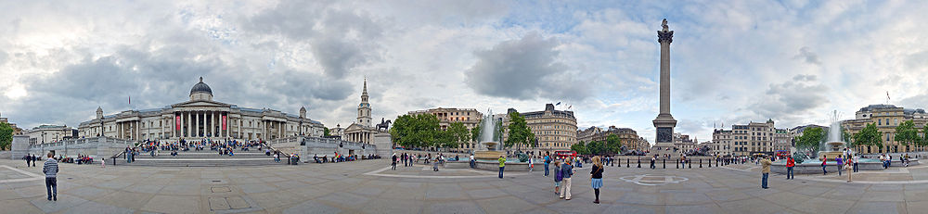

The name commemorates the Battle of Trafalgar (1805), a British naval victory of the Napoleonic Wars. The original name was to have been "King William the Fourth's Square", but George Ledwell Taylor suggested the name "Trafalgar Square".

For many years, revellers celebrating the start of a New Year have gathered on the square, despite a lack of civic celebrations being arranged for them. The lack of official events in the square was partly because the authorities were concerned that actively encouraging more partygoers would cause overcrowding. Since 2005, a firework display centred on London Eye and the South Bank of the Thames near the Square has given spectators a fitting start to the New Year.

Victory in Europe Day (VE Day) was 8 May 1945, the date when the Allies during the Second World War formally celebrated the defeat of Nazi Germany and the end of Adolf Hitler's Third Reich. Trafalgar Square was filled with a crowd wanting to hear the formal announcement by Sir Winston Churchill that the war was over. Trafalgar Square was also used as a place of celebration by people travelling there from all over the country.

There has been a Christmas ceremony at Trafalgar Square every year since 1947. Since its construction, Trafalgar Square has been a venue for political demonstrations, though the authorities have often attempted to ban them