

GDA Technologies Ltd.
32 & 46 North Phase,
TVK Industrial Estate,
Ekkaduthangal, Chennai [TN] - 97

Software Design Document (SDD)

BOOTP Client

Version 0.1

Table of Contents

1 Introduction 3
1.1 Purpose 3
1.2 Scope 3
1.3 Definitions, acronyms, and abbreviations 3
1.4 References 3
1.5 Overview 3
2 Design details 3
2.1 Architectural Design 3
2.2 Module Design 3
2.2.1 BOOTP Client Request Message Broadcast 3
2.2.2 BOOTP Client Reply Message Acquisition 3
2.2.3 BOOTP Client Set IP Address 3
2.3 Functional design 4
2.3.1 init() 4
2.3.2 Broadcast () 4
2.3.3 RandTID_Gen () 4
2.3.4 BootpRequest () 4
2.3.5 BootpReply () 4
2.3.6 ReTrans () 4
2.3.7 Failure () 4
2.3.8 Logging () 4
2.3.9 close () 4

2.4 Data design 6
2.4.1 BOOTP Packet Header 6

Software Design Document (SDD)

Introduction

Purpose
The purpose of this document is to describe the design of the BOOTP Client (BootStrap Protocol Client).

Scope
To design a BOOTP client which is a portable command line tool for Linux platform to request IP address for the host and default file from the BOOTP server which is on the same network as that of the BOOTP client and sets the IP address as the BOOTP Client’s address.

Definitions, acronyms, and abbreviations
BOOTP – Bootstrap Protocol

References
- RFC 951

Overview
This document describes the software design description of the BOOTP Client. Sub-section 2 describes ……………………………………………………………………………………………………………

Design details

Module Design
In BOOTP Client we have three main modules, they are as follows

BOOTP Client Request Message Broadcast

BOOTP Client Reply Message Acquisition

BOOTP Client Set IP Address

Functional design

A brief design description (pseudo code) of these functions

Init()
      - Initialize all structures & variables used in program
      - Obtain Network Hardware Address

Broadcast()
      - Prepare for socket for Broadcast

RandTID_Gen()
      - Transaction ID for BOOTP Packet is generated randomly.

BootpRequest()
      - Fill the BOOTP Request Header with Client MAC Address.
      - Broadcast in the network

BootpReply()
      - Accept Packet and check Validity

Retransmission()
      - If BOOTP Packet has error then Broadcast BOOTP Request Packet again.
      - If Timeout is set then Broadcast BOOTP Request Packet

Failure()
      - When Retransmission failed. Stop Logging & Terminate

Logging()
      - Action initiated by the BOOTP Client are logged into LOG File

close()
      - Terminate Connection

An interactive flow chart representing the above functionalities is shown in the next page.
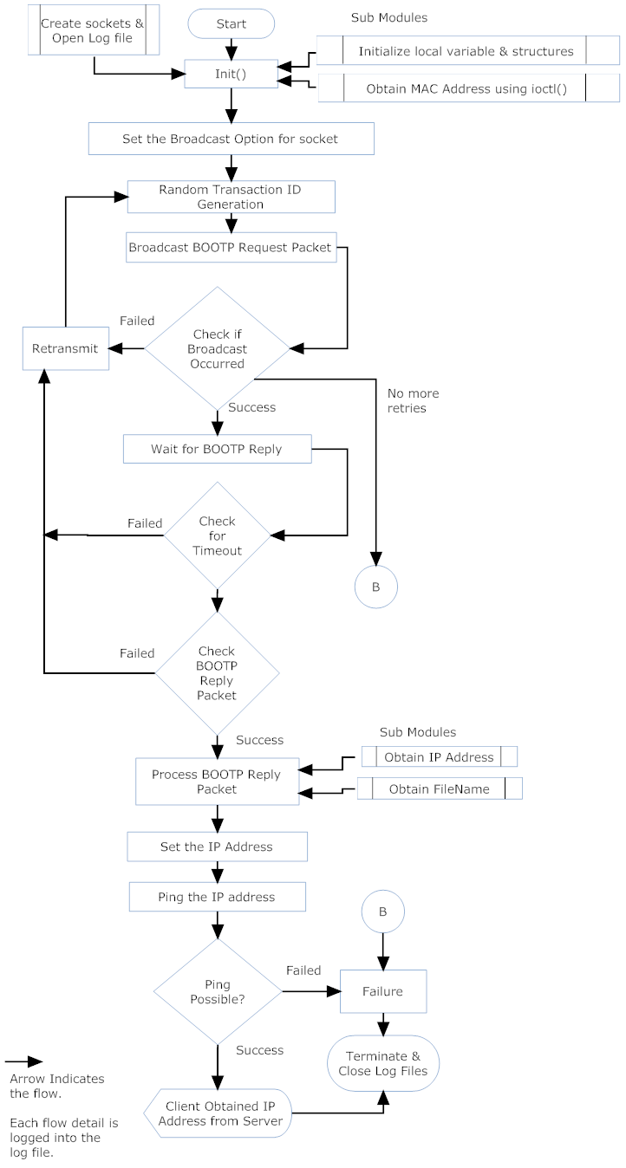

Data design

BOOTP Packet Header

S.No | FIELD | BYTES | DESCRIPTION
1 | op | 1 | Packet op code/ message type  1 = BOOTPREQUEST, 2 = BOOTPREPLY
2 | htype | 1 | hardware address type,  '1' = 10mb ethernet
3 | hlen | 1 | hardware address length  (eg '6' for 10mb Ethernet)
4 | hops | 1 | client sets to zero,  optionally used by gateways  in cross-gateway booting.
5 | xid | 4 | transaction ID, a random number,  used to match this boot request with the  responses it generates.
6 | secs | 2 | filled in by client, seconds elapsed since  client started trying to boot.
7 | -- | 2 | unused
8 | ciaddr | 4 | client IP address;  filled in by client in bootrequest if known.
9 | yiaddr | 4 | 'your' (client) IP address;  filled by server if client doesn't  know its own address (ciaddr was 0).
10 | siaddr | 4 | server IP address;  returned in bootreply by server.
11 | giaddr | 4 | gateway IP address,  used in optional cross-gateway booting.
12 | chaddr | 16 | client hardware address,  filled in by client.
13 | sname | 64 | optional server host name,  null terminated string.
14 | file | 128 | boot file name, null terminated string;  'generic' name or null in bootrequest,  fully qualified directory-path  name in bootreply.
15 | vend | 64 | optional vendor-specific area,  e.g. could be hardware type/serial on request, e.g. could be hardware type/serial on request, on reply. This info may be set aside for use by a third phase bootstrap or kernel.

