|  | |
| --- | --- |
| Population |  |
| Interstate Highway Length |  |
| Cruise Range of EVs |  |
| Proportion of EVs |  |
| Charging Requirement |  |
| The Number of Chargers per Station |  |
| Charging Time per EV |  |
| Service Time of Charging Station |  |
| Estimated Total Number of Stations |  |
| Total Number of |  |



3. Basic Model Analysis of Current Stations Network in The USA

Tesla has already sold more than 50,000 EVs in the United States and built 1,130 supercharger stations, as well as abundant destination charging stations. The concept of supercharger stations is relatively similar to the gasoline stations in our daily life: 30 minutes to go, only the time to grab a cup of coffee; according to Tesla, it takes around 1.5h to recharge the battery of Tesla model S from almost 0% to 100% with supercharger. Though the increasing sales of Tesla EV, it remains questionable that whether Tesla’s charging stations are sufficient and more stations in schedule will cope with the increasing demands.

We first need to estimate the total number of the charging stations in the United States. Moreover, the number of chargers in different stations will be significant to estimate the number of stations. By analyzing the information of charging stations provided by Tesla, we retrieve the statistical results in Table 1.

In order to estimate the number of the charging stations in the United States, we introduce a model based on the statistic (Table 2) and parameters (Table 3).

The statistic in Table 2 is retrieved form the United States Census Bureau. Moreover, we introduce another parameter: charging requirement ***Rj*** , to improve this model. Charging Requirement ***Rj*** is different in each state. It has a positive correlation with the person traveling miles per day of each state and it has a negative correlation with the cruise range of EV. To acquire approximate total number of stations, we assume all EVs are Tesla Model S, with a 335 miles cruise range (due to the range anxiety problem, we shrink it to 300 mi). In addition, the charging station network will develop in advance to ensure the stations will be sufficient for the growing number of EVs. Therefore, we will first set a real EV proportion of all passenger vehicle and the formula will output the desired network capacity with an imagine EV proportion (Fig 1).

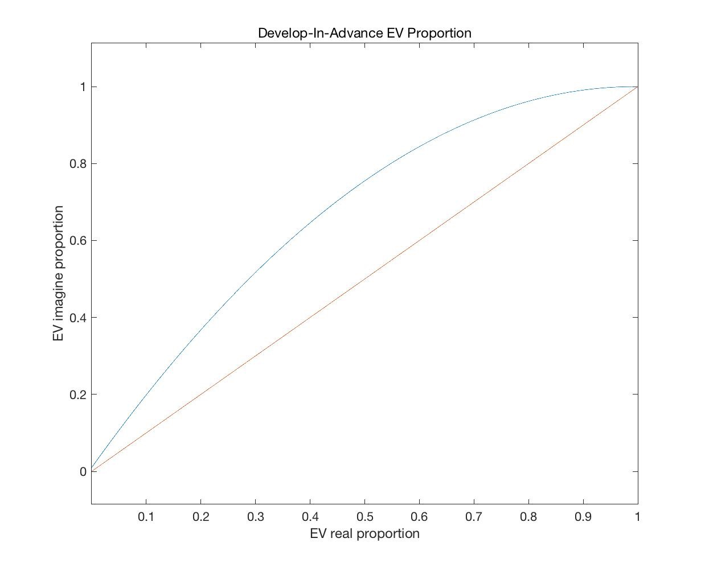

**Fig.1**

Table 4 and Fig 2 demonstrate the estimated number of supercharger station in the U.S. as well as their distribution in urban, suburban and rural areas. Moreover, when we study the Tesla current charging network in the U.S., the number of supercharger stations is 1,130 and Tesla EV market share is around 0.04% in the U.S. (only considering the number of passenger vehicle). Our estimation is 1,502 and increasing rate at this point (double the EV number, considering the sale growth of Tesla all models) is 9.85%. After analyzing Tesla’s data, we obtain the increasing rate of Tesla is 12.04% by the end of 2018. Therefore we may conclude that Tesla is on the right track to develop nationwide charging stations and the detailed distribution of stations in urban, suburban

and rural area is demonstrated in the Table 4.

