4. Model Modification

4.1 Overview of Advanced Models

Comparing to the basic model based on America, the total number of current and coming soon charging stations are already sufficient for 100% cover of electric cars. Since different country has variant geographic features and population distribution, the basic model and algorithm we create for America might also suit for other countries. Hence, our model needs further modification by considering some key factors.

Our advanced models are designed by considering a country’s population distribution and local highway network as main factors. When analyzing model one, we found a linear relationship between population in a state denoted x and number of its current charging stations, y, by calculating their correlation coefficient $r_{xy}$

$$r_{xy}= \frac{S_{xy}}{S_{x}S_{y}}$$

and $r_{xy}$ = 0.895, which showed a strongly positive linear relationship by comparing with $\frac{2}{\sqrt{n}}$, 0.28. Also, the classification of urban, suburban and rural areas is mainly based on local population and larger population means more potential purchasing. Thus, we list population density as the first factor. Moreover, charging stations are supposed to be on the main roads specially for highways due to more demands for long distance travelling and because of geographical influence, there would be more roads in cities and less in mountainous districts, so the second factor we consider as the current local highway routes.

We have two models that respectively focus on usage rates of stations and their rationality if they were built followed as our design, Population Distribution Trail model (PDT) and Shortest Route Preference model (SRP). In PDT model, the charging stations are distributed due to population distribution. Without considering how long it will take for a vehicle to reach destination if charging is required on the way, stations are placed in larger population density place as long as they could support the vehicle’s power. The second model is based on the shortest route so that electric cars could be charged on the way to the destination as soon as possible.

Given a highway network of a country, we locate the main traffic hinge and districts. We simplify them to cross lines and points shown below

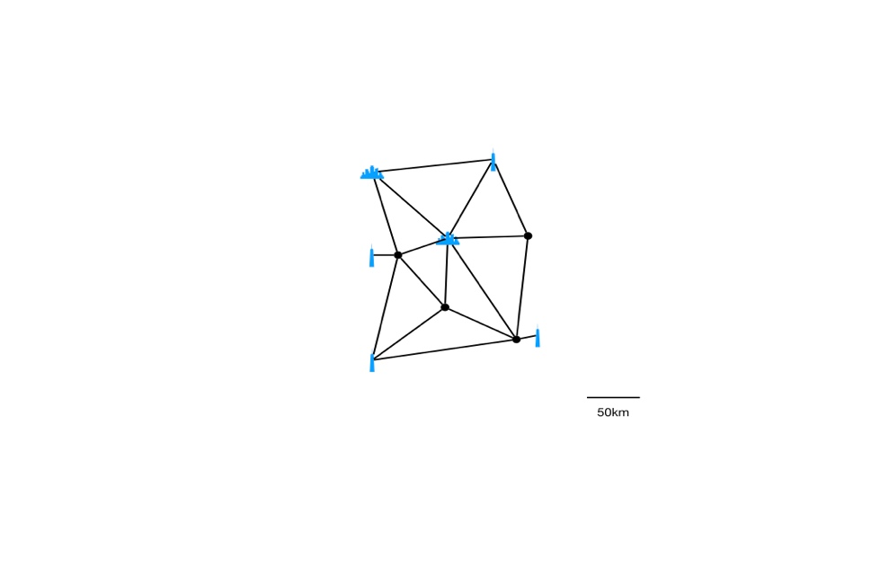

**Fig.1** A simplified highway network map in which dots mean the traffic hinge and blue marks represent provinces in different level.

As our assumption, we determine a constant cursing distance $D$. As for the travel distance, we determine it as $d$, which is obtained following the highway network from start to the end place. Our main concerns now are to set charging stations when $d>D$ reasonably and as our models are proposed, we create two methods to place stations. After that, we simulate as condition of several countries with different landscape and population distribution to evaluate its sensitivity for further classification and conclusion.

4.2 Population Distribution Trail Model (PDT)

The method could be briefly concluded as follows, denote $P=\{A, B,…,I\}$:

∆ Condition: $d>D$ and start with full electric energy, which could be treated as a station;

∆ Selectable placements of charging stations: chosen by network points within $d_{ij}≤D$,

$i, j∈P;$

∆ Stations placement: at the furthest point to the current start point that within $d_{ij}≤D;$

∆ Repeat the previous process until $d_{nI}≤D$, $n∈P-\{I\}$;

The factors affected in this model is cities position and distance from each other. In corresponding algorithm, the cities’ position or coordinates and distance between each two cities need to be recorded. Create a simplified highway network map as below. Black dots represent cities and traffic hinges demoted from A to I. Green circle has radius of cursing distance $D$ and destination traveling distance is randomized. Here we give an example when allocating the furthest point I as destination. Green dot, red dot, grey dots and blue flash represent start point, temporary end point and selectable placements for stations respectively. These denotes would be used in the following discussion.

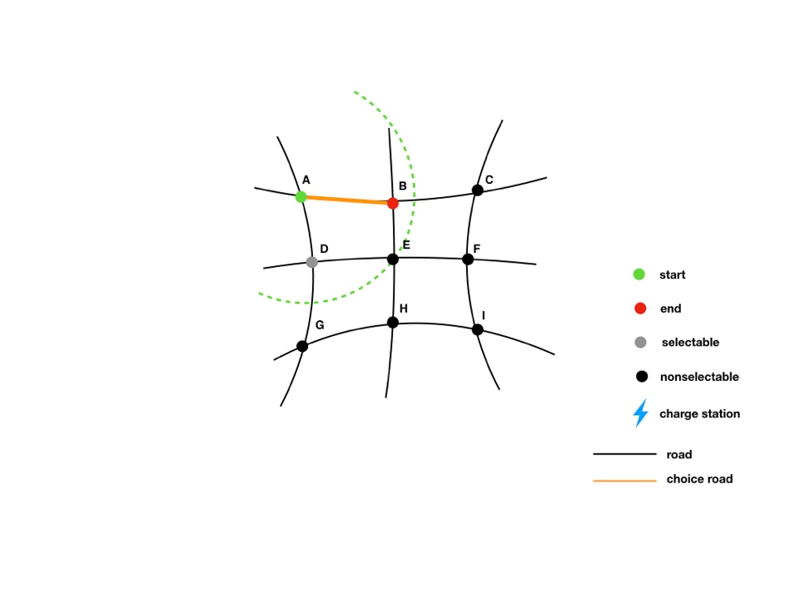

**Fig.2** Simplified Highway network map. Within the radius (green circle) $D$, we mark by grey dots to present selectable placement for charging stations. Here we have point A as start point and B, D as selectable placement. Then we choose one of selectable points as station, also for an end point, B. Notice that, when there are several selectable placements, we choose the relatively farthest point to place station.

The whole process could be represented by Figure 3 below.

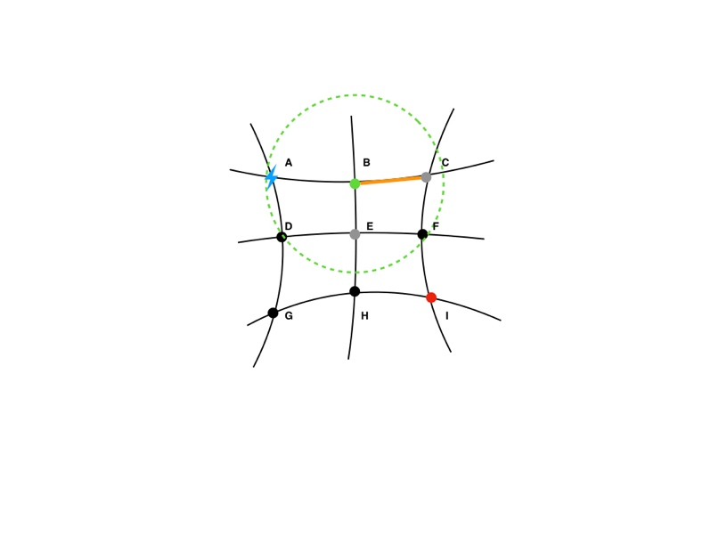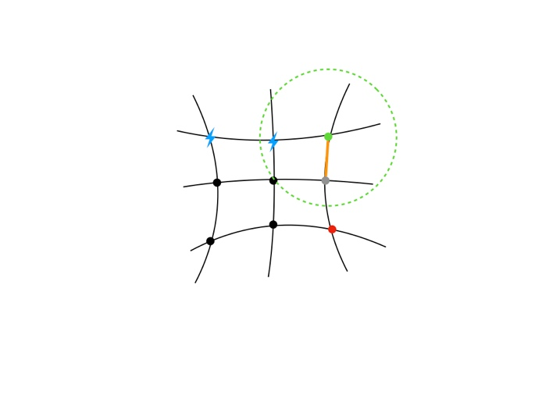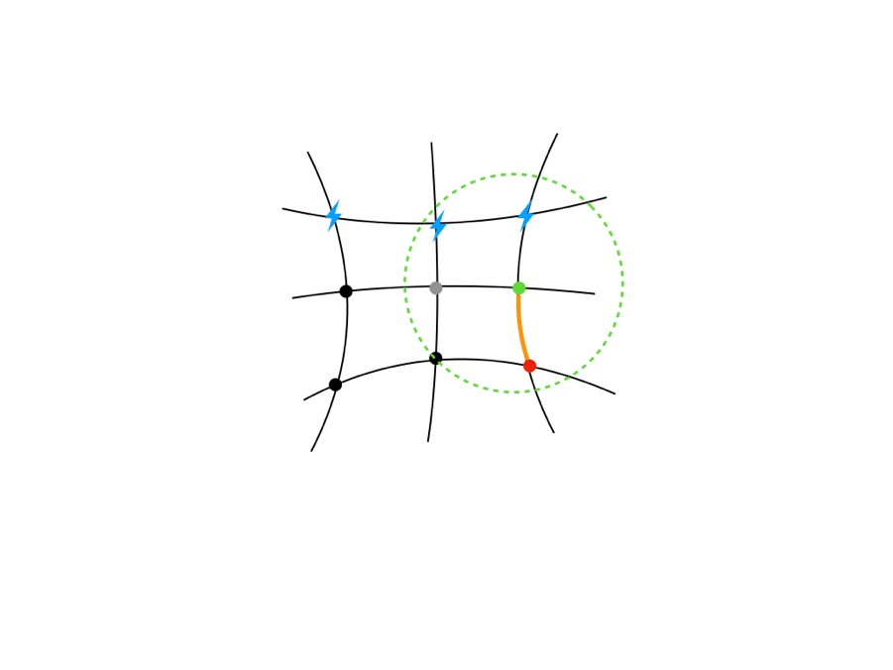

**Fig.3** Three pictures from left to right in order show the process to place the charging stations. The final result is placing 4 stations, A, B, C, along the way to destination I.

4.3 Shortest Route Preference model (SRP)

Instead of considering population distribution only, in SRP model, after the destination has been fixed, we determine the shortest route on highway network first and then only consider building charging stations along it. In this case, in spite of cities coordinates and distance between each two are needed, we also use Manhattan Distance to locate the points in a city’s neighbourhood. The whole process is similar to PDT model:

∆ Condition: $d>D$ and start with full electric energy, which could be treated as a station;

∆ Determine the best route: comparing distance between start point and destination in

different way by Manhattan Distance;

∆ Selectable placements of charging stations: chosen by network points on the chosen route

within $d_{ij}≤D$, $i, j∈P;$

∆ Stations placement: at the furthest point to the current start point that within $d_{ij}≤D;$

∆ Repeat the previous process until $d_{nI}≤D$, $n∈P-\{I\}$;

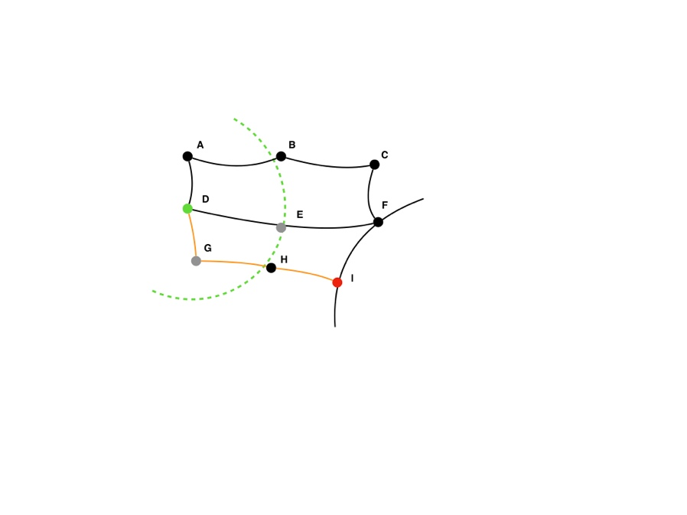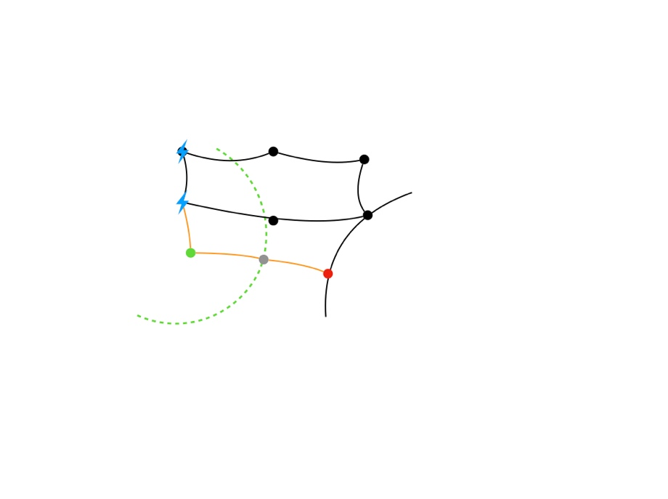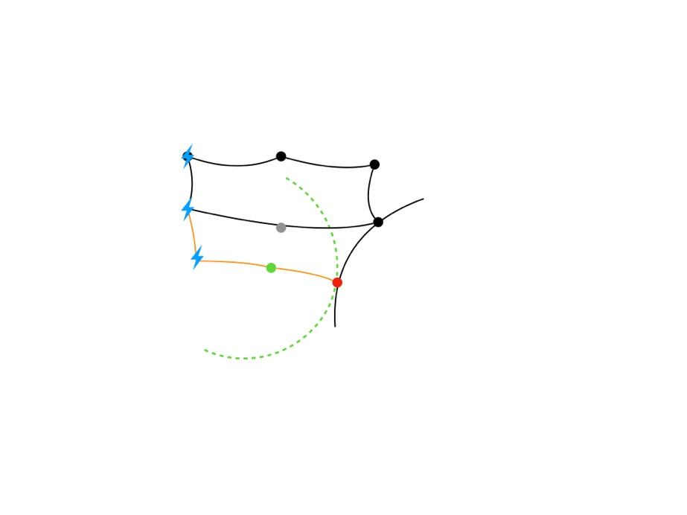

**Fig.4** Three pictures from left to right orderly show the process to place the charging stations. At the beginning, the shortest route has been chosen, shown by orange in the figure. As a result, the chosen points to place stations are A, D, G.

4.4 Rough Evaluation of PDT&SRP Models and Revisit Current Situation of America

Intuitively, two models are modification of model based on Tesla charging stations in the USA. We generally consider the population distribution and highway network as main factors. However, there are many other influential elements to discuss, such as GDP in different district, average electric vehicle holding and other production of high technology that would influence demand for charging stations. These factors would be discussed in the later sections with the electric cars’ evolution specific to one example country.

Revisit the current charging stations in the USA of Tesla, data and figure show that most stations are built near highways and there are more stations in states holding larger population such as California and New York. Apparently, the distance and population density are two main factors Tesla considers that influence charging stations distribution. Therefore, the models we create are reasonable.

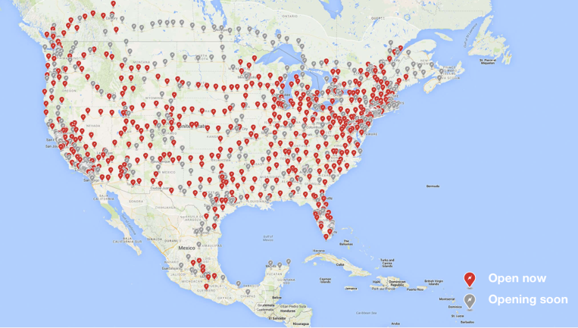

**Fig.5** The current charging stations in the USA of Tesla.