NATIONAL POLYTECHNIC INSTITUTE

Superior School of Computation

Project

Team 2

Members:

Jiménez Hernández Maira

Gutiérrez González Gustavo

Ríos Guzmán Omar Eduardo

Professor:   
Cervantes De Anda Ismael

Subject:

Instrumentation

Group:

3CV2

City of Mexico, September 12th 2018

índex

**GOALS** 3

**I INTRODUCTION** 3

**II. DEVELOPMENT** 6

I.I Realization of the Resistance Bridge 8

**2 CALCULATIONS.** 10

**III. SIMULATIONS** 16

**V. Conclusions** 18

**VI Bibliographic references** 18

# **GOALS**

Learn to use resistive sensors in this case we will use a distance sensor which we will graduate and we will know the distance traveled through the use of this resistor, as well as calibrate the resistor to know what measured value gives us the value in distance through a conversion and with this value we can use it implementing it in the digital analog converter showing the values of the voltage and being shown with the DAC watching the way how the leds turned on

# **I INTRODUCTION**

The distance sensors and distance transducers are designed to perform the measurement of linear distance or linear displacement in an automated way, since they provide an electrical signal according to the physical variation, in this case the physical variation is the distance.

The measurement ranges available are very diverse, depending on the type of distance sensor used. So there are models that have ranges of a few microns and other models that can reach hundreds of meters. Depending on the required range, the sensor format varies, being more or less bulky, with more or less protection, etc.

**Potentiometers**

A potentiometer is an electromechanical device that consists of a resistance of fixed value on which a sliding contact moves, the cursor, which divides it electrically.

The most common application of this device in instrumentation is as displacement sensor of resistive type.

The movement of the cursor causes a change in the resistance measured between the central terminal and any one of the ends. This change in resistance can be used to measure linear or angular displacements of a part coupled to the cursor. In order to obtain an electrical signal related to the displacement, it is generally supplied with a direct voltage, adopting the configuration of a simple voltage divider.

The potentiometers can be used to measure various physical quantities whenever it is possible to convert them into a displacement. Although these systems were the first used in industrial instrumentation, today the application of the potentiometer as a displacement sensor has fallen into disuse due to several problems:

- Mechanics: anchors, bearings, guides.

- Friction: shortens life. The mechanical life is usually indicated in cycles.

- Self-heating: causes errors, since the resistance varies with temperature. - Vibrations: can cause the loss of contact of the cursor on the resistance.

These problems have caused these devices to be replaced by more reliable devices based on optical detection methods such as pulse encoders.

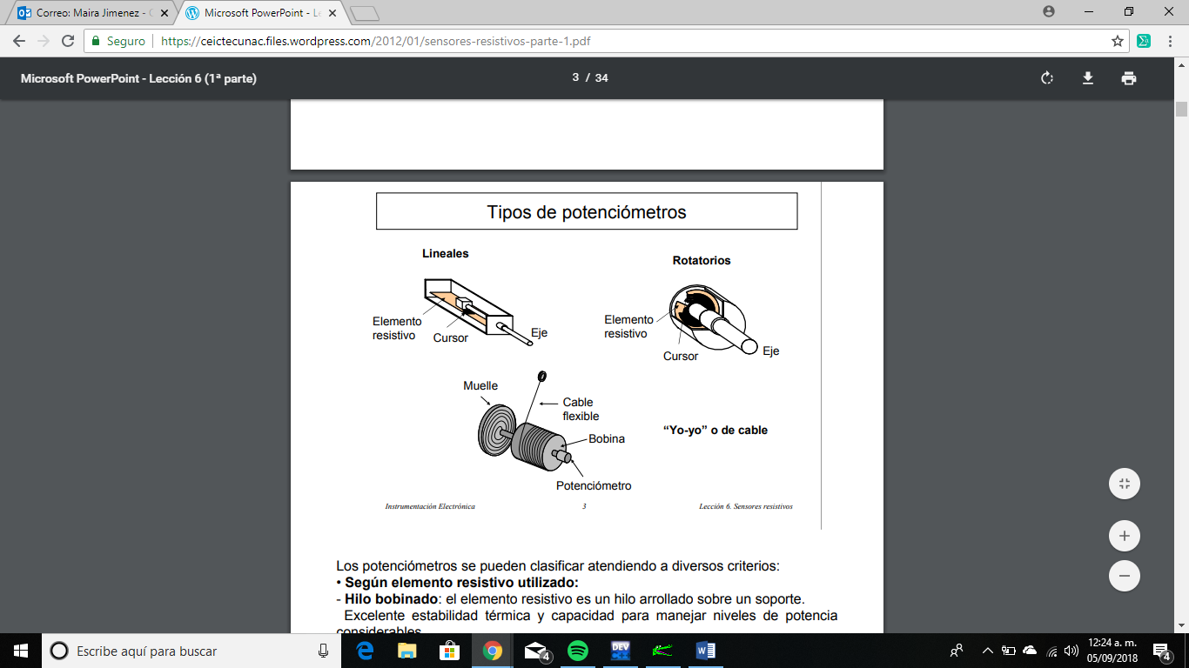

The potentiometers can be classified according to several criteria:

• According to the resistive element used:

- Winding wire: the resistive element is a thread wound on a support. Excellent thermal stability and ability to handle power levels considerable.

- No windings: the resistive element can be cermet (ceramic alloy and metal), carbon, conductive plastic, metal film.

• For the type of movement the cursor makes:

- Linear movement: the cursor describes displacements in a straight line. He displacement can range from millimeters to several meters.

- Rotary: can be of a round or multi-turn (3, 5, 10 or 15) - Rope, "yo-yo" or cable: they allow to measure the position and speed of a flexible cable wound on a coil that is subjected to the traction of a dock. They can measure several tens of meters of the cable.

**Equivalent circuit**

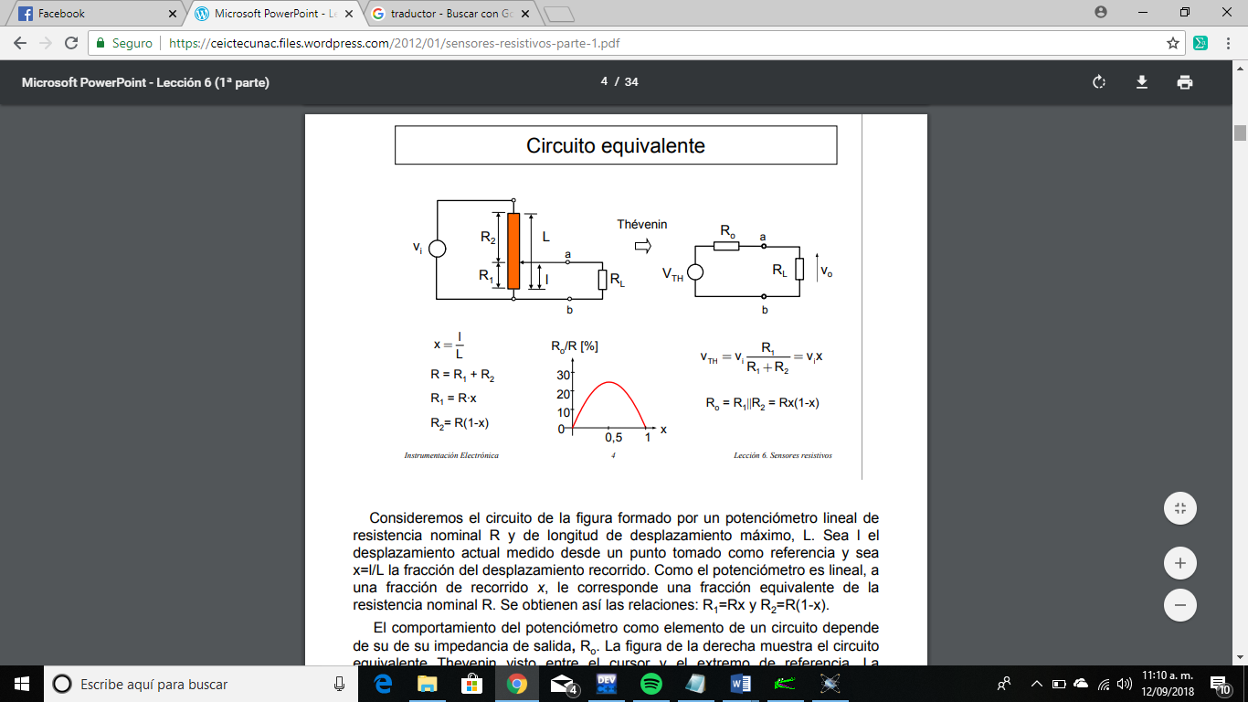

Consider the circuit of the figure formed by a linear potentiometer of nominal resistance R and maximum displacement length, L. Let l be current displacement measured from a point taken as reference and be x = l / L the fraction of the displacement traveled. Since the potentiometer is linear, a fraction of the distance x, corresponds an equivalent fraction of the nominal resistance R. The relations are thus obtained: R1 = Rx and R2 = R (1-x).

The behavior of the potentiometer as an element of a circuit depends of its output impedance, Ro. The figure on the right shows the circuit Thevenin equivalent seen between the cursor and the reference end. The Output impedance changes as a function of the displacement fraction x, up to 25% of the nominal value of the potentiometer, just in the middle of the route. In the remaining positions, except for the extremes, the effect of the output impedance will influence the voltage read, that is, will introduce an error regarding the ideal response.

An analog to digital converter or converter (Digital Analog Converter, CAD, Analog to Digital Converter, ADC) is an electronic device which is capable of converting an analog signal, voltage sea or current, into a digital signal by means of a quantizer and coding in many cases in a particular binary code. Where a code is the univocal representation of the elements, in this case, each binary numerical value corresponds to a single voltage or current value.

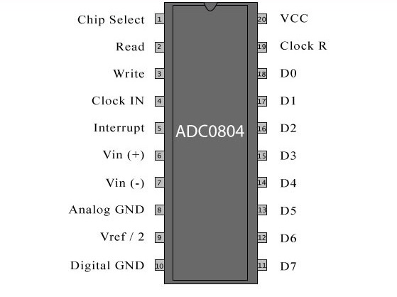

# **II. DEVELOPMENT**

Before making the circuit, measure how much is the range of the sliding resistance with the multimeter. First the lever is placed on one end of the distance sensor and the resistance value measured as shown in figure n ° 1.

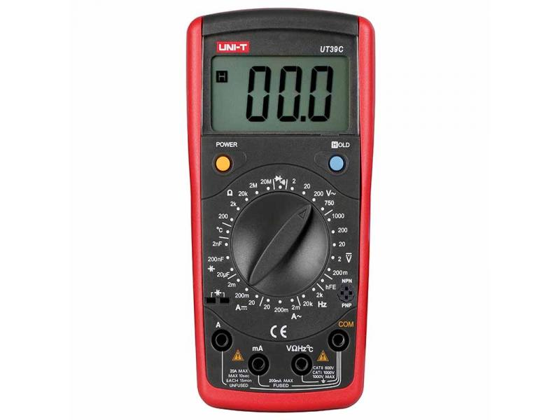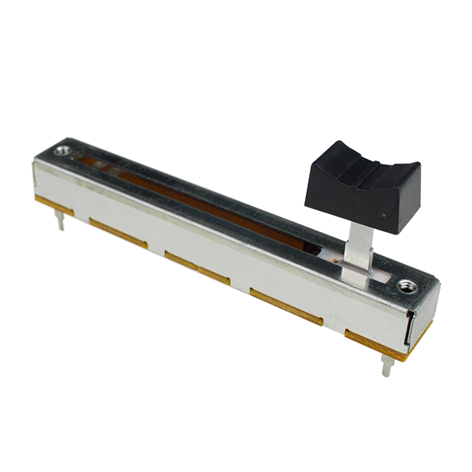

Figure n°1

|  |  |
| --- | --- |
| Minimum value of the sliding resistance (Ω) | Maximum value of the sliding resistance (Ω) |
|  |  |

Table n ° 1 Range of resistance

If we observe that it is the minimum value of the resistance of the sliding resistance, a mark is placed to start measuring until the distance reaches our sensor, each mark must have a distance of 1 cm as shown in the following figure.



The distance between the two marks is 1 cm

Figure n°2

Once we have the marks, we proceed to measure the resistance value of each centimeter with the multimeter as shown in Figure 3



Figure n°3

|  |  |  |
| --- | --- | --- |
| Distance (cm) | measured resistance value (Ω) | calculated resistance value (Ω) |
| 1 |  | 7.833 k |
| 2 |  | 15.666 k |
| 3 |  | 23.499 k |
| 4 |  | 31.332 k |
| 5 |  | 39.165 k |
| 6 |  | 47 k |

Table n°2 Strength values ​​of each centimeter.

# I.I Realization of the Resistance Bridge

We consider the range of the sliding resistance is proceeded to the development of resistance point as shown in Figure No. 4.

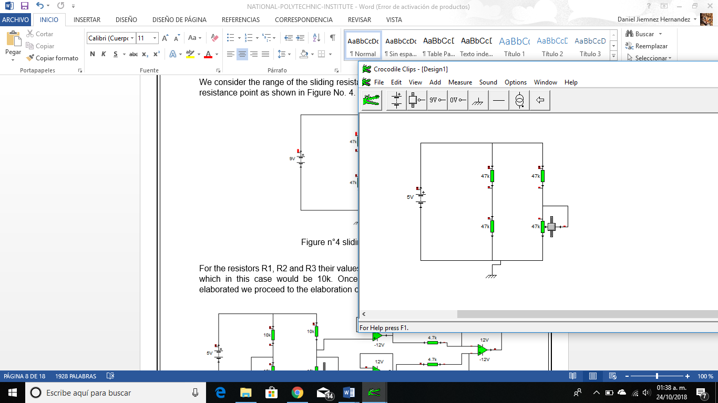

Figure n°4 sliding resistance

For the resistors R1, R2 and R3 their values ​​must be the same as the slip resistance which in this case would be 47k. Once the punete de resistencias has been elaborated we proceed to the elaboration of the circuit of figure 5.

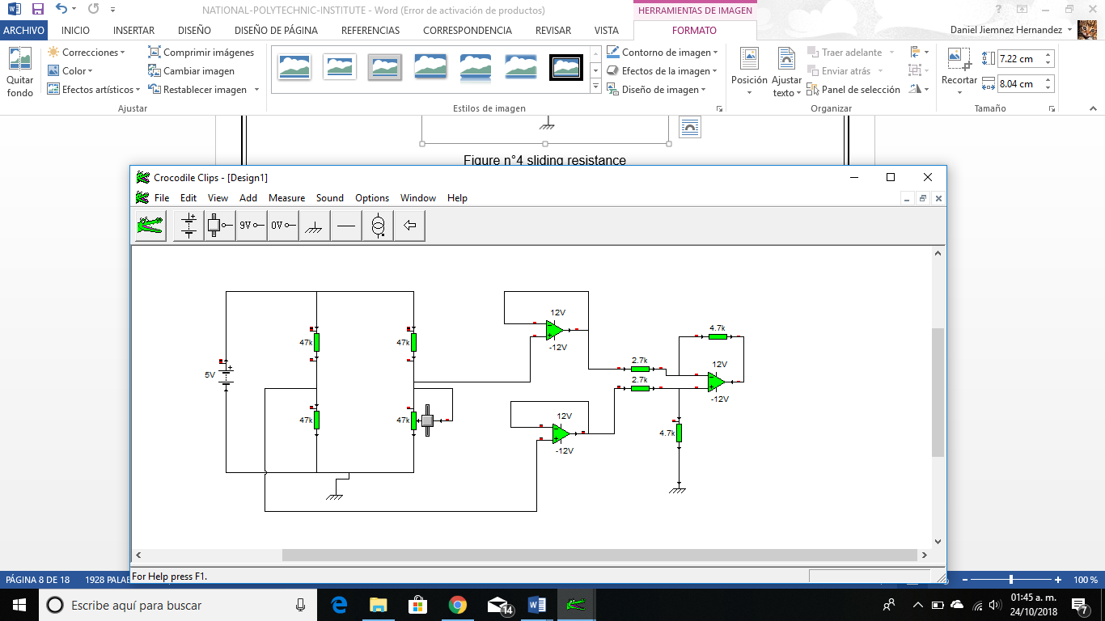

Figure n°5

The resistors Rf and Rc will have a value of 4.7kΩ, and the rersistors Ra and Rb will have a value of 2.7kΩ since our gain will be unitary. Finally, once the circuit has been assembled, it is necessary to feed the resistor bridge with 5v and the amplifiers with ± 12v. We consider the 6 distance values ​​and perform the voltage measurements that are requested in the table.

|  |  |  |  |  |  |
| --- | --- | --- | --- | --- | --- |
| Distance Sensor  (cm) | E1  (Volts) measured | E2  (Volts) measured | E1-E2  (Volts) measured | Vsal  (Volts) measured | value of the sliding resistance  (Ω) |
| 1 | 2.5v |  |  |  | k |
| 2 | 2.5v |  |  |  | k |
| 3 | 2.5v |  |  |  | k |
| 4 | 2.5v |  |  |  | k |
| 5 | 2.5v |  |  |  | k |
| 6 | 2.5v |  |  |  | k |

Table n°3 Measured values ​​of voltage.

Then we assemble the circuit using an ADC as shown in figure no. 6.

And the values of the resistors that are used in the voltage divider that is connected in terminal no.9 of the ADC. To give us a reference voltage from 0 volts to 4.44 volts. The resistance value R9 is 3.3k and R10 is 2.7k.

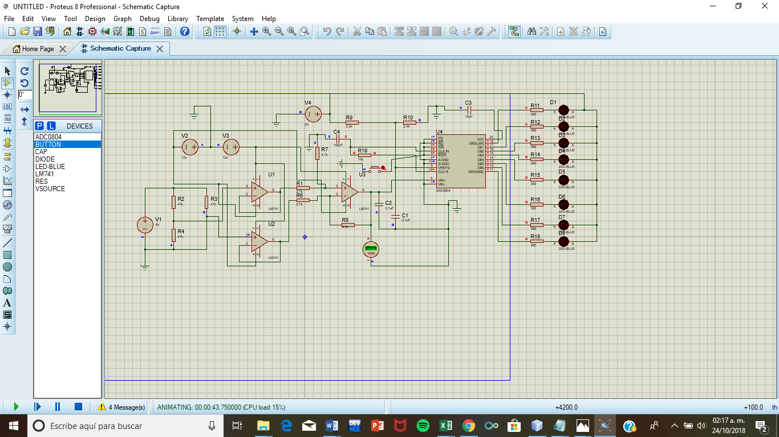

Figure n° 6

And connect the output terminal of the CAS made previously, to terminal no.6 of the ADC, as shown in figure no. 7



Figure n° 7

We calculate the resolution voltage with which the ADC works, based on the reference voltage with a range of 0 volts at 4.44 volts that is being sent to it and we were filling the table no. 4 next.

|  |  |  |  |  |  |  |  |  |  |
| --- | --- | --- | --- | --- | --- | --- | --- | --- | --- |
| Vresol== = 17.25m | | | | | | | | | |
| Measured Analog Voltage Va (V) | Binary Combination  B7 B6 B5 B4 B3 B2 B1 B0 | | | | | | | | Calculated Analog Voltage Va (V) |
|  | 1 | 1 | 1 | 1 | 1 | 1 | 1 | 1 | 4.4V |
|  | 1 | 0 | 1 | 1 | 0 | 1 | 1 | 1 | 3.15 V |
|  | 1 | 0 | 0 | 0 | 0 | 0 | 0 | 0 | 2.2 V |
|  | 0 | 1 | 0 | 1 | 0 | 1 | 0 | 1 | 1.47 V |
|  | 0 | 0 | 1 | 1 | 0 | 0 | 1 | 1 | 0.88 V |
|  | 0 | 0 | 0 | 1 | 0 | 1 | 1 | 1 | 0.40 V |
|  | 0 | 0 | 0 | 0 | 0 | 0 | 0 | 0 | 0 V |

Table n° 4

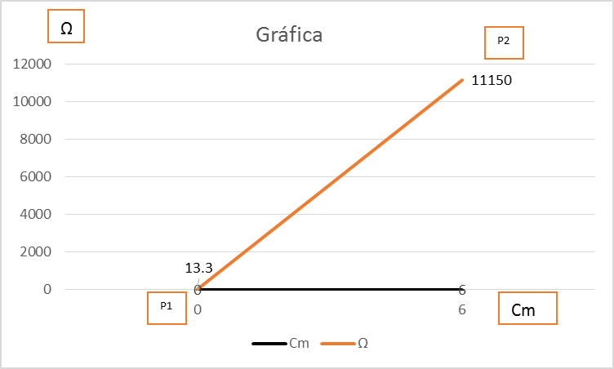

## **2 CALCULATIONS.**

Designing the CAS using the sensor  
0 Ω a 47kΩ

0 cm a 6 cm

For P1

=

For P2

=

Calculation of the current for the resistance

Para

Therefore we choose the value ofand the formule will be:

For

For 0 cm

= 0

For 6 cm

The subtraction must remain as E1-E2

For 0 cm

E1 – E2 = 2.5v – 0v = **2.5v**

For 6 cm

E1 – E2 = 2.5v – 2.5V = **0v**

**Therefore the range of operation goes from**

Using Operational Amplifiers to increase the range of 2.5v to 4.4v

Proposing Rf =

**Formulas to be used:**

**0  
k  
15.666k  
23.499k  
31.332k  
39.165k  
47k**

**k**

**4.4v  
 3.15v  
 2.2v  
 1.47v  
 0.88v  
 0.40v  
 0v**

**Vresolucion= = = 17.25m**

**Comb Bin = = 255 Comb Dec= 11111111  
  
Comb Bin = = 183 Comb Dec= 10110111  
  
Comb Bin = = 128 Comb Dec= 10000000  
  
Comb Bin = = 85 Comb Dec= 01010101  
  
Comb Bin = = 51 Comb Dec= 00110011  
  
Comb Bin = = 23 Comb Dec= 00010111  
  
Comb Bin = = 0 Comb Dec= 00000000**

|  |  |  |  |  |  |  |  |  |
| --- | --- | --- | --- | --- | --- | --- | --- | --- |
| Cm | Rsen |  | E1 | E2 | E1-E2 | Vsal | ComDec | ComBin |
| 0 | **0** |  | **2.5v** | **0v** | **2.49v** | **4.4v** | **255** | **11111111** |
| 1 | **7.833kΩ** |  | **2.5v** | **0.71v** | **1.79v** | **3.15v** | **183** | **10110111** |
| 2 | **15.666k** |  | **2.5v** | **1.249v** | **1.25v** | **2.2v** | **128** | **10000000** |
| 3 | **23.499k** |  | **2.5v** | **1.66v** | **0.84v** | **1.47v** | **85** | **01010101** |
| 4 | **31.332k** |  | **2.5v** | **2.00v** | **0.5v** | **0.88v** | **51** | **00110011** |
| 5 | **39.165k** |  | **2.5v** | **2.27v** | **0.23v** | **0.40v** | **23** | **00010111** |
| 6 | **47k** | **0** | **2.5v** | **2.5v** | **0v** | **0v** | **0** | **00000000** |

# **III. SIMULATIONS**

# 

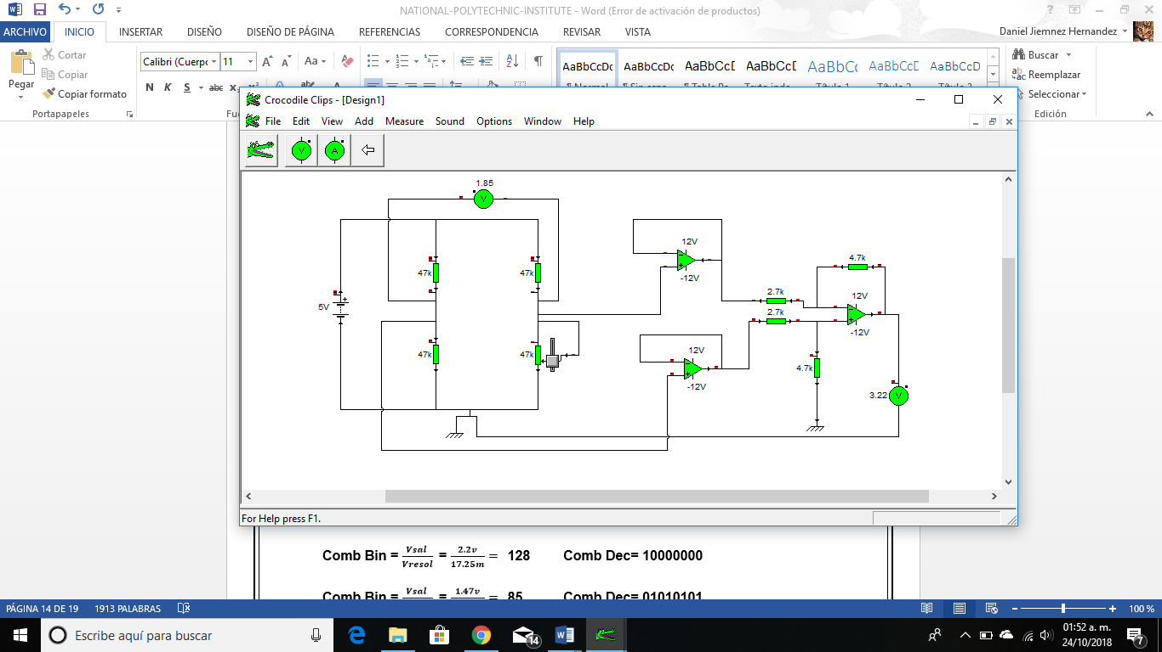

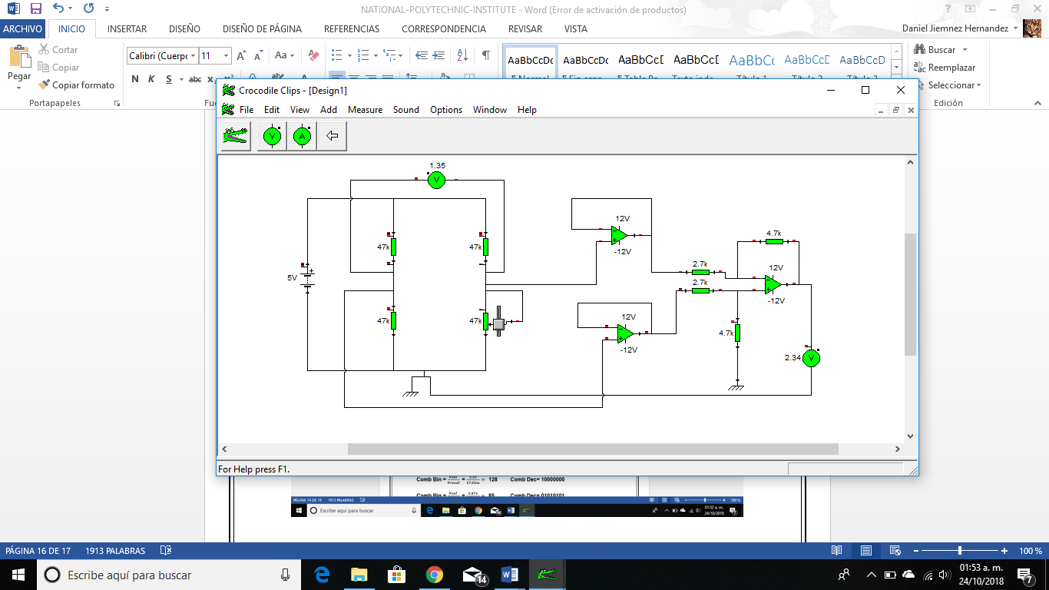

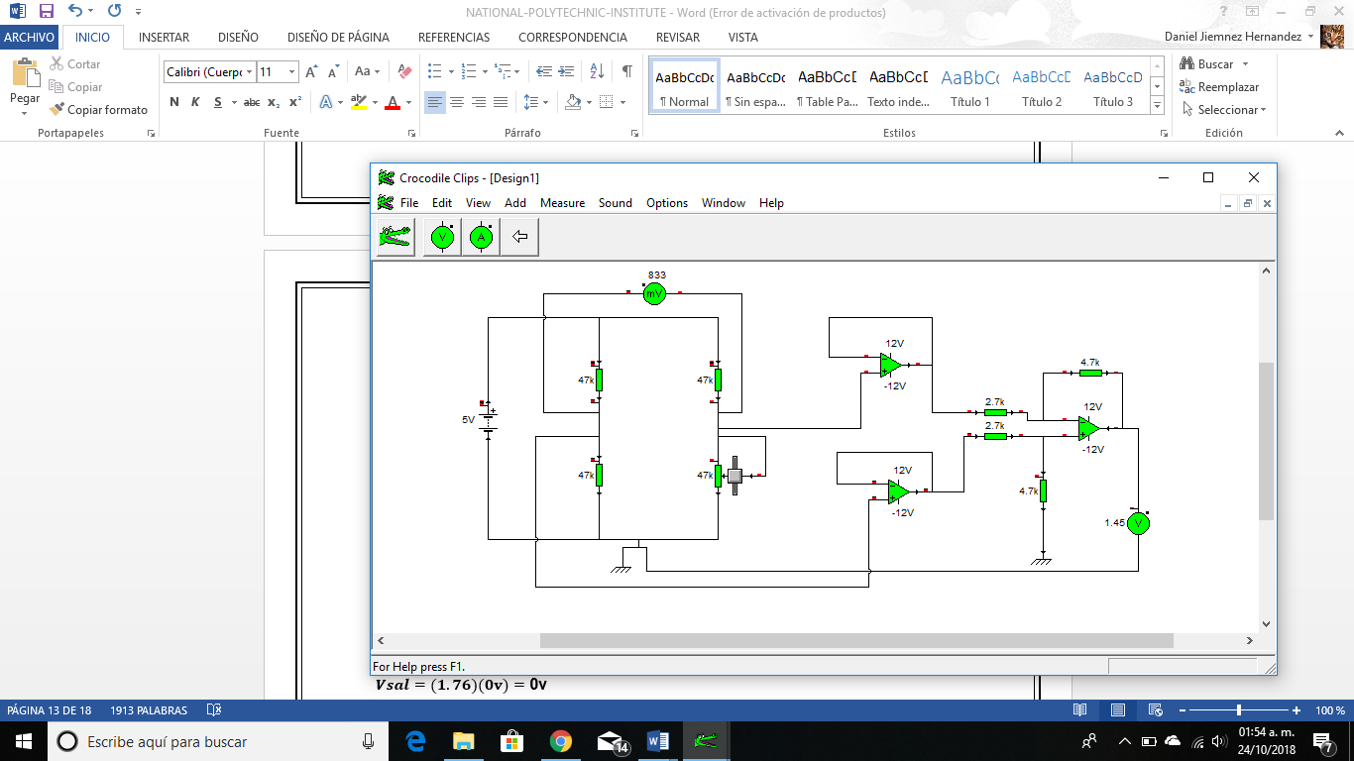

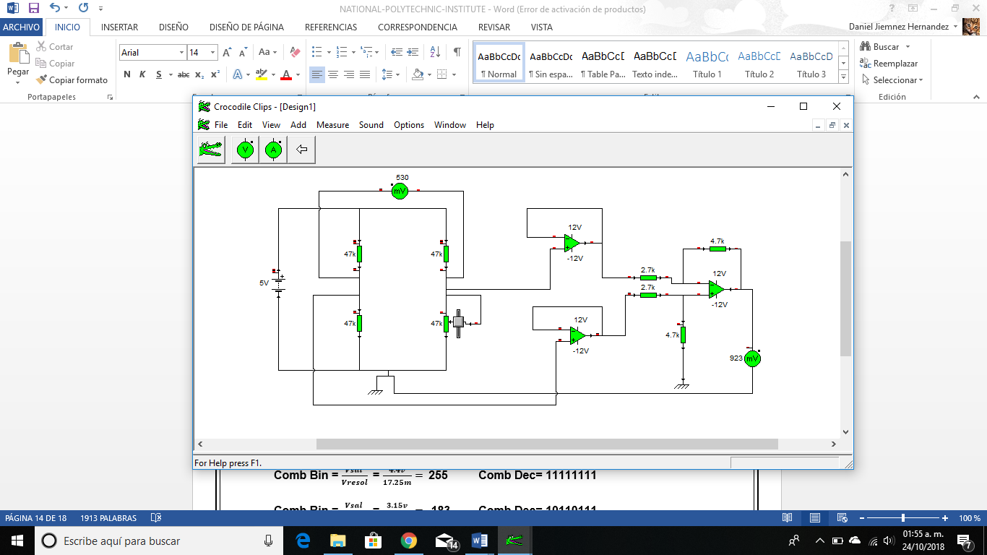

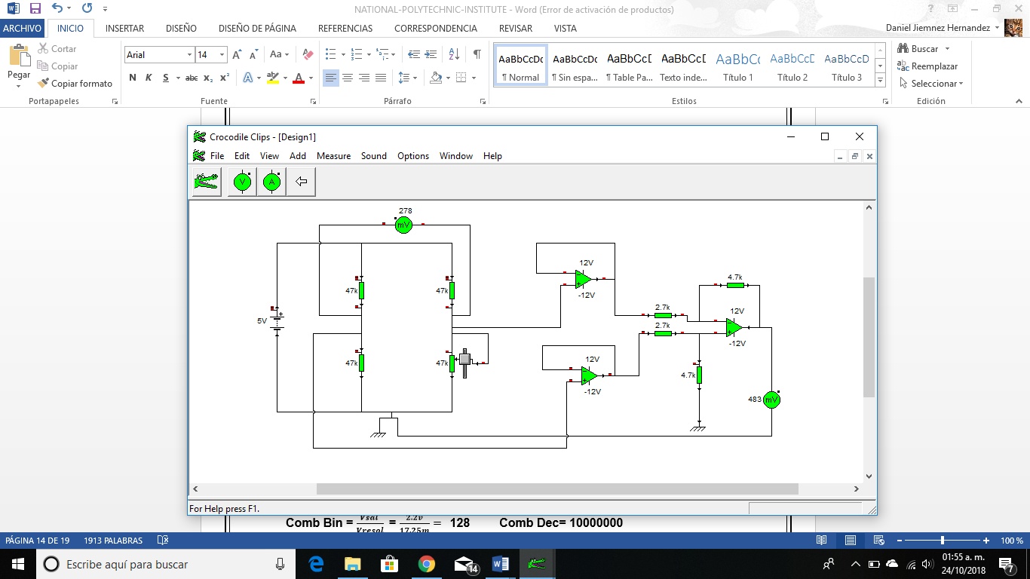

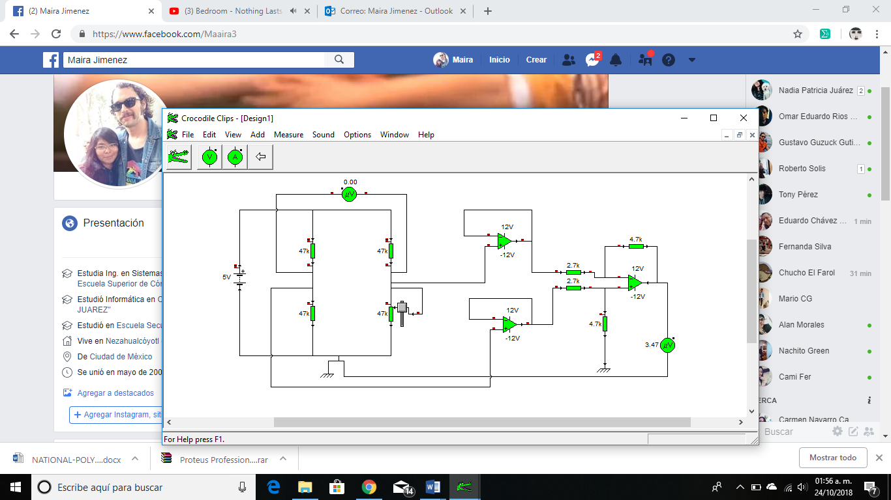



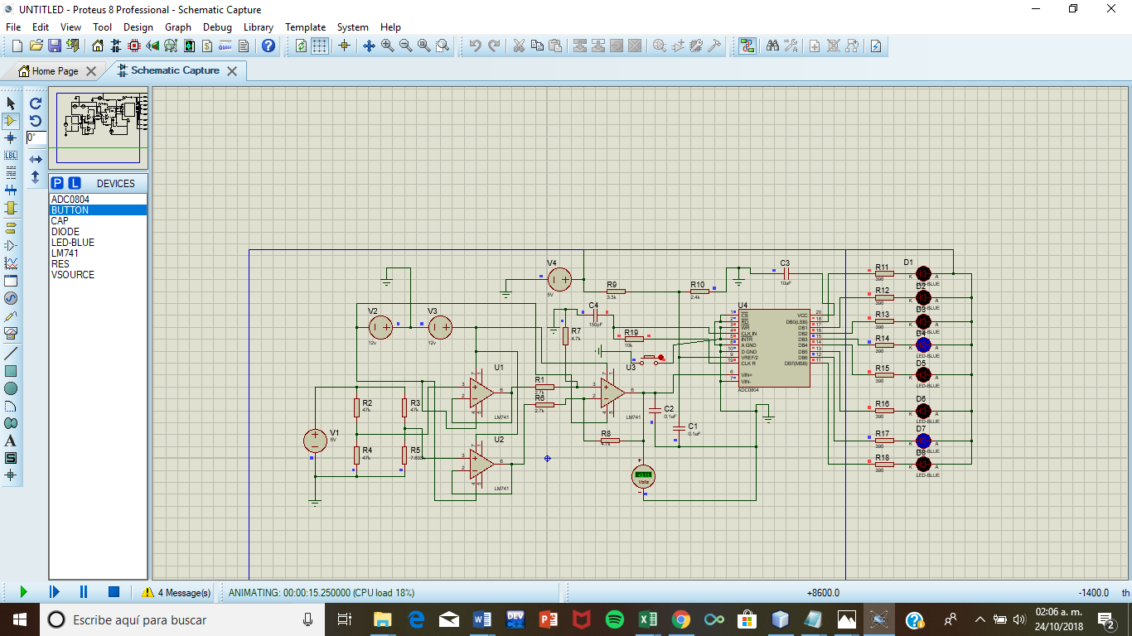

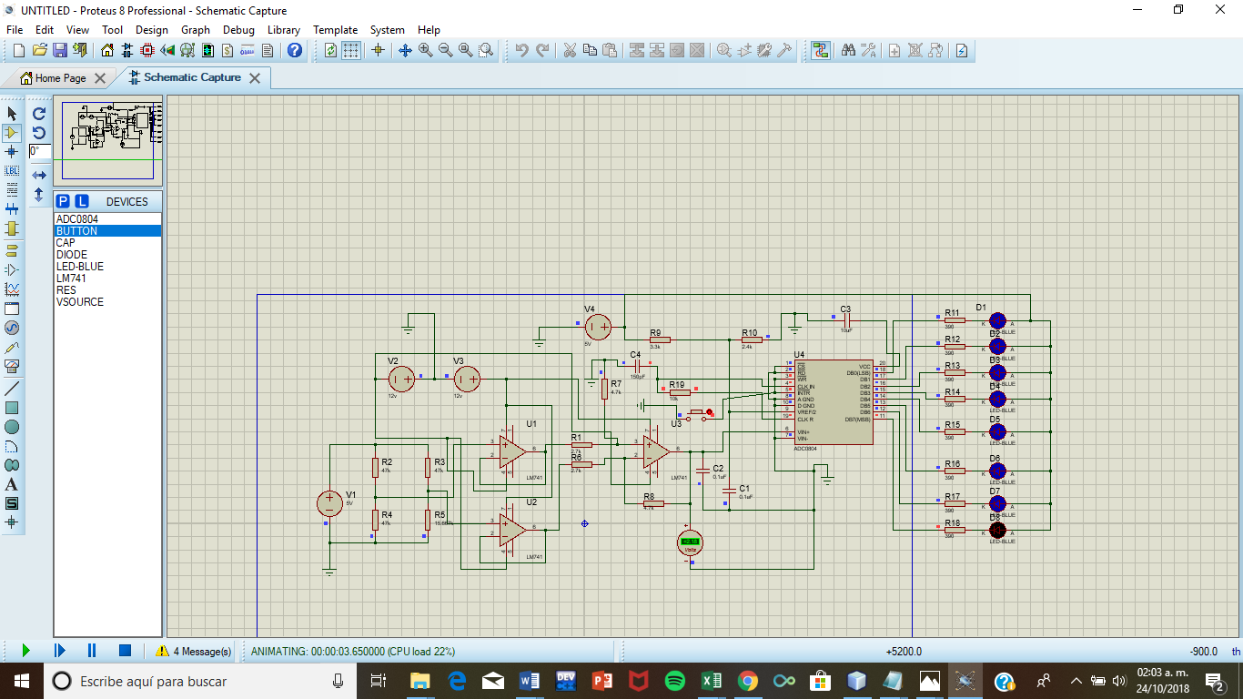

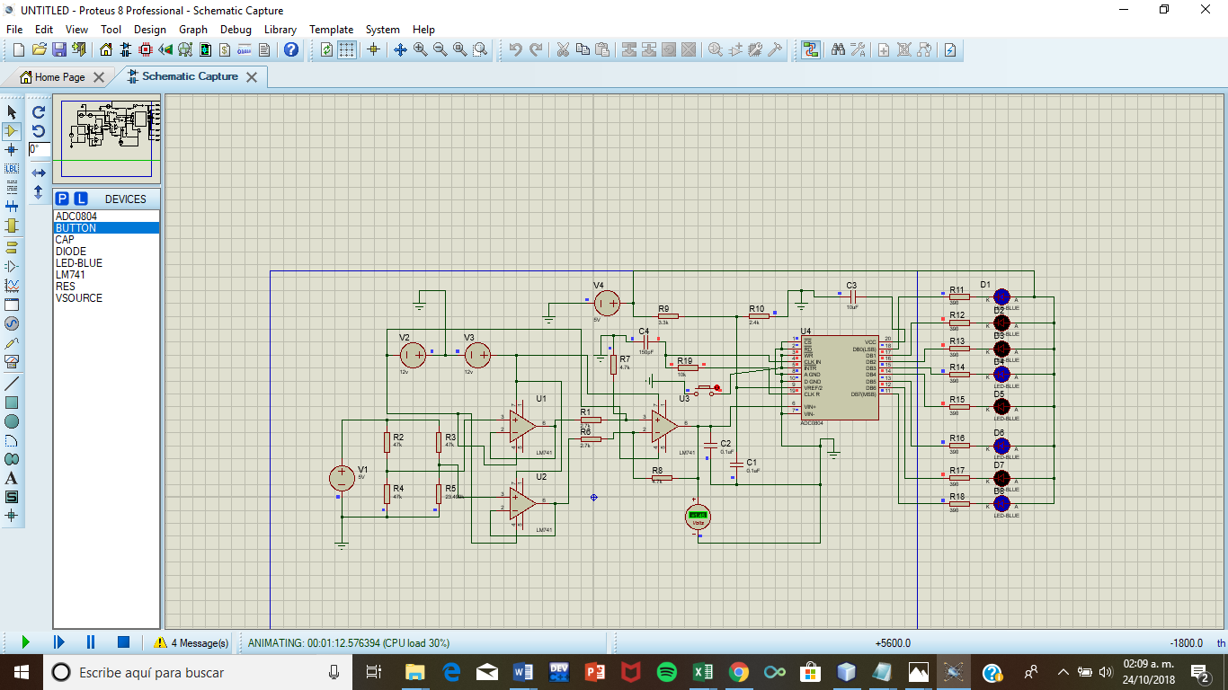

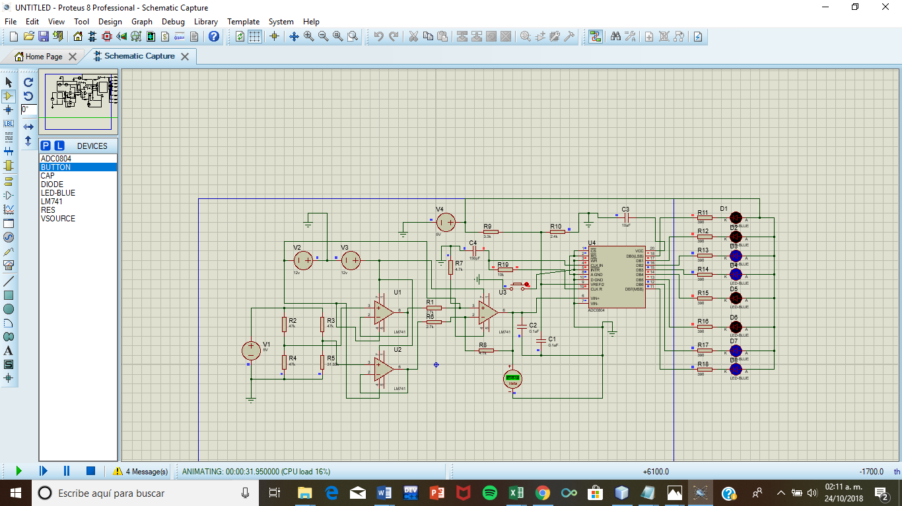

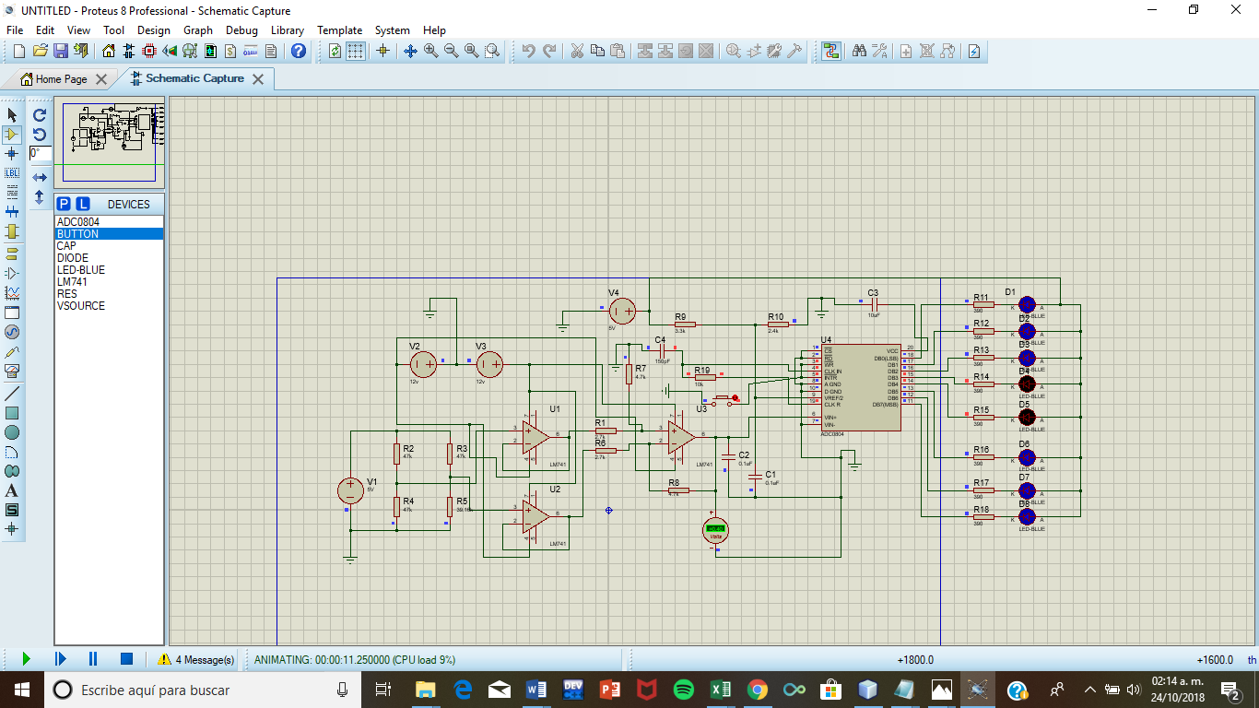

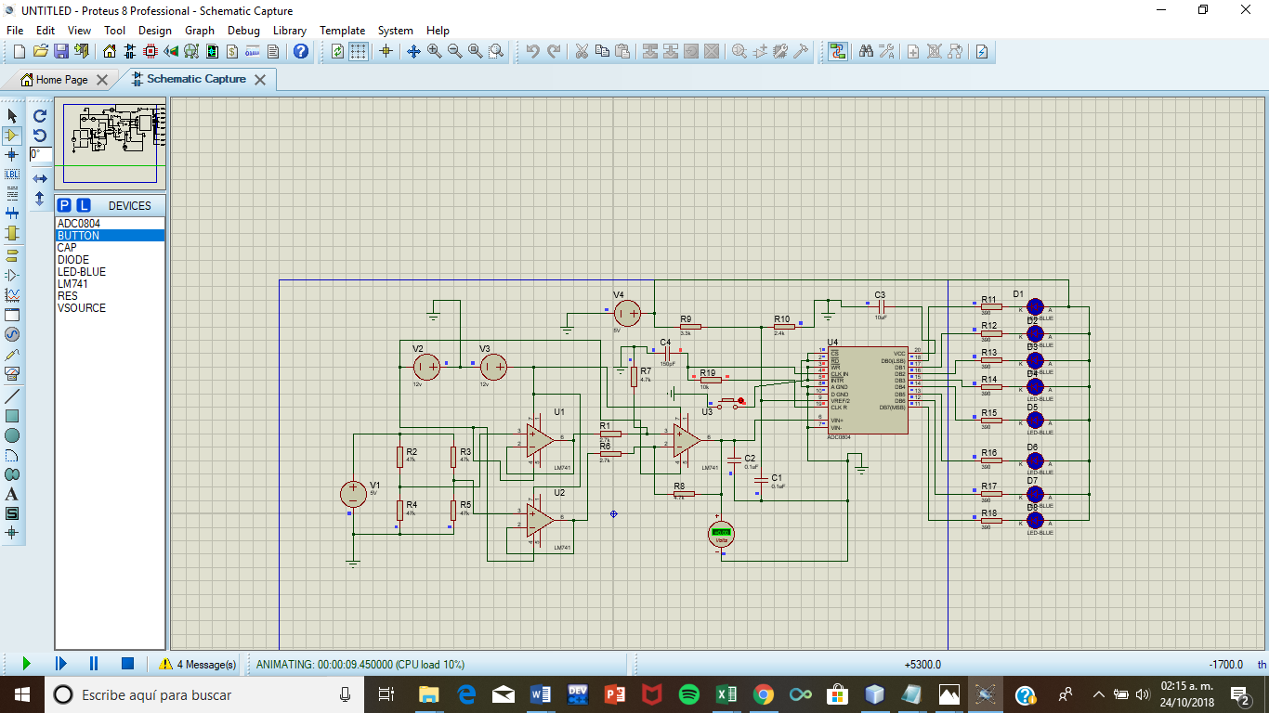

Values Simulated

|  |  |  |  |
| --- | --- | --- | --- |
| Centimetros | Vsal | Binary Combination | Decimal |
| 0 cm | 4.4v | 11111111 | 255 |
| 1 cm | 3.11v | 10110111 | 183 |
| 2 cm | 2.18v | 10000000 | 128 |
| 3 cm | 1.45v | 01010110 | 86 |
| 4 cm | 0.69v | 00110011 | 51 |
| 5 cm | 0.4v | 00011000 | 24 |
| 6 cm | 0v | 00000000 | 0 |

# **V. Conclusions**

The sensors based on the variation of the electrical resistance of a device are probably the most abundant. This is because there are many physical magnitudes that affect the value of the electrical resistance of a material. Consequently, they offer a valid solution for measurement problems.

In this practice we saw the use of the potentiometer as a resistive sensor, the variations of the voltage 2 as a function of the potentiometer were measured, as well as the difference between voltage 1 and voltage 2 and it was compared with the output voltage

With the help of the sliding resistor we observe that it gives us a value in the multimeter and this value changes as we change the value of the resistance and we can use it as a motion sensor.

# **VI Bibliographic references**

<https://ceictecunac.files.wordpress.com/2012/01/sensores-resistivos-parte-1.pdf>

<https://www.jmi.com.mx/transductores-de-temperatura>