

INSTITUTO POLITÉCNICO
NACIONAL
ESCUELA SUPERIOR DE CÓMPUTO

INSTRUMENTATION

PRACTICE 7:
Analog-Digital Converter (ADC)

GROUP:
3CV2

TEACHER:
ISMAEL CERVANTES DE ANDA

STUDENTS:
Adán Cardenas, Andrea Abigail
Bravo Torres, Alejandro
Romero Ortega, Christian

10/14/2019

Practice Objective:
The student will learn to use the digital analog-converter (DAC), as well as connect the different components that accompany it. Thus, you can find the binary value that corresponds to the analog variable under measurement.

Practice Introduction:

Practice Development:

1. Basic Circuit with ADC
Build The circuit of the Fig.1, +V = 5 V_{DC}
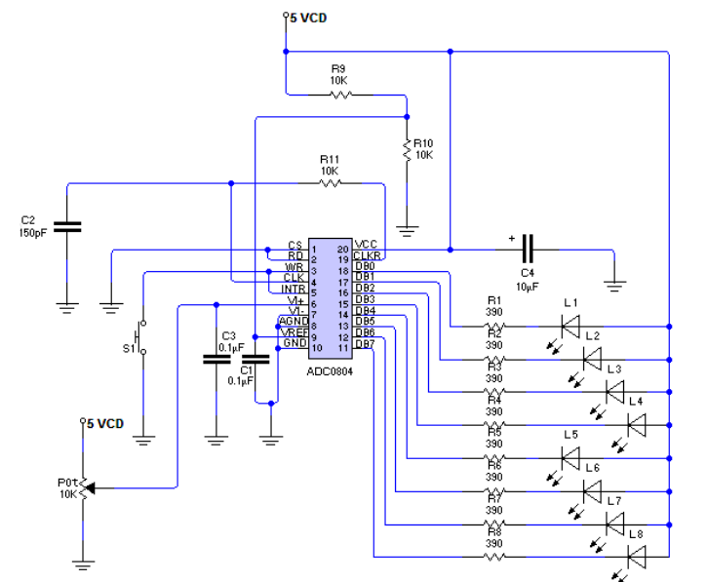
Figure 1: Basic Connection circuit with the DAC0804
The Circuit begins to operate in the cradle is energized. Switch S₁ works as a reset type, in case it does not operate immediately.
By varying the knob of the potentiometer, change in the binary combination of the LEDs is displayed.
By varying the voltage delivered by the potentiometer, we obtain ADC values and the notes in the following Table. It should be noted that the ADC's greeting is the binary complement to one of the real binary combination. To the measurement, take basic voltage to the first column in table.

V_{resolution} = 19.6078 mV
Analog Voltage Measured V_{A} [V] | Binary Combination |  |  |  |  |  |  |  | Analog Voltage Calculated V_{A} [V]
Analog Voltage Measured V_{A} [V] | B₇ | B₆ | B₅ | B₄ | B₃ | B₂ | B₁ | B₀ | Analog Voltage Calculated V_{A} [V]
0.0 | 1 | 1 | 1 | 1 | 1 | 1 | 1 | 1 | 0.00000
0.5 | 1 | 0 | 1 | 1 | 1 | 1 | 0 | 1 | 0.50980
1.0 | 1 | 0 | 0 | 1 | 0 | 1 | 0 | 0 | 1.01961
1.5 | 0 | 1 | 0 | 1 | 1 | 1 | 1 | 1 | 1.52941
2.0 | 0 | 1 | 0 | 0 | 0 | 1 | 0 | 0 | 2.05882
2.5 | 0 | 0 | 0 | 1 | 1 | 0 | 0 | 1 | 2.56862
3.0 | 0 | 0 | 0 | 0 | 0 | 1 | 0 | 0 | 3.05882
3.5 | 0 | 0 | 0 | 0 | 0 | 0 | 0 | 0 | 3.56862
4.0 | 0 | 0 | 0 | 0 | 0 | 0 | 0 | 0 | 4.03921
4.5 | 0 | 0 | 0 | 0 | 0 | 0 | 0 | 0 | 4.56862
5.0 | 0 | 0 | 0 | 0 | 0 | 0 | 0 | 0 | 4.99999

2. ADC connection with a signal conditioning circuit.
Disconnect the potentiometer found in the diagram in figure 1. Next, assemble the circuit illustrated in the image in the diagram in figure 2, and connect the output terminal of the conditioning circuit to terminal 6 of the ADC.
You have to calculate the values of R and R_{f} so that the conditioning circuit has a voltage range that is between the value of 0 V and 5 V. Consider for this calculation the total range between which the temperature sensor works. Write down the value of the gain calculated in the space found in table 2. Once you have everything ready proceed to fill in the other spaces in table 2.
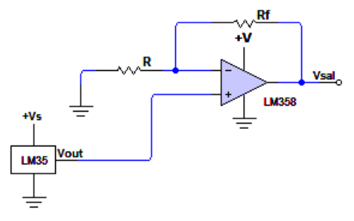

Figure 2: Signal Conditioning Circuit

Digitized values of the conditioning circuit:

3. Modification of the ADC reference voltage.
Resistors R₉ and R₁₀ of the diagram shown in Figure 1, constitute a voltage divider, by which the value of the reference voltage is set in the ADC. Then you have to modify (calculate) the value of these resistors, so that the operating range voltage (the reference voltage in turn sets the operating range), is between 0 V and 3 V.
Reconnect the circuit in Figure 2, to that of the ADC, but considering that the operating range is now 0 V to 3 V, so you have to recalculate the value of resistors R and Rf. Finally, fill in the spaces requested in table 3.

Table 3
Questionnaire
- What does the LSB and MSB represent?
LSB: Least Significant Bit. MSB: Most Significant Bit. Refers to the extreme right and extreme left bit, respectively, in a number written in the positional binary system.

- What are the most suitable circuits to place the reference voltage in the ADC?
Works with 2.5V (LM336) voltage reference

- Name 5 different types of analog to digital conversion techniques.
Ladder ramp: It is based on the comparison of the analog input signal with a precisely defined ramp signal.
By successive approximations: It is a more effective conversion technique than the previous one. It is widely used due to its combination of high resolution and speed. The scheme is practically the same, they differ in that the counter within the register is not a sequential one-by-one counter, but a programmable counter that increases or decreases according to the influence of the heaviest bit
Parallel (Flash): The converters of flash type or direct conversion, start from a radically opposite conception: speed is the basic objective of this architecture and the cost that must be paid for it is a very complex circuit although simple at the concept level. Two signals participate in the input stage, the analog signal itself to be converted and a reference signal. In the basic configuration, the analog signal is applied to the non-inverting gates of a certain number of operational amplifiers that, used as comparators, are arranged in parallel, at the input of a decoder. The reference voltage is applied to the inverting input of each comparator, which in turn attacks a resistance network of identical value and arranged in series. The result is the voltage difference between two successive comparators is 1 LSB.
Double Ramp: The ramp-type ones have precision as a strong point, and at the same time, they can only be applied to signals whose level oscillates very slowly (a typical sample rate is 10 samples per second). This device consists of an integrator based on an operational amplifier.
Voltage to frequency: In this type of converters, the continuous input voltage becomes a set of pulses whose frequency is proportional to the magnitude of the supply voltage. The pulses are counted by an electronic counter, during a specific time interval and the resulting count is displayed as a digital representation of the voltage.
Series Type: Among the new devices, there are those of serial conversion, which allows to deliver a digital sequence of 8 bit (or more) of output in serial form. The serial transmission uses a single path to transport bits of information, which makes it ideal for long distance communications, due to its low cost in cabling. This transmission is performed synchronously or asynchronously. Many of these devices are based on the method
of switched capacitor.

- What is the difference between the ADC0801 and the ADC0804?
A difference to the ADC0804, the ADC0801 contains Full-Scale Adj. The full-scale adjustment can be made by applying a differential input voltage that is 11/2 LSB less than the desired analog full-scale voltage range and then adjusting the magnitude of the VREF/2 input (pin 9 or the VCC supply if pin 9 is not used) for a digital output code that is just changing from 1111 1110 to 1111 1111.

References
https://core.ac.uk/download/pdf/47281302.pdf
http://www.ifent.org/Lecciones/digitales/secuenciales/ConvertA_D.htm
https://www.etsist.upm.es/estaticos/ingeniatic/index.php/tecnologias/item/425-conversor-anal%C3%B3gico-digital.html
https://es.wikipedia.org/wiki/Conversor_de_se%C3%B1al_anal%C3%B3gica_a_digital#Tipos_de_conversores_usuales
https://en.wikipedia.org/wiki/Analog-to-digital_converter
https://www.electronicoscaldas.com/datasheet/ADC0801-ADC0802-ADC0803-ADC0804-ADC0805_TI.pdf
http://www.ti.com/lit/ds/symlink/adc0804-n.pdf

