[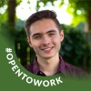](https://www.linkedin.com/in/ethan-callanan?miniProfileUrn=urn%3Ali%3Afs_miniProfile%3AACoAADDX9f8BnAQIxXJASwXsIcIisK1dsOY_LlQ" \t "_self)

[Status is reachable](https://www.linkedin.com/in/ethan-callanan?miniProfileUrn=urn%3Ali%3Afs_miniProfile%3AACoAADDX9f8BnAQIxXJASwXsIcIisK1dsOY_LlQ" \t "_self)

[Ethan Callanan• 1stDirector of Design at QMIND | Computer Science, AI at Queen's University2mo • 2 months ago](https://www.linkedin.com/in/ethan-callanan?miniProfileUrn=urn%3Ali%3Afs_miniProfile%3AACoAADDX9f8BnAQIxXJASwXsIcIisK1dsOY_LlQ" \t "_self)

3 days left, get signed up!

[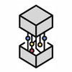](https://www.linkedin.com/company/qumind/?miniCompanyUrn=urn%3Ali%3Afs_miniCompany%3A18448654" \t "_self)

[QMIND912 followers2mo • 2 months ago](https://www.linkedin.com/company/qumind/?miniCompanyUrn=urn%3Ali%3Afs_miniCompany%3A18448654" \t "_self)

[Hurry! Only 3 more days to sign-up for the Ascend Event—happening this Saturday, November 27th. 😎](https://www.linkedin.com/feed/update/urn:li:activity:6869042145811152896/)[#machinelearning](https://www.linkedin.com/feed/hashtag/?keywords=machinelearning&highlightedUpdateUrns=urn%3Ali%3Aactivity%3A6869042996680237056) [#ai](https://www.linkedin.com/feed/hashtag/?keywords=ai&highlightedUpdateUrns=urn%3Ali%3Aactivity%3A6869042996680237056) [#artificialintelligence](https://www.linkedin.com/feed/hashtag/?keywords=artificialintelligence&highlightedUpdateUrns=urn%3Ali%3Aactivity%3A6869042996680237056) [#technology](https://www.linkedin.com/feed/hashtag/?keywords=technology&highlightedUpdateUrns=urn%3Ali%3Aactivity%3A6869042996680237056) [#queensuniversity](https://www.linkedin.com/feed/hashtag/?keywords=queensuniversity&highlightedUpdateUrns=urn%3Ali%3Aactivity%3A6869042996680237056) [#event](https://www.linkedin.com/feed/hashtag/?keywords=event&highlightedUpdateUrns=urn%3Ali%3Aactivity%3A6869042996680237056)

…see more

Your document has finished loading

* 4Max Bennett and 3 others

Like

Comment

Share

Send

Be the first to comment on this

**Feed post**

[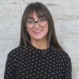](https://www.linkedin.com/in/aine-nuraizza-nuruddin?miniProfileUrn=urn%3Ali%3Afs_miniProfile%3AACoAACliaeEBx9dpZJ9GVgcOUp6RgPSkcSHFzJc" \t "_self)

[Status is reachable](https://www.linkedin.com/in/aine-nuraizza-nuruddin?miniProfileUrn=urn%3Ali%3Afs_miniProfile%3AACoAACliaeEBx9dpZJ9GVgcOUp6RgPSkcSHFzJc" \t "_self)

[Aine NurAizza Nuruddin• 1stProtection, Control & Metering Engineering Intern at Hydro One | 3rd year Electrical Engineering, Certificate of Business at Queen'sU | CIGRE Canada NGN Exec Member | OSPE Student Member4mo • 4 months ago](https://www.linkedin.com/in/aine-nuraizza-nuruddin?miniProfileUrn=urn%3Ali%3Afs_miniProfile%3AACoAACliaeEBx9dpZJ9GVgcOUp6RgPSkcSHFzJc" \t "_self)

Thrilled to announce that I will be a part of [QMIND](https://www.linkedin.com/company/qumind/) this year!! Being a member of Canada’s largest undergraduate AI and machine learning hub is itself an honour. I got selected to work with a client-facing consulting team called [The Fertility Partners](https://www.linkedin.com/company/the-fertility-partners/).  
  
I look forward to meeting my team members and diving deeper into the project this month!  
  
Meanwhile, I had a great time this past weekend attending Camp QMIND - a two-day onboarding event for design team members. I learned a lot and got inspired by speakers and fellow colleagues. The workshops were an excellent platform for beginners to understand the basics of computer-based models, working with datasets and ML algorithms.  
  
Big shoutout to [Max Bennett](https://www.linkedin.com/in/ACoAACkTLKEBI5o5f9sBs3r-_poefQZ6HubDgQU), [Sydney Corbett](https://www.linkedin.com/in/ACoAACy-Zd8BM-AGci11fT1tPwbTwMF-AY3boMk) and the team for organizing this event! It really tuned me into the mindset of changing the world through AI!!  
  
[#AI](https://www.linkedin.com/feed/hashtag/?keywords=ai&highlightedUpdateUrns=urn%3Ali%3Aactivity%3A6851720162249375744) [#dataengineering](https://www.linkedin.com/feed/hashtag/?keywords=dataengineering&highlightedUpdateUrns=urn%3Ali%3Aactivity%3A6851720162249375744) [#healthcare](https://www.linkedin.com/feed/hashtag/?keywords=healthcare&highlightedUpdateUrns=urn%3Ali%3Aactivity%3A6851720162249375744)

…see more

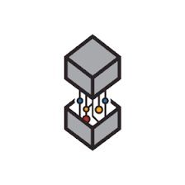

Activate to view larger image

* 58
* 6 comments

Like

Comment

Share

Send



Top of Form

Open Emoji Keyboard

Bottom of Form

Current selected sort order is Most relevantMost relevant

[[](https://www.linkedin.com/in/tetris/amanvirani/)](https://www.linkedin.com/in/tetris/amanvirani/" \t "_self)

**[Aman Virani(He/Him) 2nd degree connection2ndData Scientist at General Motors | Honours Co-op BiotechBus Economics Minor | Ex-Operations @ Nissan | Ex-Coordinator @ JANA](https://www.linkedin.com/in/tetris/amanvirani/" \t "_self)**

3mo(edited)

Congratulations Aine!!  
This is a great achievement!!

Like

1

Reply1 Reply1 Comment on Aman Virani’s comment

[[](https://www.linkedin.com/in/tetris/aine-nuraizza-nuruddin/)](https://www.linkedin.com/in/tetris/aine-nuraizza-nuruddin/" \t "_self)

[Status is reachable](https://www.linkedin.com/in/tetris/aine-nuraizza-nuruddin/" \t "_self)

**[Aine NurAizza NuruddinAuthorProtection, Control & Metering Engineering Intern at Hydro One | 3rd year Electrical Engineering, Certificate of Business at Queen'sU | CIGRE Canada NGN Exec Member | OSPE Student Member](https://www.linkedin.com/in/tetris/aine-nuraizza-nuruddin/" \t "_self)**

3mo

Thank you Aman, I am excited for this new project!

Like

Reply

Load more comments

**Feed post**

[](https://www.linkedin.com/in/wendy-w-976203118?miniProfileUrn=urn%3Ali%3Afs_miniProfile%3AACoAAB038aoB2-yLIglG4DpptABjzYRMoMelRDs" \t "_self)

[Wendy Wu(She/Her) • 1stUndergraduate Honours Thesis Student | Biomathematics at Queen's University | Incoming Research Assistant @ SickKids Hospital3mo • 3 months ago](https://www.linkedin.com/in/wendy-w-976203118?miniProfileUrn=urn%3Ali%3Afs_miniProfile%3AACoAAB038aoB2-yLIglG4DpptABjzYRMoMelRDs" \t "_self)

QMIND is hosting an Isaac Data Science Case Competition! If you want a chance to win $500 register today!!!

](https://www.linkedin.com/events/issaccasecompetition6855605321054982144/)](https://www.linkedin.com/events/issaccasecompetition6855605321054982144/)

[Sun, Oct 24, 2021, 2:30 PM - 4:30 PM EDT](https://www.linkedin.com/events/issaccasecompetition6855605321054982144/)

**[Isaac Data Science Case Competition](https://www.linkedin.com/events/issaccasecompetition6855605321054982144/)**

[Event by QMIND](https://www.linkedin.com/events/issaccasecompetition6855605321054982144/)

[Online](https://www.linkedin.com/events/issaccasecompetition6855605321054982144/)

[[](https://www.linkedin.com/events/issaccasecompetition6855605321054982144/)](https://www.linkedin.com/events/issaccasecompetition6855605321054982144/)

[[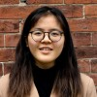](https://www.linkedin.com/events/issaccasecompetition6855605321054982144/)](https://www.linkedin.com/events/issaccasecompetition6855605321054982144/)

[Ethan Callanan, Mimi Nguyen and 25 other attendees](https://www.linkedin.com/events/issaccasecompetition6855605321054982144/)

[**View event**](https://www.linkedin.com/events/issaccasecompetition6855605321054982144/)

* 9

Like

Comment

Share

Send

Be the first to comment on this

**Feed post**

[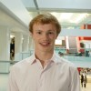](https://www.linkedin.com/in/matt-queens?miniProfileUrn=urn%3Ali%3Afs_miniProfile%3AACoAACmK3tgBITgDMyZkmbl0LUv0QtYQsm5ppB4" \t "_self)

[Matt Wright(He/Him) • 1stDirector of Disruptive Technology at QMIND | Qiskit Advocate | Teaching Assistant4mo • 4 months ago](https://www.linkedin.com/in/matt-queens?miniProfileUrn=urn%3Ali%3Afs_miniProfile%3AACoAACmK3tgBITgDMyZkmbl0LUv0QtYQsm5ppB4" \t "_self)

Checkout this event to learn more about QMIND's new Quantum Computing and Blockchain stream and find out how you can be a part of it!

](https://www.linkedin.com/events/qmindevents-welcome6841485889156317184/)](https://www.linkedin.com/events/qmindevents-welcome6841485889156317184/)

[Mon, Sep 13, 2021, 6:30 PM - 7:30 PM EDT](https://www.linkedin.com/events/qmindevents-welcome6841485889156317184/)

**[QMIND Events: Welcome!](https://www.linkedin.com/events/qmindevents-welcome6841485889156317184/)**

[Event by QMIND](https://www.linkedin.com/events/qmindevents-welcome6841485889156317184/)

[Online](https://www.linkedin.com/events/qmindevents-welcome6841485889156317184/)

[[](https://www.linkedin.com/events/qmindevents-welcome6841485889156317184/)](https://www.linkedin.com/events/qmindevents-welcome6841485889156317184/)

[[](https://www.linkedin.com/events/qmindevents-welcome6841485889156317184/)](https://www.linkedin.com/events/qmindevents-welcome6841485889156317184/)

[Ethan Callanan, Matt Wright and 113 other attendees](https://www.linkedin.com/events/qmindevents-welcome6841485889156317184/)

[**View event**](https://www.linkedin.com/events/qmindevents-welcome6841485889156317184/)

* 14

Like

Comment

Share

Send

Be the first to comment on this

**Feed post**

[](https://www.linkedin.com/in/wendy-w-976203118?miniProfileUrn=urn%3Ali%3Afs_miniProfile%3AACoAAB038aoB2-yLIglG4DpptABjzYRMoMelRDs" \t "_self)

[Wendy Wu(She/Her) • 1stUndergraduate Honours Thesis Student | Biomathematics at Queen's University | Incoming Research Assistant @ SickKids Hospital10mo • Edited • 10 months ago](https://www.linkedin.com/in/wendy-w-976203118?miniProfileUrn=urn%3Ali%3Afs_miniProfile%3AACoAAB038aoB2-yLIglG4DpptABjzYRMoMelRDs" \t "_self)

This year, I was fortunate enough to work as the Marketing-Events Coordinator at [QMIND](https://www.linkedin.com/company/qumind/), a 200+ person club at Queen's. It was definitely a challenging transition as I often experienced spiking levels of anxiety and worry as someone who doesn't fit the "typical" criteria in tech.  
  
I decided to switch career paths at the end of my second year to a more data and analytical stream and thought QMIND would align beautifully with my goals.  
  
Despite the circumstances and switch to online platforms, QMIND has been able to host 20 events this year that drew crowds from many different faculties at Queen's and beyond. I've had the pleasure of working with various portfolios and helping each and every one of them to achieve their visions.  
  
None of this could have been possible without the leadership from our managing directors [Eunice Choi (she/her)](https://www.linkedin.com/in/ACoAACFLa-sB5vbvJTqf-TaNzk45zPFDnbLGNh8), [Fakid Hossain](https://www.linkedin.com/in/ACoAACEduwsBRYtLaXzSTjUfk94nK-ANIKn9lcE) and [Colin Cumming](https://www.linkedin.com/in/ACoAACo6PFkBiFDaqecNVLON4BESFHps6YPDdUc). I want to give a big shoutout to [Griffin Clark](https://www.linkedin.com/in/ACoAACNQxuIBcOAsLIyHsoC4ZsBvn3311eu7dYA) [Jake Rakusin](https://www.linkedin.com/in/ACoAACPqymsBfuMLDtb_QUmSoXwEVe0l59qBAPA) [Natalie Nova](https://www.linkedin.com/in/ACoAACHGcTsBD8sWz1L_cqB2Hhd_b0I9hg48reM) [Christophe Gauthier](https://www.linkedin.com/in/ACoAACasVbQBK0i-qRb-a8pGPVYpGsqywImSWb8). It's been amazing to work will all of you and seeing your passions translate into the initiatives you all brought to life this year. Lastly, I want to thank [Kelsey Horn](https://www.linkedin.com/in/ACoAACTH3YIBBuaL1blACOiGxNhN_fceDXlPYeY) [Frannie S.](https://www.linkedin.com/in/ACoAAB2ofOwBlp-uTzvV-DtQi6aHkW7I6SdmaaM) for all of the marketing material you've both helped to put out. Without it, none of our events would have been the successes they were.

…see more

* 32
* 3 comments

Like

Comment

Share

Send



Top of Form

Open Emoji Keyboard

Bottom of Form

Current selected sort order is Most relevantMost relevant

[[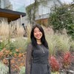](https://www.linkedin.com/in/tetris/eunice-js-choi/)](https://www.linkedin.com/in/tetris/eunice-js-choi/" \t "_self)

**[Eunice Choi(She/Her) 1st degree connection1stIncoming APM @ Clearco🚀 Prev: @Microsoft @BMO](https://www.linkedin.com/in/tetris/eunice-js-choi/" \t "_self)**

9mo

im so happy we got to work together 🥺🥰 thanks for killing it at marketing this year for us! 😎

Like

1

Reply

Load more comments

**Feed post**

[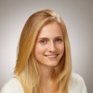](https://www.linkedin.com/in/sydneycorbett?miniProfileUrn=urn%3Ali%3Afs_miniProfile%3AACoAACy-Zd8BM-AGci11fT1tPwbTwMF-AY3boMk" \t "_self)

[Sydney Corbett• 1stManaging Director of Design at QMIND4mo • 4 months ago](https://www.linkedin.com/in/sydneycorbett?miniProfileUrn=urn%3Ali%3Afs_miniProfile%3AACoAACy-Zd8BM-AGci11fT1tPwbTwMF-AY3boMk" \t "_self)

If you are a student at Queen's and are interested in AI and other cutting edge technologies, come out to the QMIND Welcome Event!  
  
QMIND is Canada's largest undergraduate machine learning organization, offering opportunities to develop ML-powered solutions to real-world problems, explore disruptive technologies, work with clients, and expand your knowledge of the fascinating field of AI. We have technical and non-technical roles within the organization, so come out and see what QMIND has to offer for you!  
  
[#machinelearning](https://www.linkedin.com/feed/hashtag/?keywords=machinelearning&highlightedUpdateUrns=urn%3Ali%3Aactivity%3A6845530082056962048) [#ai](https://www.linkedin.com/feed/hashtag/?keywords=ai&highlightedUpdateUrns=urn%3Ali%3Aactivity%3A6845530082056962048) [#artificialintelligence](https://www.linkedin.com/feed/hashtag/?keywords=artificialintelligence&highlightedUpdateUrns=urn%3Ali%3Aactivity%3A6845530082056962048) [#ml](https://www.linkedin.com/feed/hashtag/?keywords=ml&highlightedUpdateUrns=urn%3Ali%3Aactivity%3A6845530082056962048) [#deeplearning](https://www.linkedin.com/feed/hashtag/?keywords=deeplearning&highlightedUpdateUrns=urn%3Ali%3Aactivity%3A6845530082056962048) [#datascience](https://www.linkedin.com/feed/hashtag/?keywords=datascience&highlightedUpdateUrns=urn%3Ali%3Aactivity%3A6845530082056962048) [#innovation](https://www.linkedin.com/feed/hashtag/?keywords=innovation&highlightedUpdateUrns=urn%3Ali%3Aactivity%3A6845530082056962048)

…see more

[](https://www.linkedin.com/company/qumind/?miniCompanyUrn=urn%3Ali%3Afs_miniCompany%3A18448654" \t "_self)

[QMIND912 followers4mo • 4 months ago](https://www.linkedin.com/company/qumind/?miniCompanyUrn=urn%3Ali%3Afs_miniCompany%3A18448654" \t "_self)

[Applications are now open! 🎉  
  
We’ve created the perfect opportunity for students and young leaders to discover the world of machine learning while developing unique solutions to real-world problems.  
  
Don't miss out, visit our website to apply now:](https://www.linkedin.com/feed/update/urn:li:activity:6843541609162907649/)<https://qmind.ca/join-us>  
  
[#machinelearning](https://www.linkedin.com/feed/hashtag/?keywords=machinelearning&highlightedUpdateUrns=urn%3Ali%3Aactivity%3A6845530082056962048) [#ai](https://www.linkedin.com/feed/hashtag/?keywords=ai&highlightedUpdateUrns=urn%3Ali%3Aactivity%3A6845530082056962048) [#opportunity](https://www.linkedin.com/feed/hashtag/?keywords=opportunity&highlightedUpdateUrns=urn%3Ali%3Aactivity%3A6845530082056962048) [#innovation](https://www.linkedin.com/feed/hashtag/?keywords=innovation&highlightedUpdateUrns=urn%3Ali%3Aactivity%3A6845530082056962048) [#leaders](https://www.linkedin.com/feed/hashtag/?keywords=leaders&highlightedUpdateUrns=urn%3Ali%3Aactivity%3A6845530082056962048)

…see more

](https://www.linkedin.com/events/fallhiring20216843541012720308224/)](https://www.linkedin.com/events/fallhiring20216843541012720308224/)

[Tue, Sep 14, 2021, 10:00 AM - Mon, Sep 20, 2021, 11:59 PM EDT](https://www.linkedin.com/events/fallhiring20216843541012720308224/)

**[Fall Hiring 2021](https://www.linkedin.com/events/fallhiring20216843541012720308224/)**

[Event by QMIND](https://www.linkedin.com/events/fallhiring20216843541012720308224/)

[Online](https://www.linkedin.com/events/fallhiring20216843541012720308224/)

[[](https://www.linkedin.com/events/fallhiring20216843541012720308224/)](https://www.linkedin.com/events/fallhiring20216843541012720308224/)

[[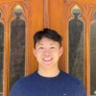](https://www.linkedin.com/events/fallhiring20216843541012720308224/)](https://www.linkedin.com/events/fallhiring20216843541012720308224/)

[Matt Wright, David Huang and 8 other connections attending](https://www.linkedin.com/events/fallhiring20216843541012720308224/)

[**View event**](https://www.linkedin.com/events/fallhiring20216843541012720308224/)

* 3

Like

Comment

Share

Send

Be the first to comment on this

**Feed post**

[](https://www.linkedin.com/in/eunice-js-choi?miniProfileUrn=urn%3Ali%3Afs_miniProfile%3AACoAACFLa-sB5vbvJTqf-TaNzk45zPFDnbLGNh8" \t "_self)

[Eunice Choi(She/Her) • 1stIncoming APM @ Clearco🚀 Prev: @Microsoft @BMO10mo • 10 months ago](https://www.linkedin.com/in/eunice-js-choi?miniProfileUrn=urn%3Ali%3Afs_miniProfile%3AACoAACFLa-sB5vbvJTqf-TaNzk45zPFDnbLGNh8" \t "_self)

Good morning everyone! Today is the day! [QMIND](https://www.linkedin.com/company/qumind/)'s Women in AI Entrepreneurship Panel is happening at 5:30 PM EST on Zoom 🚀  
  
Make sure to register using this link: <https://lnkd.in/e28t6rX>

…see more

[](https://www.linkedin.com/company/qumind/?miniCompanyUrn=urn%3Ali%3Afs_miniCompany%3A18448654" \t "_self)

[QMIND912 followers11mo • 11 months ago](https://www.linkedin.com/company/qumind/?miniCompanyUrn=urn%3Ali%3Afs_miniCompany%3A18448654" \t "_self)

[QMIND is thrilled to introduce our panelists for our upcoming Women in AI Entrepreneurship Panel!  
  
Join us tomorrow, Thursday, March 25 at 5:30 PM EST to hear from our panelists where we'll explore both the highlights and the struggles of what it's like to be building in a ground-breaking field like AI, and how personal identity from many different backgrounds plays into that. This is a can't miss event!  
  
REGISTER HERE:](https://www.linkedin.com/feed/update/urn:li:activity:6780480829660422144/)<https://lnkd.in/e28t6rX> to secure your spot today!

…see more

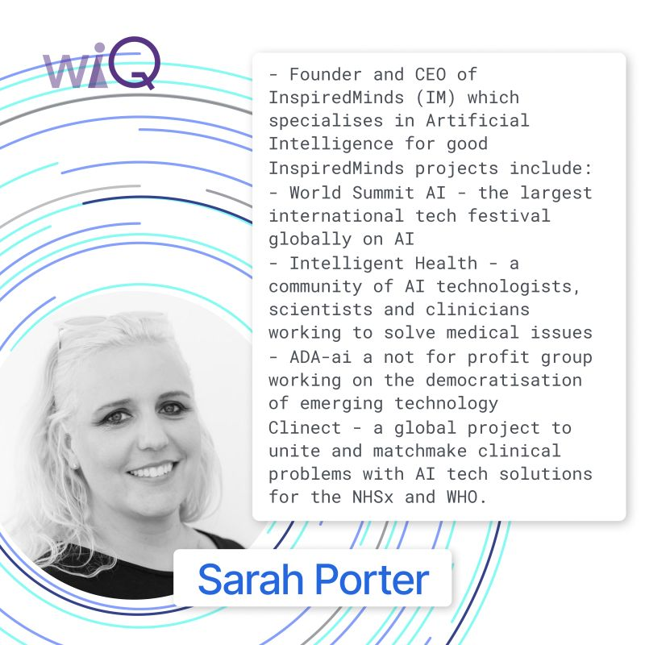

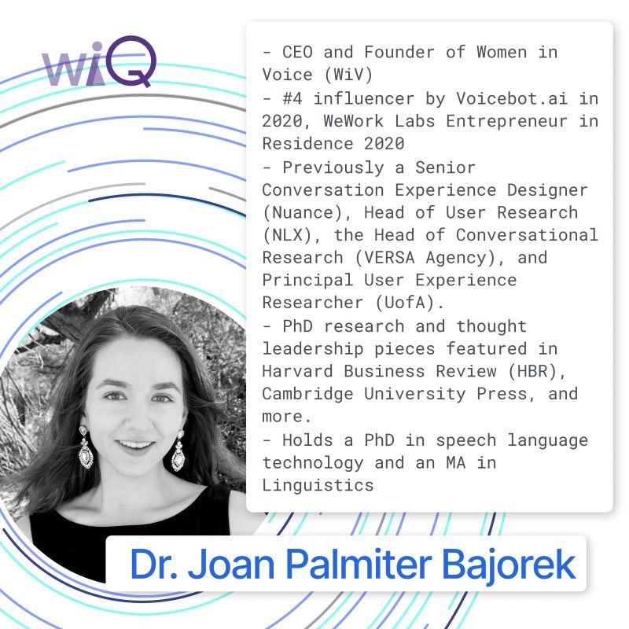

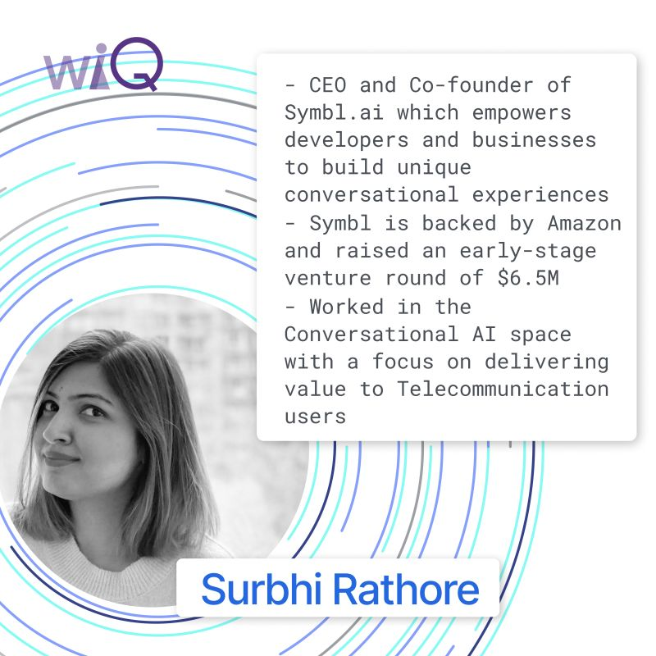

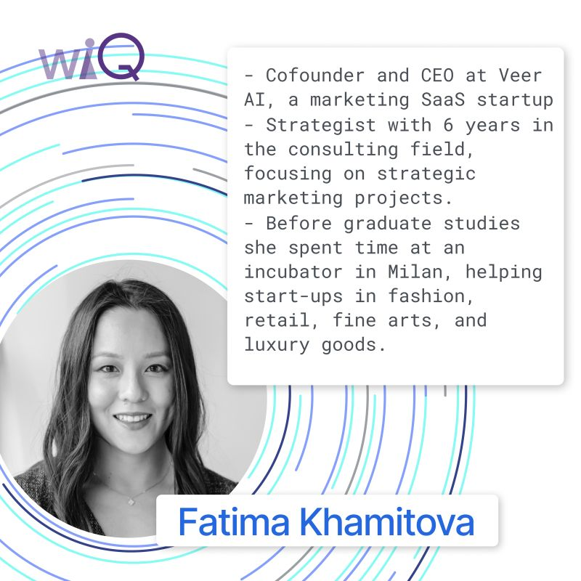

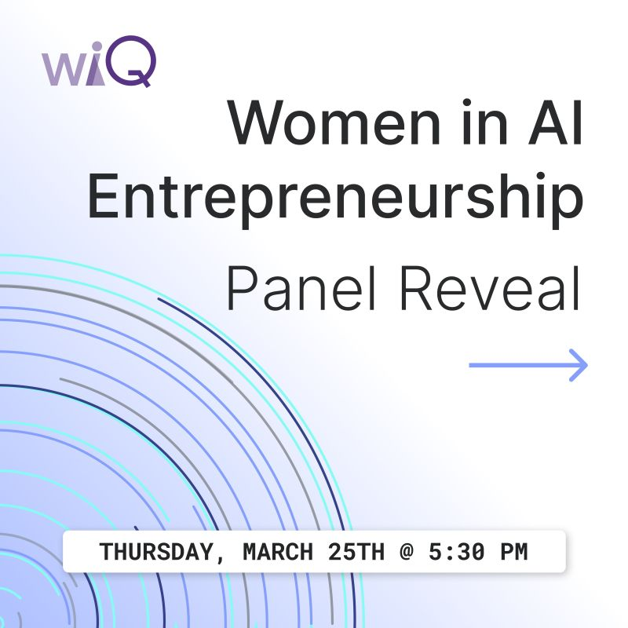

Activate to view larger image

* 1

Like

Comment

Share

Send

Be the first to comment on this

**Feed post**

[](https://www.linkedin.com/in/ethan-callanan?miniProfileUrn=urn%3Ali%3Afs_miniProfile%3AACoAADDX9f8BnAQIxXJASwXsIcIisK1dsOY_LlQ" \t "_self)

[Status is reachable](https://www.linkedin.com/in/ethan-callanan?miniProfileUrn=urn%3Ali%3Afs_miniProfile%3AACoAADDX9f8BnAQIxXJASwXsIcIisK1dsOY_LlQ" \t "_self)

[Ethan Callanan• 1stDirector of Design at QMIND | Computer Science, AI at Queen's University2mo • 2 months ago](https://www.linkedin.com/in/ethan-callanan?miniProfileUrn=urn%3Ali%3Afs_miniProfile%3AACoAADDX9f8BnAQIxXJASwXsIcIisK1dsOY_LlQ" \t "_self)

Now this is an event you DON'T want to miss!  
  
All three of QMIND's pillars (professional development, educate, and design) have come together to create this event. Featuring workshops, panels, and networking sessions in collaboration with our industry partners across North America. This is an invaluable opportunity for students looking to work or explore data science and artificial intelligence in the real world.  
  
See you there!

…see more

](https://www.linkedin.com/events/ascend6867250108766019584/)](https://www.linkedin.com/events/ascend6867250108766019584/)

[Sat, Nov 27, 2021, 11:00 AM - 4:15 PM EST](https://www.linkedin.com/events/ascend6867250108766019584/)

**[Ascend](https://www.linkedin.com/events/ascend6867250108766019584/)**

[Event by QMIND](https://www.linkedin.com/events/ascend6867250108766019584/)

[Online](https://www.linkedin.com/events/ascend6867250108766019584/)

[[](https://www.linkedin.com/events/ascend6867250108766019584/)](https://www.linkedin.com/events/ascend6867250108766019584/)

[[](https://www.linkedin.com/events/ascend6867250108766019584/)](https://www.linkedin.com/events/ascend6867250108766019584/)

[Ethan Callanan, Matt Wright and 35 other attendees](https://www.linkedin.com/events/ascend6867250108766019584/)

[**View event**](https://www.linkedin.com/events/ascend6867250108766019584/)

* 8
* 1 comment

Like

Comment

Share

Send



Top of Form

Open Emoji Keyboard

Bottom of Form

Current selected sort order is Most relevantMost relevant

[[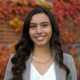](https://www.linkedin.com/in/tetris/samhollinrake/)](https://www.linkedin.com/in/tetris/samhollinrake/" \t "_self)

**[Sam Hollinrake(She/Her) 2nd degree connection2ndQueen's University Chancellor's Scholar | Queen's Commerce Law Association Co-Chair | Previously Business Analyst Intern at Arteria AI](https://www.linkedin.com/in/tetris/samhollinrake/" \t "_self)**

2mo

This looks so cool, Ethan!

Like

Reply

**Feed post**

[](https://www.linkedin.com/in/wendy-w-976203118?miniProfileUrn=urn%3Ali%3Afs_miniProfile%3AACoAAB038aoB2-yLIglG4DpptABjzYRMoMelRDs" \t "_self)

[Wendy Wu(She/Her) • 1stUndergraduate Honours Thesis Student | Biomathematics at Queen's University | Incoming Research Assistant @ SickKids Hospital10mo • 10 months ago](https://www.linkedin.com/in/wendy-w-976203118?miniProfileUrn=urn%3Ali%3Afs_miniProfile%3AACoAAB038aoB2-yLIglG4DpptABjzYRMoMelRDs" \t "_self)

[QMIND](https://www.linkedin.com/company/qumind/) has been such an integral part of my personal and professional development this past year. I couldn't be more thankful for the opportunities it gave me to collaborate and lead initiatives that help a wide range of undergraduate students.  
  
I'm genuinely so thankful for the skills I've fostered through my role as a Marketing-Events coordinator and using them to leverage my professional goals as an upcoming Data Analyst Research Assistant at Sick Kids Hospital.

…see more

[](https://www.linkedin.com/company/qumind/?miniCompanyUrn=urn%3Ali%3Afs_miniCompany%3A18448654" \t "_self)

[QMIND912 followers10mo • 10 months ago](https://www.linkedin.com/company/qumind/?miniCompanyUrn=urn%3Ali%3Afs_miniCompany%3A18448654" \t "_self)

[We are excited to reveal a selection of QMIND member placements for internships and full-time roles in 2021. QMIND works hard to provide our community with networking and interviewing resources in order to help them secure positions. We wish our members the best of luck with their new roles!](https://www.linkedin.com/feed/update/urn:li:activity:6788143858829074432/)

[…see more](https://www.linkedin.com/feed/update/urn:li:activity:6788143858829074432/)

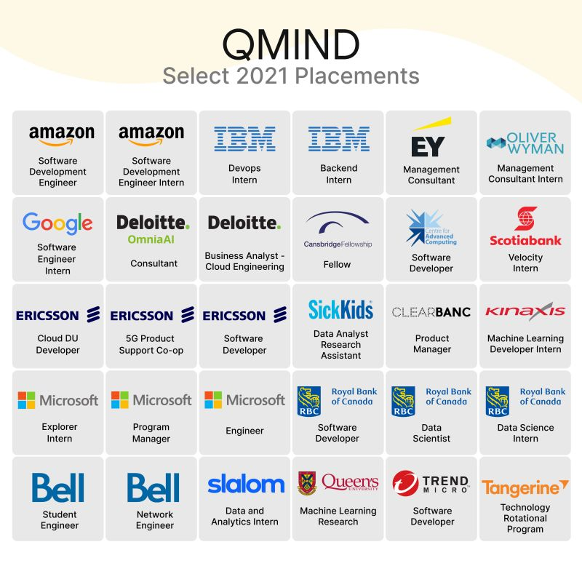

Activate to view larger image

* 5

Like

Comment

Share

Send

Be the first to comment on this

**Feed post**

[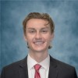](https://www.linkedin.com/in/donal-lynagh-6974431a6?miniProfileUrn=urn%3Ali%3Afs_miniProfile%3AACoAADAebBMB9SZ57eK1HcV90ZcF0xNGlk8aD9c" \t "_self)

[Status is reachable](https://www.linkedin.com/in/donal-lynagh-6974431a6?miniProfileUrn=urn%3Ali%3Afs_miniProfile%3AACoAADAebBMB9SZ57eK1HcV90ZcF0xNGlk8aD9c" \t "_self)

[Donal Lynagh(He/Him) • 1stBiomechanics | Entrepreneurship9mo • 9 months ago](https://www.linkedin.com/in/donal-lynagh-6974431a6?miniProfileUrn=urn%3Ali%3Afs_miniProfile%3AACoAADAebBMB9SZ57eK1HcV90ZcF0xNGlk8aD9c" \t "_self)

👋 Hello everyone!  
  
I’m absolutely THRILLED to share I’ll be part of the [QMIND](https://www.linkedin.com/company/qumind/) team as Director of Marketing! 🚀  
  
If you’re a Queen’s student and you have an interest in web/graphic design, brand strategy, social-media marketing, event marketing... act now! Take advantage of this incredible opportunity and apply to be a part of the [QMIND](https://www.linkedin.com/company/qumind/) marketing team!  
  
If marketing isn’t your cup of tea—be sure to check out the application package to see all the exciting ways you can get involved next year! 🤓  
  
[#webdesign](https://www.linkedin.com/feed/hashtag/?keywords=webdesign&highlightedUpdateUrns=urn%3Ali%3Aactivity%3A6793262443121537024) [#brandingdesign](https://www.linkedin.com/feed/hashtag/?keywords=brandingdesign&highlightedUpdateUrns=urn%3Ali%3Aactivity%3A6793262443121537024) [#uxdesign](https://www.linkedin.com/feed/hashtag/?keywords=uxdesign&highlightedUpdateUrns=urn%3Ali%3Aactivity%3A6793262443121537024) [#marketingdesign](https://www.linkedin.com/feed/hashtag/?keywords=marketingdesign&highlightedUpdateUrns=urn%3Ali%3Aactivity%3A6793262443121537024) [#eventmarketing](https://www.linkedin.com/feed/hashtag/?keywords=eventmarketing&highlightedUpdateUrns=urn%3Ali%3Aactivity%3A6793262443121537024)

…see more

[](https://www.linkedin.com/company/qumind/?miniCompanyUrn=urn%3Ali%3Afs_miniCompany%3A18448654" \t "_self)

[QMIND912 followers9mo • 9 months ago](https://www.linkedin.com/company/qumind/?miniCompanyUrn=urn%3Ali%3Afs_miniCompany%3A18448654" \t "_self)

[Only 3 DAYS! until applications close for project manager and coordinator roles on the QMIND 2021/2022 team. Don't miss this opportunity to join Canada's largest student-run AI organization and get exposure to the exciting world of artificial intelligence.  
  
Visit our event page here:](https://www.linkedin.com/feed/update/urn:li:activity:6792970709883777024/)<https://buff.ly/3aMsmcf>  
Coordinator Applications: <https://buff.ly/3xoppsd>  
Project Manager Applications: <https://buff.ly/3vooJRF>

…see more

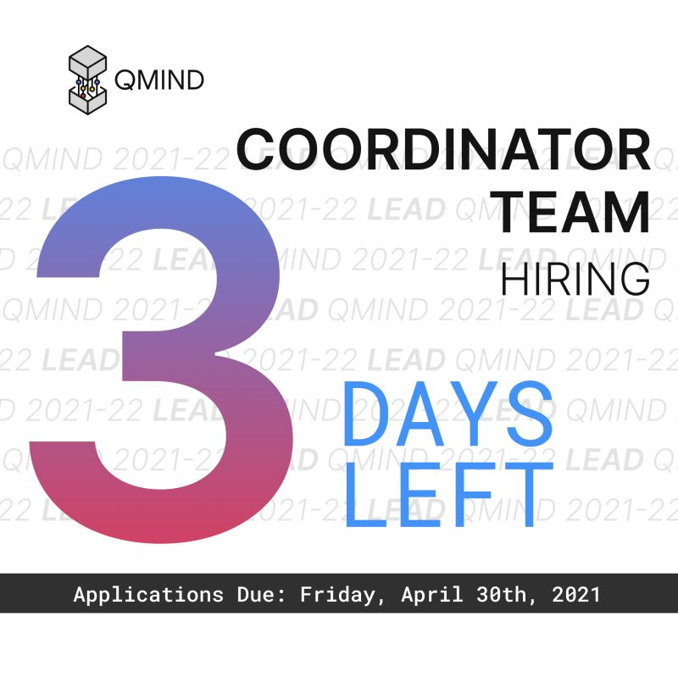

Activate to view larger image

* 9

Like

Comment

Share

Send

Be the first to comment on this

Are these results helpful?

Your feedback helps us improve search results

**Feed post**

[](https://www.linkedin.com/in/jkulchyk?miniProfileUrn=urn%3Ali%3Afs_miniProfile%3AACoAAB6rnCoBzdanR43fqE3gYubGjW2sjXzHQmE" \t "_self)

[Status is reachable](https://www.linkedin.com/in/jkulchyk?miniProfileUrn=urn%3Ali%3Afs_miniProfile%3AACoAAB6rnCoBzdanR43fqE3gYubGjW2sjXzHQmE" \t "_self)

[Jeremy Kulchyk• 1stData Scientist at Validere9mo • 9 months ago](https://www.linkedin.com/in/jkulchyk?miniProfileUrn=urn%3Ali%3Afs_miniProfile%3AACoAAB6rnCoBzdanR43fqE3gYubGjW2sjXzHQmE" \t "_self)

[](https://www.linkedin.com/company/qumind/?miniCompanyUrn=urn%3Ali%3Afs_miniCompany%3A18448654" \t "_self)

[QMIND912 followers9mo • 9 months ago](https://www.linkedin.com/company/qumind/?miniCompanyUrn=urn%3Ali%3Afs_miniCompany%3A18448654" \t "_self)

[We are extremely excited to release the QMIND 2020-21 Project Lookbook, a collection of a year’s work from nearly 200 undergraduate students at Canada’s largest undergraduate AI and machine learning organization. Download a copy here:](https://www.linkedin.com/feed/update/urn:li:activity:6791577539207929856/)<https://lnkd.in/gDrvcEi>  
  
[#ai](https://www.linkedin.com/feed/hashtag/?keywords=ai&highlightedUpdateUrns=urn%3Ali%3Aactivity%3A6791687977757155328) [#machinelearning](https://www.linkedin.com/feed/hashtag/?keywords=machinelearning&highlightedUpdateUrns=urn%3Ali%3Aactivity%3A6791687977757155328) [#datascience](https://www.linkedin.com/feed/hashtag/?keywords=datascience&highlightedUpdateUrns=urn%3Ali%3Aactivity%3A6791687977757155328) [#artificialintelligence](https://www.linkedin.com/feed/hashtag/?keywords=artificialintelligence&highlightedUpdateUrns=urn%3Ali%3Aactivity%3A6791687977757155328) [#research](https://www.linkedin.com/feed/hashtag/?keywords=research&highlightedUpdateUrns=urn%3Ali%3Aactivity%3A6791687977757155328) [#queensuniversity](https://www.linkedin.com/feed/hashtag/?keywords=queensuniversity&highlightedUpdateUrns=urn%3Ali%3Aactivity%3A6791687977757155328)

…see more

Your document has finished loading

* 7

Like

Comment

Share

Send

Be the first to comment on this

**Feed post**

[](https://www.linkedin.com/in/donal-lynagh-6974431a6?miniProfileUrn=urn%3Ali%3Afs_miniProfile%3AACoAADAebBMB9SZ57eK1HcV90ZcF0xNGlk8aD9c" \t "_self)

[Status is reachable](https://www.linkedin.com/in/donal-lynagh-6974431a6?miniProfileUrn=urn%3Ali%3Afs_miniProfile%3AACoAADAebBMB9SZ57eK1HcV90ZcF0xNGlk8aD9c" \t "_self)

[Donal Lynagh(He/Him) • 1stBiomechanics | Entrepreneurship3mo • 3 months ago](https://www.linkedin.com/in/donal-lynagh-6974431a6?miniProfileUrn=urn%3Ali%3Afs_miniProfile%3AACoAADAebBMB9SZ57eK1HcV90ZcF0xNGlk8aD9c" \t "_self)

Great opportunity open to ALL university students!

[](https://www.linkedin.com/company/qumind/?miniCompanyUrn=urn%3Ali%3Afs_miniCompany%3A18448654" \t "_self)

[QMIND912 followers3mo • 3 months ago](https://www.linkedin.com/company/qumind/?miniCompanyUrn=urn%3Ali%3Afs_miniCompany%3A18448654" \t "_self)

[Half the facts you know are probably wrong.  
  
Let's test it! Fact or fiction, dinosaurs were cold blooded...? 🔍  
  
Fewer than 10 years ago, most people would assume this to be true! We now know the answer lies somewhere in the middle, but a bigger question remains unanswered:  
  
How much do we really know about the world? 🤔  
  
According to recent studies in the field of medicine, knowledge has a half-life of 45 years. In other words, half of what physicians thought they knew about diseases was wrong or obsolete 45 years later.  
  
Wondering why? Here's your chance to find out!  
  
Discover the world of data science with](https://www.linkedin.com/feed/update/urn:li:activity:6857098646824075264/)[Isaac Operations](https://www.linkedin.com/company/isaac-operations-limited/) this Sunday, October 24th @ 2:30PM. Registration link:  
  
<https://lnkd.in/g4TF5uHr>  
  
For more details, please head to the event page.  
  
[#datascience](https://www.linkedin.com/feed/hashtag/?keywords=datascience&highlightedUpdateUrns=urn%3Ali%3Aactivity%3A6857342906232012800) [#event](https://www.linkedin.com/feed/hashtag/?keywords=event&highlightedUpdateUrns=urn%3Ali%3Aactivity%3A6857342906232012800) [#casecompetition](https://www.linkedin.com/feed/hashtag/?keywords=casecompetition&highlightedUpdateUrns=urn%3Ali%3Aactivity%3A6857342906232012800)

…see more

Your document has finished loading

* 2

Like

Comment

Share

Send

Be the first to comment on this

**Feed post**

[](https://www.linkedin.com/in/matt-queens?miniProfileUrn=urn%3Ali%3Afs_miniProfile%3AACoAACmK3tgBITgDMyZkmbl0LUv0QtYQsm5ppB4" \t "_self)

[Matt Wright(He/Him) • 1stDirector of Disruptive Technology at QMIND | Qiskit Advocate | Teaching Assistant9mo • 9 months ago](https://www.linkedin.com/in/matt-queens?miniProfileUrn=urn%3Ali%3Afs_miniProfile%3AACoAACmK3tgBITgDMyZkmbl0LUv0QtYQsm5ppB4" \t "_self)

I am excited to announce a new division at QMIND dedicated to democratizing cutting-edge technologies at the undergraduate level. Under this division, students will get hands on experience working on real-world design problems related to Quantum Computing and Blockchain. If you want to contribute and get involved in some of the most promising and in-demand fields of our generation, you should checkout QMIND’s Project Manager applications!

…see more

[](https://www.linkedin.com/company/qumind/?miniCompanyUrn=urn%3Ali%3Afs_miniCompany%3A18448654" \t "_self)

[QMIND912 followers10mo • 10 months ago](https://www.linkedin.com/company/qumind/?miniCompanyUrn=urn%3Ali%3Afs_miniCompany%3A18448654" \t "_self)

[Are you interested in the future of AI? While there’s still uncertainty ahead, applying for QMIND means you’ll be surrounded by dedicated, enthusiastic students—all while learning about one of Canada’s fastest-growing industries!  
  
Don't miss this opportunity to learn more about these flexible, team-driven positions and the in-demand jobs they can prepare you for!](https://www.linkedin.com/feed/update/urn:li:activity:6790428649016352768/)[#QualifyWithQmind](https://www.linkedin.com/feed/hashtag/?keywords=qualifywithqmind&highlightedUpdateUrns=urn%3Ali%3Aactivity%3A6792926764269228032)  
  
Visit our event page here: <https://buff.ly/3dBc7Ri>  
Coordinator Applications: <https://buff.ly/3arboQK>  
Project Manager Applications: <https://buff.ly/3n2MmMO>

…see more

Your document has finished loading

* 17

Like

Comment

Share

Send

Be the first to comment on this

**Feed post**

[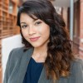](https://www.linkedin.com/in/mahdi-kabir?miniProfileUrn=urn%3Ali%3Afs_miniProfile%3AACoAABRhwfcBUsDt2Wfiq1Iime0s0RM3jc1416w" \t "_self)

[Mahdi Kabir• 1stEvents & Communications Coordinator @ Kings Distributed Systems10mo • Edited • 10 months ago](https://www.linkedin.com/in/mahdi-kabir?miniProfileUrn=urn%3Ali%3Afs_miniProfile%3AACoAABRhwfcBUsDt2Wfiq1Iime0s0RM3jc1416w" \t "_self)

QMIND's last event of the year is this really awesome Future of AI Symposium, featuring speakers [Sep P.](https://www.linkedin.com/in/ACoAAAHa954BUGO-NH2p0d64S3m_uoHOH99UFLw), founder of [AI4SDGs.org](http://ai4sdgs.org/), [Mostafa Farrokhabadi](https://www.linkedin.com/in/ACoAAA0sf_gB1Qw368IV_iBYVYq170S3b3VhkzA) Vice President of Technology at BluWave-AI, and Dr. [Fabio Ynoe de Moraes, MD](https://www.linkedin.com/in/ACoAAAjIZa8B8DGjC4DctmZzhTRb8_cf5NOR0B4) from the Department of Oncology at Kingston General Hospital and Hotel Dieu Hospital.  
  
Our expert speakers will be talking about how AI can and is being used to revolutionize the fields of sustainability, clean energy, and cancer research! Register for this can't-miss event here: <https://lnkd.in/eZejCei>

…see more

[](https://www.linkedin.com/company/qumind/?miniCompanyUrn=urn%3Ali%3Afs_miniCompany%3A18448654" \t "_self)

[QMIND912 followers10mo • Edited • 10 months ago](https://www.linkedin.com/company/qumind/?miniCompanyUrn=urn%3Ali%3Afs_miniCompany%3A18448654" \t "_self)

[Interested in learning about how AI will shape our future? Rapidly advancing technology is a key player in shaping the future of our world. Join us this Saturday, April 3 at 1:30 PM EST to hear from three knowledgeable experts, where we explore the use of cutting-edge AI and ML technologies in the realms of sustainable development, clean energy, and cancer research. Short on time? Not a problem! Each topic will be presented as 20-minute speed workshops so feel free to pop in and out as you please.  
  
DM us with any questions and register in advance here:](https://www.linkedin.com/feed/update/urn:li:activity:6783047752625512450/)<https://lnkd.in/eZejCei>

…see more

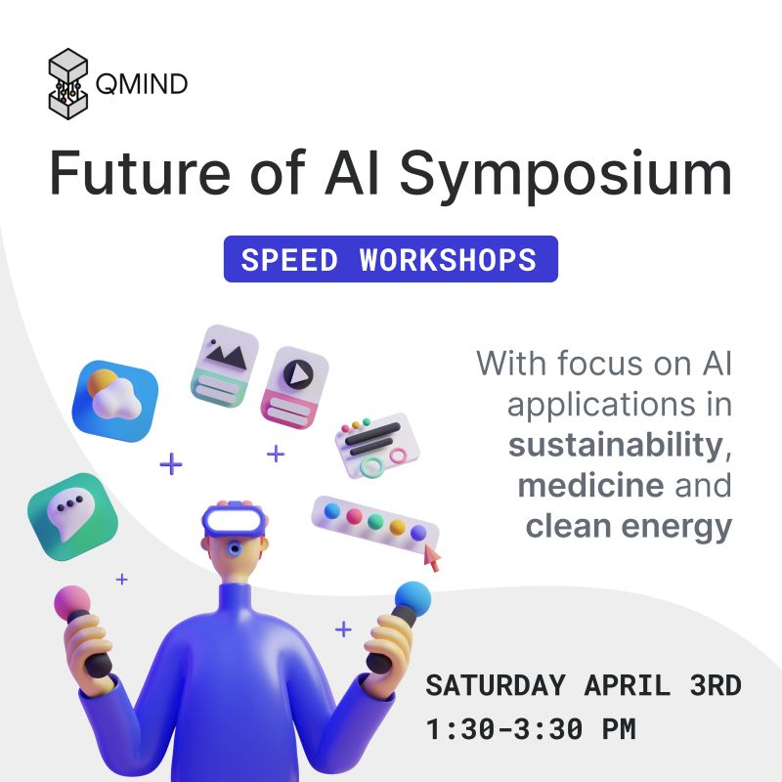

Activate to view larger image

* 9

Like

Comment

Share

Send

Be the first to comment on this

**Feed post**

[](https://www.linkedin.com/in/ethan-callanan?miniProfileUrn=urn%3Ali%3Afs_miniProfile%3AACoAADDX9f8BnAQIxXJASwXsIcIisK1dsOY_LlQ" \t "_self)

[Status is reachable](https://www.linkedin.com/in/ethan-callanan?miniProfileUrn=urn%3Ali%3Afs_miniProfile%3AACoAADDX9f8BnAQIxXJASwXsIcIisK1dsOY_LlQ" \t "_self)

[Ethan Callanan• 1stDirector of Design at QMIND | Computer Science, AI at Queen's University9mo • Edited • 9 months ago](https://www.linkedin.com/in/ethan-callanan?miniProfileUrn=urn%3Ali%3Afs_miniProfile%3AACoAADDX9f8BnAQIxXJASwXsIcIisK1dsOY_LlQ" \t "_self)

After all our hard work this year I'm excited to share that my team's work on virtual assistant attention detection was one of the top 5 papers of CUCAI 2021!  
  
This was my first year on a design team at QMIND, and I lead our team ([Jae Makitalo](https://www.linkedin.com/in/ACoAACaKZ3sBt-gjrFc2sXAjTgpGirnVsHcCYt8), [Ella Duffy](https://www.linkedin.com/in/ACoAACkkAOIBAlRnKcFl5-t9LlN2oB-BPbgjDfk), and [Kavin Z.](https://www.linkedin.com/in/ACoAAC7HMpEBI9fDhiv6YEC_LKyr0BXVa35Ue-4)) to design a computer vision model for attention-based activation system of virtual assistants. I learned a ton in the process, and I am honored that our work was recognized out of all the incredible projects presented at CUCAI this year!  
  
[#computervision](https://www.linkedin.com/feed/hashtag/?keywords=computervision&highlightedUpdateUrns=urn%3Ali%3Aactivity%3A6795062706803228672) [#ai](https://www.linkedin.com/feed/hashtag/?keywords=ai&highlightedUpdateUrns=urn%3Ali%3Aactivity%3A6795062706803228672) [#machinelearning](https://www.linkedin.com/feed/hashtag/?keywords=machinelearning&highlightedUpdateUrns=urn%3Ali%3Aactivity%3A6795062706803228672) [#design](https://www.linkedin.com/feed/hashtag/?keywords=design&highlightedUpdateUrns=urn%3Ali%3Aactivity%3A6795062706803228672)

…see more

[](https://www.linkedin.com/company/qumind/?miniCompanyUrn=urn%3Ali%3Afs_miniCompany%3A18448654" \t "_self)

[QMIND912 followers9mo • 9 months ago](https://www.linkedin.com/company/qumind/?miniCompanyUrn=urn%3Ali%3Afs_miniCompany%3A18448654" \t "_self)

[We are excited to release the Proceedings of CUCAI 2021, a showcase of all the client and research-driven work by design teams at CUCAI 2021! Check out the full papers detailing our solutions to a variety of problems such as autonomous driving, diabetic risk modelling, attention detection, and more. Congratulations to all the teams and authors for the exciting work that went into these projects, and a special congratulations to our top 5 papers on the second page! If this work is exciting to you, consider getting involved with us, or attending and/or presenting your AI project at next year’s CUCAI!](https://www.linkedin.com/feed/update/urn:li:activity:6794786756949532672/)[#ai](https://www.linkedin.com/feed/hashtag/?keywords=ai&highlightedUpdateUrns=urn%3Ali%3Aactivity%3A6795062706803228672) [#aiforall](https://www.linkedin.com/feed/hashtag/?keywords=aiforall&highlightedUpdateUrns=urn%3Ali%3Aactivity%3A6795062706803228672) [#machinelearning](https://www.linkedin.com/feed/hashtag/?keywords=machinelearning&highlightedUpdateUrns=urn%3Ali%3Aactivity%3A6795062706803228672) [#deeplearning](https://www.linkedin.com/feed/hashtag/?keywords=deeplearning&highlightedUpdateUrns=urn%3Ali%3Aactivity%3A6795062706803228672) [#undergraduate](https://www.linkedin.com/feed/hashtag/?keywords=undergraduate&highlightedUpdateUrns=urn%3Ali%3Aactivity%3A6795062706803228672) [#research](https://www.linkedin.com/feed/hashtag/?keywords=research&highlightedUpdateUrns=urn%3Ali%3Aactivity%3A6795062706803228672) [Queen's University](https://www.linkedin.com/company/queen's-university/) [School of Computing at Queen's University](https://www.linkedin.com/in/ACoAAB8Tuv0BETsk0PM6IJIePhCvjLqmyg2yHFU) [Queen's University - Faculty of Engineering and Applied Science](https://www.linkedin.com/company/queens-engineering/) [Western AI](https://www.linkedin.com/company/westernuai/)

…see more

Your document has finished loading

* 11
* 1 comment

Like

Comment

Share

Send



Top of Form

Open Emoji Keyboard

Bottom of Form

Current selected sort order is Most relevantMost relevant

[[](https://www.linkedin.com/in/tetris/samhollinrake/)](https://www.linkedin.com/in/tetris/samhollinrake/" \t "_self)

**[Sam Hollinrake(She/Her) 2nd degree connection2ndQueen's University Chancellor's Scholar | Queen's Commerce Law Association Co-Chair | Previously Business Analyst Intern at Arteria AI](https://www.linkedin.com/in/tetris/samhollinrake/" \t "_self)**

8mo

Congratulations Ethan and team - this is so impressive!

Like

1

Reply

**Feed post**

[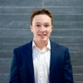](https://www.linkedin.com/in/griffin-clark-a02513146?miniProfileUrn=urn%3Ali%3Afs_miniProfile%3AACoAACNQxuIBcOAsLIyHsoC4ZsBvn3311eu7dYA" \t "_self)

[Status is reachable](https://www.linkedin.com/in/griffin-clark-a02513146?miniProfileUrn=urn%3Ali%3Afs_miniProfile%3AACoAACNQxuIBcOAsLIyHsoC4ZsBvn3311eu7dYA" \t "_self)

[Griffin Clark(He/Him) • 1stEngineering Physics student at Queen's University11mo • 11 months ago](https://www.linkedin.com/in/griffin-clark-a02513146?miniProfileUrn=urn%3Ali%3Afs_miniProfile%3AACoAACNQxuIBcOAsLIyHsoC4ZsBvn3311eu7dYA" \t "_self)

So excited for this awesome panel! Make sure to sign up through the link below.

[](https://www.linkedin.com/company/qumind/?miniCompanyUrn=urn%3Ali%3Afs_miniCompany%3A18448654" \t "_self)

[QMIND912 followers11mo • 11 months ago](https://www.linkedin.com/company/qumind/?miniCompanyUrn=urn%3Ali%3Afs_miniCompany%3A18448654" \t "_self)

[QMIND PD's main goal is to bridge the gap between students with endless talent & the tech industry to set them up for success on their career development journey. So far at QMIND PD, we showcased to students what it's like to work at big tech & the recruitment process. We now want to introduce to students what it's like to work at start-ups. Tech start-ups bring innovative solutions to the world and we hear about exciting updates on their progress on the news all the time.  
  
Join us on March 18 at 7PM EST to hear from our esteemed line of panelists and what it's like to work at a startup! They'll be sharing their own personal experiences and answer any questions you may have about working at a startup. This is a can't miss event!  
  
REGISTER HERE:](https://www.linkedin.com/feed/update/urn:li:activity:6777272297205088256/)<https://buff.ly/3qKg2P3> to secure your spot today!

…see more

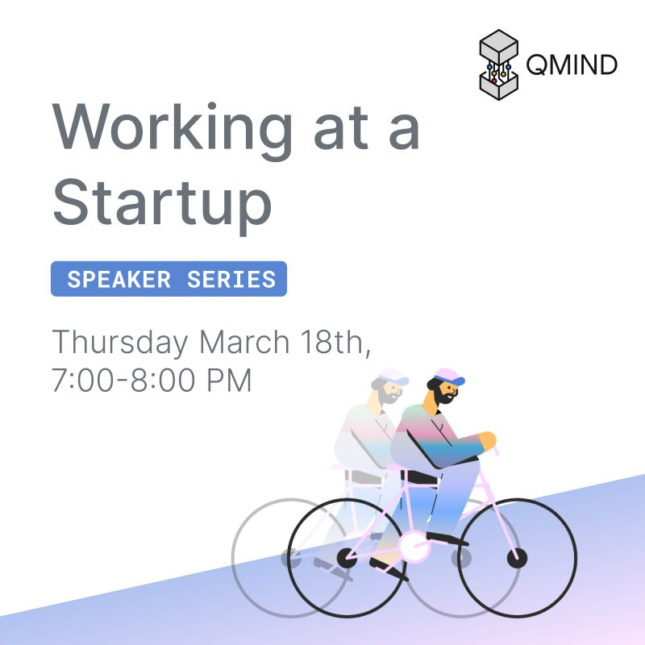

Activate to view larger image

* 3

Like

Comment

Share

Send

Be the first to comment on this

**Feed post**

[](https://www.linkedin.com/in/eunice-js-choi?miniProfileUrn=urn%3Ali%3Afs_miniProfile%3AACoAACFLa-sB5vbvJTqf-TaNzk45zPFDnbLGNh8" \t "_self)

[Eunice Choi(She/Her) • 1stIncoming APM @ Clearco🚀 Prev: @Microsoft @BMO11mo • 11 months ago](https://www.linkedin.com/in/eunice-js-choi?miniProfileUrn=urn%3Ali%3Afs_miniProfile%3AACoAACFLa-sB5vbvJTqf-TaNzk45zPFDnbLGNh8" \t "_self)

QMIND Professional Development is here with another amazing opportunity for you to learn about what it's really like to work at a tech start-up 🚀  
  
Last semester, I made the decision to pause school and try working at a start-up after working at some amazing big corporations. I learned and still learning so much about the differences of being at a start-up vs a corporation like culture, ownership, impact, challenges, resources, and what it means for my career!  
  
We invited amazing speakers [Hannah LeBlanc](https://www.linkedin.com/in/ACoAABa2mrMB5WYdy_eaL09j4cK8qBTUwYj8-zE), [Sari Abukhadra](https://www.linkedin.com/in/ACoAABPlydwBlaJDZzus6Z3rnvt-Kh2MnS-ZvpE), [Christina Chan](https://www.linkedin.com/in/ACoAABKXJpIBpr0kBwiUvpzZpHtoFWrmdLw1lWo), [Alexa L.](https://www.linkedin.com/in/ACoAACMNZOYBsPOZf5EhW5rWubyQ5WLeVQ6OuQc) from [MindBridge](https://www.linkedin.com/company/mindbridge-ai/), [Roblox](https://www.linkedin.com/company/roblox/), [Wealthsimple](https://www.linkedin.com/company/wealthsimple/), [Cash App](https://www.linkedin.com/company/cash-app/), (some who has been great mentors of mine) who will share with you what they are working on, how they made their decision to work at a start-up, and advice for those trying to pave their career path in tech!  
  
Don't miss this amazing opportunity happening tomorrow, Thursday, March 18th, 7 PM on Zoom! Register here: <https://buff.ly/3qKg2P3>  
[#tech](https://www.linkedin.com/feed/hashtag/?keywords=tech&highlightedUpdateUrns=urn%3Ali%3Aactivity%3A6777964789252657152) [#startup](https://www.linkedin.com/feed/hashtag/?keywords=startup&highlightedUpdateUrns=urn%3Ali%3Aactivity%3A6777964789252657152) [#careerjourney](https://www.linkedin.com/feed/hashtag/?keywords=careerjourney&highlightedUpdateUrns=urn%3Ali%3Aactivity%3A6777964789252657152) [#internship](https://www.linkedin.com/feed/hashtag/?keywords=internship&highlightedUpdateUrns=urn%3Ali%3Aactivity%3A6777964789252657152)

…see more

[](https://www.linkedin.com/company/qumind/?miniCompanyUrn=urn%3Ali%3Afs_miniCompany%3A18448654" \t "_self)

[QMIND912 followers11mo • 11 months ago](https://www.linkedin.com/company/qumind/?miniCompanyUrn=urn%3Ali%3Afs_miniCompany%3A18448654" \t "_self)

[QMIND is thrilled to introduce our panelists for our upcoming Working at a Startup Panel!  
  
Join us tomorrow, Thursday, March 18 at 7pm EST to hear from our panelists and their personal experiences working at a startup. This is a can't miss event!  
  
REGISTER HERE:](https://www.linkedin.com/feed/update/urn:li:activity:6777947482740596736/)<https://buff.ly/3qKg2P3> to secure your spot today!

…see more

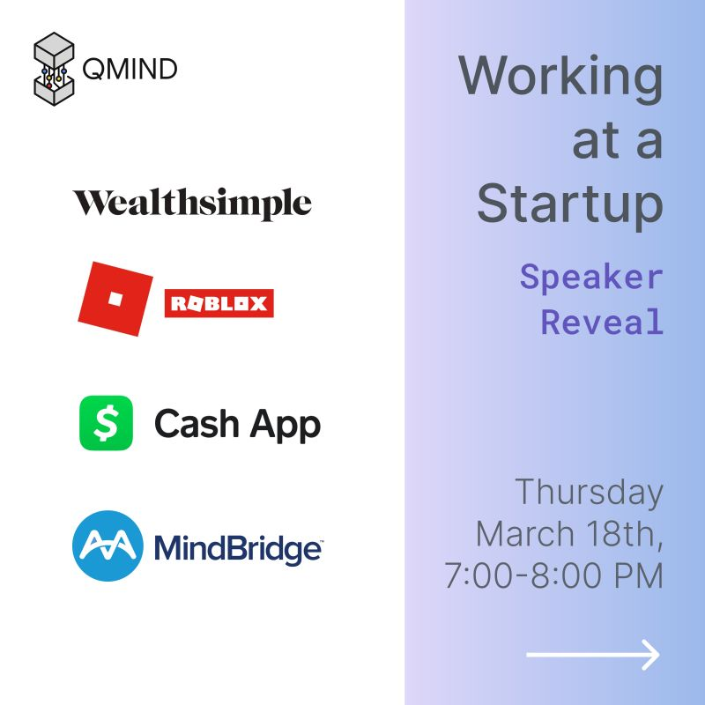

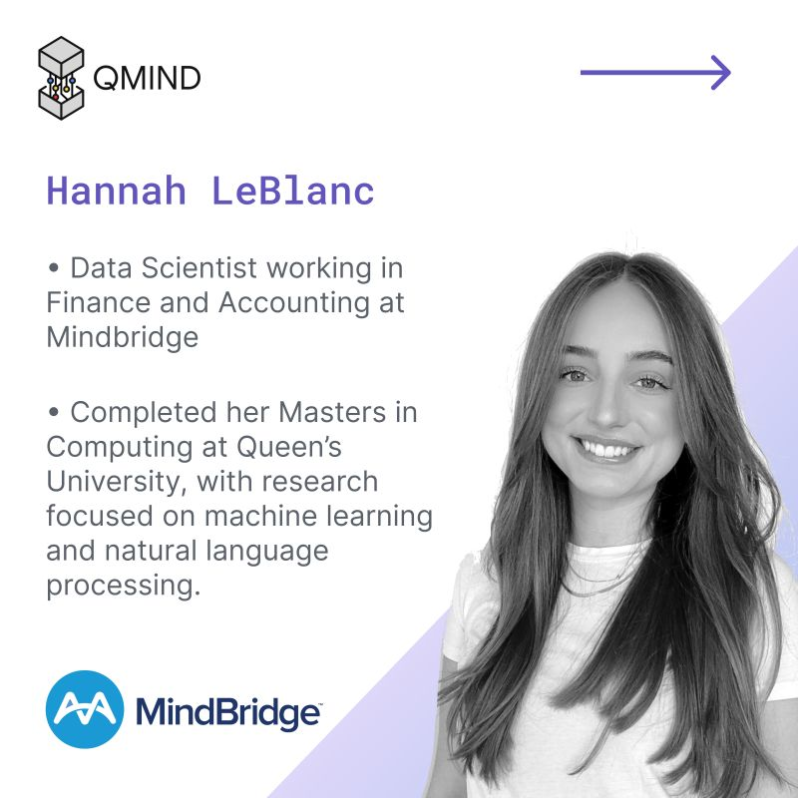

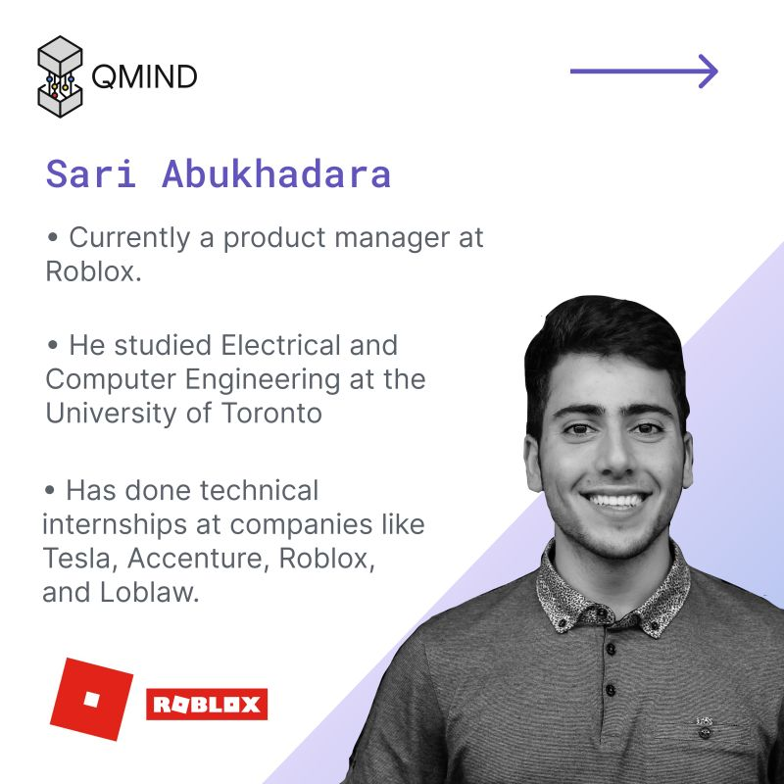

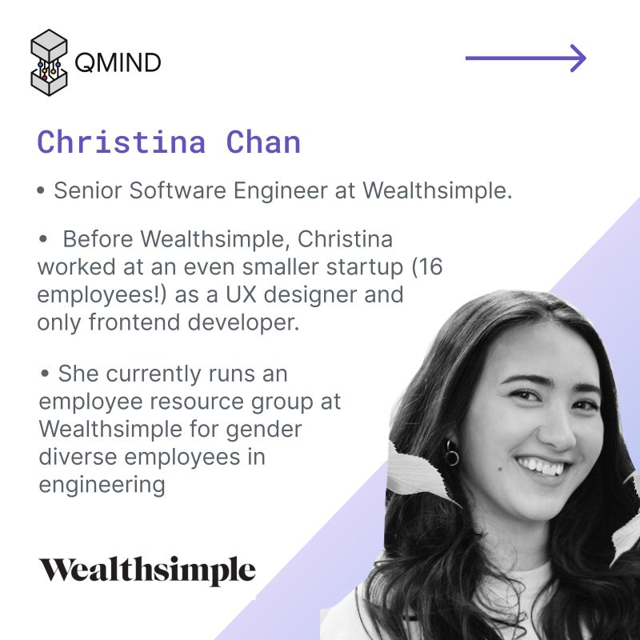

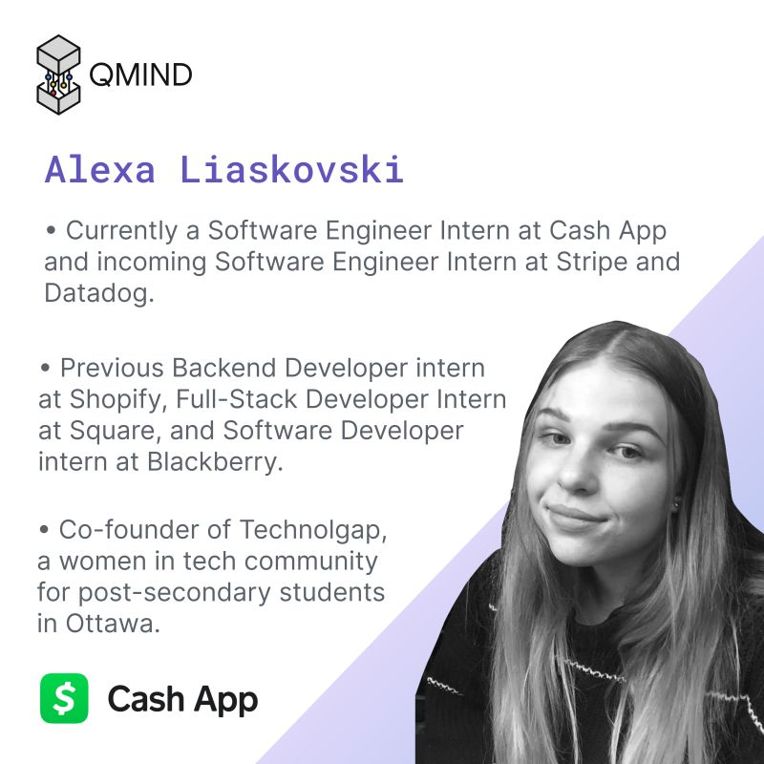

Activate to view larger image

* 14

Like

Comment

Share

Send

Be the first to comment on this

**Feed post**

[](https://www.linkedin.com/company/qumind/?miniCompanyUrn=urn%3Ali%3Afs_miniCompany%3A18448654" \t "_self)

[QMIND912 followers6d • 6 days ago](https://www.linkedin.com/company/qumind/?miniCompanyUrn=urn%3Ali%3Afs_miniCompany%3A18448654" \t "_self)

Think you have what it takes to be one of QMIND's Managing Directors next year? 😮  
  
Apply now! Applications are due Friday, January 28th by midnight. Follow this link to apply: <https://linktr.ee/qmind>  
  
P.S. Feel free to ask one of our current directors about their experience this year: [Sydney Corbett](https://www.linkedin.com/in/ACoAACy-Zd8BM-AGci11fT1tPwbTwMF-AY3boMk), [Max Bennett](https://www.linkedin.com/in/ACoAACkTLKEBI5o5f9sBs3r-_poefQZ6HubDgQU), [Elan Bibas](https://www.linkedin.com/in/ACoAABrjJN8B81Ow0waUPrrP4lpUtHdigzvnGWA)  
  
[#ai](https://www.linkedin.com/feed/hashtag/?keywords=ai&highlightedUpdateUrns=urn%3Ali%3Aactivity%3A6890085519863164928) [#machinelearning](https://www.linkedin.com/feed/hashtag/?keywords=machinelearning&highlightedUpdateUrns=urn%3Ali%3Aactivity%3A6890085519863164928) [#management](https://www.linkedin.com/feed/hashtag/?keywords=management&highlightedUpdateUrns=urn%3Ali%3Aactivity%3A6890085519863164928) [#queensuniversity](https://www.linkedin.com/feed/hashtag/?keywords=queensuniversity&highlightedUpdateUrns=urn%3Ali%3Aactivity%3A6890085519863164928) [#technology](https://www.linkedin.com/feed/hashtag/?keywords=technology&highlightedUpdateUrns=urn%3Ali%3Aactivity%3A6890085519863164928) [#leadership](https://www.linkedin.com/feed/hashtag/?keywords=leadership&highlightedUpdateUrns=urn%3Ali%3Aactivity%3A6890085519863164928) [#students](https://www.linkedin.com/feed/hashtag/?keywords=students&highlightedUpdateUrns=urn%3Ali%3Aactivity%3A6890085519863164928)

…see more

Your document has finished loading

* 13Sydney Corbett and 12 others

Like

Comment

Share

Send

Be the first to comment on this

**Feed post**

[](https://www.linkedin.com/in/alexander-salgo?miniProfileUrn=urn%3Ali%3Afs_miniProfile%3AACoAAB4AGOkBHMg0TUKoKORc1VkfAmx70XrTB8I" \t "_self)

[Alexander Salgo(He/Him) • 2ndAI Software Developer2mo • Edited • 2 months ago](https://www.linkedin.com/in/alexander-salgo?miniProfileUrn=urn%3Ali%3Afs_miniProfile%3AACoAAB4AGOkBHMg0TUKoKORc1VkfAmx70XrTB8I" \t "_self)

Got to run my first workshop as a graduate! Thanks to [QMIND](https://www.linkedin.com/company/qumind/) for the invitation

[](https://www.linkedin.com/company/distributed-compute-labs/?miniCompanyUrn=urn%3Ali%3Afs_miniCompany%3A18672608" \t "_self)

[Distributed Compute Labs408 followers2mo • Edited • 2 months ago](https://www.linkedin.com/company/distributed-compute-labs/?miniCompanyUrn=urn%3Ali%3Afs_miniCompany%3A18672608" \t "_self)

[We were thrilled to guide QMIND through the importance of datapreprocessing this past weekend! Loved meeting such a highly engaged group of students. Every collaboration with QMIND truly leaves us anticipating the next!](https://www.linkedin.com/feed/update/urn:li:activity:6871508465987268610/)[#datapreprocess](https://www.linkedin.com/feed/hashtag/?keywords=datapreprocess&highlightedUpdateUrns=urn%3Ali%3Aactivity%3A6871610490041315328) [#machinelearning](https://www.linkedin.com/feed/hashtag/?keywords=machinelearning&highlightedUpdateUrns=urn%3Ali%3Aactivity%3A6871610490041315328) [#datascience](https://www.linkedin.com/feed/hashtag/?keywords=datascience&highlightedUpdateUrns=urn%3Ali%3Aactivity%3A6871610490041315328) [#DCP](https://www.linkedin.com/feed/hashtag/?keywords=dcp&highlightedUpdateUrns=urn%3Ali%3Aactivity%3A6871610490041315328)

…see more

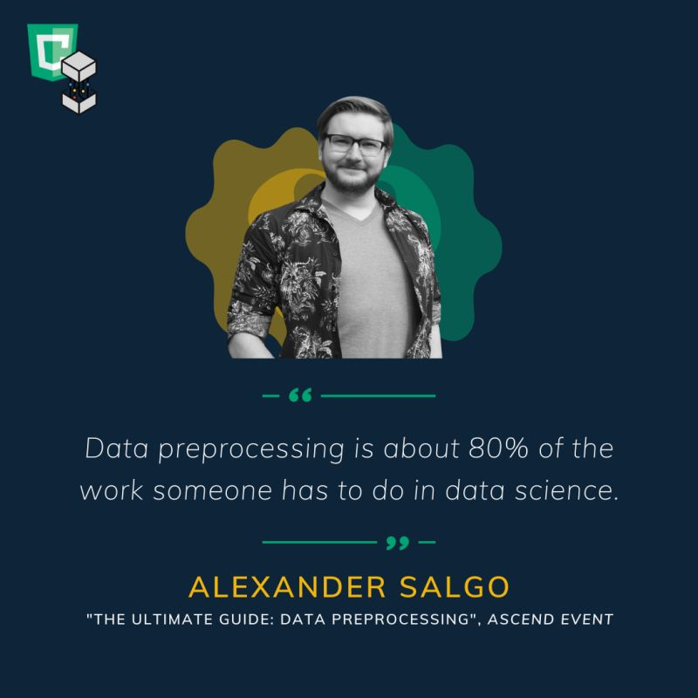

Activate to view larger imagewith Alexander Salgo and 1 other

* 23

Like

Comment

Share

Send

Be the first to comment on this

**Feed post**

[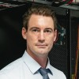](https://www.linkedin.com/in/dan-desjardins?miniProfileUrn=urn%3Ali%3Afs_miniProfile%3AACoAACI1owgB1hOxGLbVSL5qgOFJLD7EX2jUdzk" \t "_self)

[Dan Desjardins, PhD• 2ndCEO at Kings Distributed Systems2mo • 2 months ago](https://www.linkedin.com/in/dan-desjardins?miniProfileUrn=urn%3Ali%3Afs_miniProfile%3AACoAACI1owgB1hOxGLbVSL5qgOFJLD7EX2jUdzk" \t "_self)

Oi [#datascientists](https://www.linkedin.com/feed/hashtag/?keywords=datascientists&highlightedUpdateUrns=urn%3Ali%3Aactivity%3A6869403382981959680) !  
[QMIND](https://www.linkedin.com/company/qumind/) workshop on Data Preprocessing this Saturday if you're interested

* 22Ethan Callanan and 21 others
* 1 comment

Like

Comment

Share

Send



Top of Form

Open Emoji Keyboard

Bottom of Form

Current selected sort order is Most relevantMost relevant

[[](https://www.linkedin.com/company/qumind/)](https://www.linkedin.com/company/qumind/" \t "_self)

**[QMIND912 followers](https://www.linkedin.com/company/qumind/" \t "_self)**

2mo

It’s gonna be fun!

Like

1

Reply

**Feed post**

[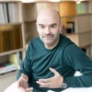](https://www.linkedin.com/in/ricardo-ruiz-2404baaa?miniProfileUrn=urn%3Ali%3Afs_miniProfile%3AACoAABc2D9ABlgqVsfzQgsaN1_-hG-2XKIv0PG8" \t "_self)

[Status is reachable](https://www.linkedin.com/in/ricardo-ruiz-2404baaa?miniProfileUrn=urn%3Ali%3Afs_miniProfile%3AACoAABc2D9ABlgqVsfzQgsaN1_-hG-2XKIv0PG8" \t "_self)

[Ricardo Ruiz• 3rd+Calidad mental organizacional. Efectivos e innovadores programas para tener personas más centradas, mejorando clima laboral, eficiencia y bienestar.1w • Edited • 1 week ago](https://www.linkedin.com/in/ricardo-ruiz-2404baaa?miniProfileUrn=urn%3Ali%3Afs_miniProfile%3AACoAABc2D9ABlgqVsfzQgsaN1_-hG-2XKIv0PG8" \t "_self)

No tiene sentido pensar que lo que esta pasando no afecta a las personas en tu organización. Si queremos que no impacte en mayor medida, y queremos cumplir con nuestro compromiso para con ellas, desde la organización debemos pasar a la acción.  
Hoy 13 de enero se conmemora el Día Mundial de la lucha contra la depresión.  
Mi programa Qmind es un programa integral, que entrega a las empresas un camino coherente y llave en mano para que sus personas desarrollen habilidades personales para mejorar sus niveles de bienestar y salud. De esta forma mis clientes pueden implantar de forma sencilla a lo largo del ejercicio, con un cronograma definido, una batería de acciones formativas con variedad de formatos y metodologías. Si quieres saber en que consiste escríbeme por privado.

…see more

](https://www.diariovasco.com/sociedad/salud/coronavirus-euskadi-trastornos-mentales-pandemia-20220113195757-nt.html)](https://www.diariovasco.com/sociedad/salud/coronavirus-euskadi-trastornos-mentales-pandemia-20220113195757-nt.html" \t "_blank)

**[Los trastornos mentales por la pandemia del Covid saturan las plazas en Psiquiatría en Euskadi](https://www.diariovasco.com/sociedad/salud/coronavirus-euskadi-trastornos-mentales-pandemia-20220113195757-nt.html" \t "_blank)**

**[diariovasco.com • 1 min read](https://www.diariovasco.com/sociedad/salud/coronavirus-euskadi-trastornos-mentales-pandemia-20220113195757-nt.html" \t "_blank)**

* 11

Like

Comment

Share

Send

Be the first to comment on this

**Feed post**

[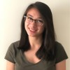](https://www.linkedin.com/in/susan-kovarik-3a6183193?miniProfileUrn=urn%3Ali%3Afs_miniProfile%3AACoAAC1o2m4BeO1zeSYwoOW1sDVIq6udgCb7UiA" \t "_self)

[Susan Kovarik• 2ndPower Attainment Intern at AMD | Third Year Electrical Engineering Student @ Queens8mo • 8 months ago](https://www.linkedin.com/in/susan-kovarik-3a6183193?miniProfileUrn=urn%3Ali%3Afs_miniProfile%3AACoAAC1o2m4BeO1zeSYwoOW1sDVIq6udgCb7UiA" \t "_self)

For the past 8 months, I've had the pleasure of working with [David Huang](https://www.linkedin.com/in/ACoAACrQ92QBryaKM7jEZx6zoiKW1Y2f-H8PXqc), [Gabrielle Mehltretter](https://www.linkedin.com/in/ACoAACi5I5EB5lrgfYEvb6aDzClqWx5Q0deUgtE) and [Nicholas Cheney](https://www.linkedin.com/in/ACoAACUMIfoBGR2Is3BD4XvUjgZ9VMUBR4GJEPg) in a design team organized by [QMIND](https://www.linkedin.com/company/qumind/).  
  
As the prevalence of diabetes rises globally, there is also growing emphasis on the need for better modeling of diabetes progression in patients. Our team worked with [LocateMotion (SenSights.AI™)](https://www.linkedin.com/company/locatemotion/), a health-tech company that aims to improve remote health monitoring of patients.  
  
Our team developed AI models for risk score modeling and complication predictions for diabetic patients using EMR (Electronic Medical Records) data from the CPCSSN database. A unidirectional RNN LSTM architecture was employed for future risk score predicting models. A bidirectional RNN GRU architecture was used to develop a model which predicted the onset of 10 diabetes related complications.  
  
It was a wonderful learning experience to watch our progress through the course of the project, from plenty of literature reviews to being considered one of the top 5 best papers written in QMIND this year. It was a tremendous team effort, and I'd like to thank my teammates, LocateMotion and QMIND for the opportunity!

…see more

Your document has finished loading

* 37
* 6 comments
* 3 shares

Like

Comment

Share

Send



Top of Form

Open Emoji Keyboard

Bottom of Form

Current selected sort order is Most relevantMost relevant

[[](https://www.linkedin.com/in/tetris/jessie-xiong/)](https://www.linkedin.com/in/tetris/jessie-xiong/" \t "_self)

**[Jessie Xiong 2nd degree connection2ndSoftware QA Intern at ecobee](https://www.linkedin.com/in/tetris/jessie-xiong/" \t "_self)**

8mo

Incredible! Can't wait to hear more about this project 😄

Like

1

Reply

Load more comments

**Feed post**

[](https://www.linkedin.com/company/mca-georgia-partnerships/?miniCompanyUrn=urn%3Ali%3Afs_miniCompany%3A18462386" \t "_self)

[Millennium Challenge Account-Georgia (MCA-Georgia)167 followers2w • 2 weeks ago](https://www.linkedin.com/company/mca-georgia-partnerships/?miniCompanyUrn=urn%3Ali%3Afs_miniCompany%3A18462386" \t "_self)

Follow

👩‍🚀‍👨‍🚀 გაიცანით ათასწლეულის ინოვაციის კონკურსი - Millennium Innovations Award-ის ერთ-ერთი ფინალისტი გუნდის - „Qminds”-ის წევრები: ლევან ლოლაშვილი, ანრი დარცმელია, დავით ძამაშვილი, ლუკა გაფრინდაშვილი, ნიკოლოზ ჯაფოშვილი (თბილისის #42 საჯარო სკოლა).  
💬 “ჩვენი მიზანი საშუალო თუ მცირე მეღვინეების დახმარებაა ღვინის წარმოებისას. ჩვენი მოწყობილობა დაღვინების პროცესში პერიოდულად იღებს ღვინის ნიმუშებს გასაანალიზებლად: pH, შაქრიანობა, CHl, SO2, SO4, ალკოჰოლის შემცველობა, სიბლანტე და დუღილისას გამოყოფილი CO2-ს რაოდენობა, რითიც დგინდება ღვინის ხარისხი, სავარაუდო დაღვინების დრო და რამდენად სწორად მიდის დაღვინების პროცესი, და ა.შ“.  
  
[#MIA](https://www.linkedin.com/feed/hashtag/?keywords=mia&highlightedUpdateUrns=urn%3Ali%3Aactivity%3A6886205986902704128)  
[#STEMeducation](https://www.linkedin.com/feed/hashtag/?keywords=stemeducation&highlightedUpdateUrns=urn%3Ali%3Aactivity%3A6886205986902704128)  
[#ათასწლეულისფონდი](https://www.linkedin.com/feed/hashtag/?keywords=%E1%83%90%E1%83%97%E1%83%90%E1%83%A1%E1%83%AC%E1%83%9A%E1%83%94%E1%83%A3%E1%83%9A%E1%83%98%E1%83%A1%E1%83%A4%E1%83%9D%E1%83%9C%E1%83%93%E1%83%98&highlightedUpdateUrns=urn%3Ali%3Aactivity%3A6886205986902704128)

…see more

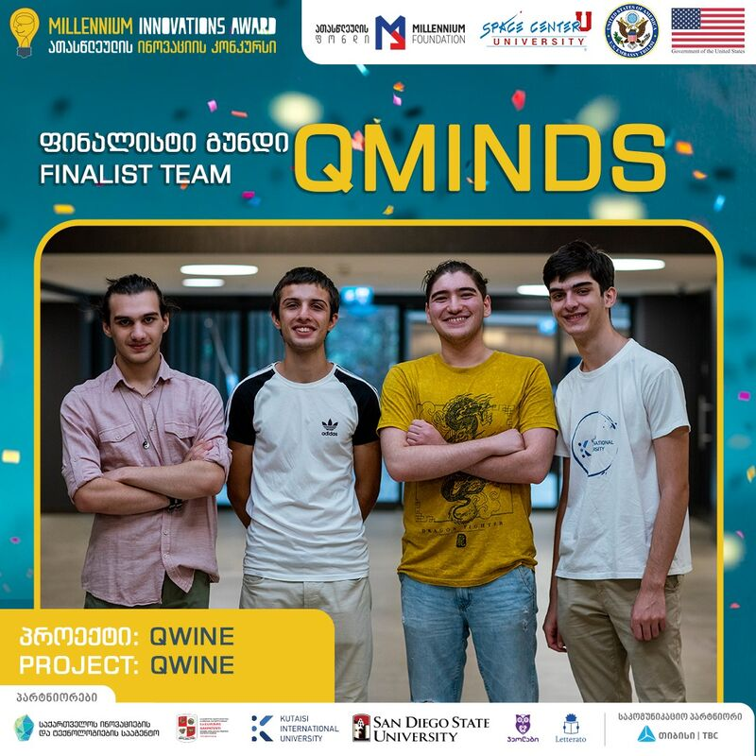

Activate to view larger image

* 5
* 1 comment

Like

Comment

Share

Send



Top of Form

Open Emoji Keyboard

Bottom of Form

Current selected sort order is Most relevantMost relevant

[[](https://www.linkedin.com/in/tetris/natela-urushadze-85230161/)](https://www.linkedin.com/in/tetris/natela-urushadze-85230161/" \t "_self)

**[Natela Urushadze out of network3rd+AC Coordinator at Tbilisi Youth Palace](https://www.linkedin.com/in/tetris/natela-urushadze-85230161/" \t "_self)**

2w

წარმატებებს გისურვებთ!

Like

Reply

**Feed post**

[](https://www.linkedin.com/company/qumind/?miniCompanyUrn=urn%3Ali%3Afs_miniCompany%3A18448654" \t "_self)

[QMIND912 followers11mo • 11 months ago](https://www.linkedin.com/company/qumind/?miniCompanyUrn=urn%3Ali%3Afs_miniCompany%3A18448654" \t "_self)

1 day left to apply to be a QMIND Director for the 2021-22 year!  
  
Check out what some of last year’s QMIND Directors ([Travis Cossarini](https://www.linkedin.com/in/ACoAACk3dLABYNFDAafBb5pO27Aw8JEjELS5p4k) and [Tania Sidhom](https://www.linkedin.com/in/ACoAACo6dzcBUNcWCZJiHpQj9C_WMrSRMRAc_5Y)) have to say about their experience in the role, and what they’ve gained from being a member of the 2020-21 Director team. This is a great opportunity to gain unbelievable leadership experience at an undergraduate level, and work alongside other extremely talented and driven students and industry professionals in a cutting-edge tech field, so don’t miss out!  
  
Apply now: <https://linktr.ee/qmind>

…see more

Your document has finished loading

* 4

Like

Comment

Share

Send

Be the first to comment on this

**Feed post**

[](https://www.linkedin.com/company/qumind/?miniCompanyUrn=urn%3Ali%3Afs_miniCompany%3A18448654" \t "_self)

[QMIND912 followers11mo • 11 months ago](https://www.linkedin.com/company/qumind/?miniCompanyUrn=urn%3Ali%3Afs_miniCompany%3A18448654" \t "_self)

QMIND Director Hiring for the 2021-22 year is now open! Being a Director is amazing opportunity for you to build your leadership abilities, create impactful connections with industry leaders, all while getting hands-on experience in the field of the future. Apply now to unlock QMIND’s full potential: <https://linktr.ee/qmind>  
  
[#leadership](https://www.linkedin.com/feed/hashtag/?keywords=leadership&highlightedUpdateUrns=urn%3Ali%3Aactivity%3A6776222154456473601) [#artificialintelliegence](https://www.linkedin.com/feed/hashtag/?keywords=artificialintelliegence&highlightedUpdateUrns=urn%3Ali%3Aactivity%3A6776222154456473601) [#queensuniversity](https://www.linkedin.com/feed/hashtag/?keywords=queensuniversity&highlightedUpdateUrns=urn%3Ali%3Aactivity%3A6776222154456473601)

…see more

Your document has finished loading

* 10

Like

Comment

Share

Send

Be the first to comment on this

**Feed post**

[](https://www.linkedin.com/company/distributed-compute-labs/?miniCompanyUrn=urn%3Ali%3Afs_miniCompany%3A18672608" \t "_self)

[Distributed Compute Labs408 followers4mo • 4 months ago](https://www.linkedin.com/company/distributed-compute-labs/?miniCompanyUrn=urn%3Ali%3Afs_miniCompany%3A18672608" \t "_self)

We're sending [Levi Stringer](https://www.linkedin.com/in/ACoAAAlvLssB3UxqbdGp8hANNXl3caFu32O9xn4)—a former Managing Director of [QMIND](https://www.linkedin.com/company/qumind/)—through a time machine at Camp QMIND tomorrow. This time, Levi Stringer won't be in the stands—he'll be delivering an industry talk at 10:40 AM tomorrow!  
  
[#DCL](https://www.linkedin.com/feed/hashtag/?keywords=dcl&highlightedUpdateUrns=urn%3Ali%3Aactivity%3A6849766688091705344) [#QMIND](https://www.linkedin.com/feed/hashtag/?keywords=qmind&highlightedUpdateUrns=urn%3Ali%3Aactivity%3A6849766688091705344) [#JavaScript](https://www.linkedin.com/feed/hashtag/?keywords=javascript&highlightedUpdateUrns=urn%3Ali%3Aactivity%3A6849766688091705344) [#Computing](https://www.linkedin.com/feed/hashtag/?keywords=computing&highlightedUpdateUrns=urn%3Ali%3Aactivity%3A6849766688091705344)

* 16
* 2 comments

Like

Comment

Share

Send



Top of Form

Open Emoji Keyboard

Bottom of Form

Current selected sort order is Most relevantMost relevant

[[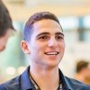](https://www.linkedin.com/in/tetris/noahifergan/)](https://www.linkedin.com/in/tetris/noahifergan/" \t "_self)

**[Noah I. 2nd degree connection2ndSales Engineering at Appian](https://www.linkedin.com/in/tetris/noahifergan/" \t "_self)**

3mo

[Levi Stringer](https://www.linkedin.com/in/ACoAAAlvLssB3UxqbdGp8hANNXl3caFu32O9xn4) hope you were safe as spacetime bent around you

Like

1

Reply

Load more comments

**Feed post**

[](https://www.linkedin.com/company/distributed-compute-labs/?miniCompanyUrn=urn%3Ali%3Afs_miniCompany%3A18672608" \t "_self)

[Distributed Compute Labs408 followers2mo • 2 months ago](https://www.linkedin.com/company/distributed-compute-labs/?miniCompanyUrn=urn%3Ali%3Afs_miniCompany%3A18672608" \t "_self)

Confused about where to start with the data your client gave you? Not to worry! Our AI software developer and AI application specialist, [Alexander Salgo](https://www.linkedin.com/in/ACoAAB4AGOkBHMg0TUKoKORc1VkfAmx70XrTB8I) and Pedro Rangel will be joining QMIND's Ascend event this Saturday to share their tips and tricks on datapreprocessing.  
  
[#QMIND](https://www.linkedin.com/feed/hashtag/?keywords=qmind&highlightedUpdateUrns=urn%3Ali%3Aactivity%3A6869390551297482752) [#datapreparation](https://www.linkedin.com/feed/hashtag/?keywords=datapreparation&highlightedUpdateUrns=urn%3Ali%3Aactivity%3A6869390551297482752) [#computing](https://www.linkedin.com/feed/hashtag/?keywords=computing&highlightedUpdateUrns=urn%3Ali%3Aactivity%3A6869390551297482752) [#machinelearning](https://www.linkedin.com/feed/hashtag/?keywords=machinelearning&highlightedUpdateUrns=urn%3Ali%3Aactivity%3A6869390551297482752)

…see more

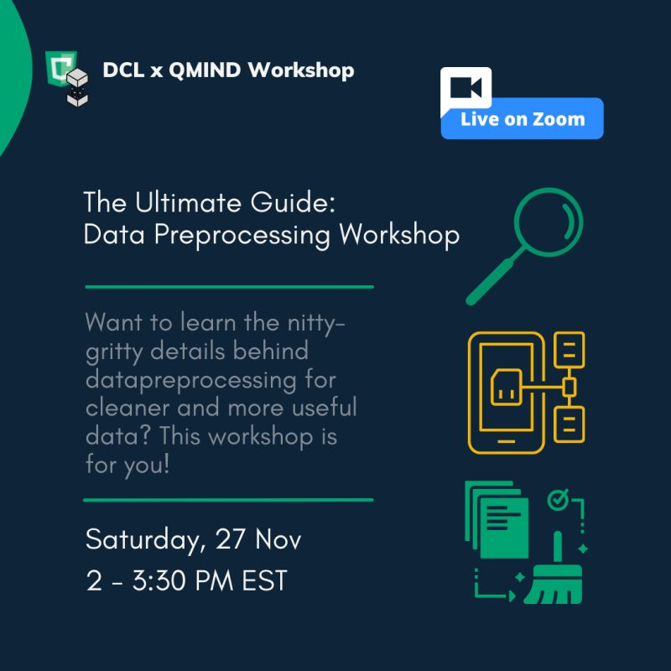

Activate to view larger imagewith Alexander Salgo and 1 other

* 11Max Bennett and 10 others

Like

Comment

Share

Send

Be the first to comment on this

**Feed post**

[Levi Stringer](https://www.linkedin.com/in/levistringer?miniProfileUrn=urn%3Ali%3Afs_miniProfile%3AACoAAAlvLssB3UxqbdGp8hANNXl3caFu32O9xn4" \t "_self)

[Levi Stringer• 2ndMachine Learning Task Force Lead at Kings Distributed Systems4mo • 4 months ago](https://www.linkedin.com/in/levistringer?miniProfileUrn=urn%3Ali%3Afs_miniProfile%3AACoAAAlvLssB3UxqbdGp8hANNXl3caFu32O9xn4" \t "_self)

Big thanks to QMIND for letting me share my experience!

[](https://www.linkedin.com/company/distributed-compute-labs/?miniCompanyUrn=urn%3Ali%3Afs_miniCompany%3A18672608" \t "_self)

[Distributed Compute Labs408 followers4mo • 4 months ago](https://www.linkedin.com/company/distributed-compute-labs/?miniCompanyUrn=urn%3Ali%3Afs_miniCompany%3A18672608" \t "_self)

[Seeing over 100 new and returning members at Camp QMIND, listening to a former Managing Director's journey, is absolutely mind-blowing. We're so proud to have been educating, sponsoring, and supporting](https://www.linkedin.com/feed/update/urn:li:activity:6850086994522062848/)[QMIND](https://www.linkedin.com/company/qumind/) for the past three years!  
  
[#DCL](https://www.linkedin.com/feed/hashtag/?keywords=dcl&highlightedUpdateUrns=urn%3Ali%3Aactivity%3A6850088890045399040) [#QMIND](https://www.linkedin.com/feed/hashtag/?keywords=qmind&highlightedUpdateUrns=urn%3Ali%3Aactivity%3A6850088890045399040) [#JavaScript](https://www.linkedin.com/feed/hashtag/?keywords=javascript&highlightedUpdateUrns=urn%3Ali%3Aactivity%3A6850088890045399040) [#Computing](https://www.linkedin.com/feed/hashtag/?keywords=computing&highlightedUpdateUrns=urn%3Ali%3Aactivity%3A6850088890045399040) [#Sponsorship](https://www.linkedin.com/feed/hashtag/?keywords=sponsorship&highlightedUpdateUrns=urn%3Ali%3Aactivity%3A6850088890045399040)

…see more

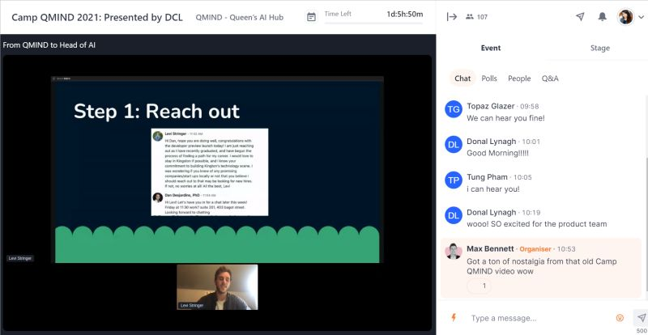

Activate to view larger imagewith Donal Lynagh and 4 others

* 24
* 1 comment

Like

Comment

Share

Send



Top of Form

Open Emoji Keyboard

Bottom of Form

Current selected sort order is Most relevantMost relevant

[[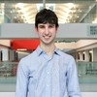](https://www.linkedin.com/in/tetris/jacobseiler/)](https://www.linkedin.com/in/tetris/jacobseiler/" \t "_self)

[Status is reachable](https://www.linkedin.com/in/tetris/jacobseiler/" \t "_self)

**[Jacob Seiler(He/Him) 1st degree connection1stDirector of Events @ QMIND | CS @ Queen's University | Incoming SDE @ Amazon](https://www.linkedin.com/in/tetris/jacobseiler/" \t "_self)**

3mo

Happy to have you Levi!

Like

1

Reply

**Feed post**

[](https://www.linkedin.com/in/jessica-boland-78696817?miniProfileUrn=urn%3Ali%3Afs_miniProfile%3AACoAAAOF_FYBvcTqXz0OgDPUpjJLNV4ZBze_E9M" \t "_self)

[Jessica Boland• 2ndManager, Career Education and Professional Experience at Queen's University - Faculty of Engineering and Applied Science1yr • 1 year ago](https://www.linkedin.com/in/jessica-boland-78696817?miniProfileUrn=urn%3Ali%3Afs_miniProfile%3AACoAAAOF_FYBvcTqXz0OgDPUpjJLNV4ZBze_E9M" \t "_self)

Hiring manager and recruiters - if you don’t know [QMIND](https://www.linkedin.com/company/qumind/) yet - give them a follow. This is an incredible group of undergraduate students designing innovative AI solutions to real-world problems. They’ve even designed their own course in AI to increase accessibility to content for [Queen's University](https://www.linkedin.com/company/queen's-university/) and beyond 🤩  
  
[#AI](https://www.linkedin.com/feed/hashtag/?keywords=ai&highlightedUpdateUrns=urn%3Ali%3Aactivity%3A6755321412589817856) [#ML](https://www.linkedin.com/feed/hashtag/?keywords=ml&highlightedUpdateUrns=urn%3Ali%3Aactivity%3A6755321412589817856) [#science](https://www.linkedin.com/feed/hashtag/?keywords=science&highlightedUpdateUrns=urn%3Ali%3Aactivity%3A6755321412589817856) [#stem](https://www.linkedin.com/feed/hashtag/?keywords=stem&highlightedUpdateUrns=urn%3Ali%3Aactivity%3A6755321412589817856) [#queensu](https://www.linkedin.com/feed/hashtag/?keywords=queensu&highlightedUpdateUrns=urn%3Ali%3Aactivity%3A6755321412589817856)

…see more

[](https://www.linkedin.com/company/qumind/?miniCompanyUrn=urn%3Ali%3Afs_miniCompany%3A18448654" \t "_self)

[QMIND912 followers1yr • 1 year ago](https://www.linkedin.com/company/qumind/?miniCompanyUrn=urn%3Ali%3Afs_miniCompany%3A18448654" \t "_self)

[QMIND is thrilled to release our lectures from our internal Camp QMIND training event this past fall. These are a great resource to anyone looking to expand their knowledge of AI or get an introduction to AI topics.  
  
You can find all the lecture videos as well as other great AI and ML educational resources on our Youtube Channel:](https://www.linkedin.com/feed/update/urn:li:activity:6754090440246513664/)<https://lnkd.in/eScF89a>

…see more

Your document has finished loading

* 4
* 1 comment

Like

Comment

Share

Send



Top of Form

Open Emoji Keyboard

Bottom of Form

Current selected sort order is Most relevantMost relevant

[[](https://www.linkedin.com/in/tetris/davidarthurs/)](https://www.linkedin.com/in/tetris/davidarthurs/" \t "_self)

**[David Arthurs 2nd degree connection2ndPresident/Founder, SKYMAX Consulting, Inc.](https://www.linkedin.com/in/tetris/davidarthurs/" \t "_self)**

1y

Very cool Jess, thank you for sharing! Following now. :)

Like

1

Reply

**Feed post**

[](https://www.linkedin.com/company/qumind/?miniCompanyUrn=urn%3Ali%3Afs_miniCompany%3A18448654" \t "_self)

[QMIND912 followers10mo • 10 months ago](https://www.linkedin.com/company/qumind/?miniCompanyUrn=urn%3Ali%3Afs_miniCompany%3A18448654" \t "_self)

QMIND 2021/22 Director Applications Due Tonight!  
  
Less than 24 hours left - don’t miss out on one of the best and most rewarding leadership experiences you’ll find. Be surrounded by talent, passion and innovation and do work that makes an impact far outside of Queen’s. Check out for yourself what some of QMIND’s current directors ([Christophe Gauthier](https://www.linkedin.com/in/ACoAACasVbQBK0i-qRb-a8pGPVYpGsqywImSWb8) and [Natalie Nova](https://www.linkedin.com/in/ACoAACHGcTsBD8sWz1L_cqB2Hhd_b0I9hg48reM)) have to say about their experience and the impact they’ve been able to make during their time as a Director.  
  
Apply Now: <https://linktr.ee/qmind>

…see more

Your document has finished loading

* 7

Like

Comment

Share

Send

Be the first to comment on this