Lab 3b

D0011E

# Part 1

We split the simulation into two screenshots since we could not fit it all in one.

The simulation for AND and OR.

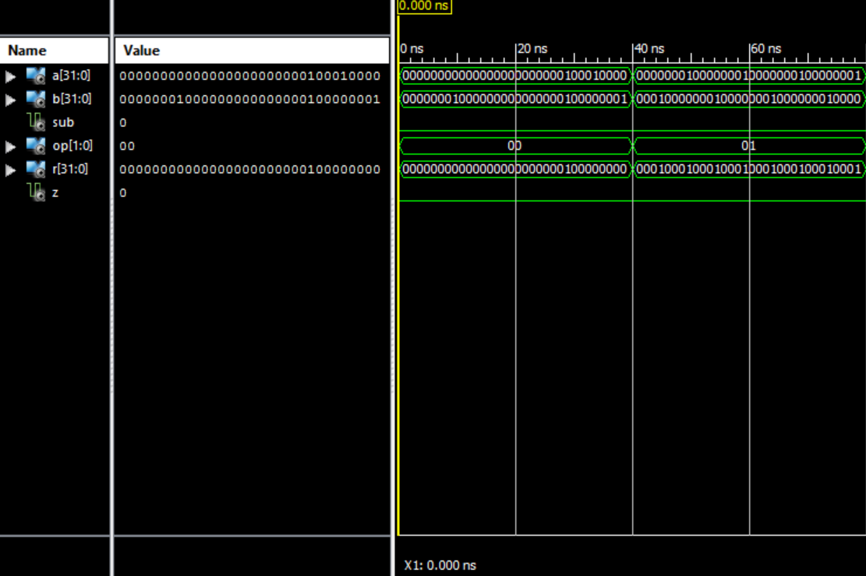

The simulation without AND and OR.

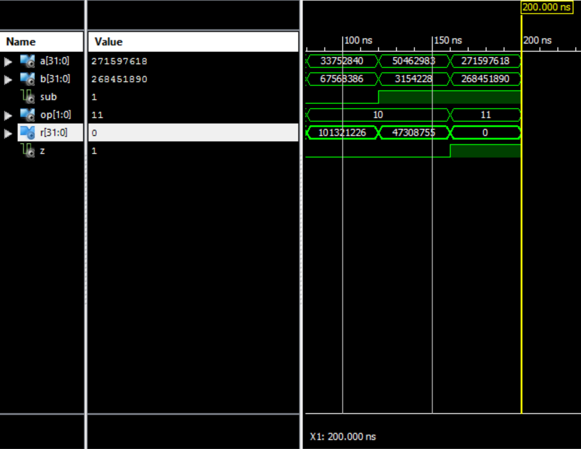

# Part 2

The RTL schematic for PCPlus4

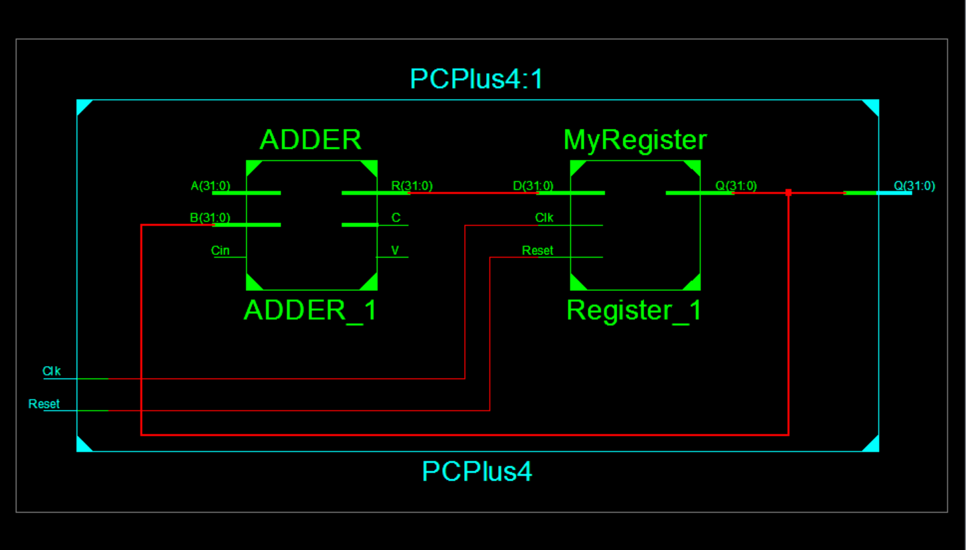

The simulation of PCPlus4

