# Restarting Pods With Encryption Key Creation

This document aims to present how sts-prod-encryption-key-creation lambda function gets permission to restart pods created by sts-js-avro-encryption-processor deployment. The same applies to all other environments.

The setup involves following resources.

* Role sts in golf-prd-cluster(EKS) in js-gol-f-prod AWS account
* Role Binding object: sts-binding in golf-prd-cluster (EKS) in js-gol-f-prod AWS account
* IAM role: sts-prd-js-encryption-role in js-gol-f-prod AWS account
* IAM role: sts-prod-encryption-key-creation-lambda-role in grada-cranberry-prod AWS account
* Lambda function: sts-prod-encryption-key-creation in grada-cranberry-prod AWS account

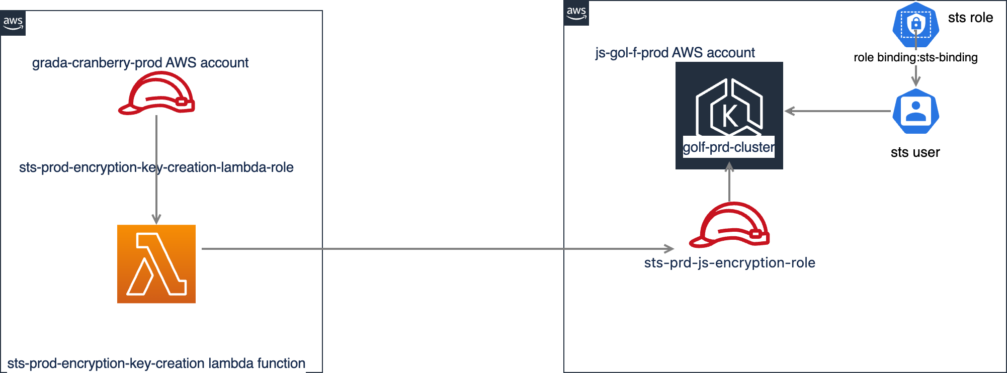

## Role sts in golf-prd-cluster(EKS) in js-gol-f-prod AWS account

A role in EKS contains rules that represent a set of permissions.  A rule specifies the actions it allows performing on different resources in the cluster. Existing sts role allows performing any action on deployments in sts namespace.

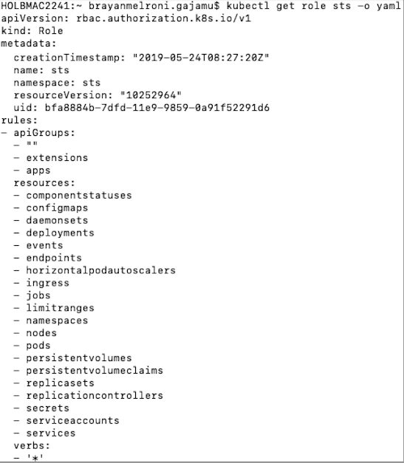

## Role Binding object: sts-binding in golf-prd-cluster (EKS) in js-gol-f-prod AWS account

A Role Binding object in an EKS cluster links a role with a user. sts role in EKS cluster is bound to a user called sts via an existing role binding object called sts-binding.

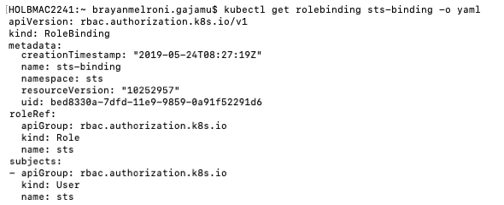

That means the sts user can perform all actions defined in sts role. So that sts user can perform any action on a deployment.

## IAM role: sts-prd-js-encryption-role in js-gol-f-prod AWS account

This is the IAM role for service account named sts:sts-prd-js-encryption-service-account. It was decided to do following changes to the role.

* sts user in EKS cluster was mapped to this IAM role via updating aws-auth config map in the kube-system namespace.

           Command used to update the mapping : kubectl edit  configmap aws-auth -n kube-system

           Updated aws-auth config map looks like below.

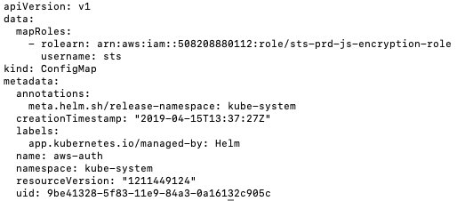

           After updating above configmap, 'sts-prd-js-encryption-role' IAM role inherits all the permissions from sts user. That means this role can now perform any action on a deployment in the EKS cluster.

           Reference: <https://docs.aws.amazon.com/eks/latest/userguide/add-user-role.html>

* Following statement was added to the policy attached to the role, so that this role gets permission to get descriptive information about the EKS cluster.

           {  
            "Action": [  
                "eks:DescribeCluster"  
            ],  
            "Effect": "Allow",  
            "Resource": "arn:aws:eks:eu-west-1:508208880112:cluster/golf-prd-cluster"  
         }

         Reference : <https://docs.aws.amazon.com/eks/latest/APIReference/API_DescribeCluster.html>

* The IAM role attached to the lambda function in grada-cranberry-prod AWS account was added as a trusted entity for this role, so that it can assume this role. Exact statement added is mentioned below.

          {  
            "Sid": "",  
            "Effect": "Allow",  
            "Principal": {  
                "AWS": "arn:aws:iam::903716715040:role/sts-prod-encryption-key-creation-lambda-role"  
            },  
            "Action": "sts:AssumeRole"  
        }

## IAM role: sts-prod-encryption-key-creation-lambda-role in grada-cranberry-prod AWS account

This is the IAM role for sts-prod-encryption-key-creation lambda function. Following policy was attached to this role, so that it can assume sts-prd-js-encryption-role in js-gol-f-prod AWS account.

{  
    "Statement": [  
        {  
            "Action": [  
                "sts:AssumeRole"  
            ],  
            "Effect": "Allow",  
            "Resource": "arn:aws:iam::508208880112:role/sts-prd-js-encryption-role"  
        }  
    ],  
    "Version": "2012-10-17"  
}

After setting all above, sts-prod-encryption-key-creation-lambda-role inherits following permissions.

* It can  perform any action on a deployment in the EKS cluster.
* It can describe EKS cluster, so that it can retrieve EKS API server endpoint and certificate authority data to access the cluster.

## Lambda function: sts-prod-encryption-key-creation in grada-cranberry-prod AWS account

* A lambda layer containing boto3, datetime, kubernetes[<https://github.com/kubernetes-client/python>] python packages were added to the function.
* Python code to assume the  sts-prd-js-encryption-role, connect to the EKS cluster and restart the pods was added.

Updated python code file can be found at <https://github.com/JSainsburyPLC/grada-cranberry-infrastructure/blob/prod/terraform/modules/encryption/lambda_python_scripts/create_new_encryption_keys.py>