# Unit Testing

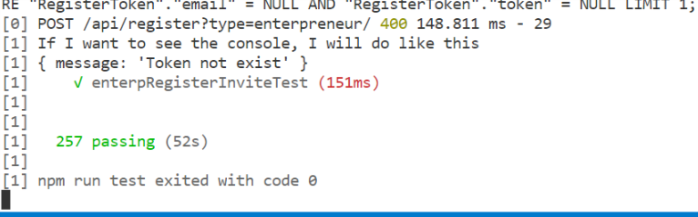

* 257 pass test case

# System testing

SSL report from Qualys

­­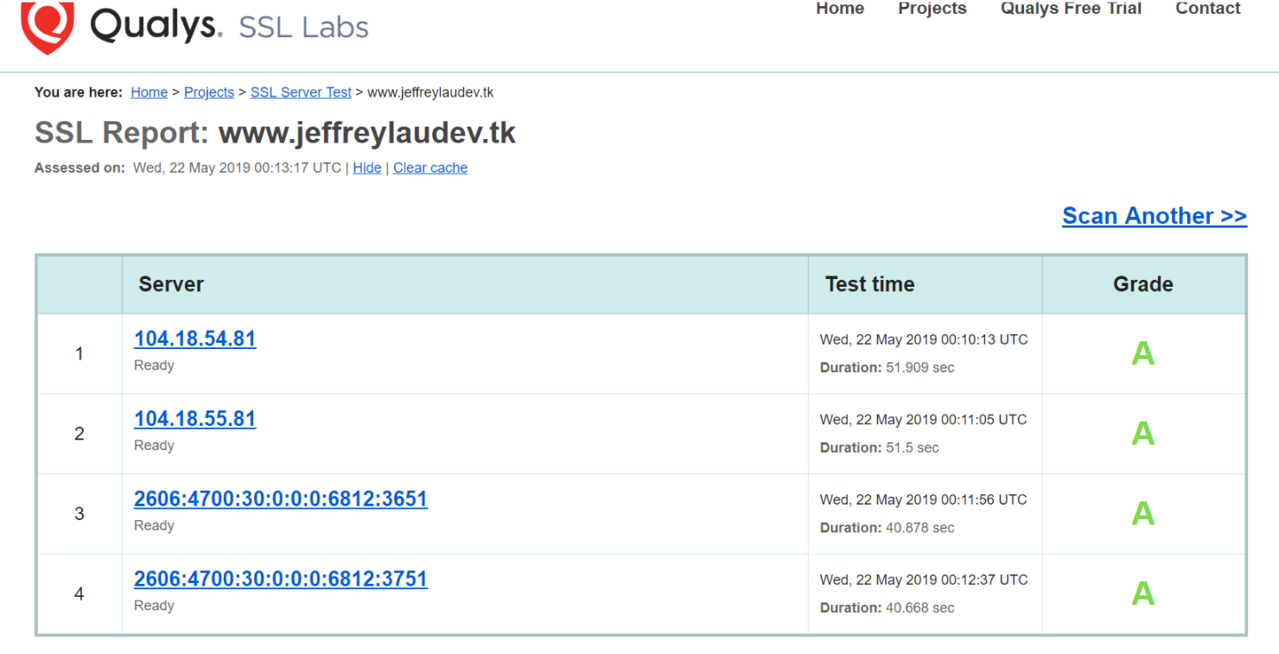

CloudFlare protection

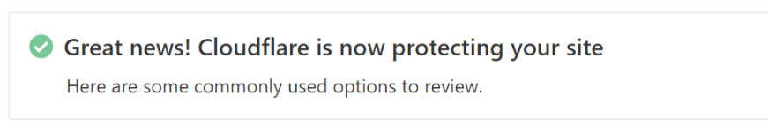

Audit Light House

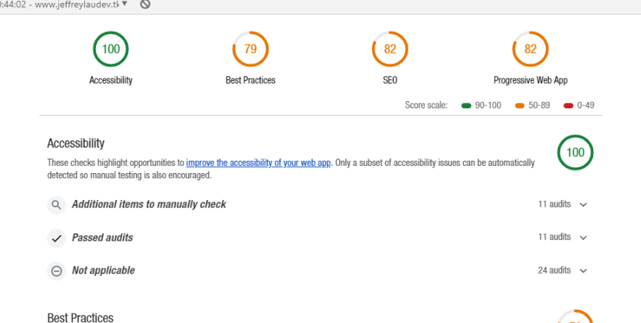

# Mannual Testing

* About 7 Users have test the product

# UI Automation Testing

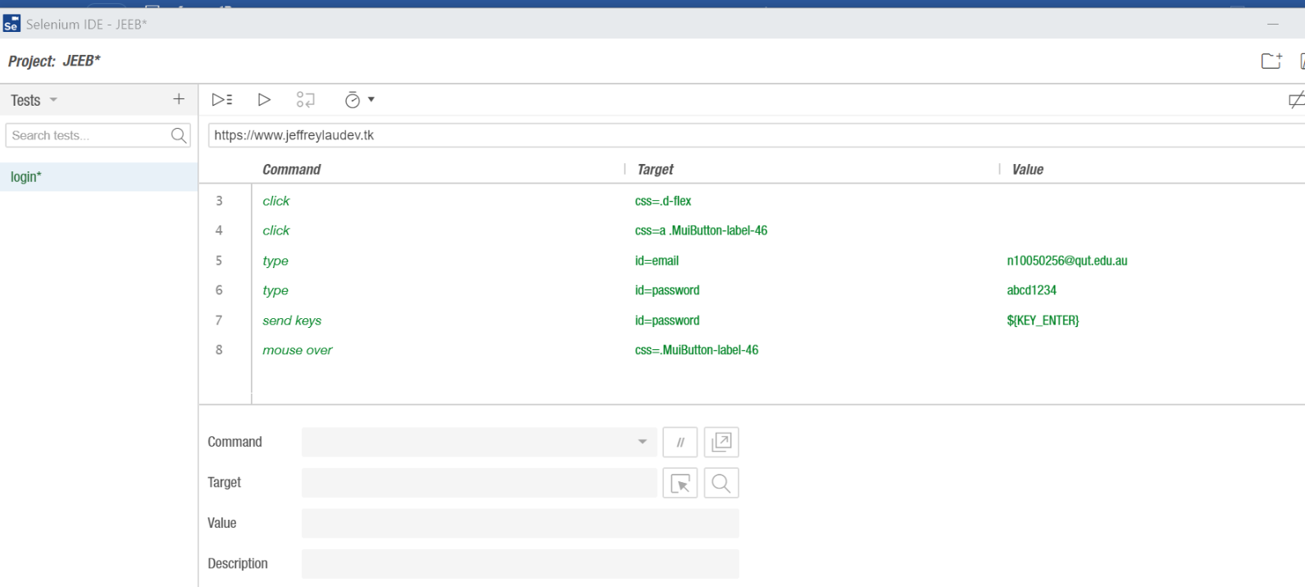

# User Acceptance Testing (UAT)

