**Lab 2 Report**

**LAB # 2**

**SECTION # 1**

**Ben Rayborn**

**SUBMISSION DATE: 02/03/2020**

**01/28/2020**

# Problem

**Problem 1: Creating Your Own Program**

This has us print our name, class, and the date, each on a new line. (1)

**Problem 2: A Simple Program with Input**

This has us write and test a program with given code to calculate the area of a rectangle (2). Then, we expanded this to calculate the volume of a cube and run the given test case cube 2x64x8. (3)

**Problem 3: Mysterious Output**

This was a debugging exercise. The first error used %lf where %d is needed. The second error was not stating the variable being referenced. The third error used %d where %lf is needed.

int main(int argc, char *argv[])

{

int integer_result;

double decimal_result;

integer_result = 77 / 5;

printf("The value of 77/5 is %d, using integer math.\n", integer_result);

//This used %lf where %d should be used for integers.

integer_result = 2 + 3;

printf("The value of 2+3 is %d.\n", integer_result);

//This didn't state the variable being referenced.

decimal_result = 1.0 / 22.0;

printf("The value 1.0/22.0 is %lf.\n", decimal_result);

//This used %d where %lf should be used for doubles.

return 0;

}

## Problem 4: Simple Arithmetic

This problem had us run several calculations to illustrate the results given a variety of integer and decimal inputs and integer and decimal outputs. We then had to create a calculation for area of a circle from circumference, a feet to meters conversion, and a Fahrenheit to Celcius conversion. For readability, I first calculated the radius from the circumference (radius = circumference/(2*pi)), then calculated the area (area = pi*r^2). For the remain two the conversions were given and it was a simple plug in, making sure order of operations is maintained. The discrepancies in program math vs. actual math are the following:

E: (22/3) runs first, giving 7

F: The final calculation 22/9 is truncated

J: Everything is calculated to 2.44, but is in the end assigned to an int, truncating to 2.

Screenshots (4) and (5) show running the program and the output in txt format.

**Problem 5: Working with I/O - Pythagorean Theorem**

This uses the Pythagorean Theorem to calculate the hypotenuse of a right triangle. It is run with the test case a = 5, b = 9. (6)

# Analysis

This lab provided experience in debugging as well as attention to detail. The errors intentionally introduced are common errors that will come up at some point, usually resulting in failure to compile. Some errors (maybe not errors at all depending on your intentions) resulted in a difference in expected answer based on the kind of input and output types for calculations. Other errors were user error in input, only caught after careful verification of the results to find where the input was entered incorrectly.

# Design

The design of these programs was well laid out in the lab instructions. Problem 4 may have been shortened by doing the print and calculation in one line rather than enter in the variables, run the calculation, then print the calculation.

# Testing

All programs compiled without error. Some tests were run where appropriate. All test cases explicitly given ran as expected.

# Comments

Hopefully this is sufficient. Please let me know if there are any gaps in the lab report that should be addressed in future reports.

# Screen Shots

1:

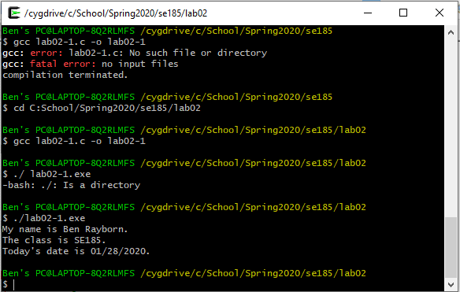

2:

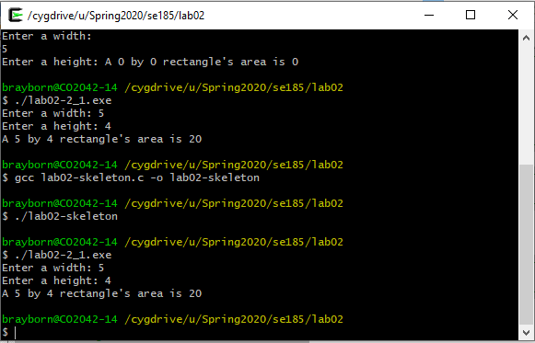

3:

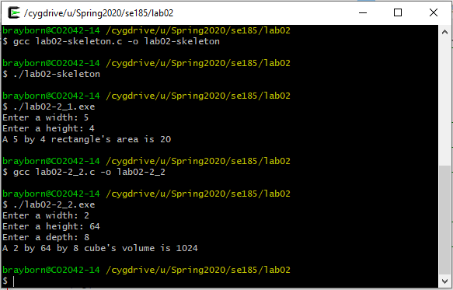

4:

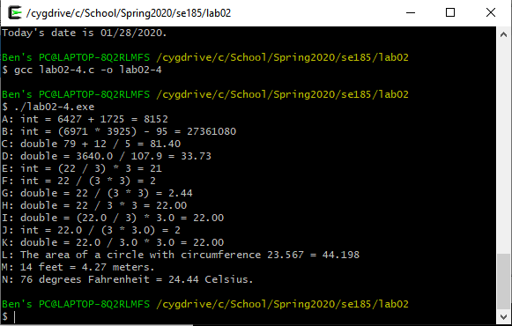

5:

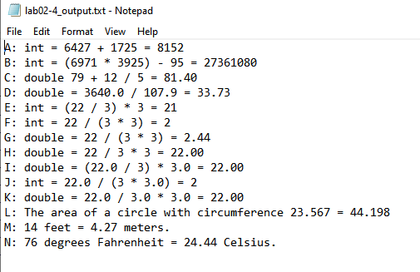

6:

