**Piggs Peak Project application user guide**

By Brayden Chase & Chris Collins

NBCC-Saint John

Technical Writing and Research

Table of Contents

Introduction 2

Scope 3

Purpose 4

User Guide 5

Logging in 5

Viewing Students 6

View and Edit Student Information 8

Adding a Student 10

More Page 13

Conclusion 14

# Introduction

Welcome to the Piggs Peak Project Application. This comprehensive user guide will cover everything you need to know in order to use the application. The guide covers step by step processes for everything from logging in to adding new students into the database. This application is a powerful tool that will greatly increase the efficiency of the Piggs Peak Projects overall goals.

# Scope

This application is intended to be used by staff members of the Piggs Peak Project and associated professionals. This app serves as a centralized platform for managing sponsorship details, tracking student progress, and facilitating the addition of new students into our program.

# Purpose

This application is intended to facilitate the addition of new students into the Piggs Peak Project by gathering student information through a single application. The application is capable of providing important information about students and their prioritization within the program. Users are capable of viewing individual student data or searching for students with specific criteria.

This application also aims to eliminate the need for paper copies of student information which subsequently requires to be added manually to the database. The application improves the security of the process as well through password encryption and authorization to keep vital information private.

# User Guide

## A screenshot of a login page Description automatically generatedLogging in

1. Enter your username into the ‘Username’ area on the form.
2. Enter your password into the ‘Password’ area on the form. If you have forgotten your password, you can select the ‘Forgot?’ button in this area.
3. Press the ‘Login’ button once your username and password have been entered.

## A screenshot of a computer Description automatically generatedViewing Students

1. Upon logging in, the user is presented with the student search page.
2. Users can filter their search results using the students first or last name, school, gender, or form number.
3. They can also view all students by leaving the search criteria blank. Press the ‘Search’ button to view the results.
4. Users can clear all search criteria by pressing the ‘Clear’ button.

1. The ‘Next’ and ‘Previous’ buttons are used to navigate the table filled from the search result.
2. To perform another search, click on the ‘Filter’ button to expand the search section.

## View and Edit Student Information

1. To view a student’s information, select a student from the table.

1. Once a student is selected, press the ‘Edit Student’ button to navigate to that student’s page. (See ‘Add Student’ section)
2. When a student is selected, users can also view the sponsorship history of that student by pressing the ‘View Sponsors’ button.

## Adding a Student

1. To add a new student, press the ‘Add Student' button on the student page.

1. New students entered into the database must have a name and gender before being accepted.

1. The five buttons on the top of the page navigate through each part of the student form.
2. The ‘Personal’ section displayed above allows for adding and removing pictures.

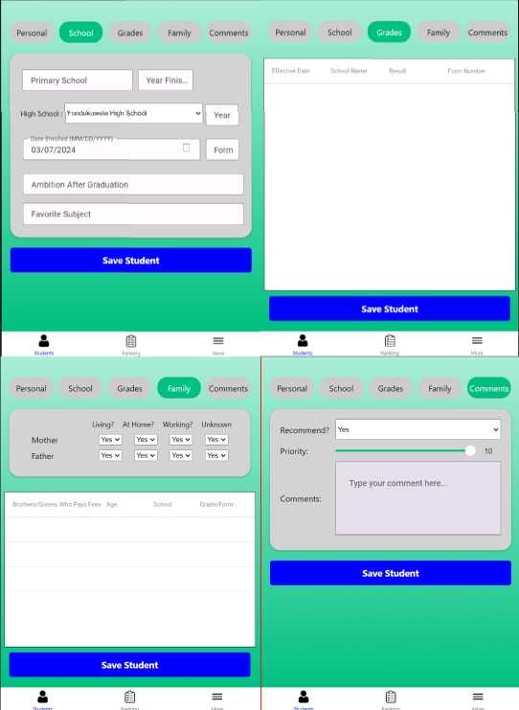

1. The subsequent sections of the form have additional information that can be collected.
2. The user can save a new student on any page by pressing the ‘Save Student’ button.

## More Page

1. The ‘More’ page gives the user the ability to log out of the current session by pressing the ‘Logout’ button.
2. The user can access the audit trail and missing data report from this section.

# Conclusion

This concludes the user guide on the Piggs Peak Project application. This application is available on Android, IOS and web platforms.

Users experiencing issues with their login credentials should contact a Piggs Peak Project staff member. Any issues with network connection should be reported to the system administrator.