Project: Todo Application Functional Tests
Course: CSD-380 Mod 4
Description: Five functional test cases against the Todo web app, mapped to the CSD-380 Business Requirements Document.
Date: 2026/06/26
To complete the test case plan, fill out the information for Project, Course, Description and Date in the header below.
.
TABLE OF CONTENTS
Page Load via Standard URL (Req 10) 2
Add a New Todo Item (Req 2) 2
Edit an Existing Todo Item (Req 3) 3

For each test, the developer should: provide a test description, a test objective, the developer name and date tested. For each step, fill out the actions to be taken and describe the expected results, and indicate yes or no for each step depending upon the result. The peer tester should provide their name, date tested, indicate yes or no for each step depending upon the result, and a screenshot (thumbnail) of the result.

Test 1 | Page Load via Standard URL
 | Test Objective: Verify that the Todo application loads correctly when accessed through its standard public URL. | Developer: Max Jankowski  Date tested: 2026/06/26 | Peer tester: Brayan Covarrubias  Date tested: 6/28/2026
Step | Action | Expected results: | Developer pass/fail | Tester pass/fail  + Screenshot
1 | Open a web browser and go to https://buwebdev.github.io/todo/ | The Todo application page loads without any browser errors, network errors, or blank content. | Yes | 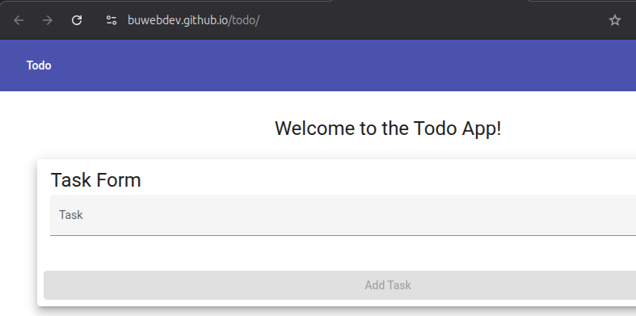  Yes
2 | Inspect the page title displayed in the browser tab | The browser tab title reads Todo. | Yes | 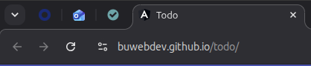  Yes
3 | Verify the page contains a visible input field for adding tasks | An input field or text box is visible and available on the page. | Yes | 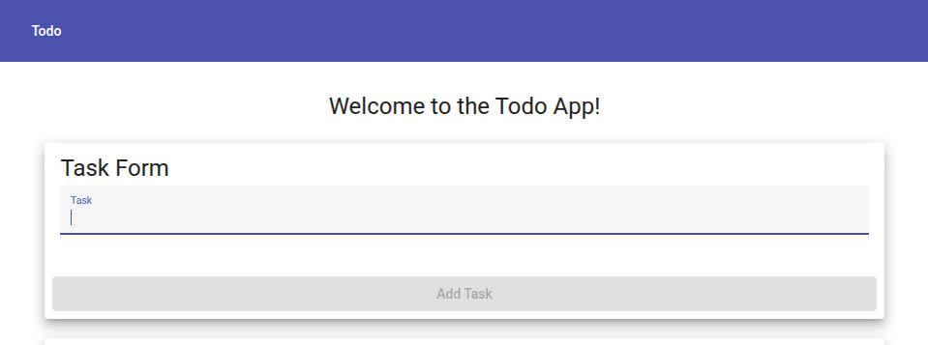  Yes
4 | Press F5 or click the browser Refresh button to reload the page | The page reloads successfully without errors and returns to its default state. | Yes | 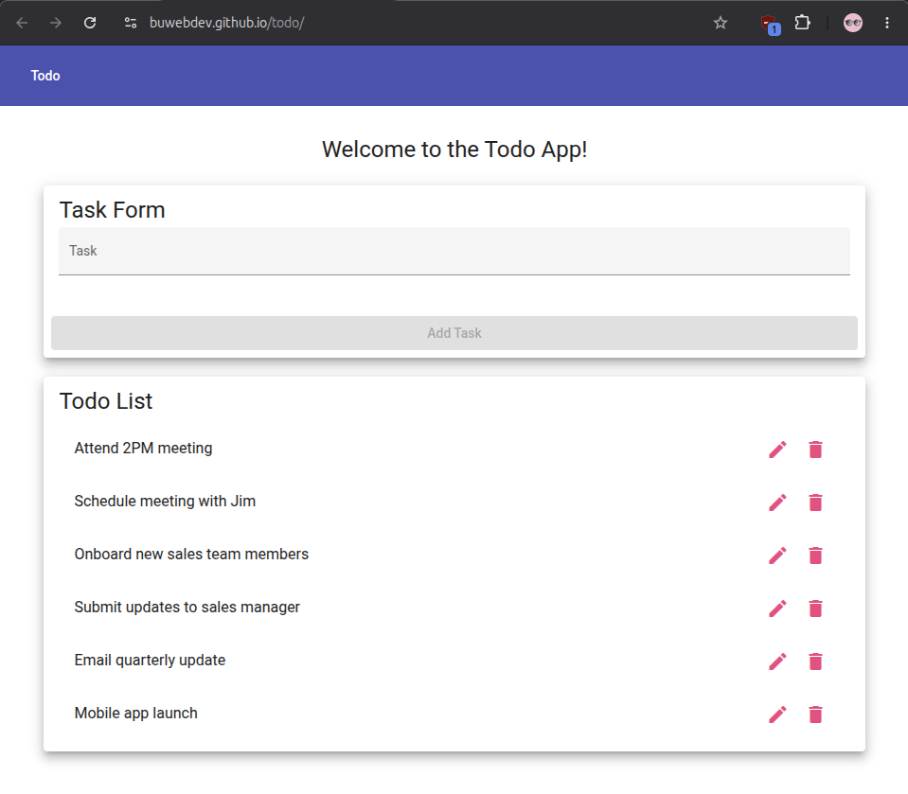  Yes
5 | Copy the URL, open a new browser tab, paste the URL, and press Enter | The Todo application loads in the new tab in the same way as the original tab. | Yes | 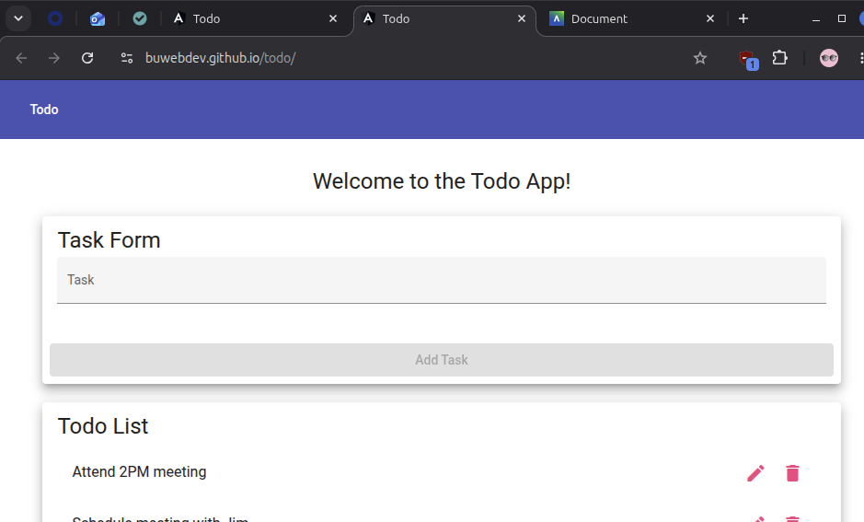  Yes
Comments | Page load is the first gate for all other functionality — if the URL fails, no other test can proceed. This test was verified in Google Chrome; the result should be consistent across Firefox and Edge. Any difference in behavior across browsers should be flagged as a separate defect against Req 10.

Test 2 | Add a New Todo Item
 | Test Objective: Verify that a user can enter text into the input field and successfully add a new task to the todo list. | Developer: Max Jankowski  Date tested: 2026/06/26 | Peer tester: Brayan Covarrubias  Date tested: 6/28/2026
Step | Action | Expected results: | Developer pass/fail | Tester pass/fail
1 | Starting at https://buwebdev.github.io/todo/ and confirm the page has loaded | The page loads and the input field is visible and empty. | Yes | 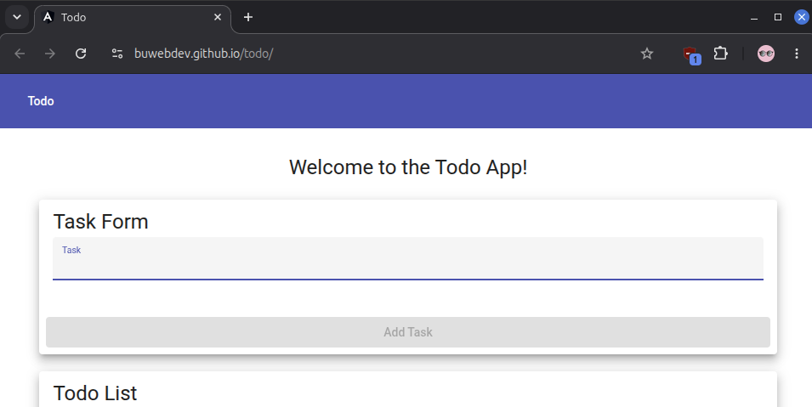  Yes
2 | Click inside the input field and type: Complete CSD-380 assignment | The typed text appears inside the input field as it is entered. | Yes | 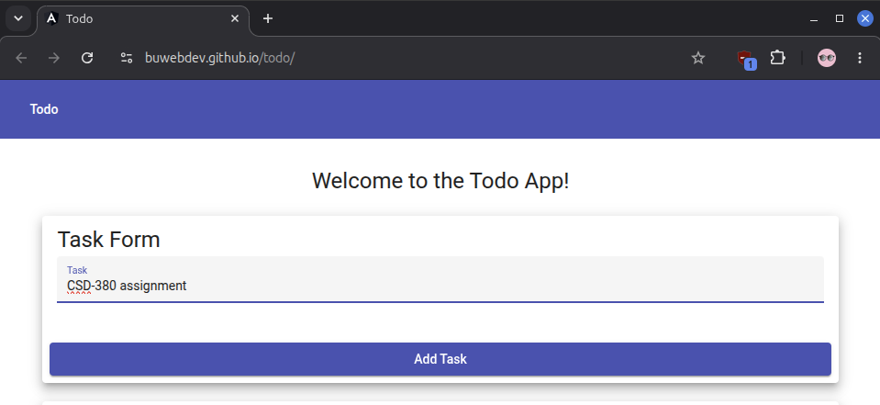  Yes
3 | Press the Enter key or click the Add button to submit the task | The new task Complete CSD-380 assignment appears in the task list below the input field. | Yes | 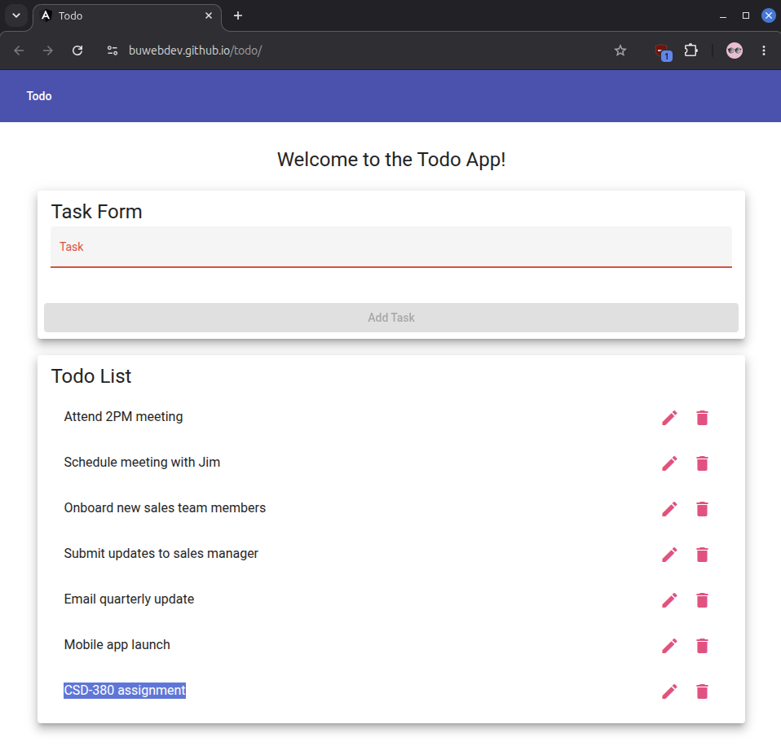  Yes – Enter key does not Add Task, must click button
4 | Confirm the input field is cleared after submission | The input field returns to an empty state after the task is added. | Yes | 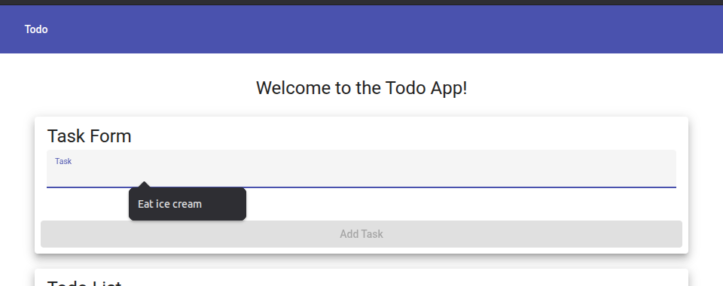  Yes
5 | Add a second task by typing Review test plan and pressing Enter | The second task Review test plan appears in the list below the first task. | Yes | 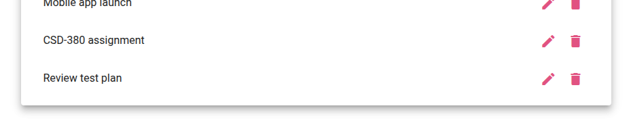  Yes, but no Enter, must click Add Task
Comments | Adding tasks is the highest-priority create requirement and the core function of the application. The test confirms both that the task is stored in the list and that the input field resets correctly to allow additional entries. The two-task sequence in step 5 begins to verify that the list can hold multiple items without overwriting the previous entry.

Test 3 | Edit an Existing Todo Item
 | Test Objective: Verify that a user can open an existing task for editing, modify its text, save the changes, and confirm the updated text is reflected in the task list. | Developer: Max Jankowski  Date tested: 2026/06/26 | Peer tester: Brayan Covarrubias  Date tested: 6/28/2026
Step | Action | Expected results: | Developer pass/fail | Tester pass/fail
1 | Go to https://buwebdev.github.io/todo/ and add the task: Original task text | The task Original task text appears in the list. | Yes | 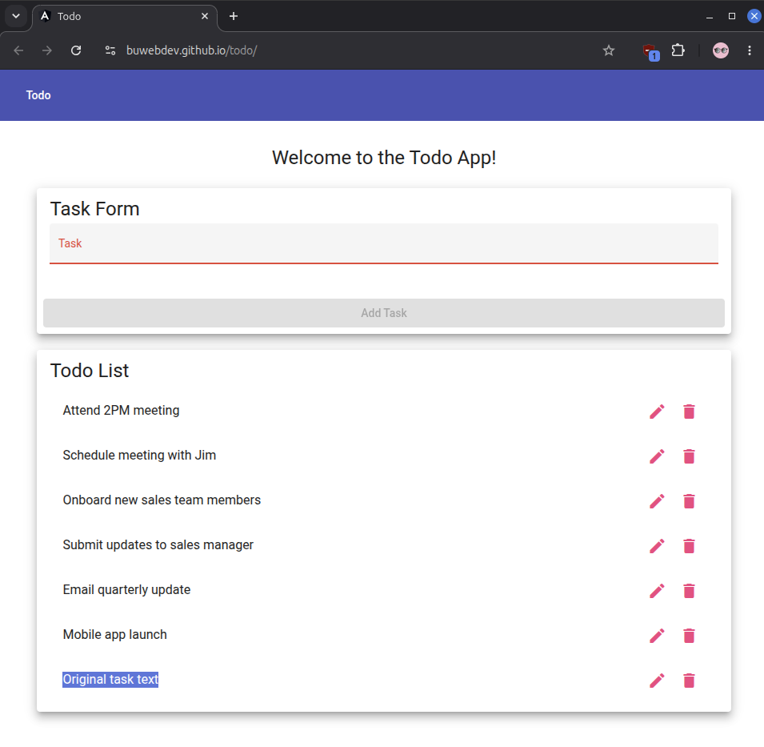  Yes
2 | Locate and click the edit control for Original task text (typically a pencil icon or double-click) | Task enters an editable state, displaying an input field pre-filled with Original task text. | Yes | 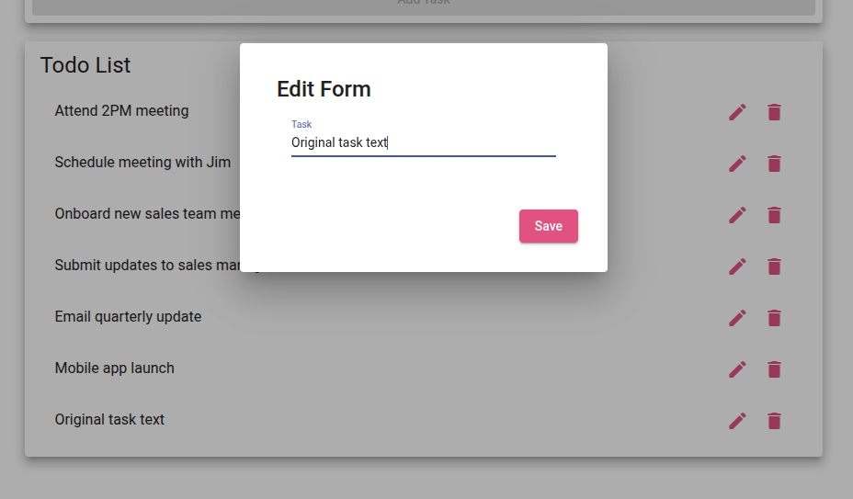  Yes
3 | Clear the existing text and type: Updated task text | Input field now contains only Updated task text. | Yes | 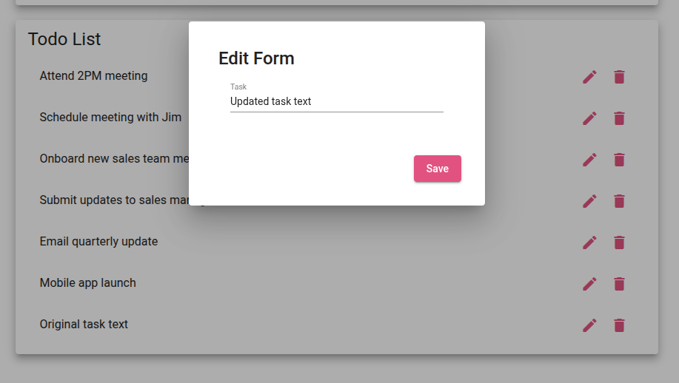  Yes
4 | Save the edit by pressing Enter or clicking the save/confirm button | The task list displays Updated task text in place of Original task text. The edit input is no longer visible. | Yes | 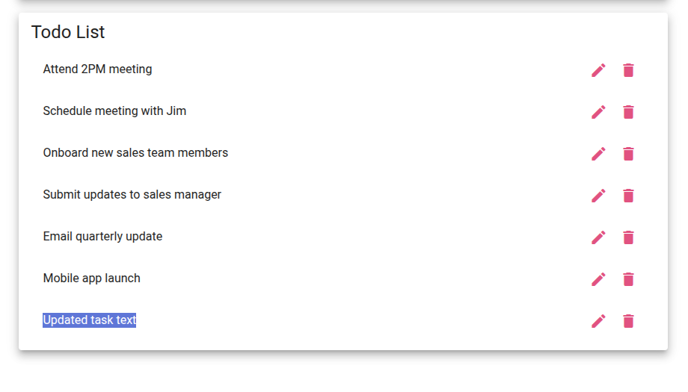  Yes
5 | Verify no duplicate entry was created by the edit | The list contains exactly one item reading Updated task text. Original task text no longer appears. | Yes | 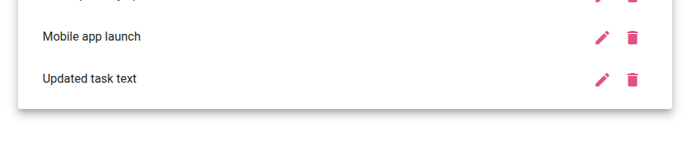  Yes
Comments | Edit is ranked 4th in the BRD, making it the third-highest priority functional requirement post URL access and task creation. Steps 4 and 5 together confirm that the edit replaces the original entry rather than appending a duplicate, which would be a data integrity failure.

Test 4 | Delete a Todo Item
 | Test Objective: Verify that a user can permanently remove a task from the todo list and that only the targeted item is deleted. | Developer: Max Jankowski  Date tested: 2026/07/26 | Peer tester: Brayan Covarrubias  Date tested: 6/28/2026
Step | Action | Expected results: | Developer pass/fail | Tester pass/fail
1 | Go into https://buwebdev.github.io/todo/ and add two tasks: Task to keep and Task to delete | Both tasks appear in the task list. | Yes | 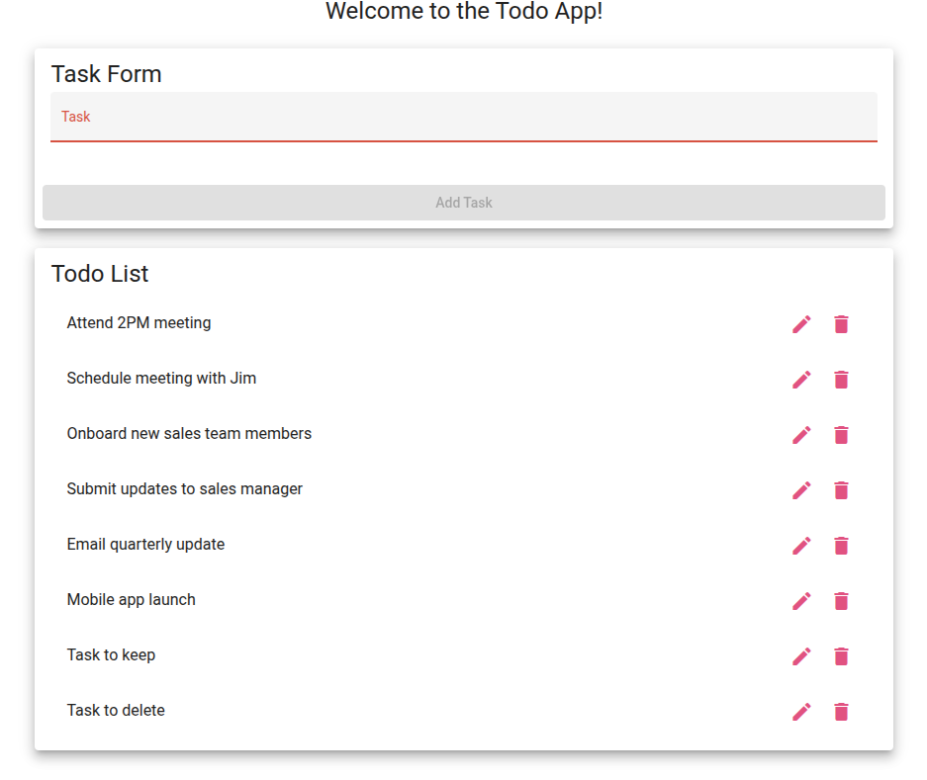  Yes
2 | Locate the delete button or control (often an X icon) for Task to delete and click it | The Task to delete entry is removed from the list immediately. | Yes | 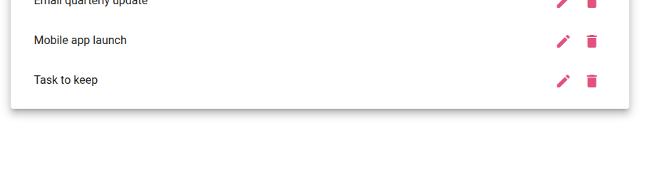  Yes
3 | Confirm that Task to keep is still present in the list after the deletion | Task to keep remains in the list and is unaffected by the deletion of the other item. | Yes |   Yes
4 | Refresh the browser page | delete remains gone after the refresh. Task to keep is still present. | Yes | 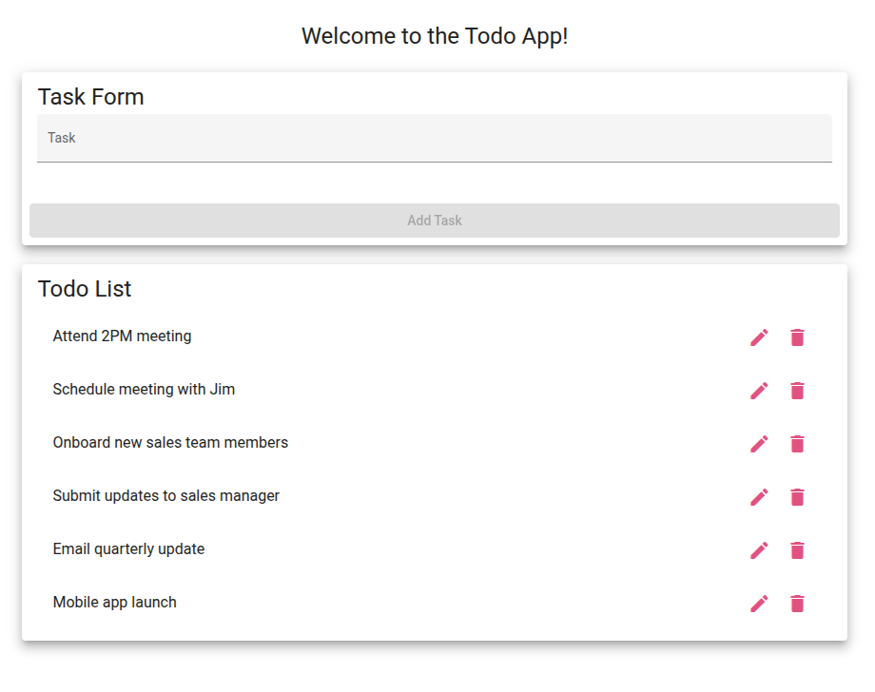  No – all tasks are reset when refreshed
5 | Delete Task to keep using the same delete control | Keep is removed from the list, leaving the list empty. | Yes |   No – doesn’t exist after being reset by refresh
Comments | Delete is a destructive action and we don’t want to have the user perform this by mistake, so confirming that only the targeted item is removed is as important as confirming the deletion itself works. The refresh in 4 checks whether the deletion is properly persisted. The final step verifies that deletion works consistently for any item in the list, not just the first one added.

Test 5 | Empty Form Validation
 | Test Objective: Verify that the application prevents users from submitting a blank entry on both the create form and the edit form. | Developer: Max Jankowski  Date tested: 2026/07/26 | Peer tester: Brayan Covarrubias  Date tested: 6/28/2026
Step | Action | Expected results: | Developer pass/fail | Tester pass/fail
1 | Go to https://buwebdev.github.io/todo/ and click inside the new task input field without typing anything | The input field is empty and focused. | Yes | 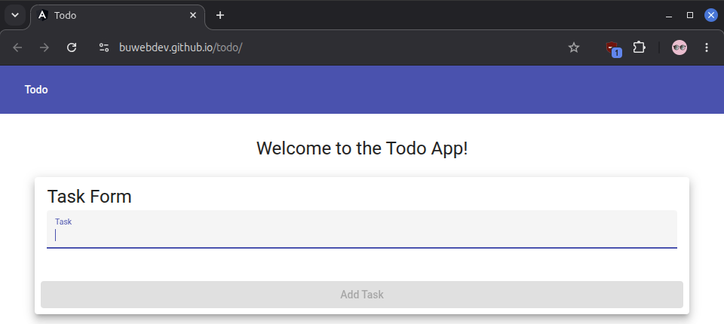  Yes
2 | Press the Enter key or click the Add/Submit button without entering any text | The application does not add a blank item to the list. An error indicator or simple prevention of submission is shown. | Yes | 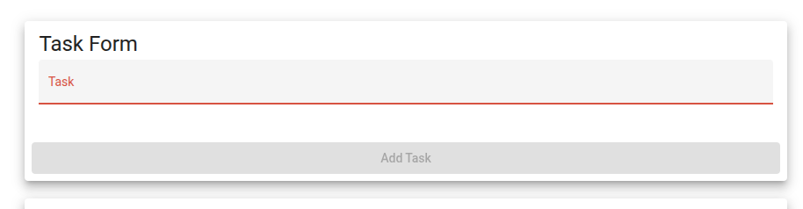  Yes
3 | Add a valid task: Test validation task. Then click its edit control to open the edit form | Thee task enters edit mode with its current text pre-filled in the edit input field. | Yes | 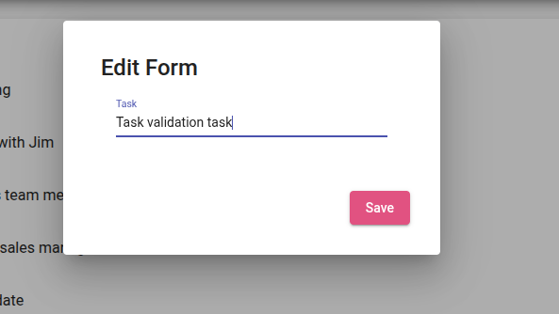  Yes
4 | Clear all text from the edit input field so it is empty, then attempt to save by pressing Enter or clicking confirm | Application does not save the blank edit. An error indicator is shown and the original text is preserved. | Yes | 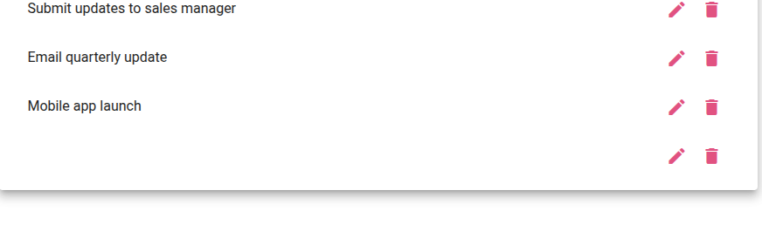  No – task is saved with empty text
5 | Type Validated edit text into the edit field and save | The task is updated to Validated edit text, confirming that valid edits still save correctly after the empty entry prevention is in place. | Yes | 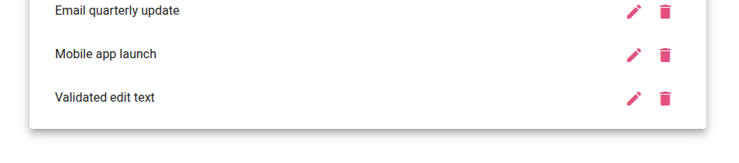  Yes
Comments | Step 5 included to confirm that validation logic does not break normal saving behavior, a common side effect of overly aggressive input guards. If the application accepts blank submissions on either form, it should be logged as a defect against the specific requirement number.

Resources:

10 important guidelines | practitest. (n.d.). https://www.practitest.com/resource-center/article/write-a-test-case/

testrail. (n.d.-a). https://www.testrail.com/blog/effective-test-cases-templates/

