Patrice Moracchini
CSD380-308A
June 25th, 2026

Todo Application Test Plan
Assignment module 4.2
Pr. Sampson

Test 1 | Create a new todo task item
 | Test Objective:  The test checks that the user can add a task item to the Todo list. | Developer: Patrice Moracchini  Date tested: 2026/06/25 | Peer tester: Brayan Covarrubias  Date tested: 6/28/2026
Step | Action | Expected results: | Developer pass/fail | Tester pass/fail
1 | Visit https://buwebdev.github.io/todo/ | The browser displays the page. | Yes | 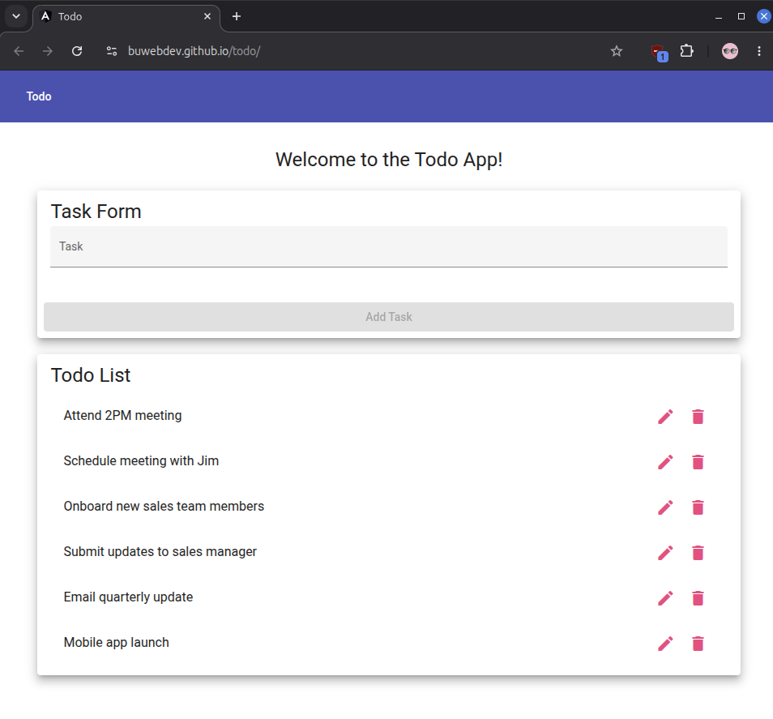  Yes
2 | Click in the task form box. | The cursor appears under “Task”. | Yes | 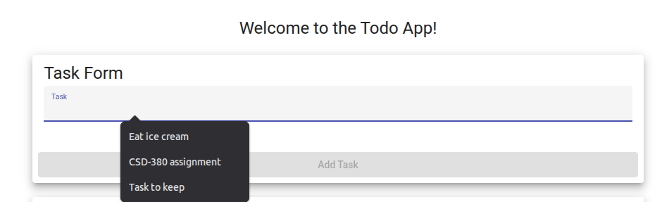  Yes
3 | Type the new task item. | The text appears as the user types it. | Yes | 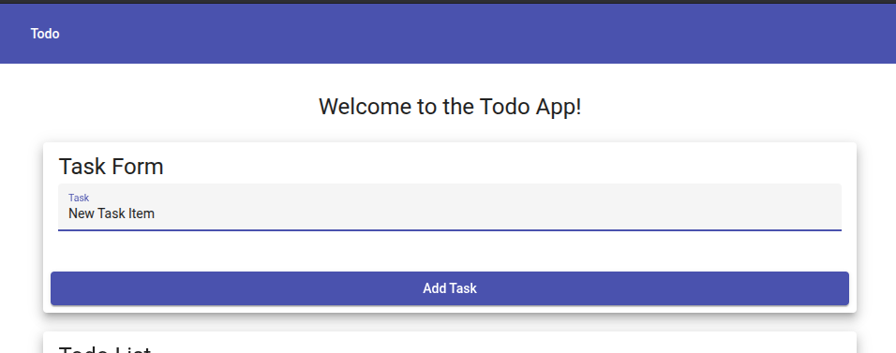  Yes
4 | Click “Add Task”. | The box is clickable and the task is submitted. | Yes |   Yes
5 | Scroll down to check the task has been added. | The task appears at the bottom of the list. | Yes | 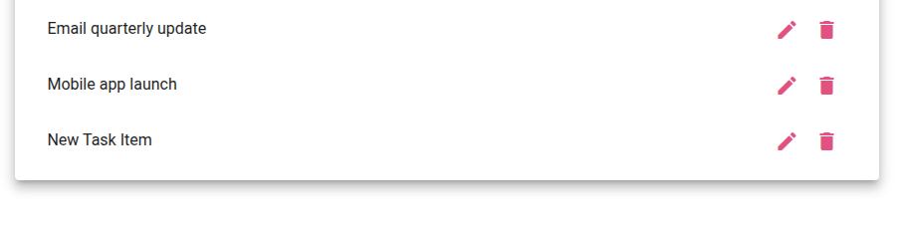  Yes
Comments | Objective complete – page was able to successfully load up and display properly, task was able to be added and appeared at the bottom of the list view.

Screenshot:

Test 2 | View a list of todo task items
 | Test Objective:  The test checks that the user is able to view a list of todo task items. | Developer: Patrice Moracchini  Date tested: 2026/06/25 | Peer tester: Brayan Covarrubias  Date tested: 6/28/2026
Step | Action | Expected results: | Developer pass/fail | Tester pass/fail
1 | Visit https://buwebdev.github.io/todo/ | The browser loads the page without error. | Yes | 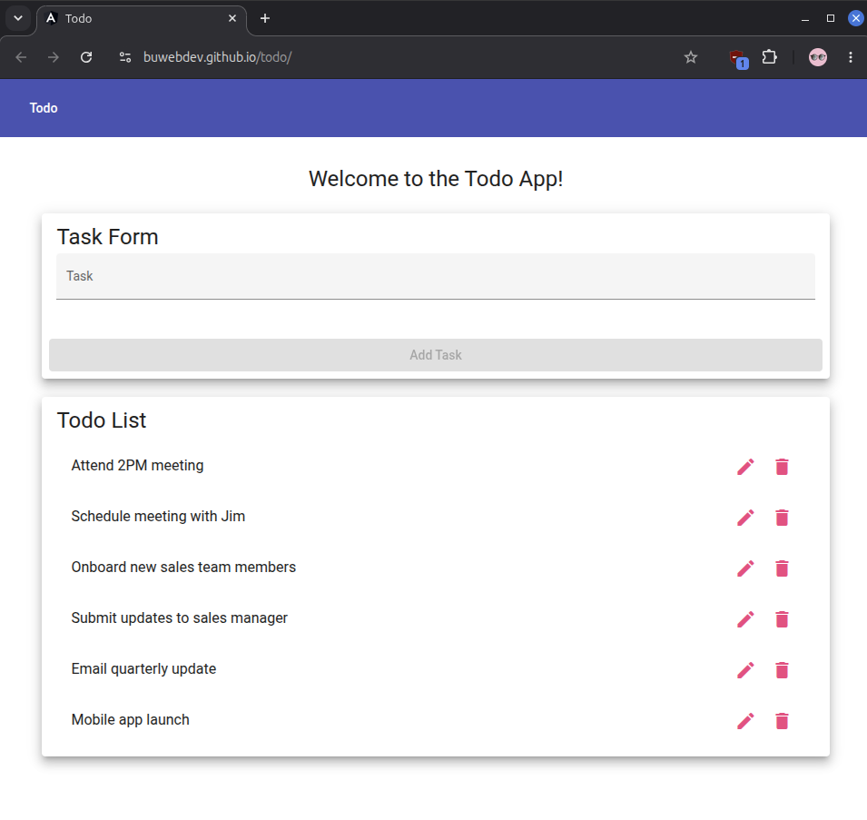  Yes
2 | Scroll down to see the complete todo list | The page is responsive the scroll works and it displays the complete todo list. | Yes |   Yes
3 | Refresh the page. | The browser displays correctly the page with the todo list. | yes |   Yes
Comments | Objective complete – the browser does display the page correctly without error with a sample task list to view, even after refreshing.

Screenshot:

Test 3 | Edit a todo task item
 | Test Objective:  The test checks that the user can edit a task item from the list. | Developer: Patrice Moracchini  Date tested: 2026/06/25 | Peer tester: Brayan Covarrubias  Date tested: 6/28/2026
Step | Action | Expected results: | Developer pass/fail | Tester pass/fail
1 | Visit https://buwebdev.github.io/todo/ | The browser displays the page. | Yes |   Yes
2 | Click the pencil-shaped icon. | The icon is clickable and an “Edit Form” window appears with the task, a cursor and a save button. | Yes | 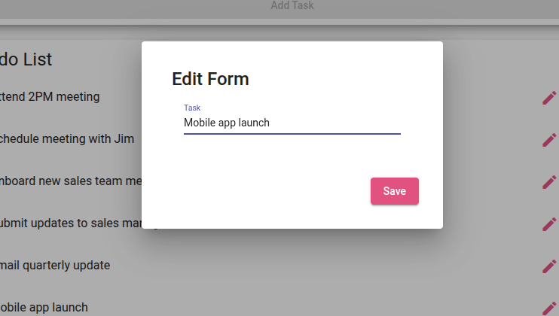  Yes
3 | Edit the task and submit it. | The task can be edited and saved. | Yes | 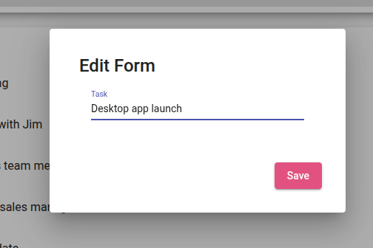  Yes
4 | Confirm that the task has been edited and appears in the list. | The edited task is listed. | Yes | 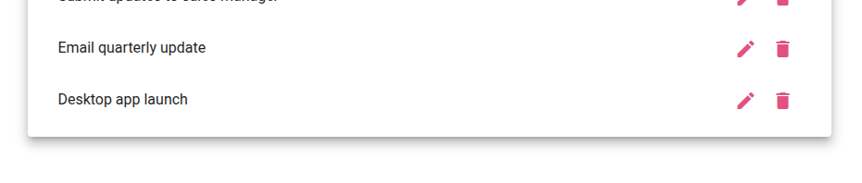  Yes
Comments | Objective complete – I was able to get the page to display and able to edit any task using the pencil-shaped icon. The task of “Mobile app launch” was successfully updated as “Desktop app launch” after saving edit form.

Screenshot:

Test 4 | Delete a todo task item
 | Test Objective:  The test checks that the user is able to delete a task item from the list. | Developer: Patrice Moracchini  Date tested: 2026/06/25 | Peer tester: Brayan Covarrubias  Date tested: 6/28/2026
Step | Action | Expected results: | Developer pass/fail | Tester pass/fail
1 | Visit https://buwebdev.github.io/todo/ | The browser displays the page. | Yes |   Yes
2 | Click on the “trash can” shaped icon corresponding to the task that the user wants to delete. | The app removes the chosen task. | Yes | 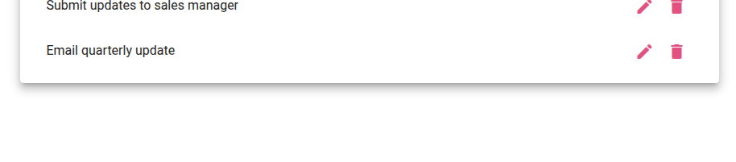  Yes
3 | Review the list. | The chosen task has been removed from the list. | Yes | 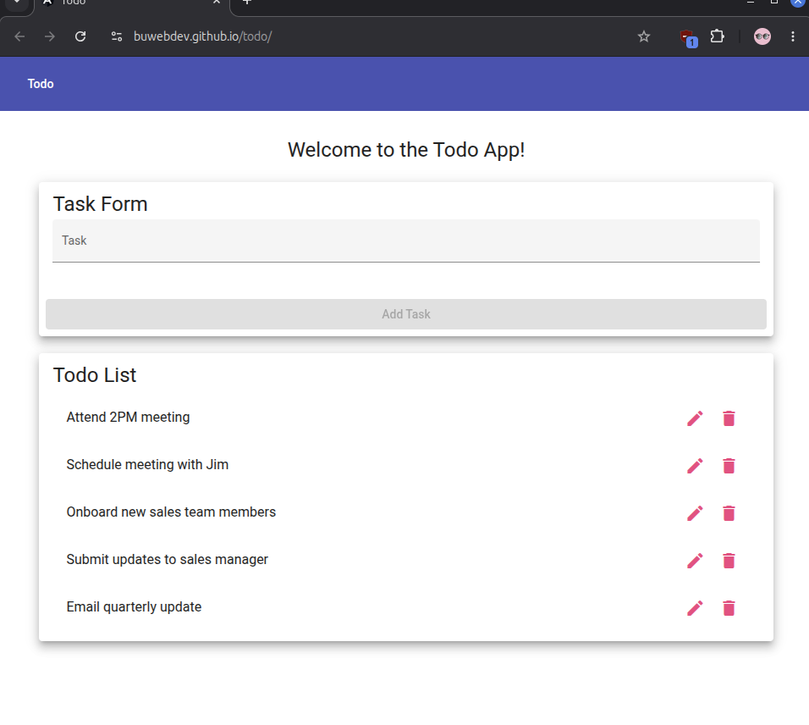  Yes
Comments | Objective complete – upon page load, I was able to delete the “Mobile app launch” task using the trash can icon. Task disappeared from the list view, indicating successful deletion.

Screenshot:

Test 5 | For invalid URLs, provide users with a custom 404 error page
 | Test Objective:  The test checks that when the user enters an invalid URL, the browser will display a custom 404 error page. | Developer: Patrice Moracchini  Date tested: 2026/06/25 | Peer tester: Brayan Covarrubias  Date tested: 6/28/2026
Step | Action | Expected results: | Developer pass/fail | Tester pass/fail
1 | Visit https://buwebdev.github.io/tod | The browser requests an address with a character missing. | Yes | 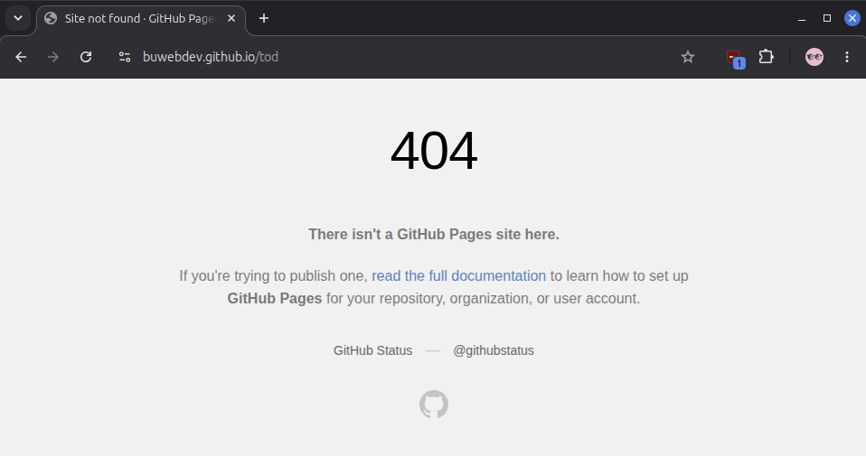  Yes
2 | Review the displayed page. | A 404 error page with a custom message appears | Yes |   Yes
3 | Refresh the page with the same typo. | The same 404 error page appears. | Yes |   Yes
4 | Enter the right address https://buwebdev.github.io/todo/ | The page displays correctly without error. | Yes | 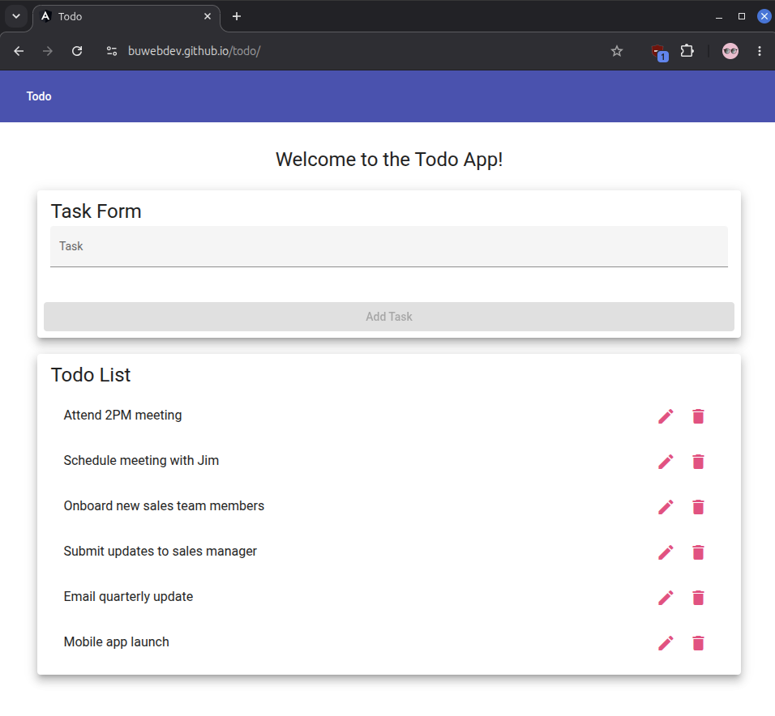  Yes
Comments | Objective complete – when the URL is requested incorrectly, a GitHub 404 error page shows up on initial and repeated attempts. Worth noting the page is a default GitHub 404 error page, not a custom one.

Screenshot:

