Explore Rexburg Site Plan

Brayden Dawson

WDD 130

Overview

Purpose

The purpose of my site is to be a guide to people that have recently moved to or are visiting Rexburg. This site is to help those in Rexburg to find places in Rexburg that are hidden gems from the perspective of locals. It’s designed to help you explore your area smarter and discover great places you might have missed.

Audience
The targeted audience for this site are college students and young adults looking for good hangout or study spots, new residents or visitors who want quick, trustworthy local recommendations and community members interested in exploring their town more deeply.

Branding

Website Logo
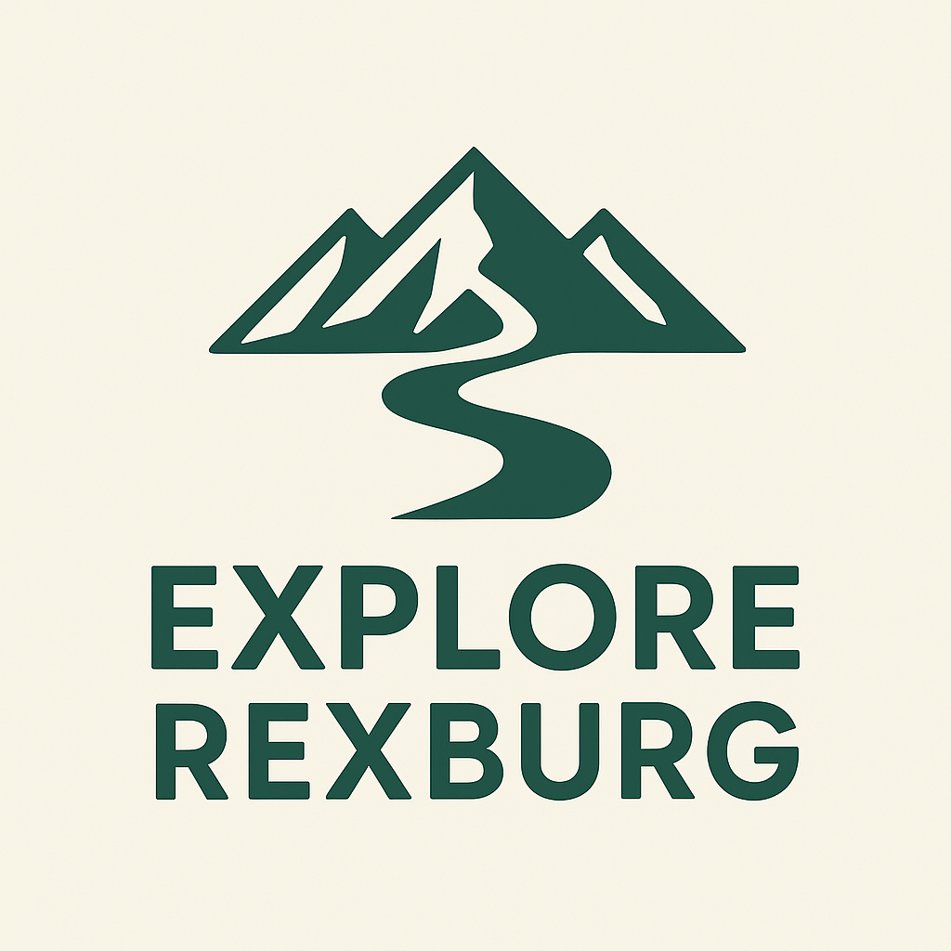

Style Guide

Color Palette
Primary | Secondary | Accent 1 | Accent 2
#F2D0A9 | #6D98BA | #B48291 | #3A5A40

Typography

Heading Font: Lexend Deca

https://fonts.google.com/selection?categoryFilters=Feeling:%2FExpressive%2FCalm

Paragraph Font: Delius

https://fonts.google.com/specimen/Delius?categoryFilters=Feeling:%2FExpressive%2FCute

Navigation
Home Explore Favorites

Content
Rexburg rapids:
Rexburg Rapids is the perfect place to soak off the heat of the summer here in southeast Idaho!
Here you'll find:
Two Water Slides, Splash Park, Lazy River, Splash Climbing Wall, Lap Pool, & Much More!

Fat Cats Rexburg:
Fat Cats Rexburg is a family-friendly entertainment center packed with things to do for all ages. Whether you’re looking to bowl a few games, catch the latest movie, play arcade favorites, or enjoy great food, it’s the go-to spot in Rexburg for casual fun. The atmosphere is upbeat and welcoming, making it perfect for date nights, group outings, or a relaxed night with friends.
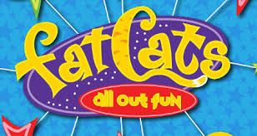
Yellowstone Bear World:
No vacation to the Yellowstone National Park or Grand Teton National Park region is complete without an adventure into the wild at Yellowstone Bear World, a drive-thru wildlife park. During your visit you will be surrounded by the free-roaming wildlife of North America as you drive your personal vehicle through the park. Wildlife you will see includes Rocky Mountain Elk, Bison, White-tail Deer, Mule Deer, Rocky Mountain Goats, and of course American Black Bear and Grizzly Bear. Remember to visit our petting zoo, enjoy the amusement rides, dine at the Hungry Bear Cafe, and explore the animatronic dinosaurs in Jurassic Creek!
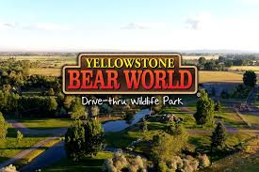
BYU-Idaho Ropes Course:
Looking for a fun FHE activity? Check out the Ropes Course! They're three levels for every challenge: the bottom level has moderate challenges and the top level is the most difficult. You'll be connected to a continuous belay system to keep you safe while you explore the course.
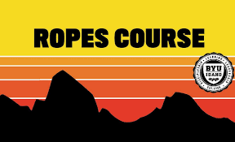

Wireframes

Home
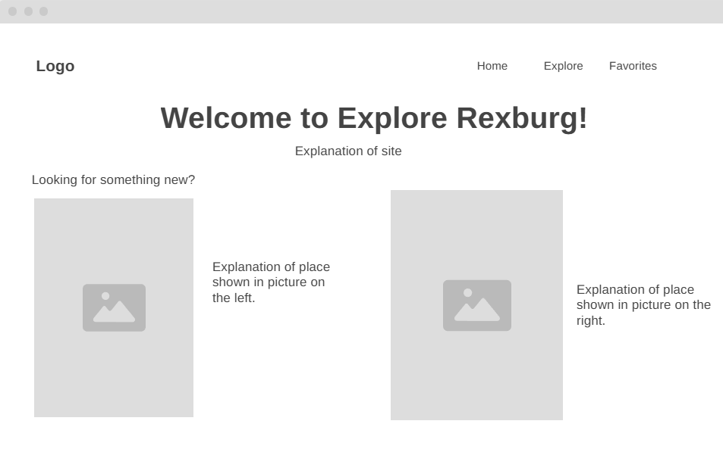

Page 1 (Explore)
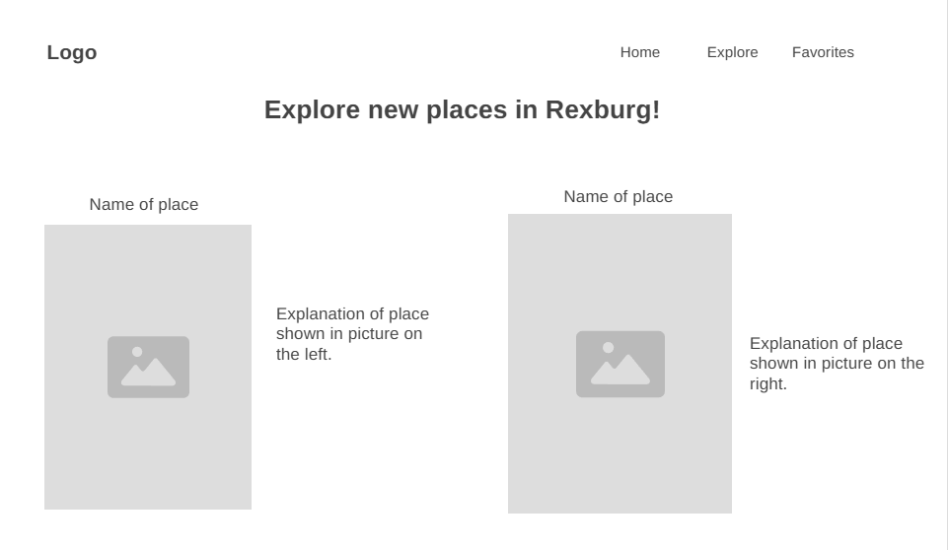
Page 2 (Favorites)
