Judith Martin: A00278762

Blake Gervais: A00287928

Brayden Liinamaa: A00291859

**Project Scope:**

The main idea behind the app is to encourage more people to practice drawing every day.

The app will connect to an online database with a series of prompts randomly generated daily. Users are encouraged to draw something based on the current day's prompt and submit an image of it. Once submitted, they can look at other user’s drawings. Users can also view past prompts and drawings they submitted.

**Features and Functionality:**

Each day a prompt is generated and added to a table in a database.

Users can upload images that are saved to a database.

Users can delete images that they have uploaded.

**Technical Specifications:**

**Wireframes:**

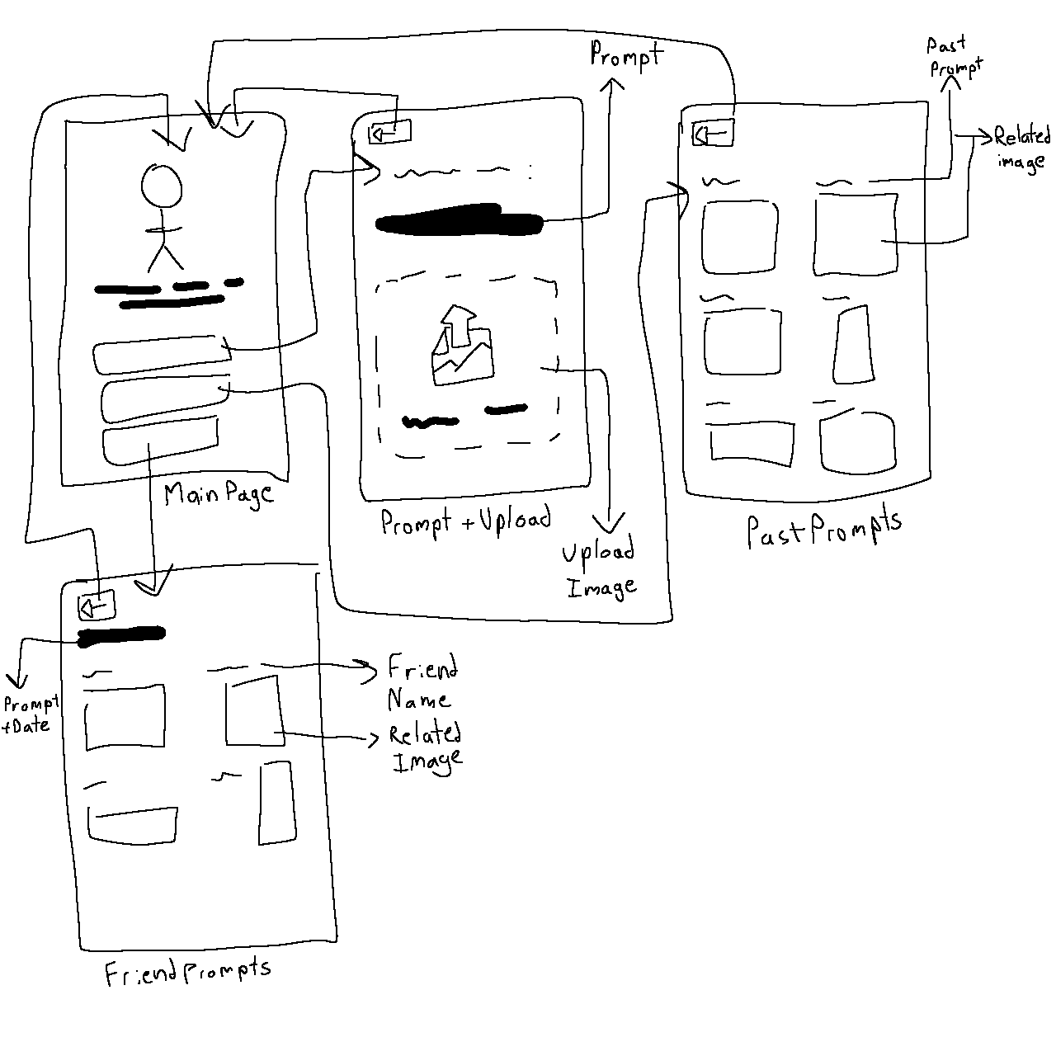

There are 3 pages users can navigate between: Main Page, Current Prompt, and Past Prompts. (Potentially a past drawings page as well).

The Main Page allows users to navigate to the other pages as well as upload images.

The Current Prompt Page displays the current prompt as well as other users' drawings of the current prompt.

The Past Prompts Page displays all past prompts the user has submitted a drawing for as well as the drawing the user submitted for each prompt. (Potentially allow the user to view friends' past drawings as well).

The User Account Page would allow the user to view their account information and change preferences (i.e. dark/light theme). (Would also potentially allow the user to add/remove friends).

User Stories:

| As an artist, I want an easy way to warm up without thinking about what to draw too much. |
| --- |
| I want something creative to do for a little while each day. |
| I want to see the things my friends create and how they interpret prompts. |
| I want a way to keep track of my improvement over time. |