For the final project we are running optical flow (dense, using Farneback’s) and LS-PIV over 5 videos to evaluate their effectiveness and what impacts them.
- 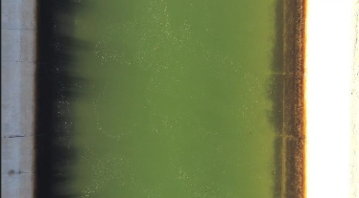 Site name: CCC
- 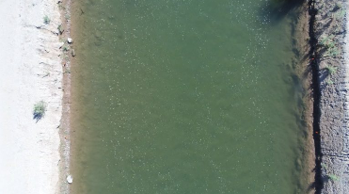 Site name: RMC
- 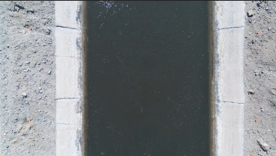 Site name: WMD
- 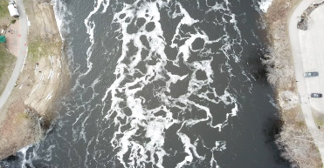 Site name: ACR
- 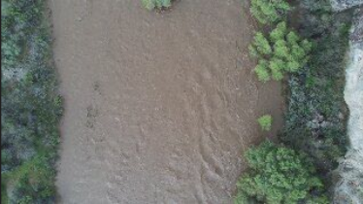 Site name: AFR
The first video was used to build and validate the algorithms and should serve as a baseline.
Data Table:

