Assignment 2: Optimal Search

1. Go through Dijkstra’s algorithm by hand for this graph:

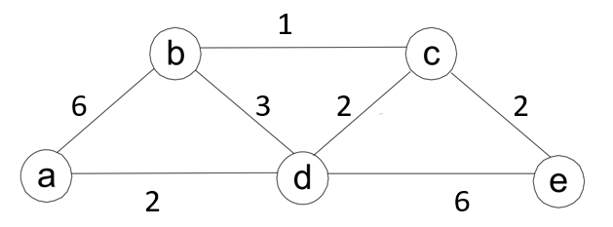

Give the shortest path from a to each other vertex, along with the length of that path. List your results in the order in which Dijkstra’s algorithm finds them.

1. Create a Python implementation of A\*. Run the program on the airport graph below. Your output should list the nodes in the shortest path in order of traversal, as well as the total cost of the path.

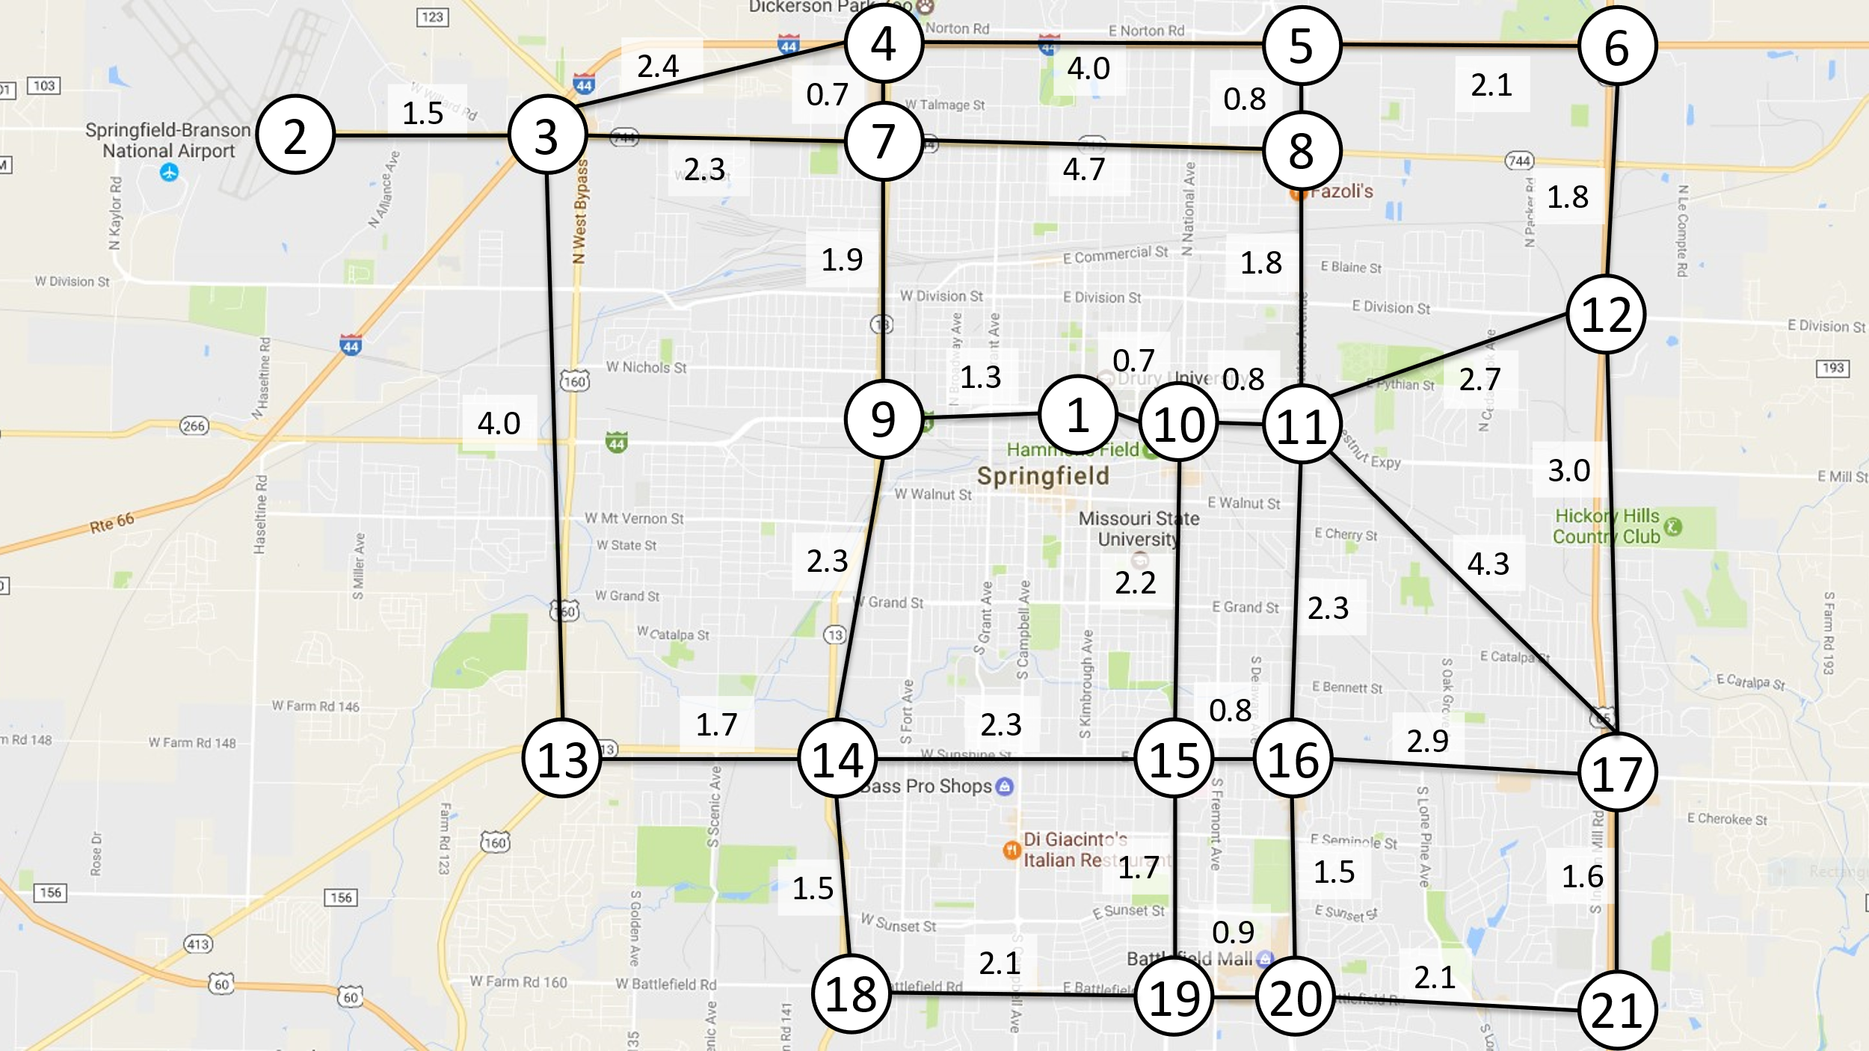

Submit a transcript of executing your program below and your source code in a separate file: