 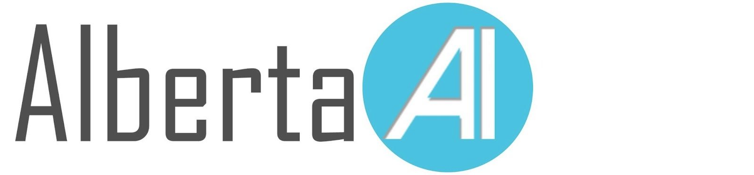 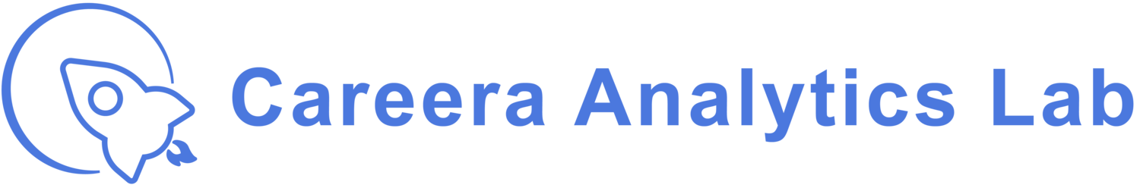

NLP: Let the Machine Do the Reading

### **Introduction**

The goal of the six weeks is to help you get a great understanding of Natural Language Processing, learn about Transformers and how to use a pre-trained NLP model and fine-tune it on a downstream task. We’ll be using Pytorch.

### **Who will you work with?**

* Nikunj Patel
* Hasan Badran

### **Deliverable**

A fine-tuned NLP model that is capable of understanding the context of a given text and extracting the answer for a specific question.

### **Prerequisites**

Basic knowledge in Python and Neural networks.

### **Weekly Content (Aug 8th - Sep 12th, every Sunday 3-5 pm EDT)**

| **Week** | **During Session** | **Details** |
| --- | --- | --- |
| 1 | Introduction to NLP | Understand what NLP is about, what models are used in real world applications. Seq2Seq learning and attention. (Text classification using Word2Vec/Seq2Seq) |
| 2 | Transformers | Learn about and understand state-of-the-art (SOTA) Transformer-based NLP models and how they work, how they achieve best performance with self-attention mechanisms. (Text classification using Transformers) |
| 3 | Named-entity recognition (NER) | Learn about and understand NER. Use a bert-base-NER that has been trained to recognize named entities. |
| 4 | Question-answering | Learn about the LayoutLM model. Load a pre-trained model and fine tune it on a downstream task. (i.e. Visual question answering task) |
| 5 | Web development | Develop a web application using python and Flask to showcase NLP model you built in week 4 |
| 6 | Presentations | Demo/present, QnA |