Step 1: Forked the repository from given source <https://github.com/hotosm/tasking-manager>

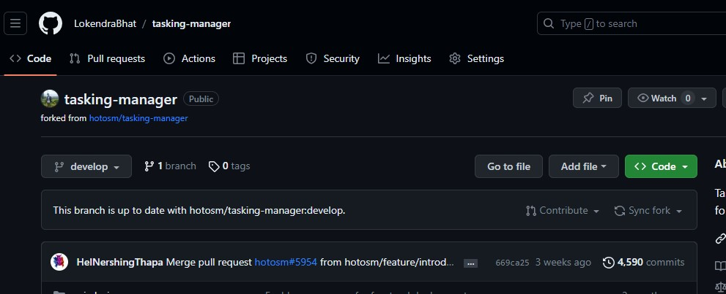

Step 2: Cloned the forked repository from GitHub using command

**$git clone <URL_of_FORKED_REPO>**

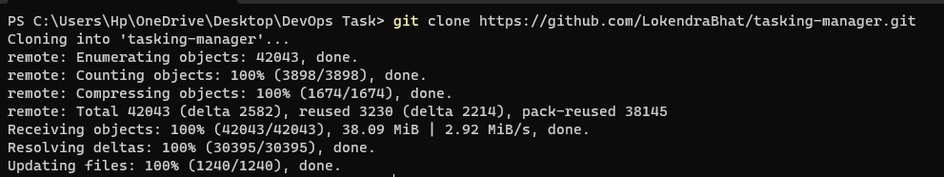

Step 3: To deploy the project following steps were attempt:

* First of all I created New branch using command [git branch task] and do changes in yml file.
* Figure-out components of project and found that project contains many micro-services with different APIs at frontend and backend.
* I found that in compose file there is tasking-manager.env is used but not present in project. So I copied example.env into tasking-manager.env and edit accordingly to run compose file.
* I created account in Openstreetmap and copy the client ID and secret from OpenStreetMap into configuration file `tasking-manager.env`, and set the variables: `TM_CLIENT_ID` `TM_CLIENT_SECRET`, `TM_REDIRECT_URI` and `TM_SCOPE`.

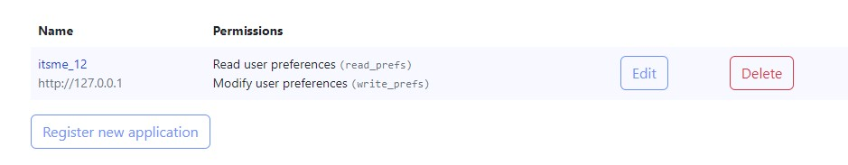

* After editing required information in configuration file then the following command executed

$docker-compose up –d

* But while executing there is error

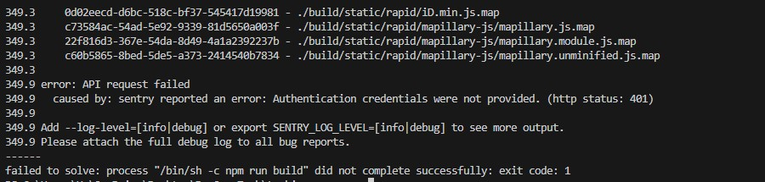

* Also while executing npm install in frontend file.

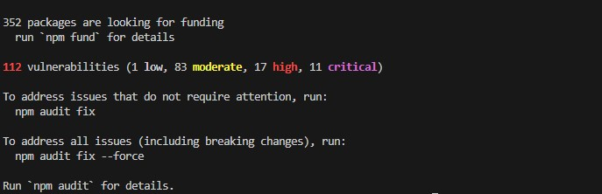

* After that I visited URL <https://tasks.hotosm.org> where the actual project was deployed, create user and check features. I try to run it locally as well but can’t able to do.
* There is permission denied so I unable to do any further tasks. I think I am not that experienced as well. I took too much time and effort but I can’t solve this problem. I am sorry to not able to show my knowledge through this task because it is too bulky and hard to understand deeply. I perform many changes but the different type of problems arises continuously.

Finally to complete last task I perform following commands

* git remote add upstream <URL_OF_REPO>
* git push --set-upstream origin task

Then from GitHub I pull and merge the changes from `task` branch.