Costco Concierge Services: Case #11495763

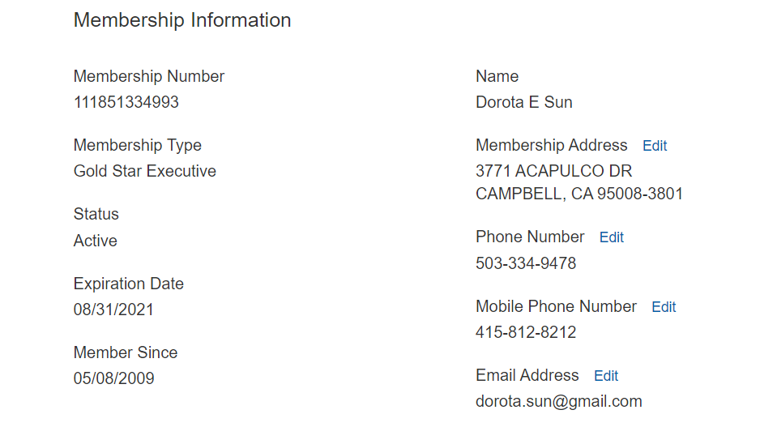

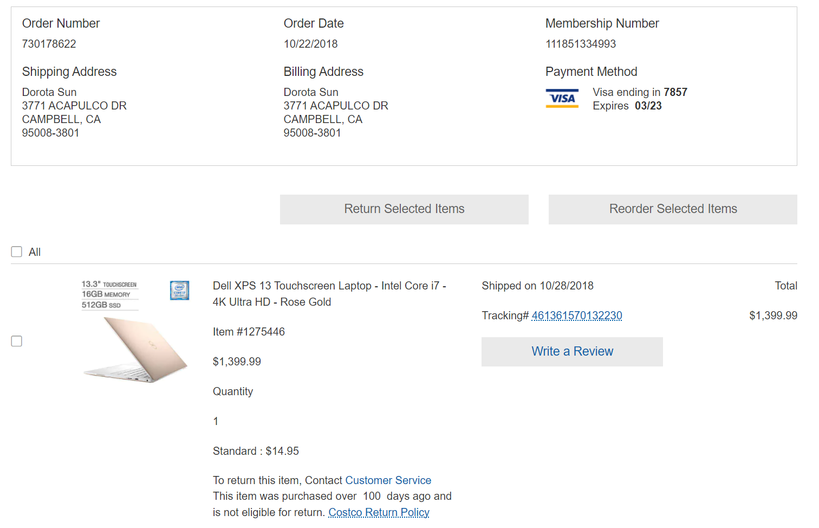

Concierge Services Status Update - Case #11495763

Trevor S.

Ecommerce Resolution Specialist

Costco Wholesale

Phone: 1-800-955-2292

**Shari 3462272**

**Costco Concierge Customer Relations Manager**| Alorica | Fort Myers Contact Center |866.611.6103-79056