1. **Port Number**

* **HTTP: 80**
* **HTTPS: 443 TCP/UDP**
* TCP/IP connection is always made to an IP address (you can think of an IP-address as the address of a certain computer, even if that is not always the case) and a specific (logical, not physical) port on that address.
* Usually **one port** is coupled to a **specific process or "service**" on the target computer. Some port numbers are [standardized](https://en.wikipedia.org/wiki/List_of_TCP_and_UDP_port_numbers), like 80 for http, 25 for smtp and so on. Because of that standardization you usually don't need to put port numbers into your web addresses.
* So if you say something like [http://www.stackoverflow.com](http://www.stackoverflow.com/), the part "stackoverflow.com" resolves to an IP address (in my case 64.34.119.12) and because my browser knows the standard it tries to connect to port 80 on that address. Thus this is the same as [http://www.stackoverflow.com:80](http://www.stackoverflow.com/).

**localhost**/web is equal to **localhost:80**/web OR to **127.0.0.1:80**/web

**localhost:8080**/web is equal to **localhost:8080**/web OR to **127.0.0.1:8080**/web

## HTTP - 80

Port 80 is associated with HTTP, Hypertext Transfer Protocol. It comes under the category of a **TCP protocol**. It is one of the most famous and widely used ports in the world. The main purpose of port 80 is to allow the browser to connect to the web pages on the internet. Port 80 basically expects or waits for the web client to ask for a connection. Once this connection has been made, you will get the privilege to connect to the World Wide Web and get access to various web pages out there. In fact, HTTP - 80 is one of the most important ports associated with the TCP protocol. Moreover, this port is generally used during the application layer of the TCP/IP Model.

## HTTPS - 443

HTTPS - 443 is also associated with the **TCP protocol**. HTTPS port 443 also lets you connect to the internet by establishing a connection between the webpages and the browser. This lets you connect to the World Wide Web. However, **this port has an added feature of security to it**, which HTTP port 80 does not have. This port is intended for establishing secure connections to make sure that the data is transmitted over a secure network. The use receives a warning if the browser is trying to access a webpage which is not secure. This port comes into being during the application layer. It basically encrypts and authenticates the network packets before transferring them over the network to increase the security. This feature of security is introduced by the use of SSL, which can also be referred to as Secure Socket Layer.

## FTP - 20, 21

FTP is the abbreviation of "File Transfer Protocol". The purpose of FTP is to transfer files over the internet. It basically lays down all the rules which are to be followed during the transfer of data. Due to the concern of security, it also asks for authentication by the user before the transfer of data. It is associated with the **TCP protocol** and corresponds to two ports, port 20 and 21. Both of these ports function during the application layer.

Port 20 performs the task of forwarding and transferring of data. It takes over the task of transferring FTP data when it is in active mode.

Port 21 performs the task of signaling for FTP. It listens to all of the commands and provides a flow control for data. It is quite essential for maintaining the flow of data.

## TELNET - 23

TELNET port 23 comes under the category of **TCP Protocols**. Its main function is to establish a connection between a server and a remote computer. It establishes a connection once the authentication method has been approved. However, this port is not suitable to establish secure connections and does not cater to the concern of security. It enables the remote connection of a computer to be established with routers and switches as well. It makes use of a virtual terminal protocol to make a connection with the server. It comes into existence during the application layer of the TCP/IP protocol.

## IMAP - 143

IMAP is the abbreviation of 'Internet Message Access Protocol'. The IMAP -143 Port lies under the category of **TCP protocol**. The primary purpose of this port is to retrieve emails from a remote server without having the need to download the email. You have the liberty to access the emails from anywhere by connecting to the server and viewing your email after providing authentication. This opportunity has been provided to you because of the existence of this port. It reserves a virtual memory for the email which enables you to read it by connecting to the server. However, you may also download the mail if you wish to. It also provides you the ability to search for your messages from a bunch of them to get to your desired one. IMAP 143 Port generally operates at the Application Layer of a TCP/IP Model. In addition to this, it also makes sure that the data remain secure during this connection.

## SSH - 22

SSH is also referred to as 'Secure Shell'. It operates on the port number 22 of the **TCP protocol**. It carries out the task of remotely connecting to a remote server or host. It allows you to execute a number of commands and move your files remotely as well. However, it is one of the most secure ways of accessing your files remotely. Using this port, you can remotely connect to a computer and move your files with ease. This port sends the data over the network in an encrypted form which adds an extra layer of security on it. In addition to this, only authorized people will be able to remotely log on to their systems using the Port 22 which makes sure that the information does not get into unauthorized hands. It provides the chance to move files within networks as well as gives the privilege to move files between different networks securely. It operates at the Application Layer of the TCP/IP Model and is considered as one of the most secure and reliable ports for accessing files remotely.

## DNS – 53

## DNS query is initially sent with UDP by client, if no response from server in 5 sec, client will send TCP query.

## DNS response from DNS server is always in TCP.

DNS is referred to as 'Domain Name System'. It operates on the port 53 of **TCP and UDP protocols**. DNS makes use of relational databases to link the host names of the computers or networks to their respective IP Addresses. The port 53 waits for requests from **DHCP** to transfer the data over the network. It operates on the Application Layer of the TCP/IP Model.

*TCP protocol* is used by the **Zone Transfer** function of the **DNS server**. Once the connection is established, the zone data will be sent by the server using the **TCP 53 port**. However, when the query has to be transferred from **the client computer**, it will be sent using the port 53 on **UDP protocol**. However, if no response is received from the server within 5 seconds, the DNS query will be sent using the port 53 of TCP Protocol.

## DHCP - 67, 68

DHCP is also known as **'Dynamic Host Configuration Protocol'**. It basically runs on the **UDP protocol**. The basic purpose of DHCP is to **assign IP Address** related information to **the clients** on a network automatically. This information may comprise of subnet mask, IP Address etc. Many of the devices are automatically configured to look for IP Addresses using DHCP when they connect on a network. It makes it quite reliable to assign all the devices on a network with automatically produced IP Addresses. It generally operates on the Application layer of the TCP/IP Model. DHCP basically makes use of 2 ports; Port 67 and Port 68.

**UDP Port 67** performs the task of accepting address requests from DHCP and sending the data to the server. On the other hand, **UDP Port 68** performs the task of responding to all the requests of DHCP and forwarding data to the client.

**POP3-110**

POP3 is also referred to as Post Office Protocol Version 3. It operates on the port 110 of **TCP Protocol**. It allows the email messages to be retrieved from the SMTP servers. Using this port, you can download the messages from the server and then read them. However, this means that you will not be able to access the messages and read them without downloading them. Furthermore, the messages are also deleted from the server once they are downloaded. However, this port does not cater to the issue of security. The authentication details transferred over the network are not encrypted and sent in plain text. This means that any hacker can easily intercept this information and misuse it. Port 110 generally operates on the Application layer of the TCP/IP Model.

We have discussed some of the most common and widely used Ports above. We have seen how each of these ports are either related to the UDP protocol or TCP protocol and are used at the Transport or Application layer. All of these ports perform different tasks and different processes. While we have some ports where our data can be sent securely, there are some others where the transfer of data is of more significance than its security. We can also combine different protocols to add the feature of security. For example, SSL can be added to HTTPS port to add a feature of security to it. Considering the uses and applications of these ports, it is important to realize their significance in the process of transmission of data over a network. Not only do they help you to transfer data, they also let you enjoy some other facilities as well. In fact, it is not wrong to say that networking will not be complete without the existence of these TCP and UDP Ports.

The [Transmission Control Protocol (TCP)](https://www.lifewire.com/transmission-control-protocol-and-internet-protocol-816255) uses a set of communication channels called [ports](https://www.lifewire.com/port-numbers-on-computer-networks-817939) to manage system messaging among several different applications running on the same physical device. Unlike the physical ports on computers like [USB ports](https://www.lifewire.com/what-is-a-usb-port-818166) or [Ethernet ports](https://www.lifewire.com/what-is-an-ethernet-port-817546), TCP ports are virtual — programmable entries numbered between 0 and 65535.

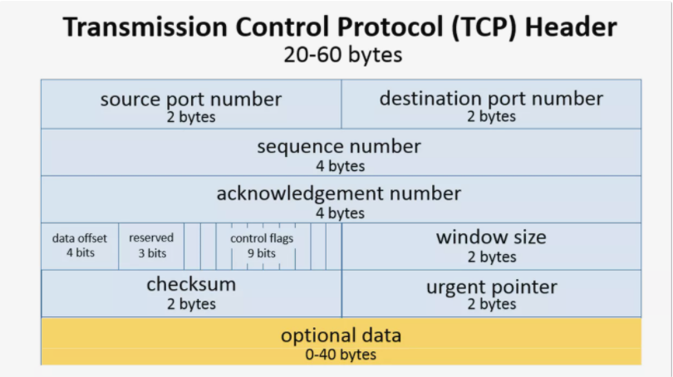

1. **Domain Names**

[the anatomy of a URL](https://themeisle.com/blog/what-is-a-website-url/)

https://themeisle.com/

This URL contains two parts:

* **A protocol** (https**:**) is a set of guidelines that a browser follows to send a request to the server.
* The **domain**, themeisle.com, **or URL** to the main website. A domain consists of two parts:
  + the TLD (**top level domain**) which is the **.com** part (or [another domain extension](https://themeisle.com/blog/domain-extensions-guide/)), and
  + the SLD **(second level domain**), themeisle, the name that you buy from a [domain registrar](https://themeisle.com/blog/best-domain-registrars/).

A **sub-domain** contains a second name before the SLD. For instance, if the ThemeIsle blog was hosted on https://**blog**.themeisle.com, the blog would be the **sub-domain**.

A subdomain is commonly used to logically separate a website into **sections**. You can use a subdomain to launch a career site (careers.yoursite.com), a forum (forum.yoursite.com) or for customer support (support.yoursite.com). You may use subdomains to create blogs of different themes too. For instance, [sbnation.com](https://www.sbnation.com/) is a sports news blog. However, it uses blogs like [weaintgotnohistory.sbnation.com](https://weaintgotnohistory.sbnation.com/) and [theshortfuse.sbnation.com](https://theshortfuse.sbnation.com/) for specific teams on different subdomains

 Before you can set up any subdomain, you have to have a main domain. If you don’t have that taken care of yet, here are our guides on [choosing a domain name](https://themeisle.com/blog/how-to-choose-a-domain-name/) and [how to register a domain name](https://themeisle.com/blog/how-to-register-a-domain-name/).

Once you buy a domain, you also buy the rights for subdomains within it. Broadly, these are the steps that you must follow to create a subdomain:

* Come up with the name of the subdomain, enter it as a record in your DNS settings.
* Redirect to the server that hosts your subdomain.

When you are entering a record in your DNS settings, you would notice that www.yoursite.com points to yoursite.com. This essentially makes **www a subdomain** too!

<https://themeisle.com/blog/fix-broken-links-in-wordpress/>

1. The protocol – *HTTP* or *HTTPS*.
2. The domain name (including the TLD) that identifies a site.
3. The path leading to a specific web page.

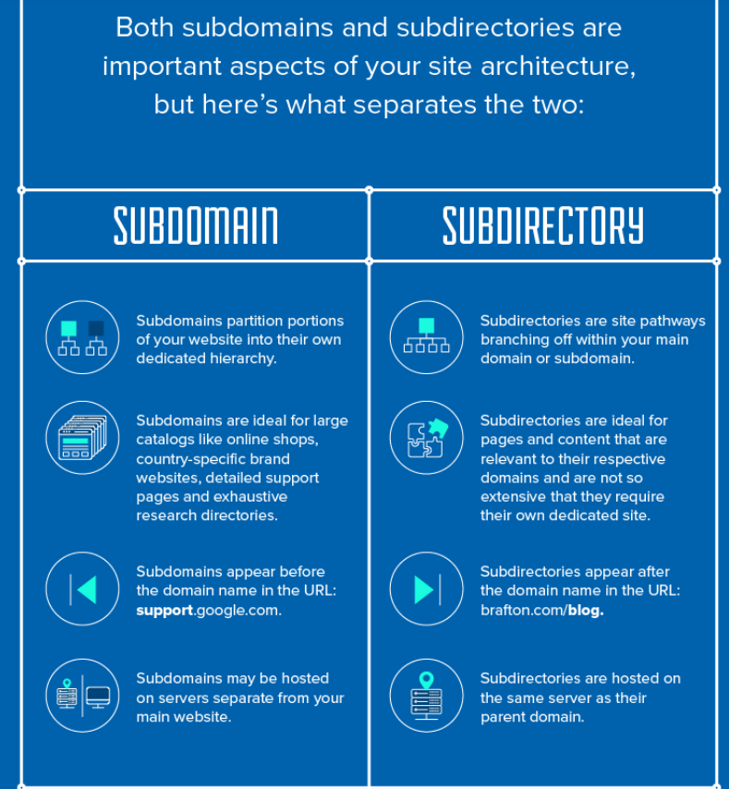

Your **main domain** – also known as a primary domain or a root domain – is essentially the name of your website

In Brafton’s case, our **main domain** name is [**brafton.com**](http://brafton.com/). Notice I didn’t say [**www.brafton.com**](http://www.brafton.com/) or [**https://www.brafton.com**](https://www.brafton.com/), which are technically our site URLs.

A subdomain is a division of your website that you want to distinguish with its own unique identity and content. For instance, if Brafton wanted to create a subdomain for our blog page (we don’t), our subdomain name would be **[blog.brafton.com](http://blog.brafton.com/)**.**The structure and components of a URL**

A URL is usually made up of several parts. To understand the structure and the components, we will dismantle the following example URL:

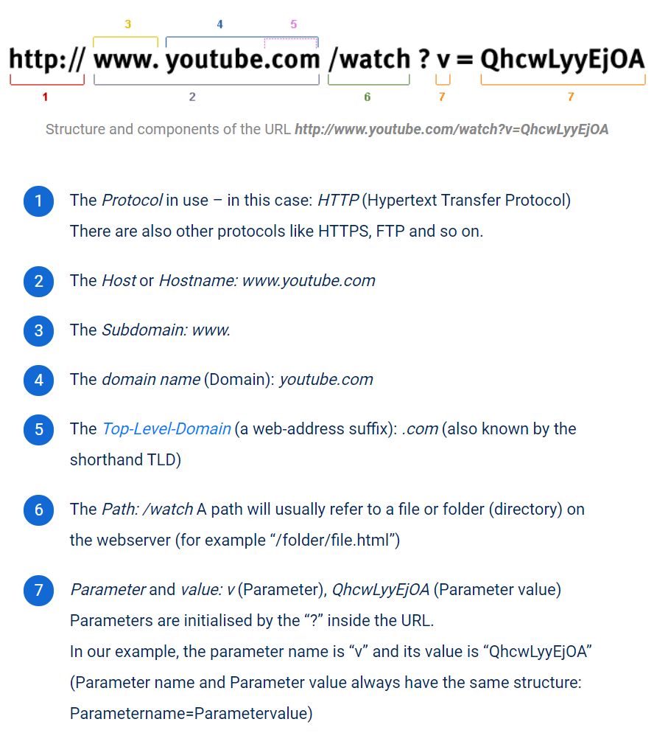

General language use

If we talk about a URL, we usually mean the concrete path to a directory (http://www.domain.com/a-directory/) or a file (http://www.domain.com/documents/study.pdf) on a website.

Subdomain vs. Subfolder

Another common distinction you’ll need to make when it comes to subdomains is the difference between a subdomain and a subfolder.

By now, you already know what a subdomain is, but a subfolder is a bit different. With a subfolder, you’re adding a folder to your existing domain.

So, instead of creating a new subdomain for your blog like “blog.mysite.com,” you’ll use a subfolder instead “mysite.com/blog.”

For example, here at HostGator you can access the blog by navigating to “https://www.hostgator.com/blog” , not “blog.hostgator.com”.

When you’re thinking about using a subdomain, you should really view it as creating a separate website. Although subdomains branch off of an existing domain name, they do take more work to build, grow, and maintain.

A subfolder is a way to organize your site more easily. Think of it as creating categories for your blog and blog posts. If you have a sports website, you could create subfolders for each sport you cover. So, you’d end up with a URL structure something like the following: “sports.com/basketball,” “sports.com/football,” “sports.com/hockey,” and on and on. Each page could operate as its own separate sports-specific blog with each page filled with unique content about that sport.

1. **What Happens When You Type in a URL**
2. You enter a URL into a web browser
3. The browser looks up the IP address for the domain name via **DNS**
4. The browser sends a HTTP *request* to the server
5. The server sends back a HTTP *response*
6. The browser begins rendering the HTML
7. The browser sends requests for additional objects embedded in HTML (images, css, JavaScript) and repeats steps 3-5.
8. Once the page is loaded, the browser sends further async requests as needed.
9. **DNS (Domain name system)**

The browser extracts the domain name from the URL.

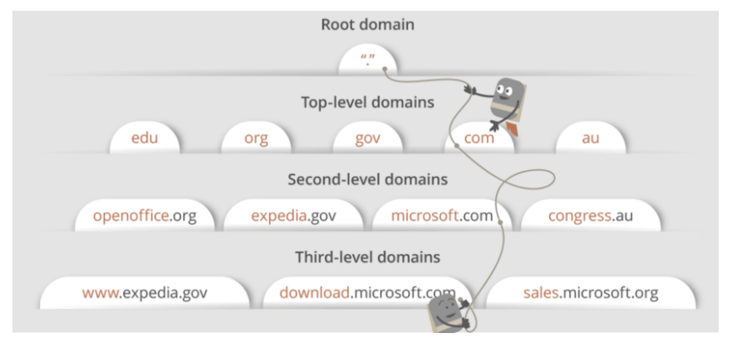

## DNS lookup to find IP address

After hitting the URL, the first thing that needs to happen is to resolve IP address associated with the **domain name**.

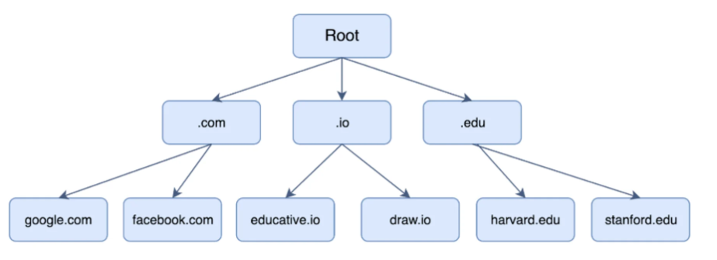

There are 4 local cache to check :

1. The browser’s local cache is checked
2. The operating system’s cache is checked
3. The **router** is checked for the record.
4. Lastly, the query is sent to the **Resolver Server**( Internet Service Provider (ISP)) for it to check its cache.

Hence, if the record cannot be found locally, a full DNS resolution is conducted as follows:

1. The first point of contact for a full resolution is a **root server**. As of the writing of this post, 1017 instances of root servers exist.
2. The root server returns the **IP address** of the relevant **top level domain server**.
3. The top level domain returns **the IP address** of the **second level domain server**.
4. The second-level domain server contains the DNS record of the server we are looking for. The **second-level domain server returns the IP address to the browser**.

This is the overview, but there are **four layers** through which this domain name query goes through. Let’s understand the steps:

* 1. After hitting the URL, the **browser cache** is checked. As browser maintains its DNS records for some amount of time for the websites you have visited earlier. Hence, firstly, DNS query runs here to find the IP address associated with the domain name.
  2. The second place where DNS query runs in **OS cache** followed by **router cache**.
  3. If in the above steps, a DNS query does not get resolved, then it takes the help of resolver server. **Resolver server (Recursive server)** is nothing but your ISP (Internet service provider). The query is sent to ISP where DNS query runs in**ISP cache.**

Recursive servers/Resolver Servers are the workhorses in the DNS lookup process. They often have to make numerous DNS lookups in order to respond with the proper IP for the querying client. These kinds of servers are typically managed by an ISP (Internet Service Provider) or specialty resolving DNS providers.

* 1. If in 3rd steps as well, no results found, then request sends to **top or root server** of the DNS hierarchy. There it never happens that it says no results found, but actually it tells, from where this information you can get. If you are searching IP address of the top level domain (.com,.net,.Gov,. org). It tells the resolver server to search **TLD server** (Top level domain).

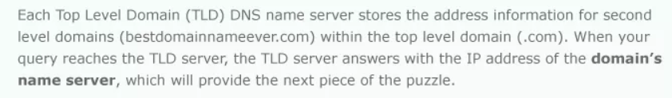

* 1. Now, resolver asks TLD server to give IP address of our domain name. TLD stores address information of domain name. It tells the resolver to ask it to **Authoritative Name server.**

The requests that reach Authoritative Name Server are from [Resolving name servers (resolvers)](https://www.cloudns.net/wiki/article/202) and the authoritative servers will either have the complete answer or they will pass to the name server who is responsible for it. The authoritative servers don’t cache query results.

*Authoritative DNS servers store the “maps” of your domain names to IP addresses. This domain name to IP mapping is usually configured by system administrators.*

* 1. The authoritative name server is responsible for knowing everything about the domain name. Finally, resolver (ISP) gets the IP address associated with the domain name and sends it back to the browser.

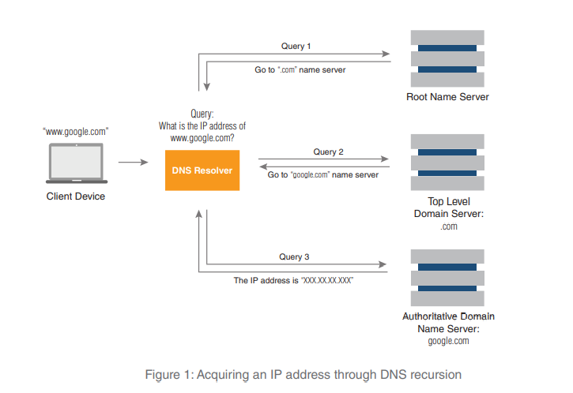

After getting an IP address, **resolver stores it in its cache** so that next time, if the same query comes then it does not have to go to all these steps again. It can now provide IP address from their cache.

The **resolver** repeatedly obtains destination IP addresses and updates its cache. It is called a “**recursive DNS server**” because it uses recursion to perform the resolution process. Once the resolver obtains the IP address requested by the client device, that client can begin communicating with the intended domain.

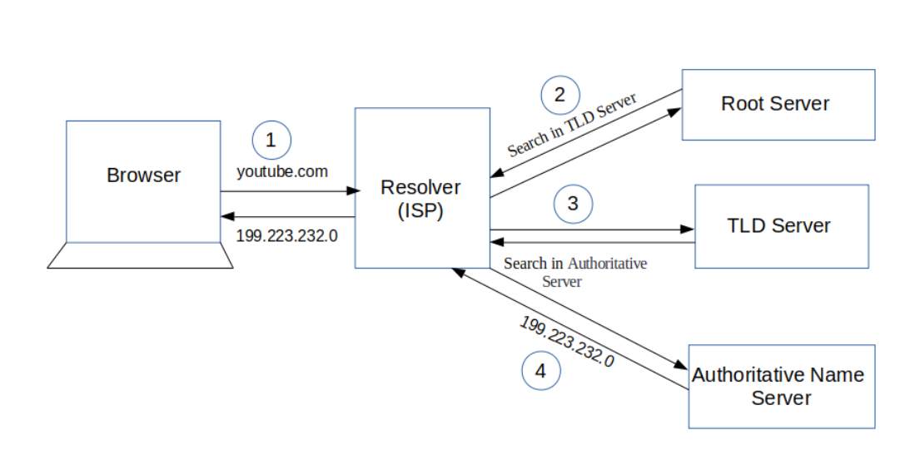

**Non-authoritative answer** simply means the answer is not fetched from the authoritative DNS server for the queried domain name.

The Importance of an Authoritative DNS Server Authoritative DNS servers are managed by or on behalf of the domain owner. Internet service providers often host the service. Because they have complete and up-to-date information about their zones these servers are the authoritative source for IP addresses. That fact makes authoritative DNS servers crucial to an organization’s availability on the Internet. Constant change is the nature of a network. Traffic growth, re-allocation of capacity, and the evolution of web-based services are frequent drivers. Since each network element requires an accurate IP address, every change requires a corresponding and timely update to the authoritative DNS server. This ups the ante for authoritative DNS servers because not only must they be reliable; they must also be well-managed and secure

**DNS how it works**

DNS system can be divided into three tiers. They are:

* root DNS servers
* top-level domain DNS servers
* authoritative DNS servers

There's another class of DNS Server usually called local DNS server or **Resolver server** whose IP address is specified on your operating system.

When your browser connects to a website say example.com, the browser first queries your **Resolver server** to get the IP address of example.com.

* If the **Resolver server** doesn't have the A record of example.com, it will query one of the **root DNS servers.**
* The root DNS server will say: I don't have the A record but I know the **top-level domain DNS** server which is responsible for .com domains.
* Then your **Resolver server** query the top-level domain DNS server which is responsible for .com domains. The TLD DNS server will respond: I don't know either but I know which DNS server is **authoritative** for example.com.
* So your **Resolver server** queries the authoritative DNS server. Because the actual DNS record is stored on that authoritative DNS server, so it will give your local DNS server an answer.
* Then this query result is cached on your local DNS server but it can be outdated. When the TTL time has expired, your **Resolver server** will update the query result from the authoritative DNS server. Whenever you query a DNS record on your **Resolver server**, it returns a non-authoritative (unofficial) answer. If you want an authoritative answer, you must explicitly specify the authoritative DNS server when you use **nslookup** or other utilities.
* The answer you've received is essentially a cached or forwarded response from your local DNS server. Basically, a non-authoritative name server is one that does not contain the records for the zone being queried; your local DNS is likely not going to have Google's name records, for example.

You can get the name servers that are authoritative for a given domain by running **host -t ns example.com** to retrieve the NS record for example.com.

In the case of Google, we see:

**$ host -t ns google.com**

**google.com name server ns4.google.com.**

**google.com name server ns1.google.com.**

**google.com name server ns2.google.com.**

**google.com name server ns3.google.com.**

If you subsequently run your nslookup command against one of those servers, you will get the authoritative answer:

$ **nslookup www.google.com** ns1.google.com

Server: ns1.google.com

Address: 216.239.32.10#53

www.google.com canonical name = www.l.google.com.

Name: www.l.google.com

Address: 173.194.43.49

Name: www.l.google.com

Address: 173.194.43.50

Name: www.l.google.com

Address: 173.194.43.48

Name: www.l.google.com

Address: 173.194.43.52

Name: www.l.google.com

Address: 173.194.43.51

If you're using nslookup, to get the NS record type, you can run something like this in interactive mode:

$ nslookup

> set querytype=ns

> google.com

Server: 127.0.0.1

Address: 127.0.0.1#53

Non-authoritative answer:

google.com nameserver = ns3.google.com.

google.com nameserver = ns4.google.com.

google.com nameserver = ns1.google.com.

google.com nameserver = ns2.google.com.

Authoritative answers can be found from:

ns1.google.com internet address = 216.239.32.10

So, setting querytype=ns does what the above host command did.

Basically, it's what the name says it is. An authoritative answer comes from a nameserver that is considered authoritative for the domain which it's returning a record for (one of the nameservers in the list for the domain you did a lookup on), and a non-authoritative answer comes from anywhere else (a nameserver not in the list for the domain you did a lookup on).

It's basically a distinction between a nameserver that's an official nameserver for the domain you're querying, and a nameserver that isn't. Nameservers that aren't authoritative are getting their answers second (or third or fourth...) hand - just relaying the information along from somewhere else.

So, for example, If I did an nslookup of maps.google.com right now, I would get a response from one of my configured nameservers. (Either from my ISP, or my domain.) It would come back as non-authoritative because neither my ISP's nameservers, nor my own are in the list of nameservers for google.com. They aren't Google's nameservers, so they're not the authoritative source that creates the NS records.

## Distributed Denial of Service (DDoS). This is the most infamous type of DNS attack and has many sub-variants. In a DDoS attack authoritative DNS servers are overwhelmed with messages, queries, zone transfers, TCP, UDP, and other traffic. This traffic may be amplified in packet size and query volume for greater effect. If a DDoS attack is successful, the authoritative DNS server resources are consumed responding to attack traffic, thereby ignoring legitimate access to services. This amounts to a “denial of service” to valid users and their traffic. Cache poisoning. A cache poisoning attacker sends bogus IP addresses in a forged DNS response to a recursive DNS server and if the attack is successful, that server caches and maps a bogus IP address to a domain. Once the bogus address is cached, that DNS server will respond to a legitimate DNS query with the false IP address. An unsuspecting client could then transact information with the attacker rather than the intended web service. Man-in-the-middle attack (MITM). This is often a means to perform another attack, such as DNS spoofing. A MITM attack uses a machine that compromises the network to intercept traffic. It then spoofs DNS transactions and delivers counterfeit IP addresses to clients, similar to cache poisoning. Here again unsuspecting traffic is routed to a host controlled by the attacker rather than the intended service.

## Berkeley Internet Name Domain (BIND) is the most popular Domain Name System (DNS) server

## DNS Zone

## TCP connection initiates with the server by Browser

Once the **IP address** of the computer (where your website information is there) is**found**, it **initiates connection** with it. To communicate over the network,**internet protocol** is followed. **TCP/IP** is most common protocol. A connection is built between two using a process called **‘TCP 3-way handshake’**. Let’s understand the process in brief:

1. A client computer sends a **SYN** (synchronize) **message** means, whether second computer is open for new connection or not.
2. Then**another computer**, if open for new connection, it sends **acknowledge ACK** with SYN message as well.
3. After this, **first computer** receives its message and acknowledge by **sending** an**ACK message.**

To better  understand, look below diagram.

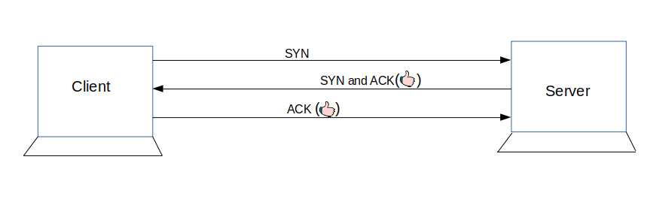

## What is HTTP?

These requests follow a ‘protocol’ or ‘rules of communication’ called **HyperText Transfer Protocol (HTTP)**. This protocol dictates the **format** of the messages, when what message is sent, appropriate responses, and how messages are interpreted. **HTTP messages** are of two types: **request** and **response**.

An HTTP **request message** consists of a **request line** and **headers**, and body if appropriate. The message starts with a request line and is followed by headers. Here’s a sample HTTP request:

GET /path/to/file/index.html HTTP/1.1  
  
Host: www.educative.io  
  
Connection: close  
  
User-agent: Mozilla/5.0  
  
Accept-language: fr  
  
Accept: text/html

The **request line** consists of a **request method**, a **path**, and the **HTTP version**.

The request method, GET, in the example above tells the server what to do. GET, for example, tells the server that the client wants to get the resource found at the given file path.

Other examples of request methods include DELETE, which tells the server to delete a resource at the given path, and PUT, which tells the server to put a supplied resource at the given path. The HTTP version is also specified to cater for the differences between each.

Next come the HTTP **headers**. Headers allow the client to communicate extra information such as the server type and the date. Each header is on a separate line and contains a name and value, separated by a colon.

There are many headers which provide different functions. For example, the connection header indicates whether user is on a HTTP connection type.

The server then sends an HTTP **response message**. Here’s a sample response message:

HTTP/1.1 200 OK  
  
Connection: close  
  
Date: Tue, 18 Aug 2015 15: 44 : 04 GMT  
  
Server: Apache/2.2.3 (CentOS)  
  
Last-Modified: Tue, 18 Aug 2015 15:11:03 GMT   
  
Content-Length: 6821  
  
Content-Type: text/html  
   
[The object/file that was requested]

Response messages consist of a **status line** to start with, followed by a number of **headers**, followed by a **blank line** and ends with a resource if any was requested.

The **status line** consists of the **HTTP version** and a **status code**. There are a few types of status codes. A common example is the infamous 404 Not Found status code.