1. **pytest测试实战pdf_Pytest测试实战之token处理（十一）**

[**https://blog.csdn.net/weixin_39961943/article/details/110969947?ops_request_misc=&request_id=&biz_id=102&utm_term=pytest%20request%20token%20test&utm_medium=distribute.pc_search_result.none-task-blog-2~all~sobaiduweb~default-0-.pc_search_result_before_js&spm=1018.2226.3001.4187**](https://blog.csdn.net/weixin_39961943/article/details/110969947?ops_request_misc=&request_id=&biz_id=102&utm_term=pytest%20request%20token%20test&utm_medium=distribute.pc_search_result.none-task-blog-2~all~sobaiduweb~default-0-.pc_search_result_before_js&spm=1018.2226.3001.4187)

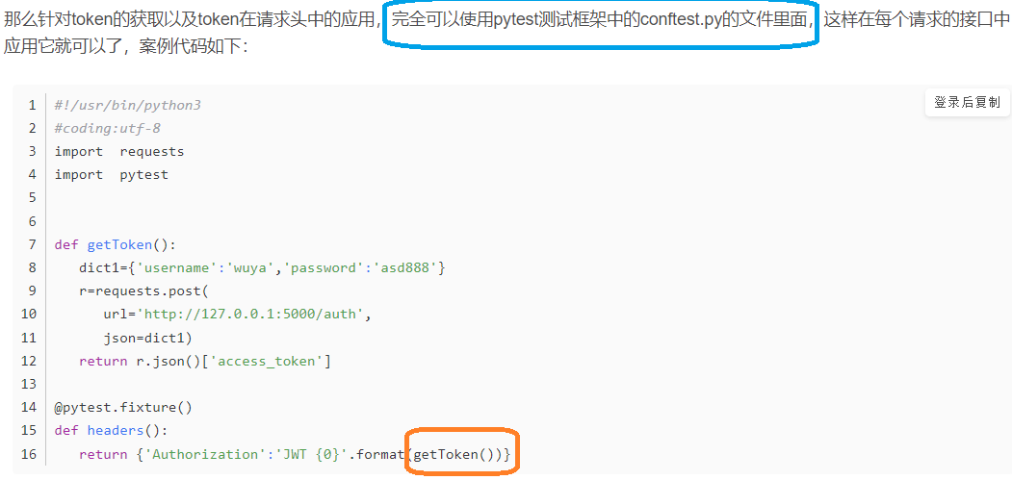

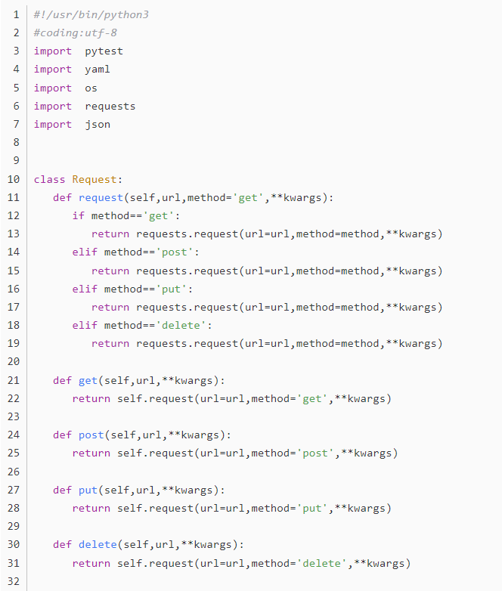

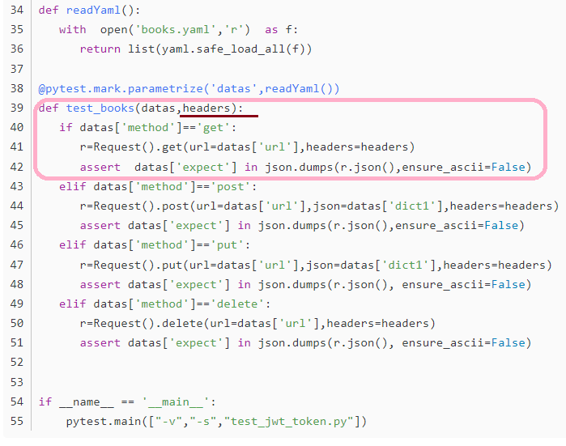

**虽然每次生成的token都是不一样的，但是结合conftest.py就可以很轻松的解决这个问题**

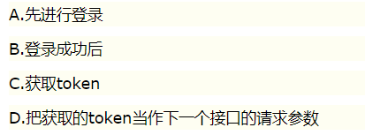

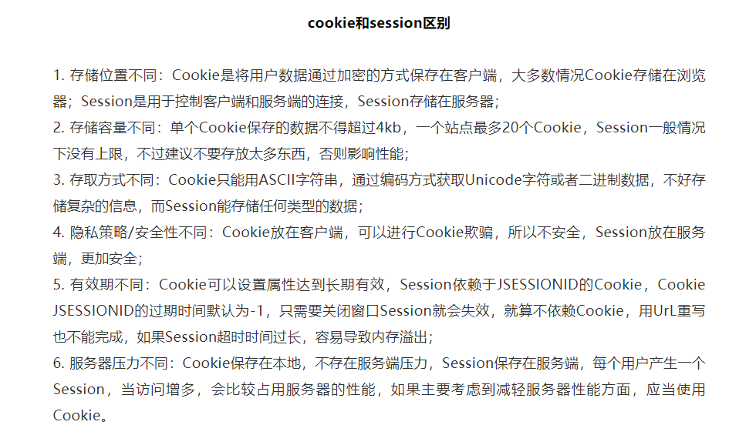

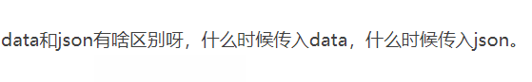

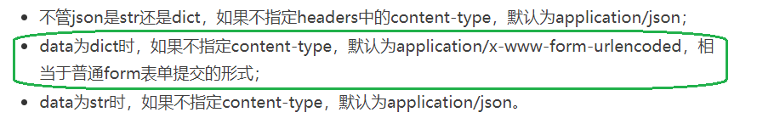

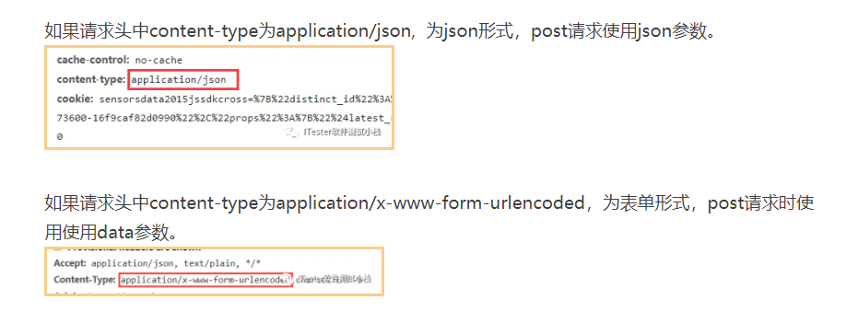

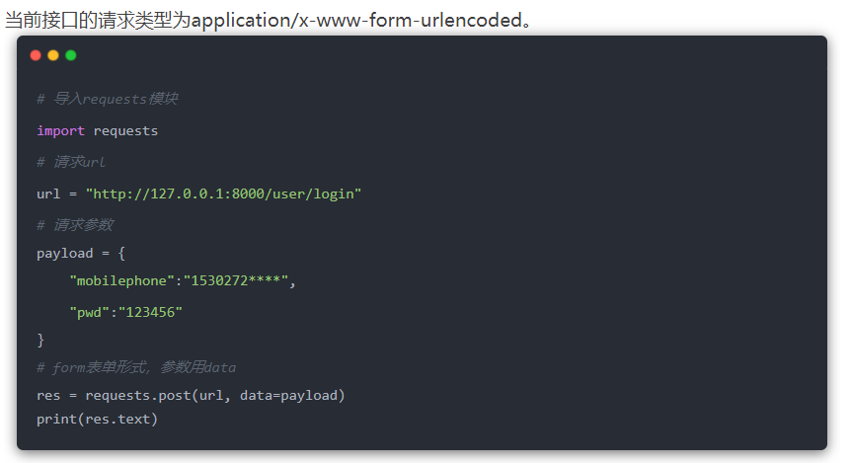

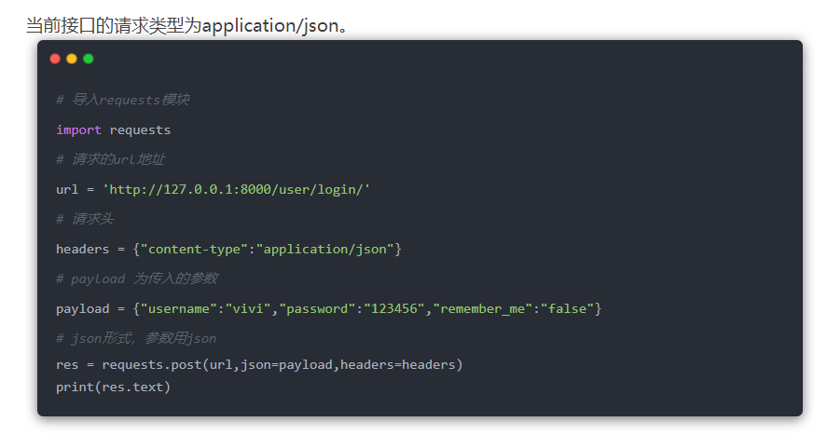

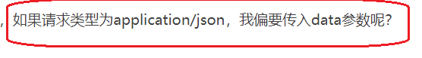

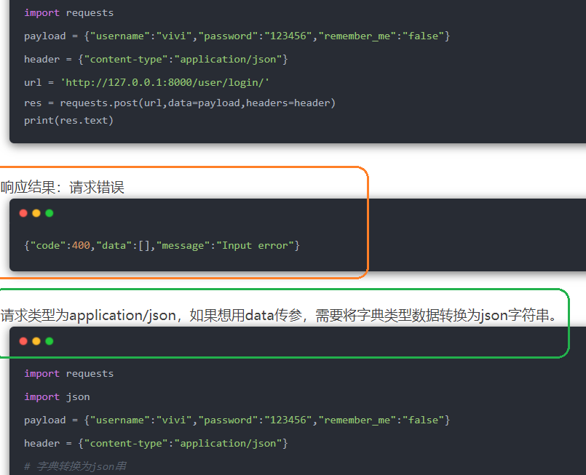

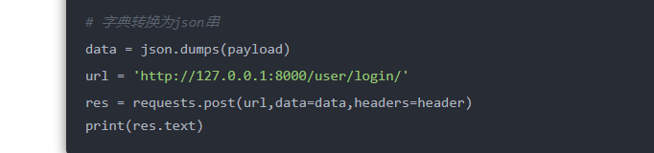

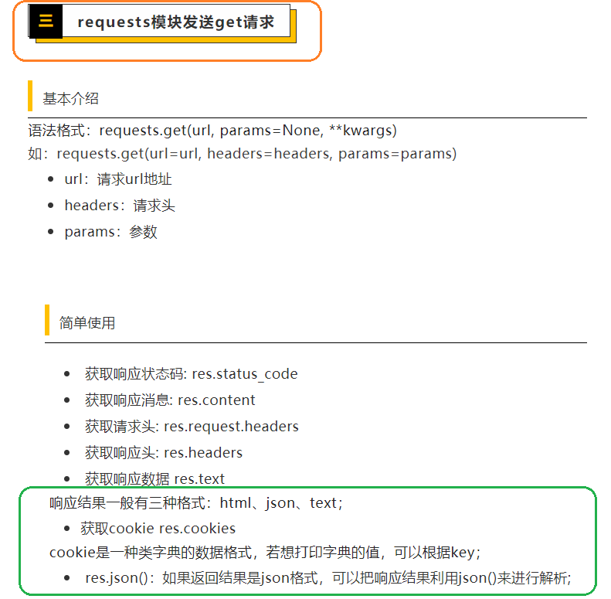

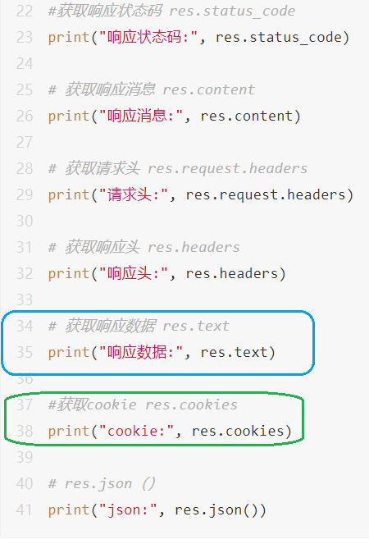

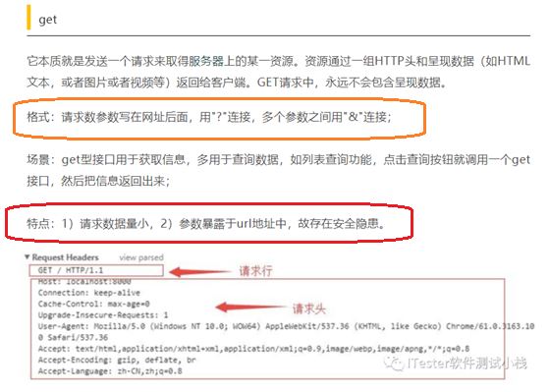

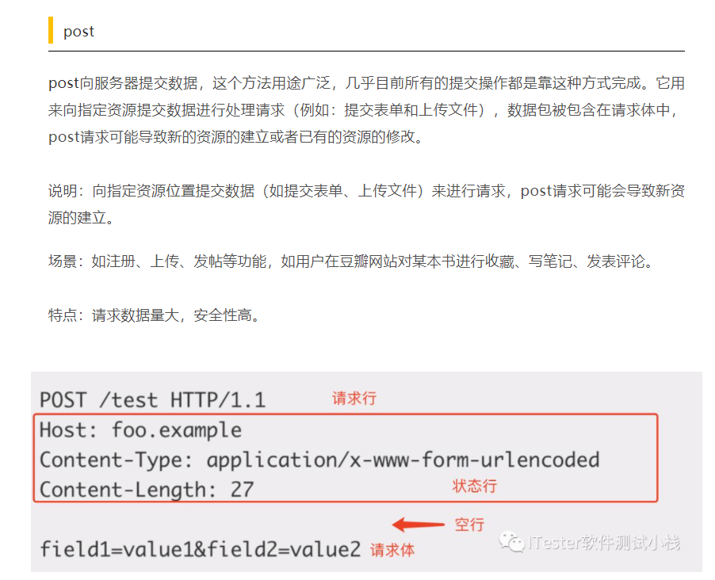

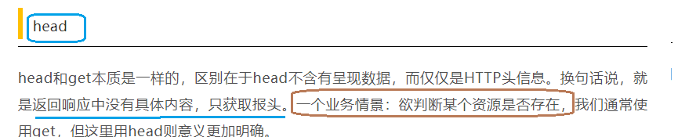

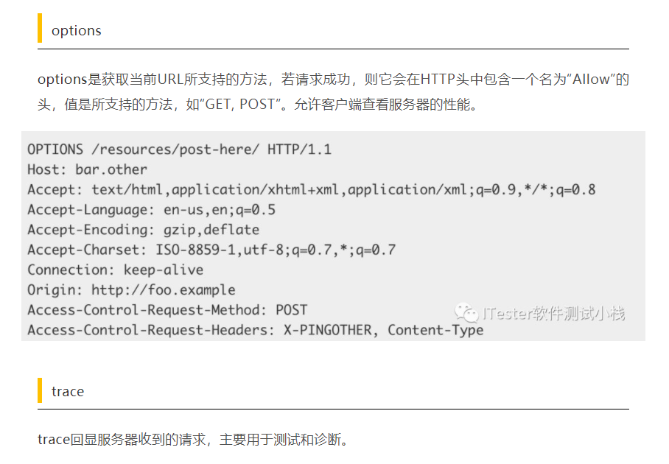

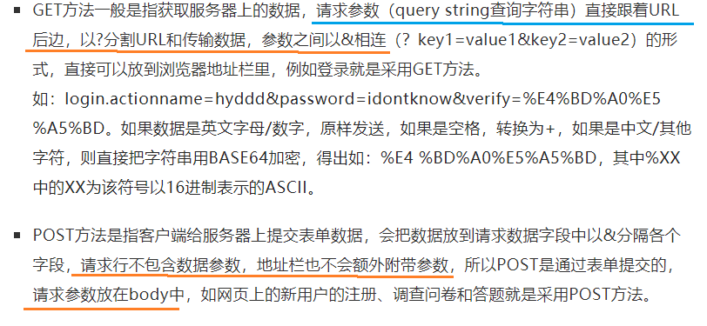

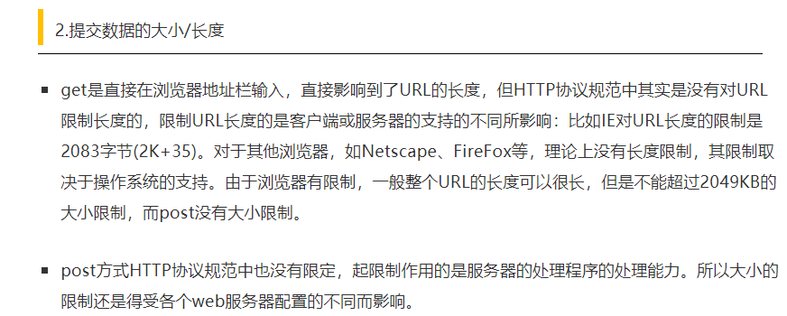

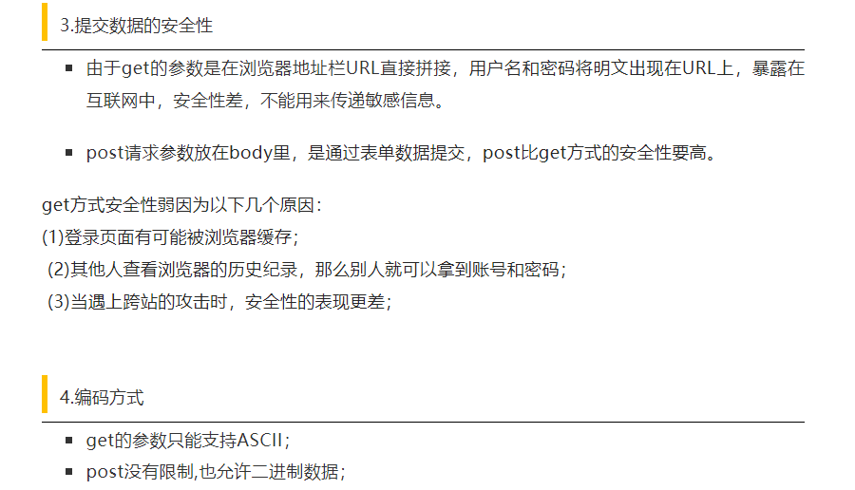

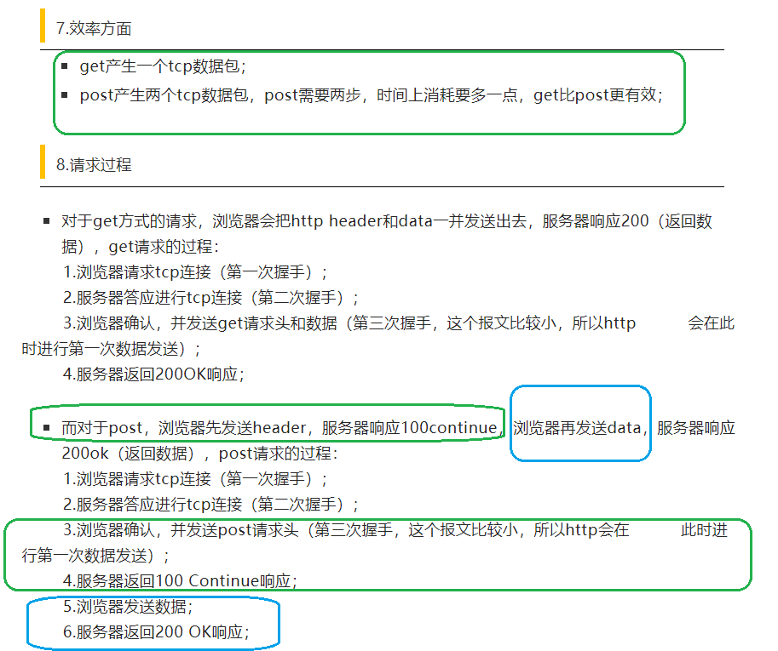

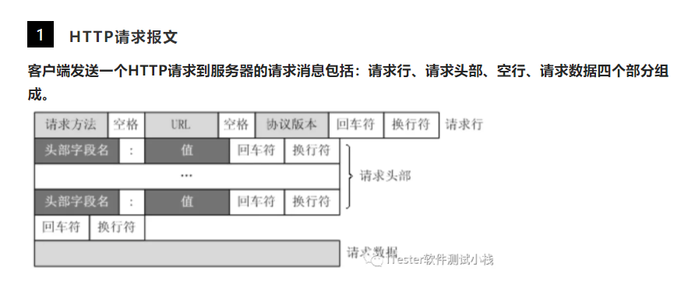

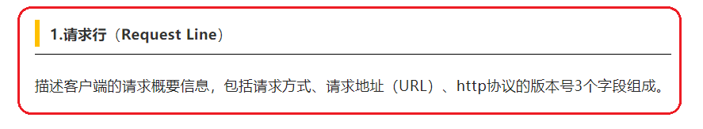

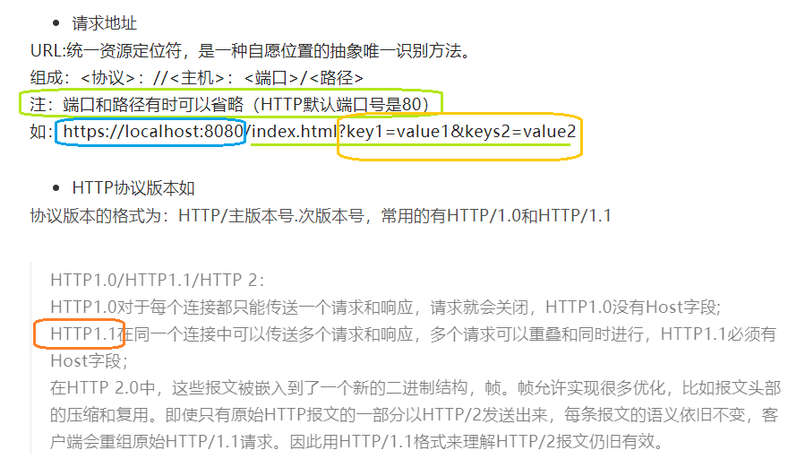

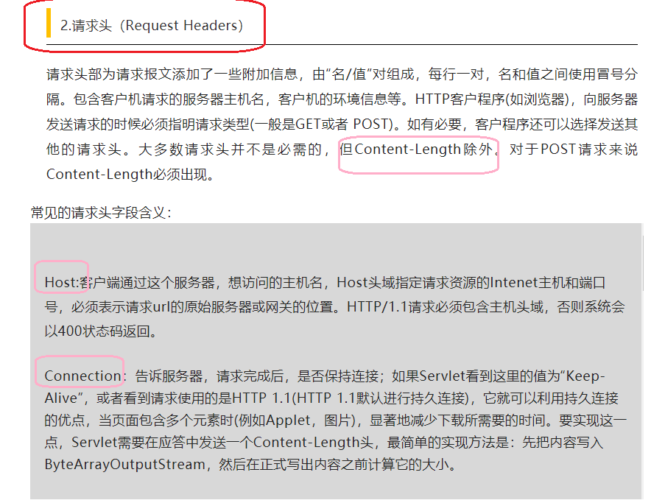

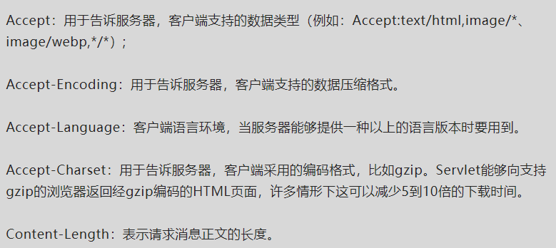

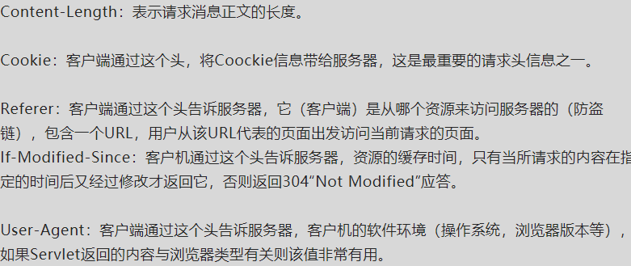

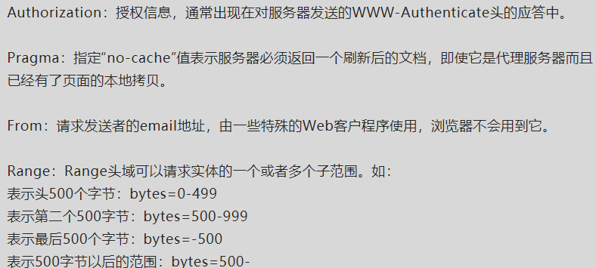

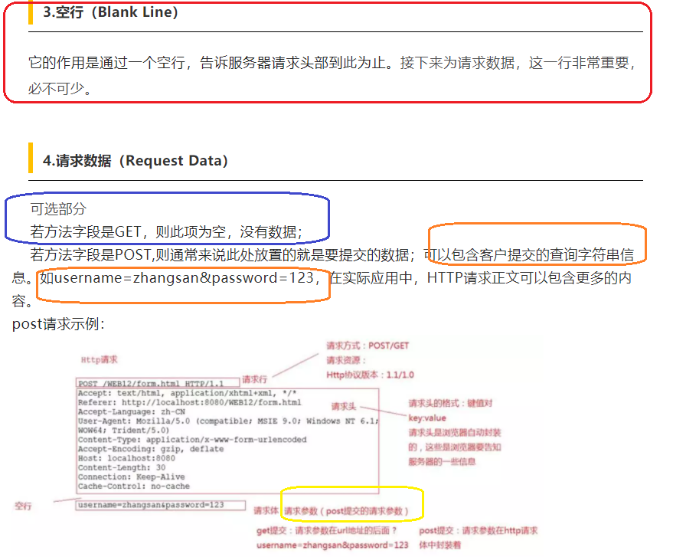

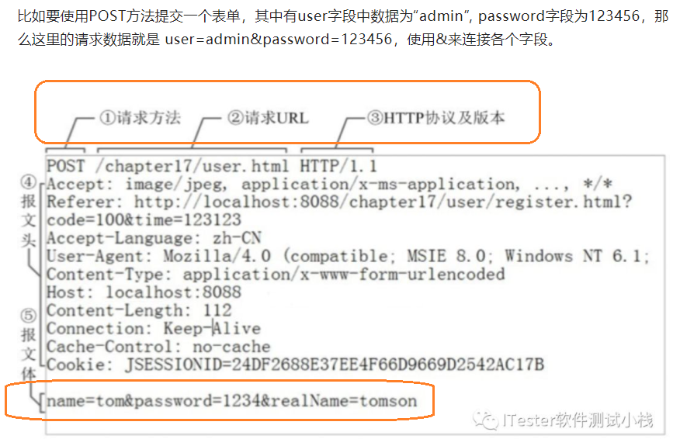

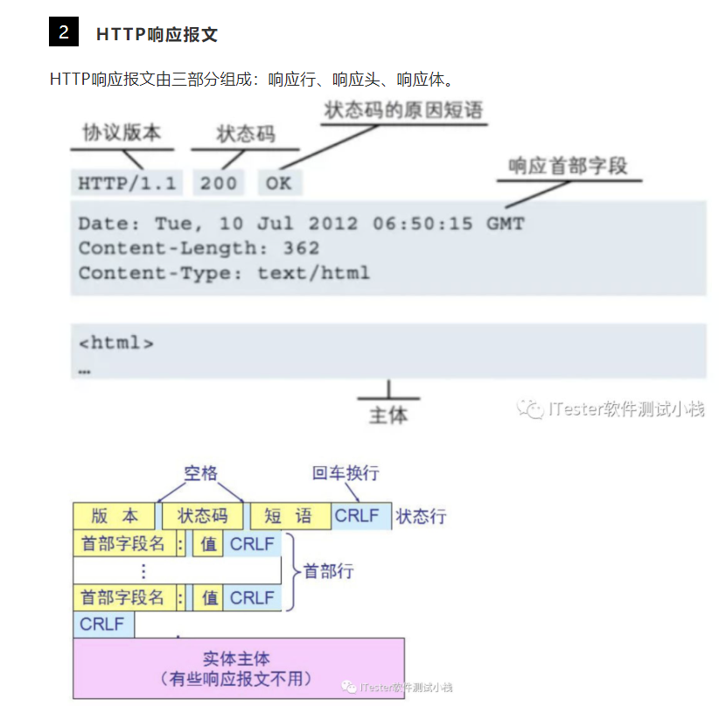

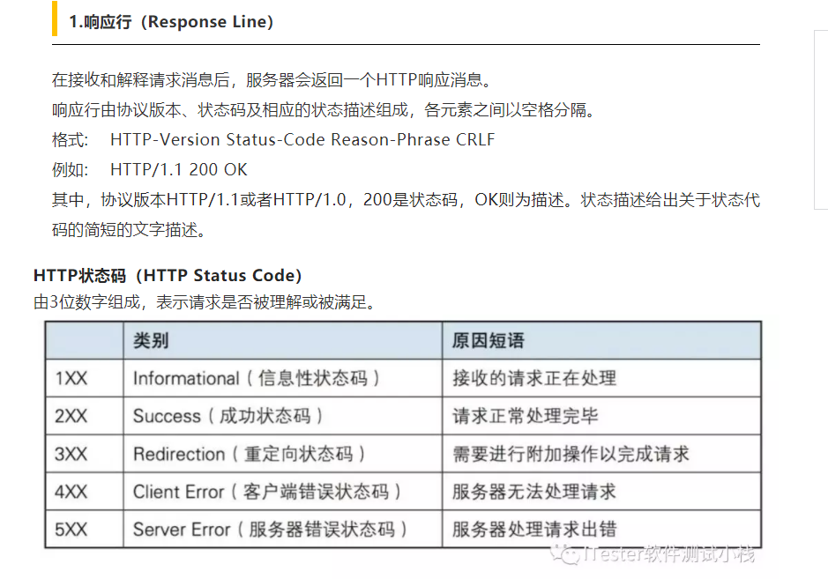

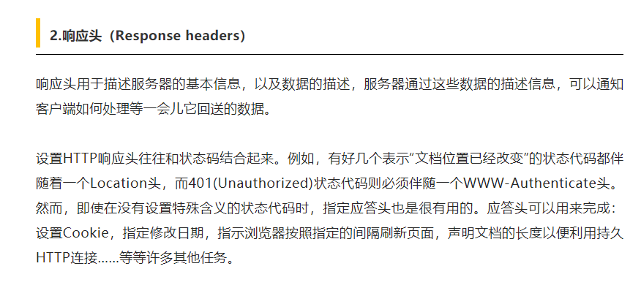

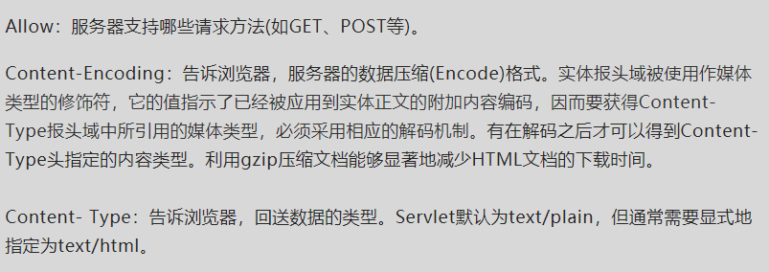

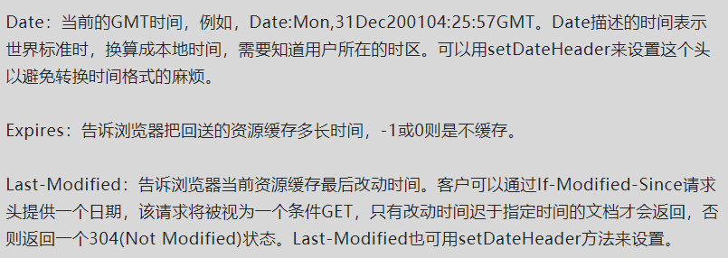

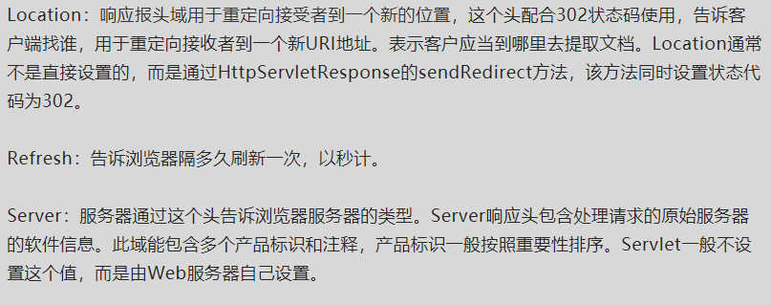

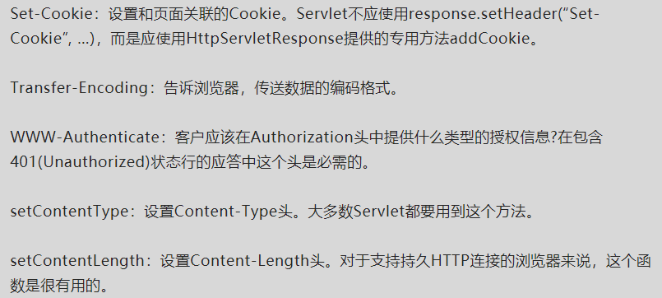

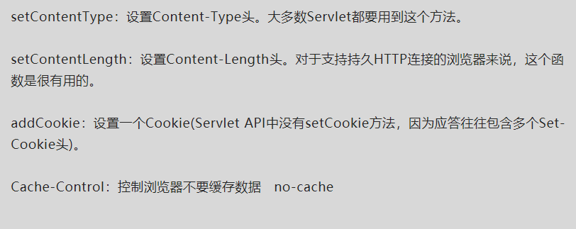

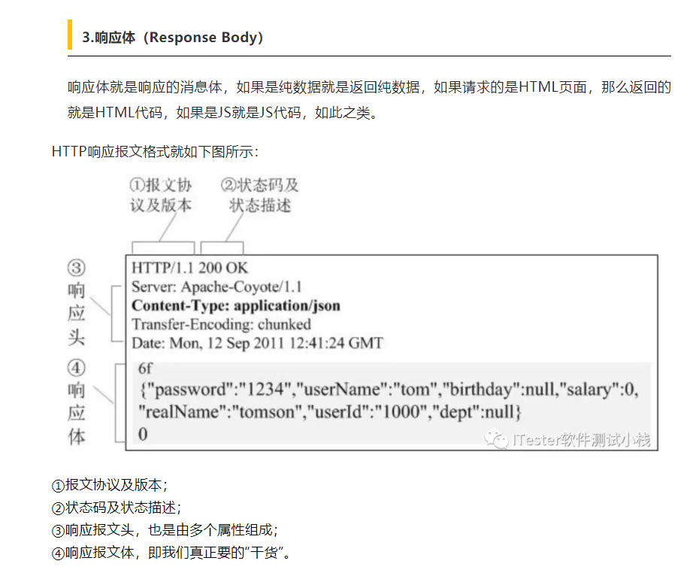

* **pytest测试实战pdf_Pytest测试实战之token处理（十一）**

[**https://blog.csdn.net/weixin_39961943/article/details/110969947?ops_request_misc=&request_id=&biz_id=102&utm_term=pytest%20request%20token%20test&utm_medium=distribute.pc_search_result.none-task-blog-2~all~sobaiduweb~default-0-.pc_search_result_before_js&spm=1018.2226.3001.4187**](https://blog.csdn.net/weixin_39961943/article/details/110969947?ops_request_misc=&request_id=&biz_id=102&utm_term=pytest%20request%20token%20test&utm_medium=distribute.pc_search_result.none-task-blog-2~all~sobaiduweb~default-0-.pc_search_result_before_js&spm=1018.2226.3001.4187)

