1. Get

import requests  
  
'''  
 URL Parameters Request method: URL parameter  
 For example: request http://httpbin.org/get?first_name=hello&last_name=word  
'''  
  
params = {"first_name": "hello", "last_name": "word"}  
responds = requests.get("http://httpbin.org/get", params=params)  
print(responds.text)  
print(responds.url)

1. Post

import requests  
  
params = {"first_name": "hello", "last_name": "word"}  
headers = {"Content-Tpye": "application/x-www-form-urlencoded"}  
responds = requests.post("http://httpbin.org/post", data=params, headers=headers)  
print(responds.text)  
print(responds.url)  
print(responds.request)

1. Json post

import requests  
  
'''  
 URL Parameters Request method: URL parameter  
 For example: request http://httpbin.org/get?first_name=hello&last_name=word in a POST method  
'''  
  
params = {"first_name": "hello", "last_name": "word"}  
headers = {"Content-Tpye": "application/json"}  
responds = requests.post("http://httpbin.org/post", json=params, headers=headers)  
print(responds.text)  
print(responds.url)  
print(responds.request)

1. **Packaging Request Method**

* Directly call a general function

import requests  
import json  
  
  
class ApiRequest(object):  
  
 # ----- The first request method package the Request library, the call can be used according to the actual situation  
 def send_requests(self, method, url, data=None, params=None, headers=None, cookies=None, json=None, files=None,  
 timeout=None):  
 self.r = requests.request(method, url, data=data, params=params, headers=headers, cookies=cookies, json=json,  
 files=files, timeout=timeout)  
 return self.r

* Call individual method function through a filter/gen function

import requests  
import json  
  
  
class ApiRequest(object):  
  
 def get(self, url, data=None, headers=None):  
 if headers is not None:  
 res = requests.get(url=url, data=data, headers=headers)  
 else:  
 res = requests.get(url=url)  
 return res.json()  
  
 "" "POST request" ""  
  
  
def post(self, url, data, headers):  
 if headers is not None:  
 res = requests.post(url=url, data=data, headers=headers)  
 else:  
 res = requests.post(url=url, data=data)  
 if str(res) == "<Response [200]>":  
 return res.json()  
 else:  
 return res.text()  
  
 "" "" "" "" ""  
  
  
def all_method(self, method, url, data=None, headers=None):  
 if method == 'get' or method == 'GET':  
 res = self.get(url, data, headers)  
 elif method == 'post' or method == 'POST':  
 res = self.post(url, data, headers)  
 elif method == 'put' or method == 'PUT':  
 res = self.post(url, data, headers)  
 elif method == 'delete' or method == 'DELETE':  
 res = self.delete(url, data, headers)  
 else:  
 Res = 'request mode is incorrect'  
 return json.dump(res, ensure_ascii=False, indent=4, sort_keys=True, separators=(',', ':'))

# **Pytest实战**

<https://cloud.tencent.com/developer/article/1730701>

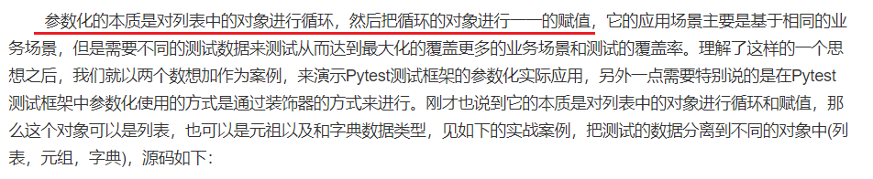

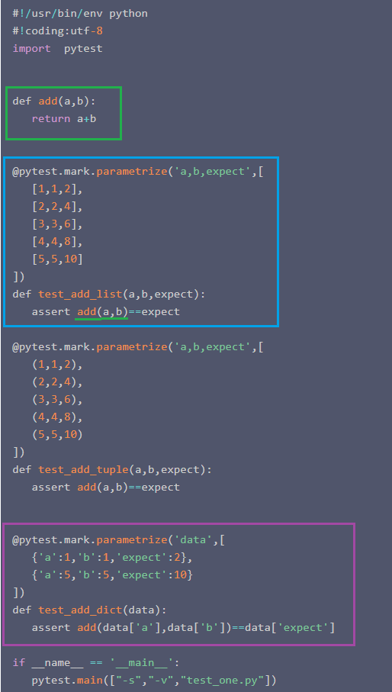

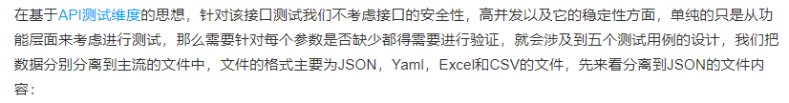

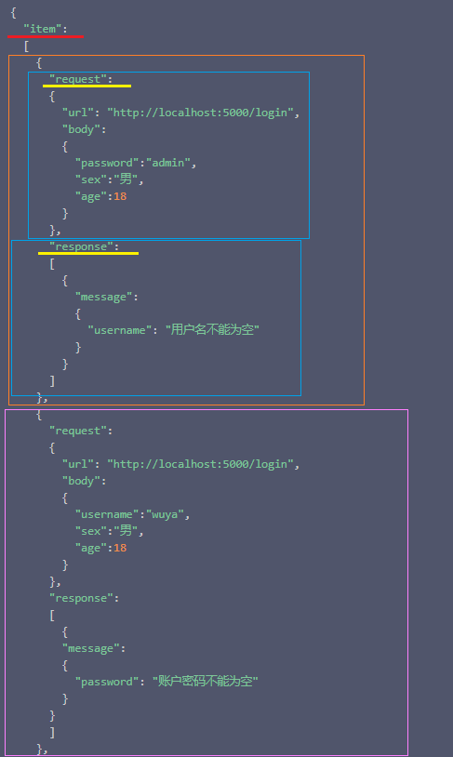

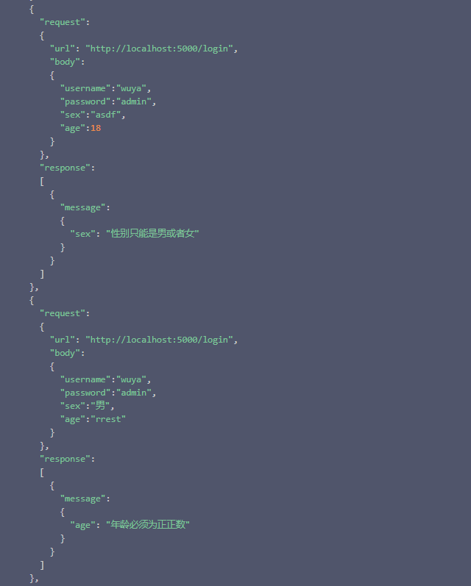

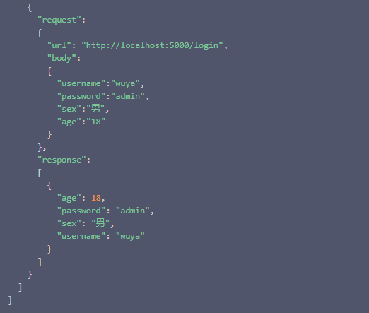

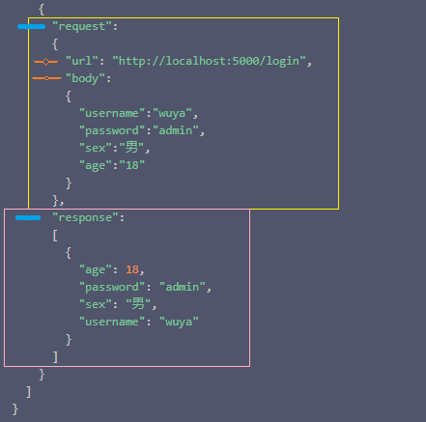

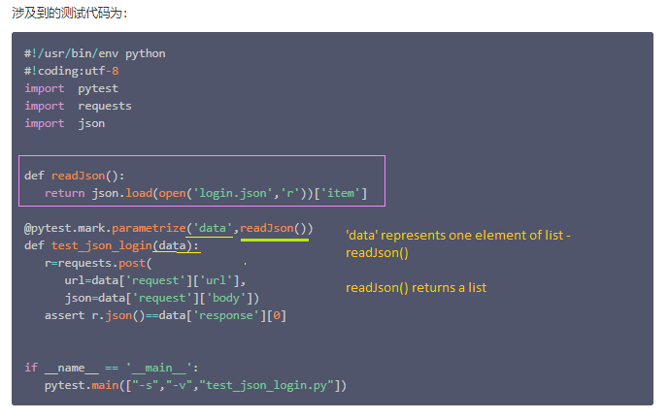

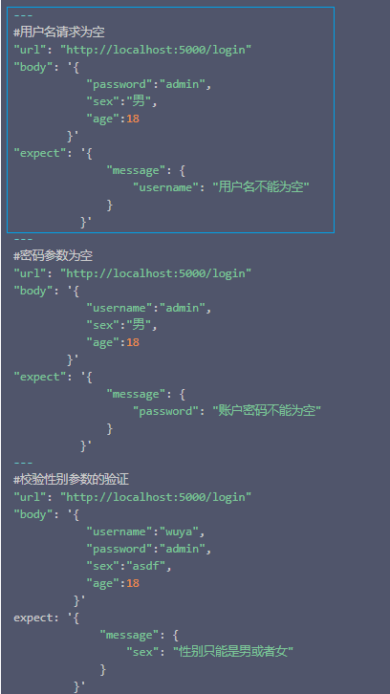

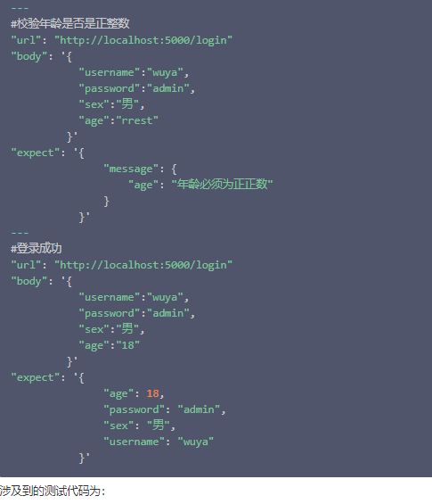

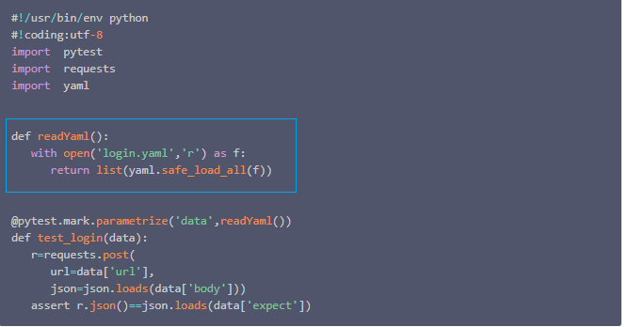

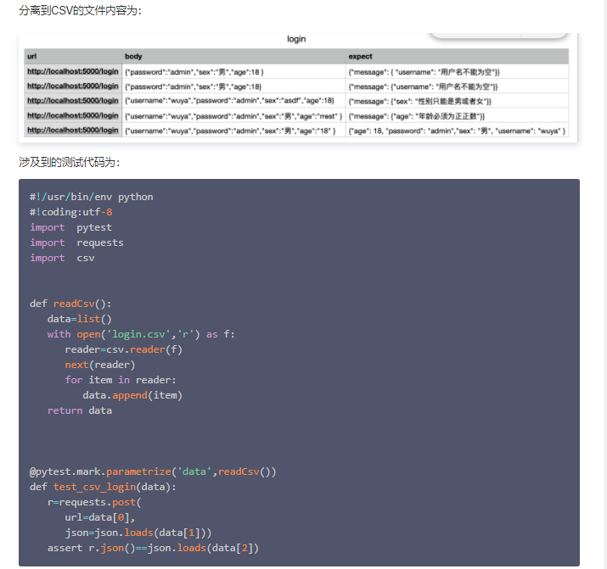

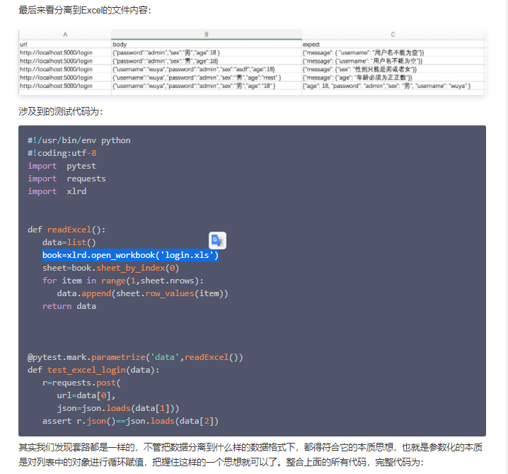

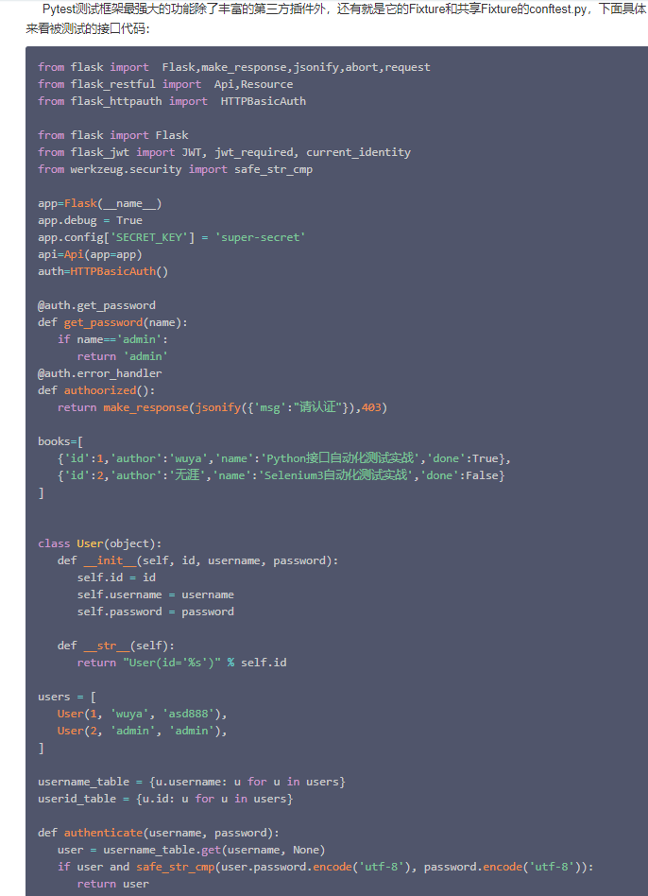

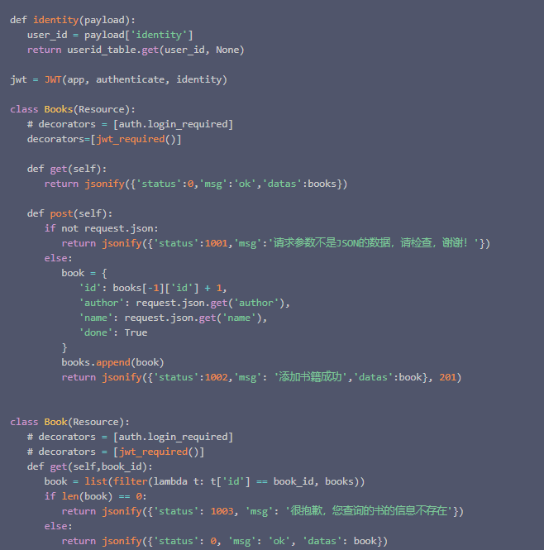

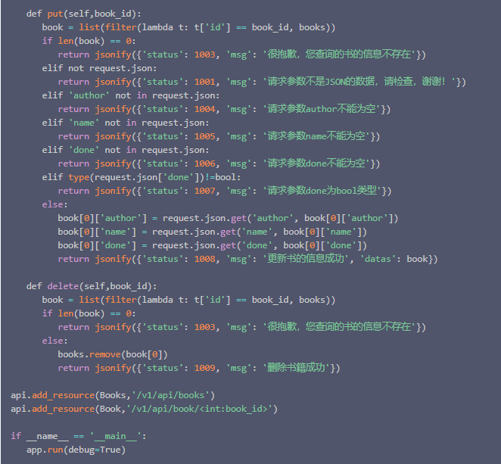

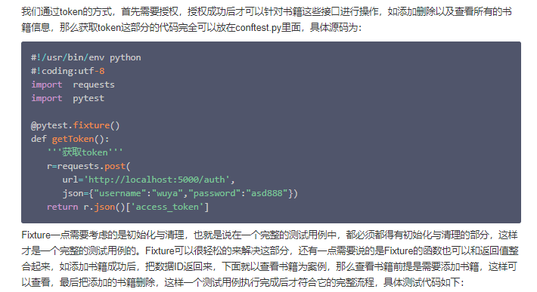

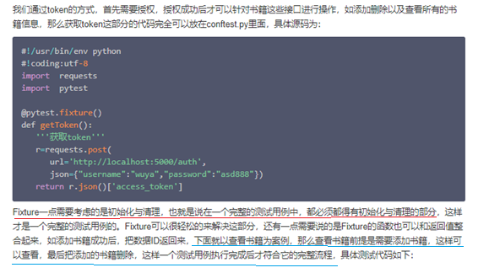

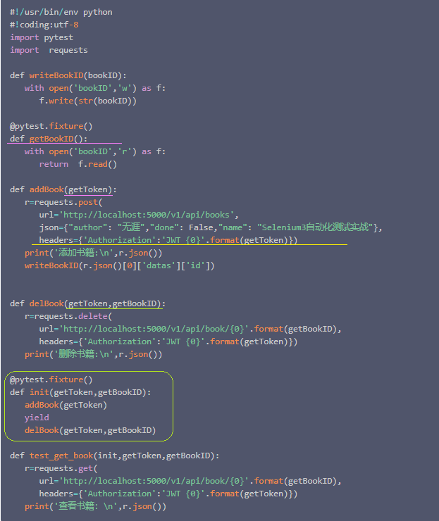

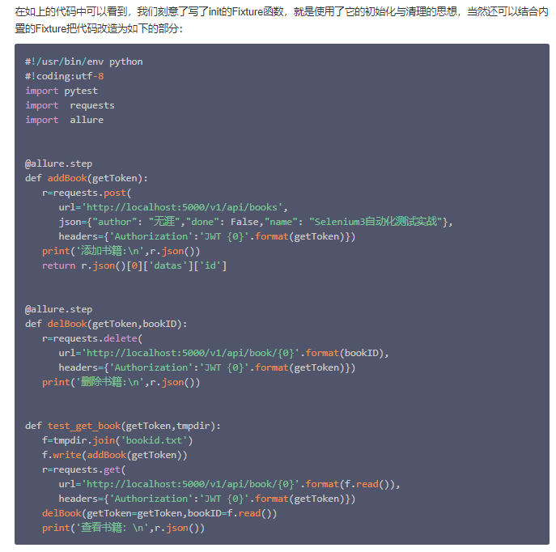

# Pytest接口自动化测试框架搭建模板

<https://blog.csdn.net/VXadmin/article/details/112966633?utm_medium=distribute.pc_relevant.none-task-blog-baidujs_baidulandingword-4&spm=1001.2101.3001.4242>

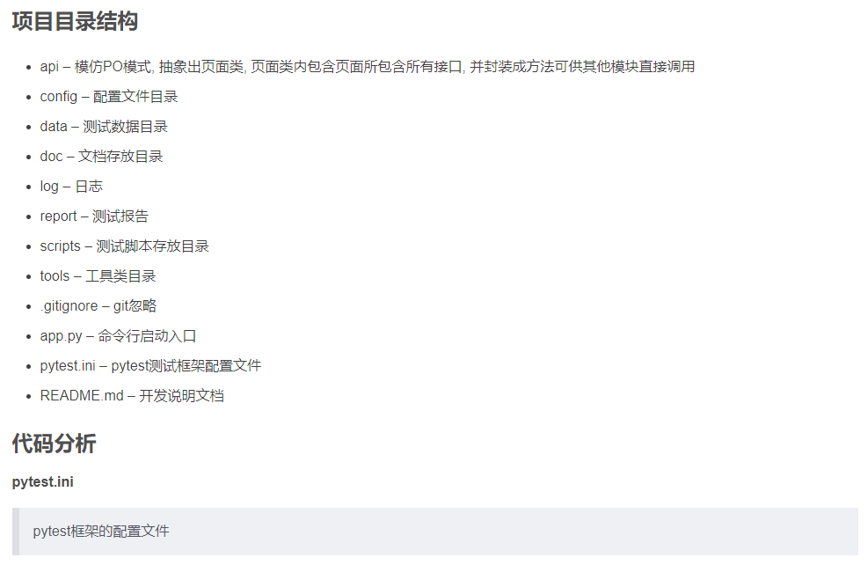

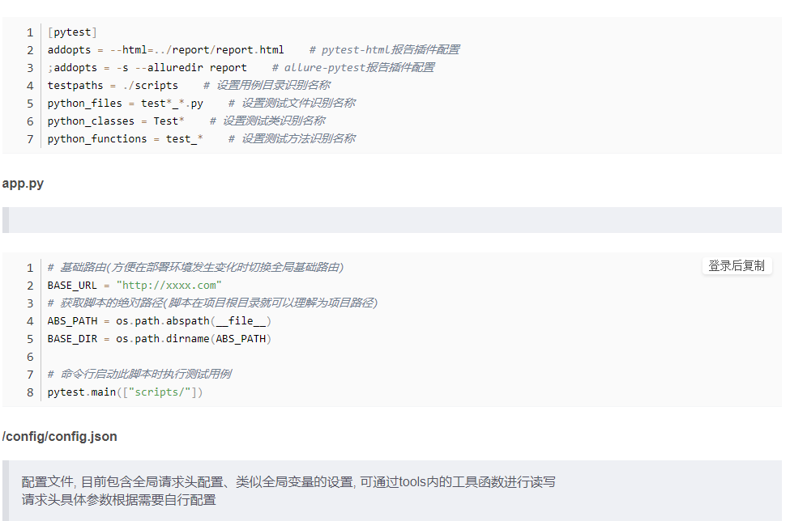

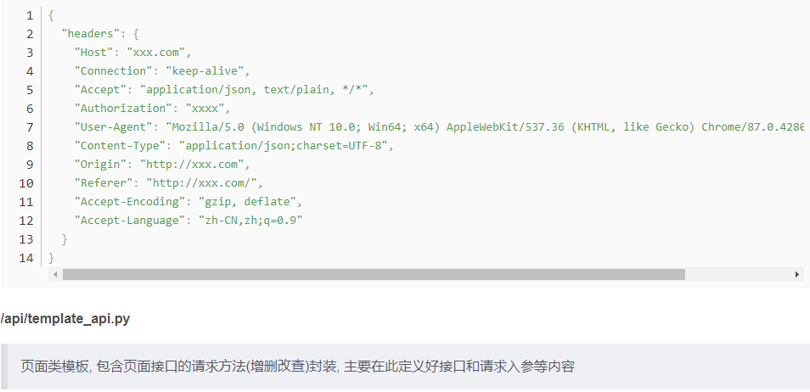

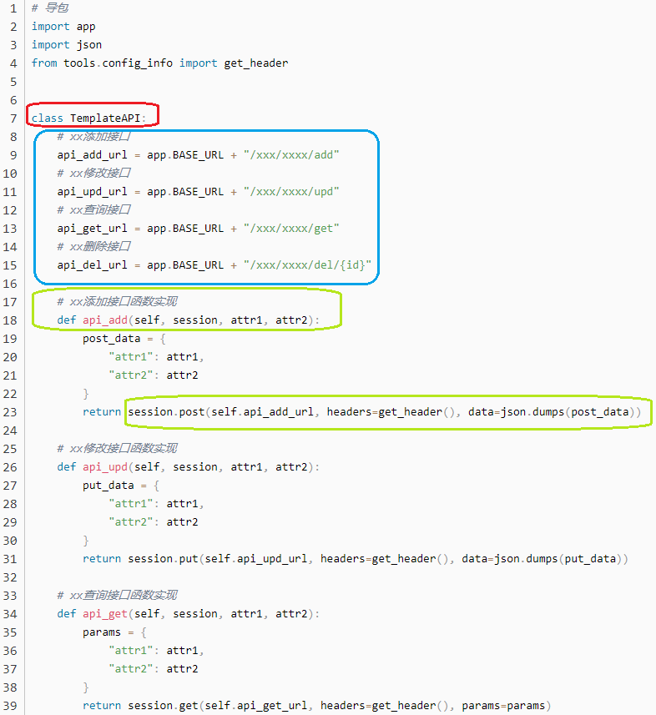

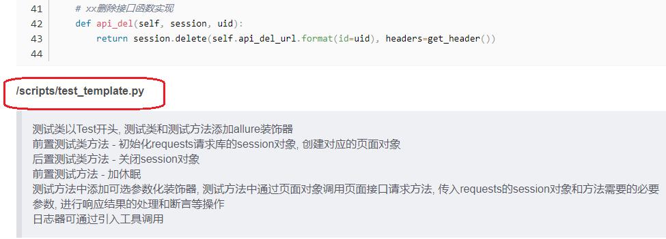

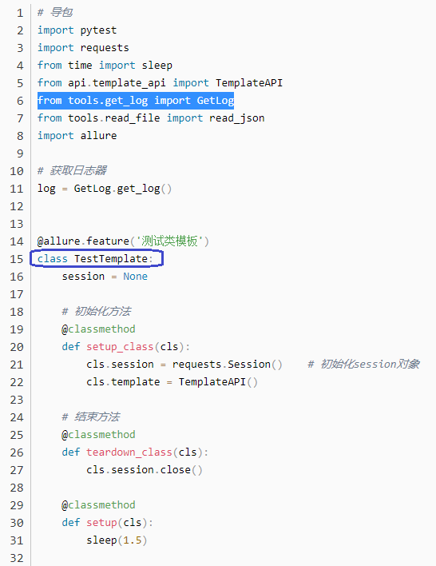

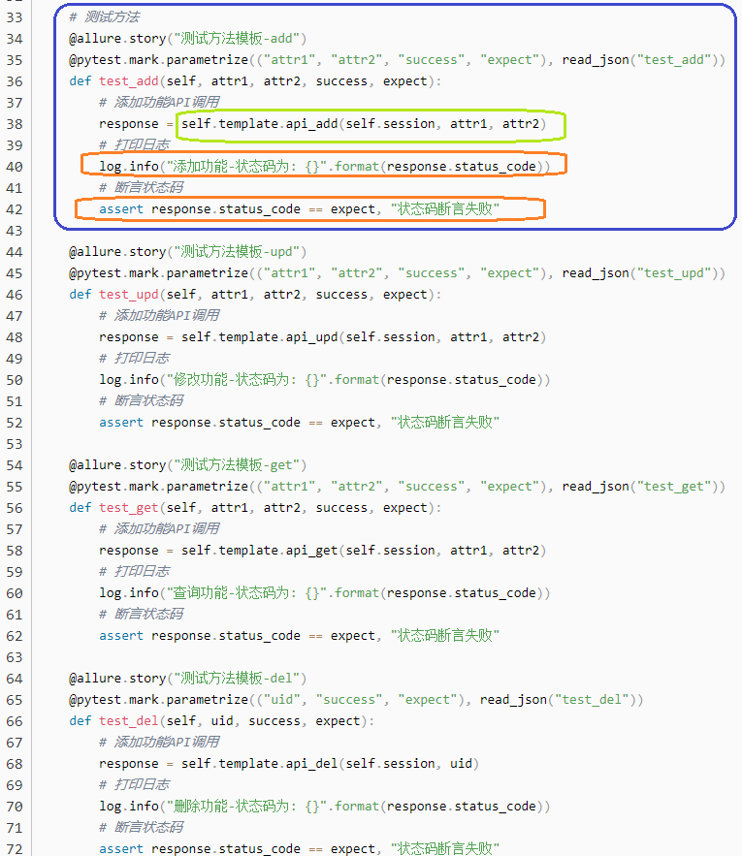

# Python+unittest+requests 接口自动化测试框架搭建 完整的框架搭建过程 实战

<https://blog.csdn.net/songlh1234/article/details/84317617?utm_medium=distribute.pc_relevant.none-task-blog-2%7Edefault%7EBlogCommendFromMachineLearnPai2%7Edefault-4.control&depth_1-utm_source=distribute.pc_relevant.none-task-blog-2%7Edefault%7EBlogCommendFromMachineLearnPai2%7Edefault-4.control>

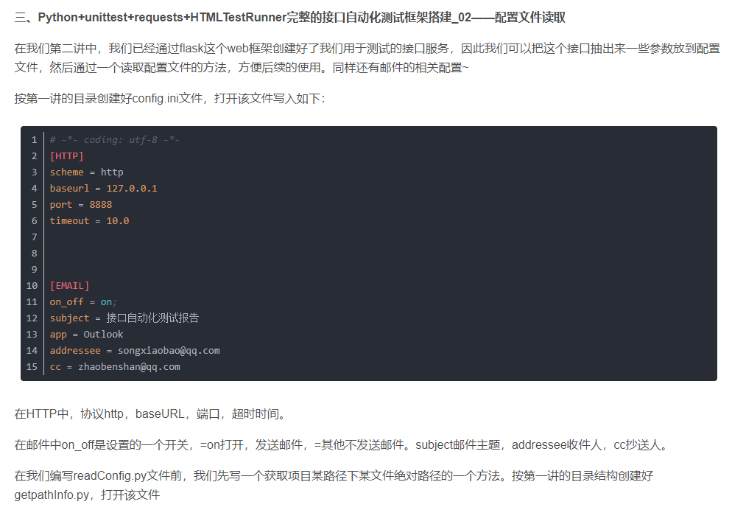

# Python+Requests+Pytest 接口自动化测试脚本总结

<https://blog.csdn.net/changyixue/article/details/105362848>

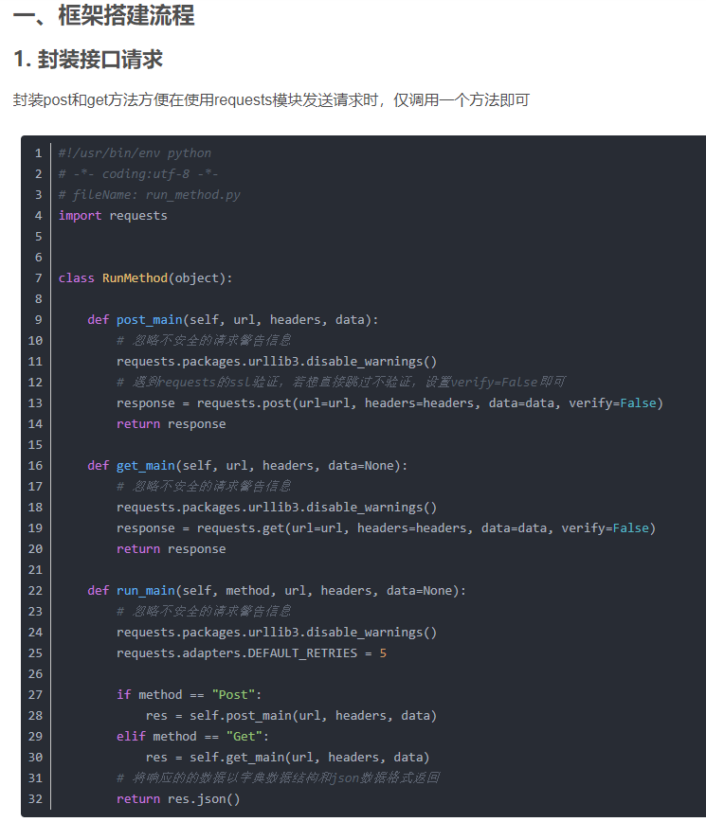

### 2. 存储接口信息

使用yml文件作为配置文件，存储每一个接口信息，主要包括”接口名称、method、url、data和headers“，以及预期结果”expected“

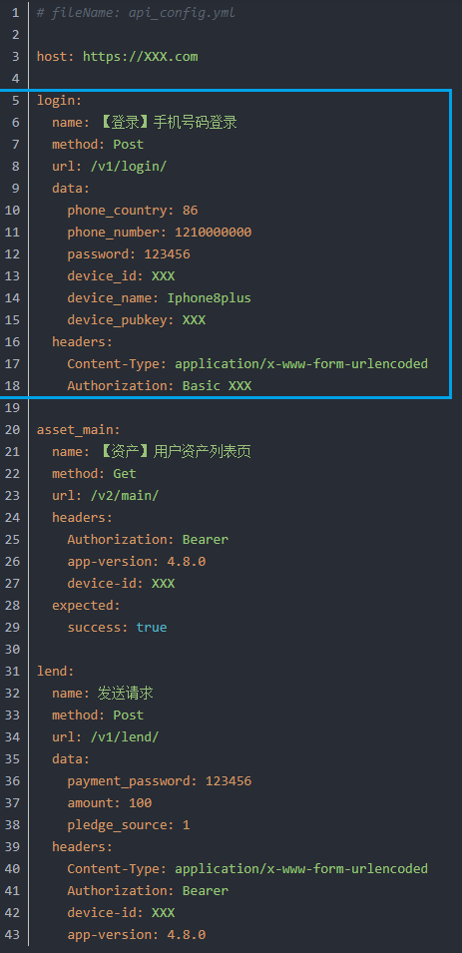

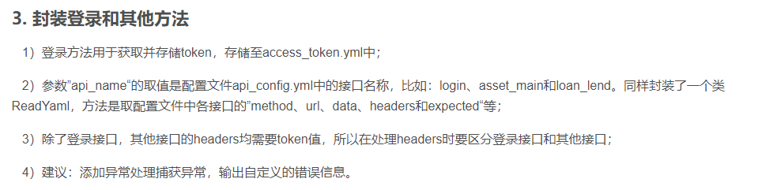

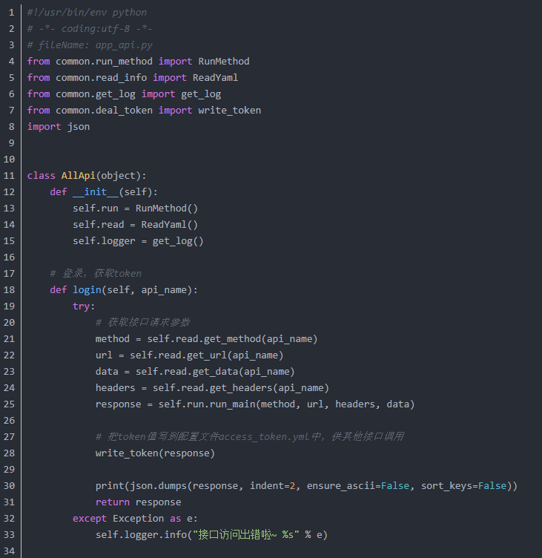

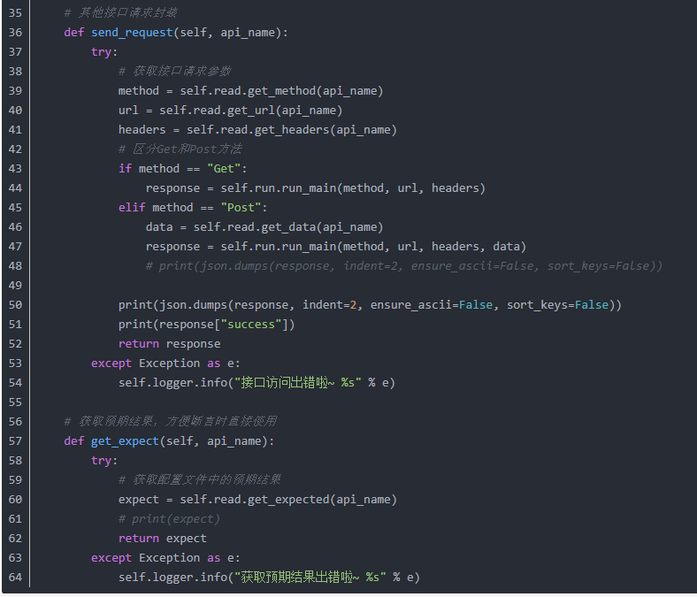

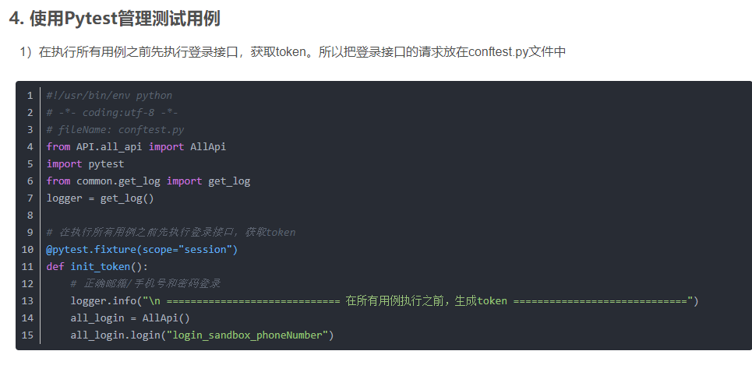

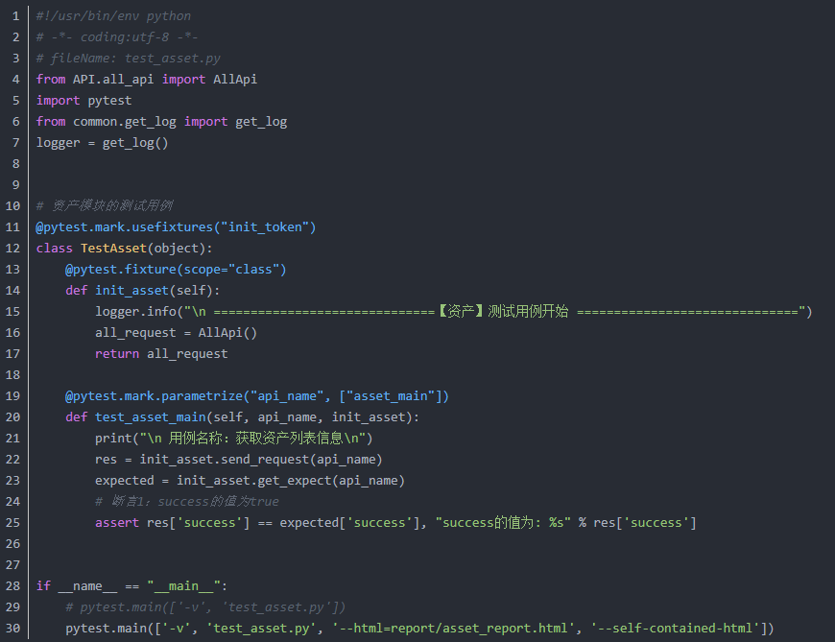

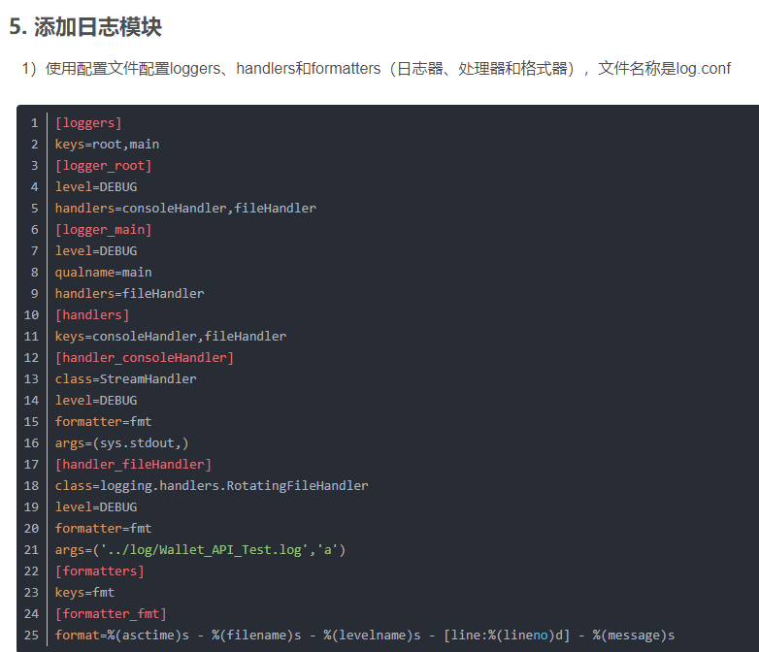

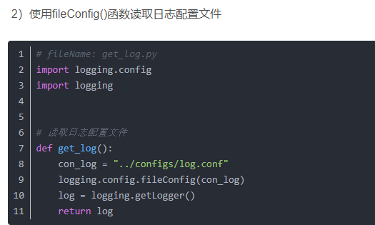

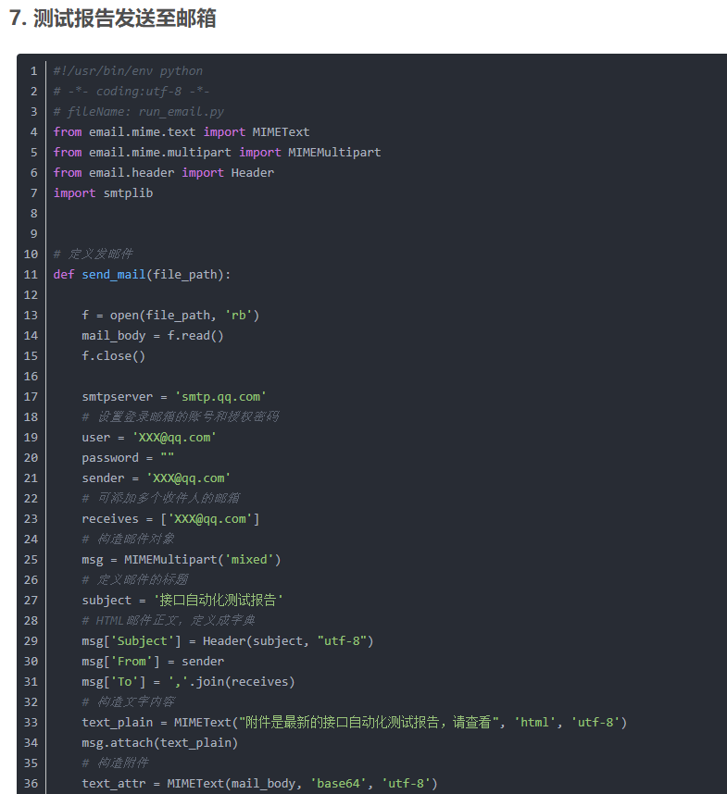

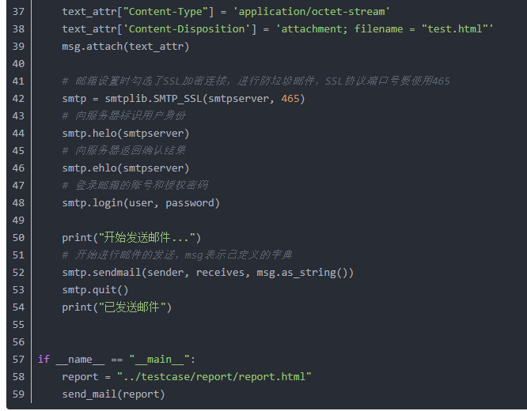

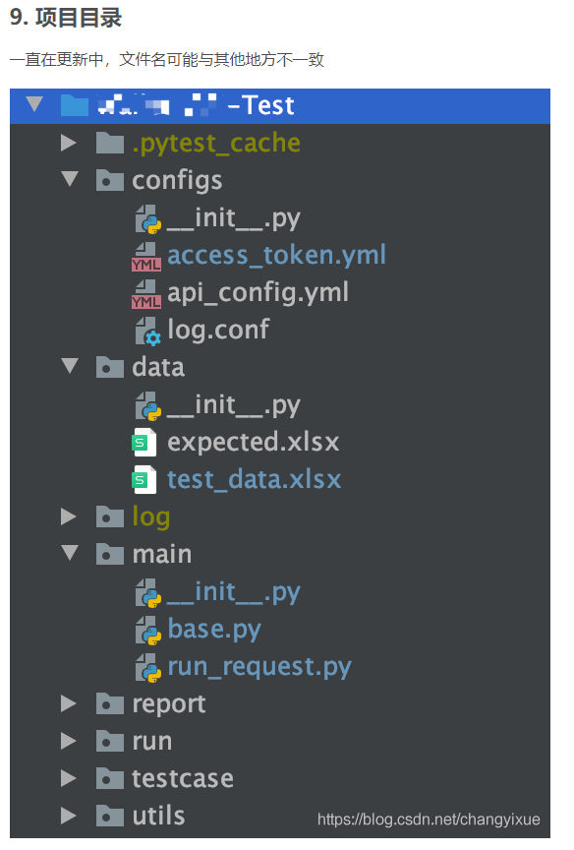

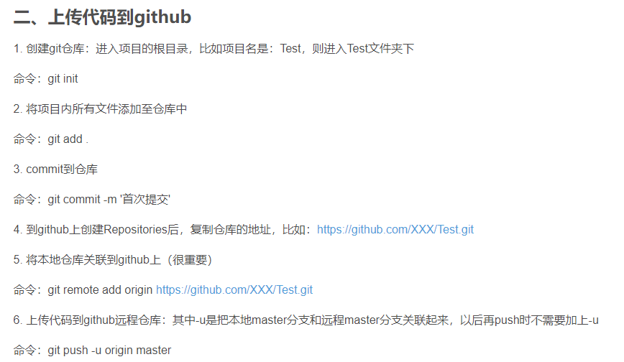

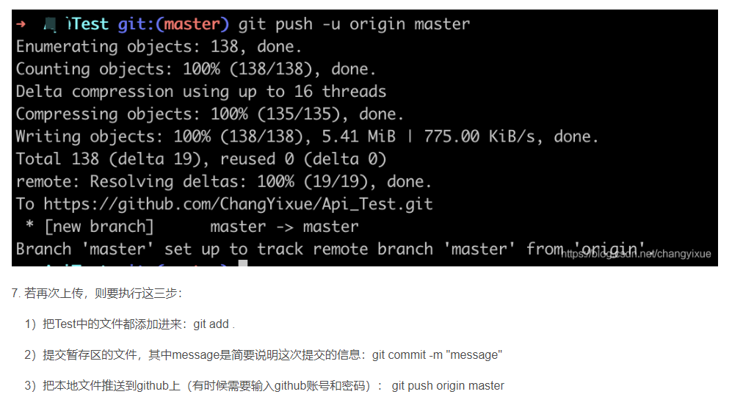

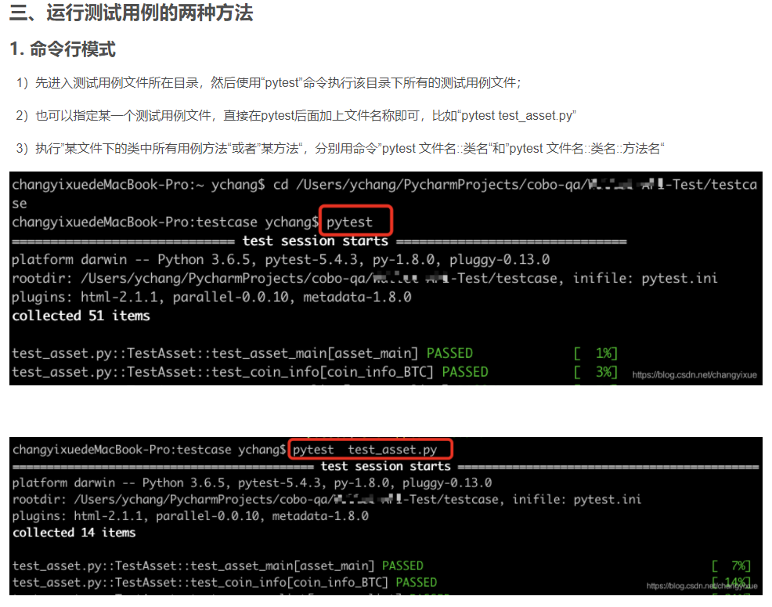

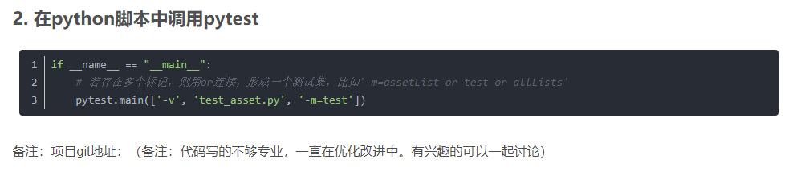

<https://github.com/ChangYixue/Test.git>

# 用python脚本实现一次获取token，多次使用token

