Native Mobile Apps

Native apps are developed specifically for a particular mobile device and are **installed directly onto the device** itself. Users download the app via app stores such **as Apple App Store, Google Play store**, etc.

Native apps are built for specific mobile operating system such as Apple iOS or Android OS. An app made for Apple iOS will not work on Android OS or Windows OS. So if you want your app to work across all major mobile operating systems, you must build separate apps for each operating system. This means more money and more effort (time, resources).

Before deciding whether to build a native app, you need to know the Pros and Cons of such an approach.

**Pros**

* They can be used offline, which makes them faster to open and access anytime.
* In some cases, the performance is faster because they store information locally and only synchronise with the server after the user is done using the app.
* They allow the user to use device-specific hand gestures. Android and iOS are gradually developing different conventions for interaction, and a native app responds the way its user expects.
* Native apps get the approval of the app store they are intended for, which means most of the time the user can be assured of improved safety and security of the app.
* They allow direct access to device hardware that is either more difficult or impossible with a mobile app (camera, accelerometer, etc.)

**Cons**

* More expensive to develop, especially when the app needs to be compatible with multiple mobile operating systems, thus multiplying the development costs.
* Cost of app maintenance is higher (especially if this app supports more than one mobile platform).
* Getting the app approved for the various app stores can prove to be long and tedious for the developer
* Use of the app is contingent on the user's willingness to download and install the app onto their mobile device

**Mobile Web Apps**

Web Apps are basically internet-enabled applications that are **accessible via the mobile device's Web browser**. Users don't need to downloaded and install the app onto mobile device in order to access it.

The app is written as web pages in HTML and CSS, with the interactive parts in Jquery, JavaScript or similar language. Meaning that single web app can be used on most devices capable of surfing the web, regardless of the operating system they use.

Let's see what the Pros and Con' of a mobile web app.

**Pros**

* They are instantly accessible to users via a browser across a range of devices (iPhone, Android, Windows, etc.).
* They are much easier to update or maintain by the developer. If you want to change the design or content of a mobile web app, you simply publish the update to the server and the changes are immediately visible.
* They are much easier for users to discover since their pages can be displayed in search results and listed in common search engines such as Google or Bing.
* Visitors to your regular website can be automatically sent to the mobile web app when they are on a handheld mobile device (using device detection).
* Just like a standard website, mobile websites / web app can be developed as database-driven web applications that act very much like native apps.
* The development is considerably more time and cost-effective than development of a native app, using programming languages and technologies that are more commonly understood and have a much larger developer base.

**Cons**

* Mobile Web apps only have limited scope as far as accessing a mobile device's features is concerned (device-specific hand gestures, sensors, etc.).
* There are so many variations between web browsers and browser versions and phones that it makes it challenging to develop a stable web-app that runs on all devices without any issues.
* They are not listed in 'App Stores'. So if someone is looking for your app in the app store, they will be unable to discover it though such means.
* Since there is no regularised quality control system for Web apps, users may not always be guaranteed safety and security of the app.
* Web apps are unavailable when offline, even as a basic version.

So, which is better - a native app or a web app? It depends on your end goals. If your goal is to establish a broad mobile presence, then you should go for a mobile web app.

If your goal is to provide an application that needs to work more like a computer program than a website, rich with interaction, a native mobile app would be the best choice.

## ****Web applications vs websites****

As a matter of fact, there is no difference between a webpage and a website for end-users. They simply type the URL address and don’t have to think about it, from there. The key is that the **“website”** should do what it is supposed to do.

At the same time, for an eCommerce development team, there is a big difference between creating a website or a web application. Keep this in mind when you decide between websites versus web applications for your online business. To make the right decision for your company, you should consider the following information in the article, below.

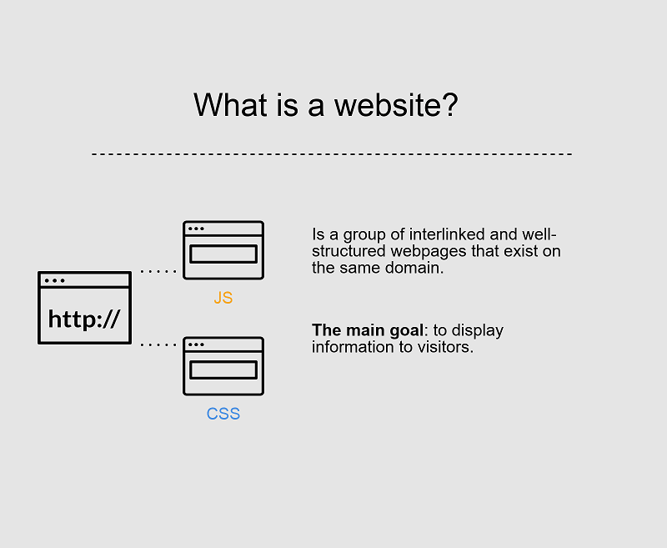

### ****Websites: main features****

Typically, websites are informational in nature. Great examples are blogs and sites that contain the news. The main purpose is to provide users with information.



Here is an example of a landing page, developed by the Dinarys team.

In most cases, users have zero or limited interaction with web pages. By **“limited”**, we mean subscribe forms or search boxes. So, should you use this solution for your eCommerce business model?

If you want to place only a small amount of information about your business (including description, upcoming events and contact information), you would choose a website for your needs.

Also read: [How to Build a Successful Retail Website for Your Business](https://dinarys.com/blog/build-successful-retail-website-for-your-business)

### Web Applications: main features

### ****Web Applications: main features****

Unlike sites, web applications are more responsive to visitors’ actions. Web apps are still informative, but your visitors can interact with the information you provide, in some way. Moreover, they can manipulate data and request different information.

As a specific application example, let’s take a closer look at your online banking app. Here, you can see information and even make some actions and transactions, with some simple input.

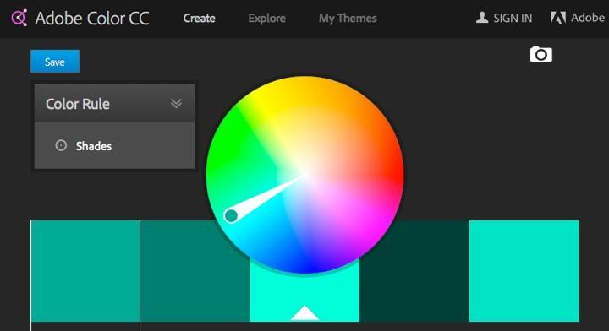

Useful apps make your life easier. For instance, with [Adobe Color CC](https://color.adobe.com/).

## Web apps vs websites: key differences

## ****Web apps vs websites: key differences****

To be more precise, we’d like to tell you about the basic differences between web-page and web app features.

### ****Interactivity****

The first variance is the different degree of interaction available. While a site contains text and visual content, users cannot interact with it, necessarily, and apps give users the possibility of **not only reading but also manipulating information** on the page. This is a kind of a dialog between the user and the business. The user interacts with the site interface and gets a **response** in the form of electronic payments, online chats, document downloads, and more.

An online shop, that allows users to buy items and search through the catalog, can be a web app. Another impressive example is social networks. They often include blog platforms, chats, customized content and unlimited content sharing.

Also read: [Top 9 Essential Features for Custom E-Commerce Websites](https://dinarys.com/blog/top-essential-features-custom-ecommerce-websites)

Today, most websites have a hint of interactivity, because users appreciate and respond to that feature. For this reason, some website owners prefer to add small web app elements to their websites.

Some restaurants place Google Maps widgets on their contact page so that users can find a direct route to their restaurant. At the same time, most websites contain informational content, rather than interactivity. That way, website visitors spend more time listening, reading or viewing the page. Unlike websites, web app visitors are mostly focused on interaction.

### ****Integration****

The action of bringing different components together to build more comprehensive systems is called integration. Developers can integrate web applications and sites with other software, including **ERP, CRM, etc**. In most cases, most people do an integration with apps. Why? Because of their complex features that may require additional information from extra systems. One of the most popular integrations in eCommerce is the integration of an app with Customer Relationship Management (CRM) systems. This helps online retailers store customers’ personal data, order information, and improves the work of the sales team. With the integration, all application user data is automatically collected and stored in **CRM systems**. Such integration also enables your online shop team to explore customer behavior, buying habits, and be more effective in dealing with negative reviews.  This is extremely beneficial for online shop owners since all changes in customer data will be automatically reflected in the CRM. This method of engagement with customer data will bring an increase in sales and overall improvement of an online shop’s management processes.

In some cases, website owners perform integration with CRM to provide visitors with more personalized content. Unlike web apps, such integration with websites is an optional feature, rather than part of the main functionality.

### ****Authentication****

This process includes entering user data to gain access to the site or the system.

This feature is vital for systems that require any personal information. At this stage, however, it is important to pay special attention to security, which is necessary to prevent unauthorized access and theft of users’ personal data.

Also read: [5 Tips for Magnificent eCommerce Website Design](https://dinarys.com/blog/ecommerce-website-design)

Unlike sites, applications more often require authentication. Why? Because they provide users with a broader scope of options than a website. For instance, when using social networks, the system warns you about weak logins and passwords. This may result in stealing your information from hackers.

Most informative sites use authentication and, in some cases, it is used to give users more options that are not provided to unregistered users. If unregistered users can only view articles, registered users can leave comments, share via social networks, etc. This is also a great way to block spammers.

In this way, authentication is required for both web apps and sites.

**Both websites and web applications run in browsers, both require access to the internet**

The first point to start ‘web application vs. website’ differentiation with is interactivity. A website provides visual and text content that the user can see and read, but not affect in any way. In the case of a web application, the user can not only read the page content but also manipulate the data on this page. The interaction takes the form of a dialog: the user clicks a button or submits a form and gets a response from the page. This response may take a form of a document download, online chat, electronic payment and more.

An illustrative example of **a web application** interactivity is an **online banking application** that performs transactions based on a customer’s input. Similar functionality can be found in **an online store** that allows visitors to search through the catalog and buy items instantly. **Social networks** are another impressive example. They connect users via chats and blog platforms, generate feed content based on users’ preferences and allow for almost unlimited content sharing, not to speak of their built-in mini-applications for user entertainment.

The problem is that today one can rarely encounter a website without a hint of interactivity. **Modern websites usually contain small web application elements.** For example, a restaurant’s website may contain a Google Maps widget showing a route to this restaurant. However, in the case of websites, the balance between the informational content and interactivity is shifted towards the former. **A typical website contains far fewer interactive elements than informational content**, and the user usually spends most of the time on a website reading, viewing, or listening. The situation is the opposite with web applications, as their core functionality is based on interaction.

**Web applications mostly require authentication**, as they offer a much broader scope of options than websites. Consider an example of social networks. When you register, you create an account and get a unique identification number. The system warns you if your login and password are weak. If you leave them unchanged, hackers may reach your account and steal your information, as well as irritate other users with junk emails under your name.

**Authentication is not obligatory for informational websites**. The user may be offered to register to get access to additional options unavailable to unregistered website visitors. For example, you may look through news and featured articles on a news website without bothering to register. However, if you want to leave a comment you will have to log in. This way, users confirm their identity allowing the system to block spammers.

## Web applications with special names

There are web applications with special names that may already be familiar to you:

### Web portals

A portal is an environment for integrating diverse applications and various content. It enables to configure content and offers personalized user experience, which means that the user gets only the content tailored to what he or she needs.

Consider a bank web portal as an example. It may provide links to account information, bill payments, and deposits. Each of them is a web application, but they are accessed from the central hub – the web portal.

|  |
| --- |
| **Use example of our web portal project to build a better understanding.**  [**VIEW THE PROJECT**](https://www.scnsoft.com/case-studies/viber-billing) |

### Online stores

An online store (or an e-shop) is an application used for selling goods or services over the internet. The process goes the following way: a customer chooses a product and clicks a button to order it; then, the system processes the order.

One of the features of an online store is the users’ ability to make online payments. To pay online, the user should indicate their credit card number, and, in some cases, passport details, email, or telephone number. To make the transaction secure, the user has to be authorized.

## What’s the Difference Between a Mobile Website and an App (Application)?

Before you can evaluate the benefits of a mobile website vs. an app it’s important to understand the key differences between the two. Both apps and mobile websites are accessed on a handheld devices such as smartphones (e.g. iPhone, Android and Blackberry) and tablets.

**A**[**mobile website**](https://www.hswsolutions.com/services/mobile-web-development/advantages)**is similar to any other website in that it consists of browser-based HTML pages that are linked together and accessed over the Internet (**for mobile typically WiFi or 3G or 4G networks). **The obvious characteristic that distinguishes a mobile website from a standard website is the fact that it is designed for the smaller handheld display and touch-screen interface**. Increasingly, [responsive web design](https://www.hswsolutions.com/services/responsive-website-design-services) is becoming the new standard for websites that are not only mobile-friendly, but that can scale to any sized device - from desktop down to tablet and handheld smartphones.

Like any website, mobile websites/responsive sites can display text content, data, images and video. They can also access mobile-specific features such as click-to-call (to dial a phone number) or location-based mapping.

**Apps are actual applications that are downloaded and installed on your mobile device**, rather than being rendered within a browser. Users visit device-specific portals such as  Apple’s App Store, Android Market, or Blackberry App World in order to find and download apps for a given operating system. **The app may pull content and data from the Internet, in similar fashion to a website**, or **it may download the content so that it can be accessed without an Internet connection**.

## Advantages of a Mobile Website vs. Native Apps

If your goals are primarily related to marketing or public communications, a mobile/responsive website is almost always going to make sense as a practical first step in your mobile outreach strategy. This is because a mobile website has a number of inherent advantages over apps, including broader accessibility, compatibility and cost-effectiveness.

Check**Immediacy – Mobile Websites Are Instantly Available**  
A mobile website is instantly accessible to users via a browser across a range of devices (iPhone, Android, BlackBerry, etc).  Apps on the other hand require the user to first download and install the app from an app marketplace before the content or application can be viewed - a significant barrier between initial engagement and action/conversion.

Check**Compatibility – Mobile Websites are Compatible Across Devices**  
A single mobile website can reach users across many different types of mobile devices, whereas native apps require a separate version to be developed for each type of device. Furthermore, mobile website URLs are easily integrated within other mobile technologies such as SMS, [QR Codes](https://www.hswsolutions.com/services/mobile-web-development/qr-code-marketing) and near field communication (NFC).

Check**Upgradability – Mobile Websites Can Be Updated Instantly**  
A mobile website is much more dynamic than an app in terms of pure flexibility to update content. If you want to change the design or content of a mobile website you simply publish the edit once and the changes are immediately visible; updating an app on the other hand requires the updates to be pushed to users, which then must be downloaded in order to update the app on each type of device.

Check**Findability – Mobile Websites Can be Found Easily**  
Mobile websites are much easier for users to find because their pages can be displayed in search results and listed in industry-specific directories, making it easy for qualified visitors to find you. Most importantly, visitors to your regular website can be automatically sent to your mobile site when they are on a handheld (using device-detection).  In contrast, the visibility of apps are largely restricted to manufacturer app stores.

Check**Shareability – Mobile Websites Can be Shared Easily by Publishers, and Between Users**  
Mobile website URLs are easily shared between users via a simple link (e.g. within an email or text message, Facebook or Twitter post). Publishers can easily direct users to a mobile website from a blog or website, or even in print. An app simply cannot be shared in this fashion.

Check**Reach – Mobile Websites Have Broader Reach**  
Because a mobile website is accessible across platforms and can be easily shared among users, as well as search engines, it has far greater reach capability than a native app.

Check**LifeCycle – Mobile Websites Can’t be Deleted**  
The average shelf-life of an app is pretty short, [less than 30 days according to some research](http://techcrunch.com/2009/02/19/pinch-media-data-shows-the-average-shelf-life-of-an-iphone-app-is-less-than-30-days/), so unless your app is something truly unique and/or useful (ideally, both), it’s questionable how long it will last on a user’s device. Mobile websites on the other hand are always available for users to return to them.

Check**A Mobile Website Can be an App!**  
Just like a standard website, mobile websites can be developed as database-driven web applications that act very much like native apps. A mobile web application can be a practical alternative to native app development.

Check**Time and Cost - Mobile Websites are Easier and Less Expensive**  
Last but certainly not least, mobile website development is considerably more time and cost-effective than development of a native app, especially if you need to have a presence on different platforms (requiring development of multiple apps).

Check**Support and Maintenance**  
The investment considerations of app vs website don’t end with the initial launch; properly supporting and maintaining an app (upgrades, testing, compatibility issues and ongoing development) is more much more expensive and involved than supporting a website over time.

**A mobile website is a website optimized and scaled for mobile devices**. Typical features include smaller fonts, fewer page elements and less white space (when compared to desktop versions).

**A mobile app** is a program accessed via the internet or stored locally. **Mobile apps can use device’s native features**, which allows developers to create better, more intuitive and faster user experiences for customers.