- Chasing Low Volume Pump is dangerous. Be careful with the flush.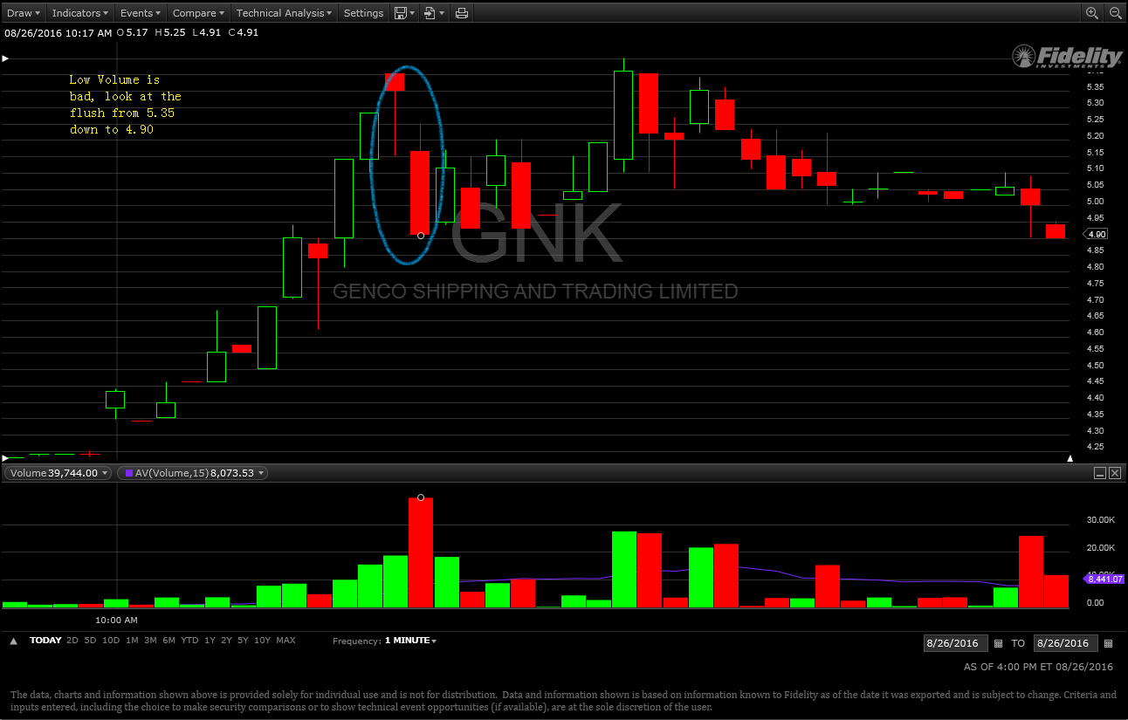

- When chasing pump, be careful with when reaching TOP. It is easy to identify. When you see price is not going up, starts going sideways and low and lower buying price starts to show up.
- When chasing pump at high price, if within 2- 3 mins, price not going up, it is time to exit. Wait no more than 3 mins after entry.
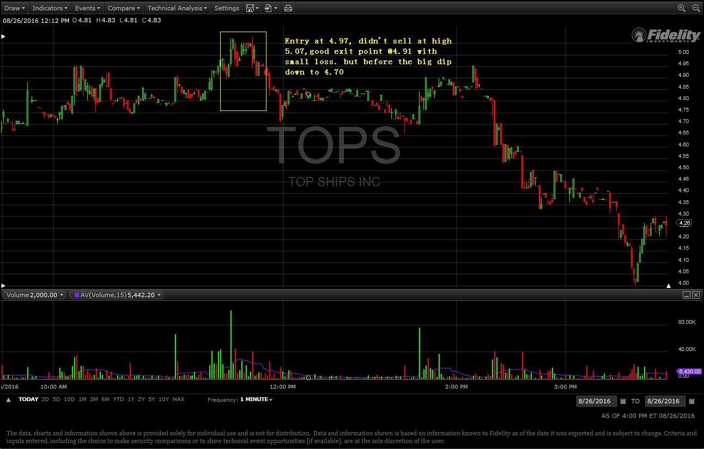
- Generally, after entry in a momentum stock, if price does not go up in 3 mins, exit.
- Choppy upward trend, do not chase, chase clean and smooth pump.
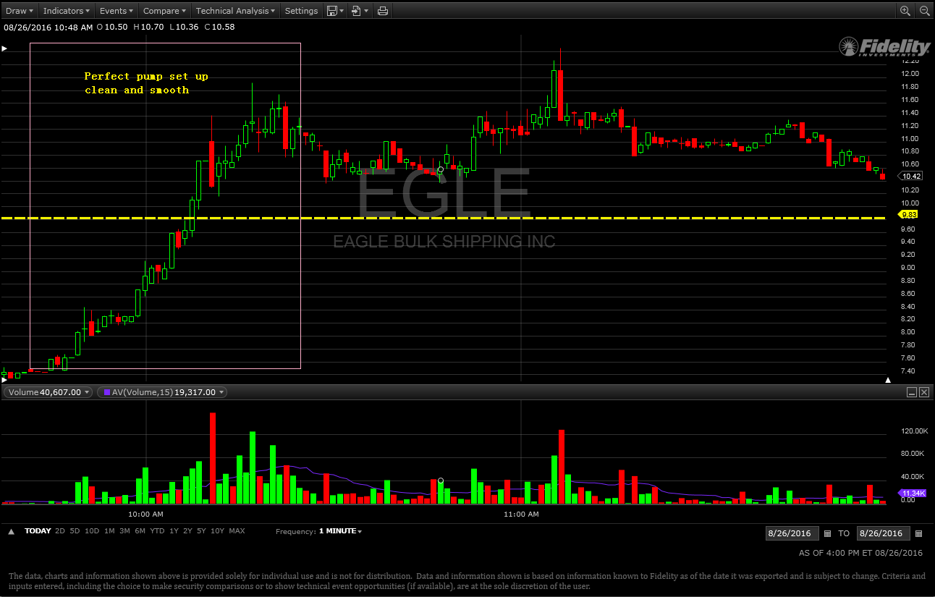
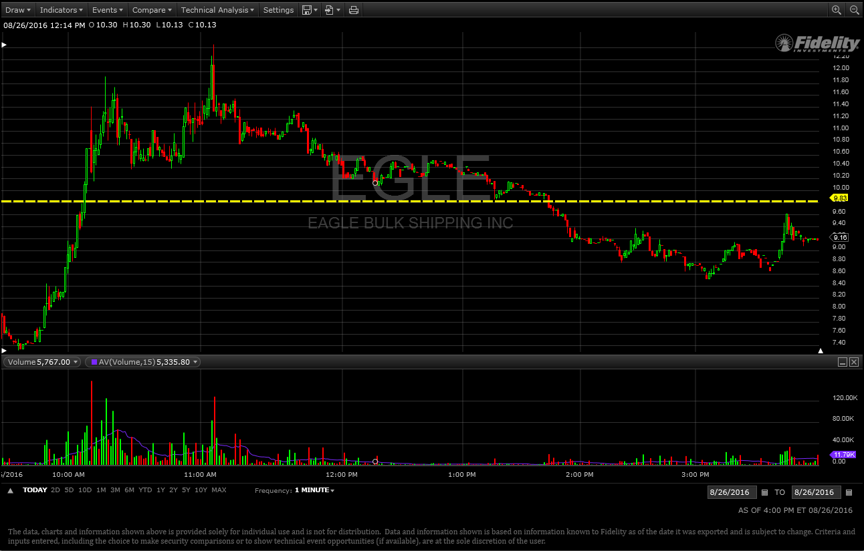

8-29
- SPU: lesson: bought too late at too high price. Sold too late not on the top price.
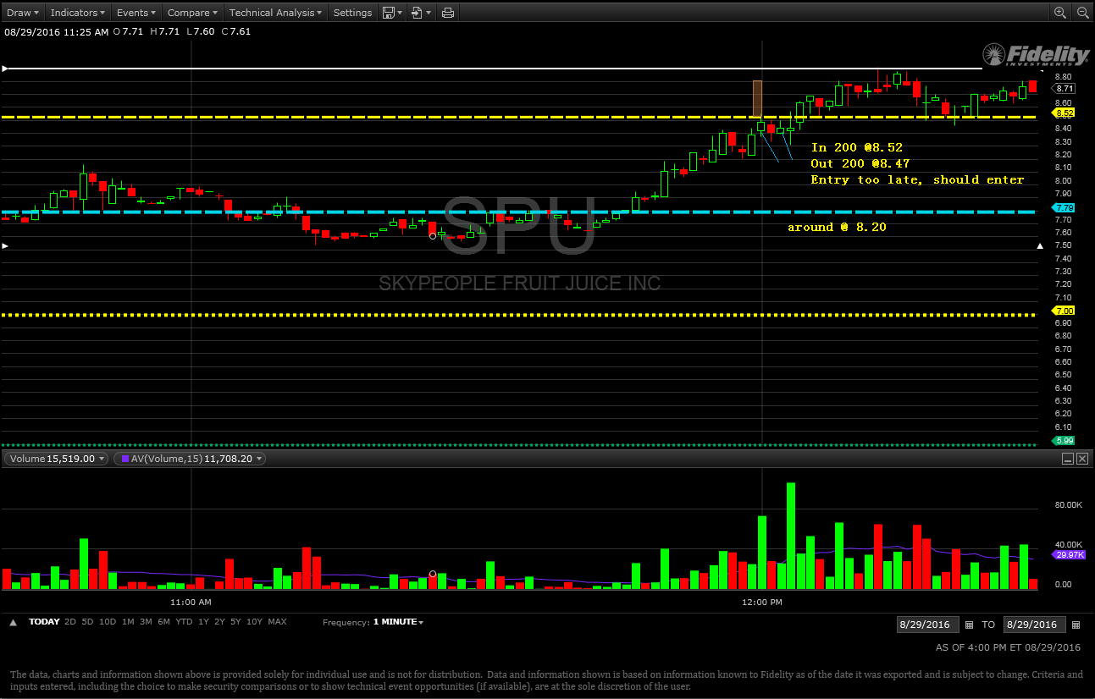
- Second trade
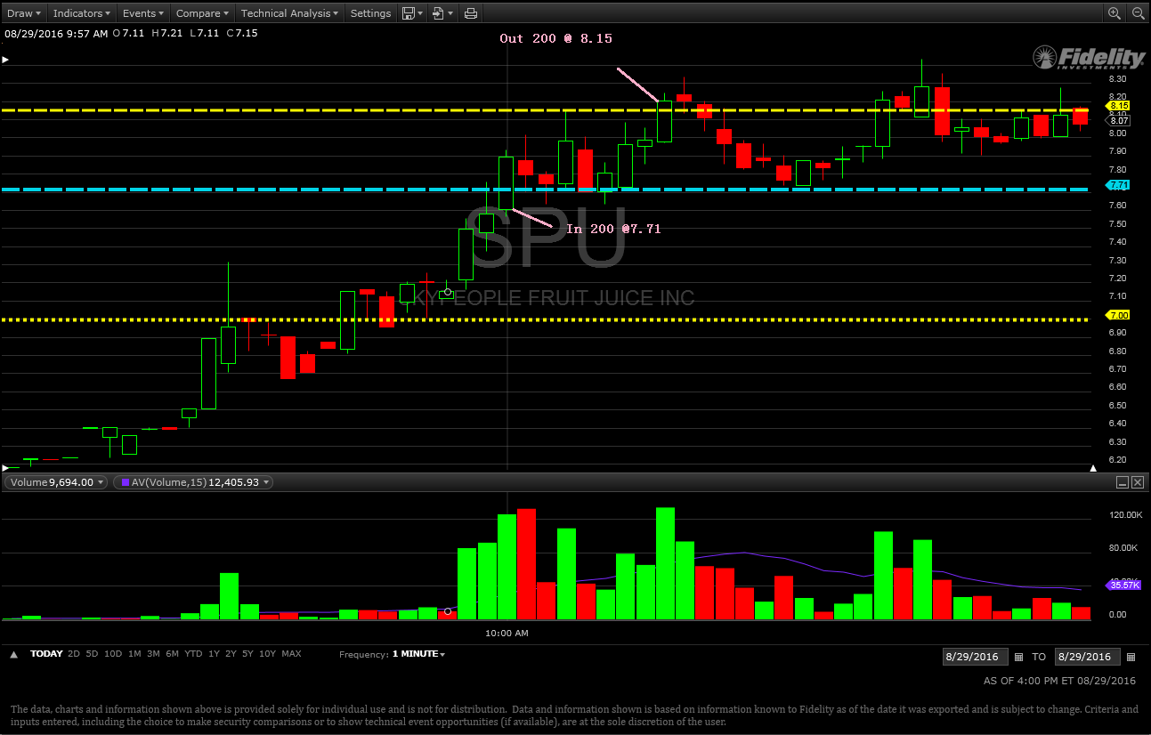
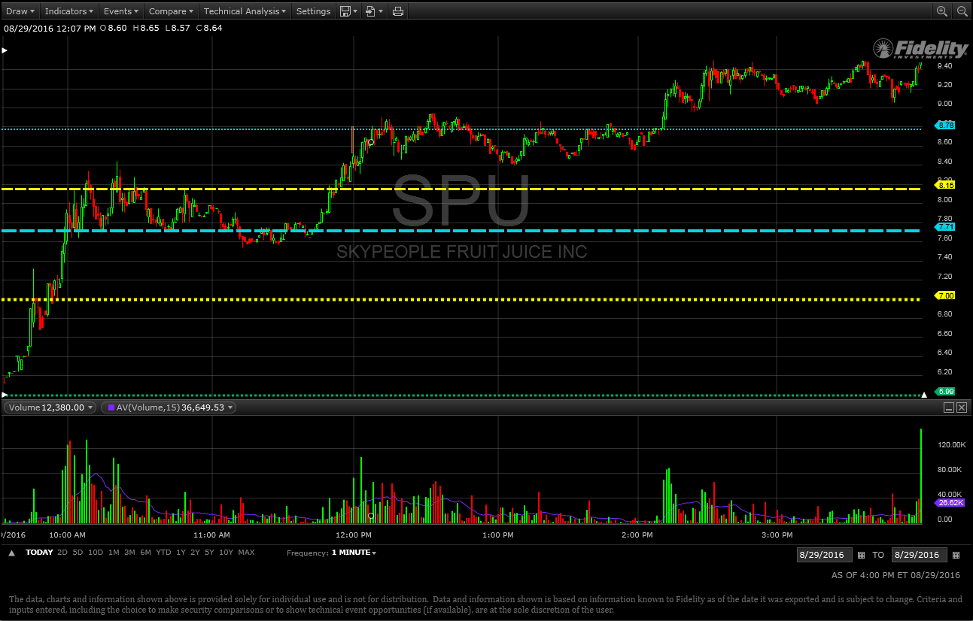

8-31 -120 ( 2 trade)
Must stick to the rule: buy at low, if not going up, exit.
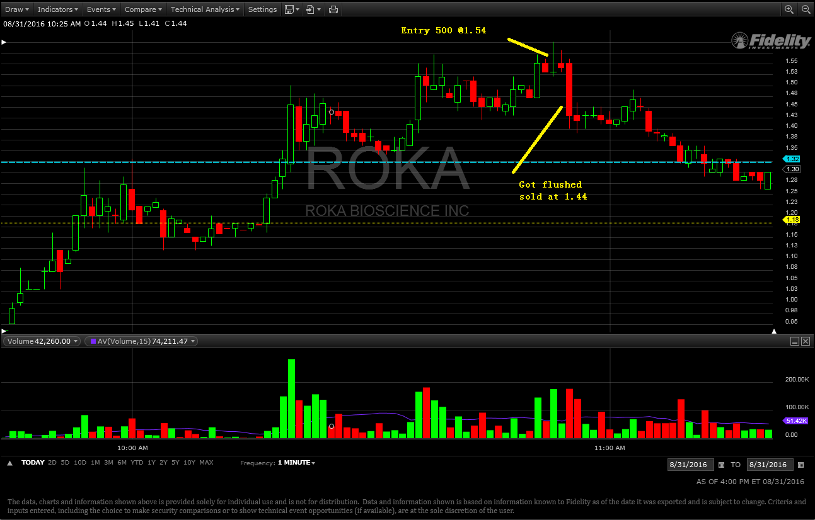

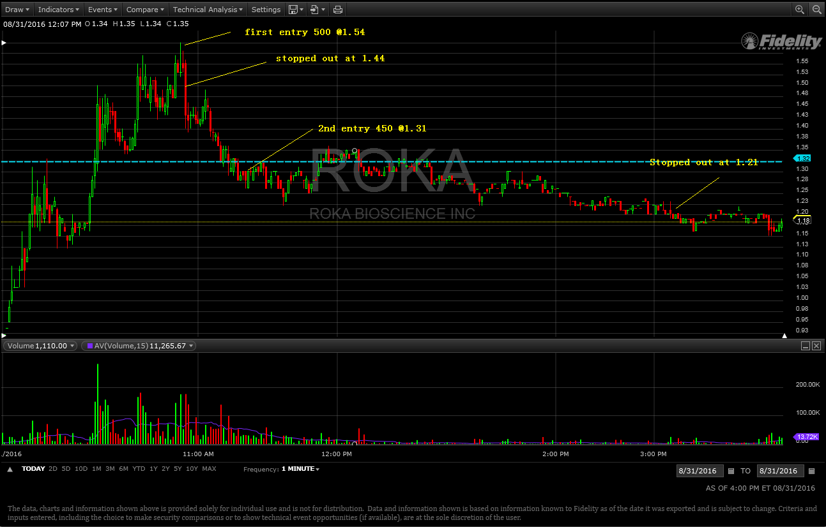

9-1 (-50) two trades
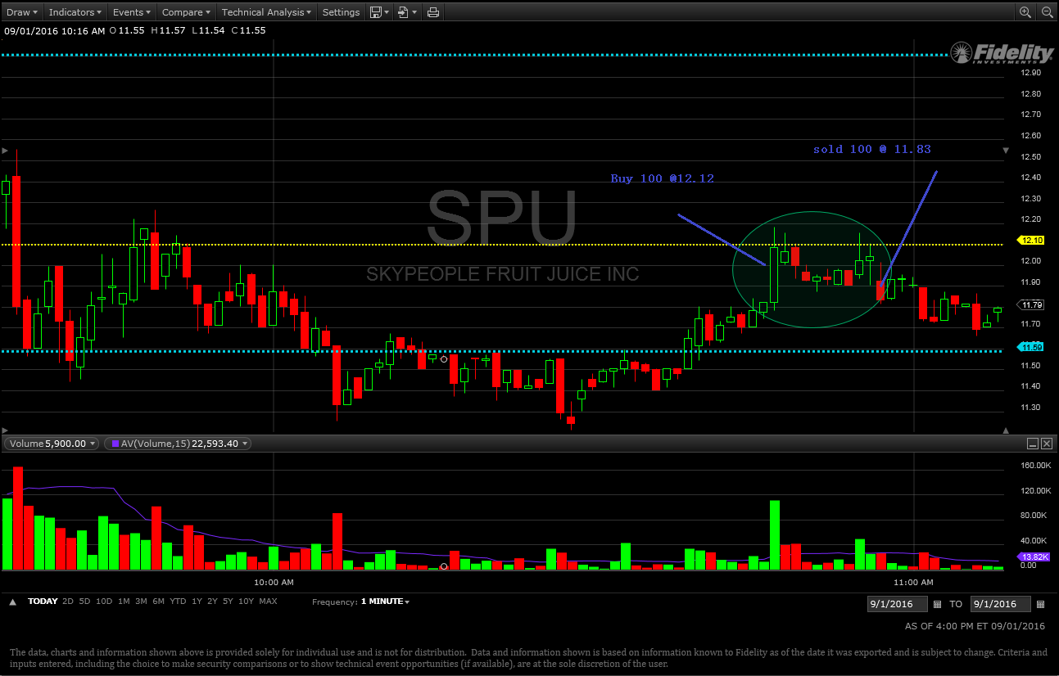

Double bottom or even triple bottom, is time for entry.
Double top or multiple tops is absolutely time to exit
3 mins is the maximum time wait for going up after entry.
9-7
- Bad Entry at 2.18 and didn’t exit until stopped at 2.10
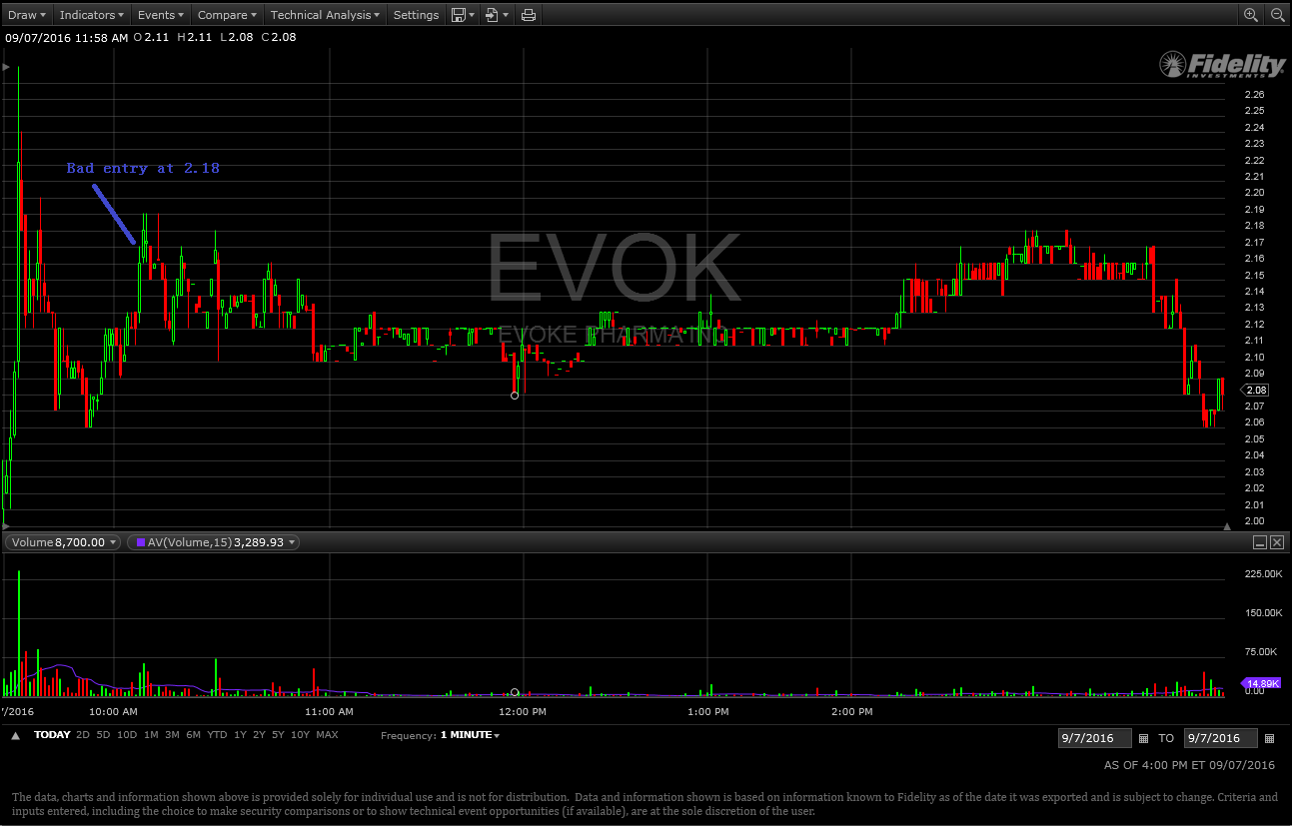
- NVFY: very nice and clean pump from 1.7 to 2; Missed
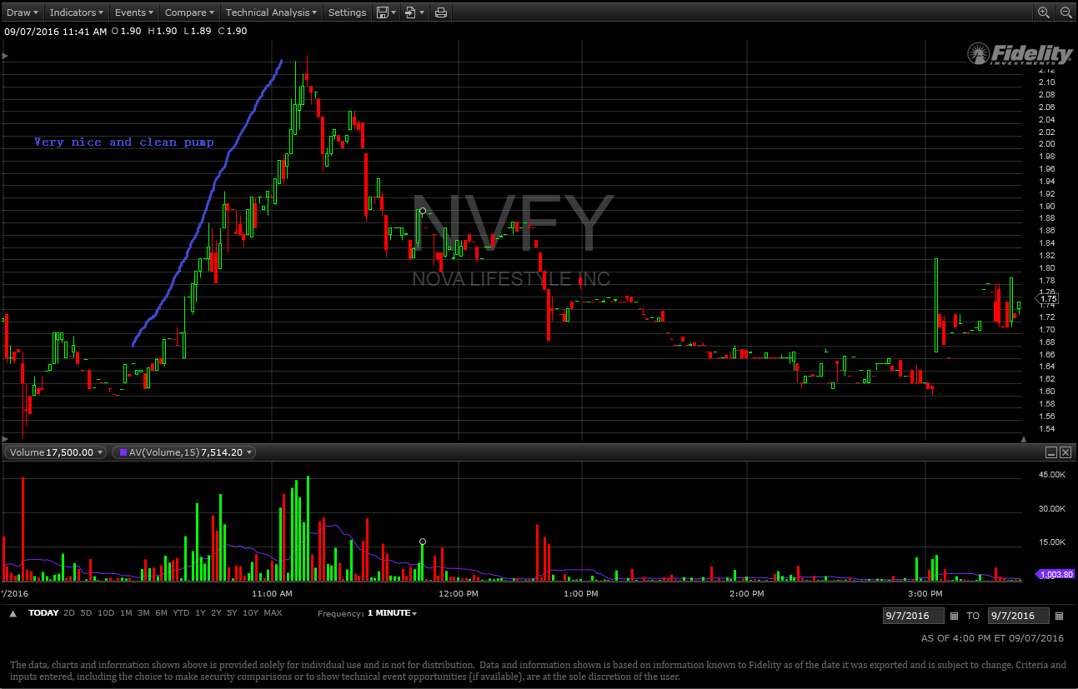
- NAVB very nice pump 30%
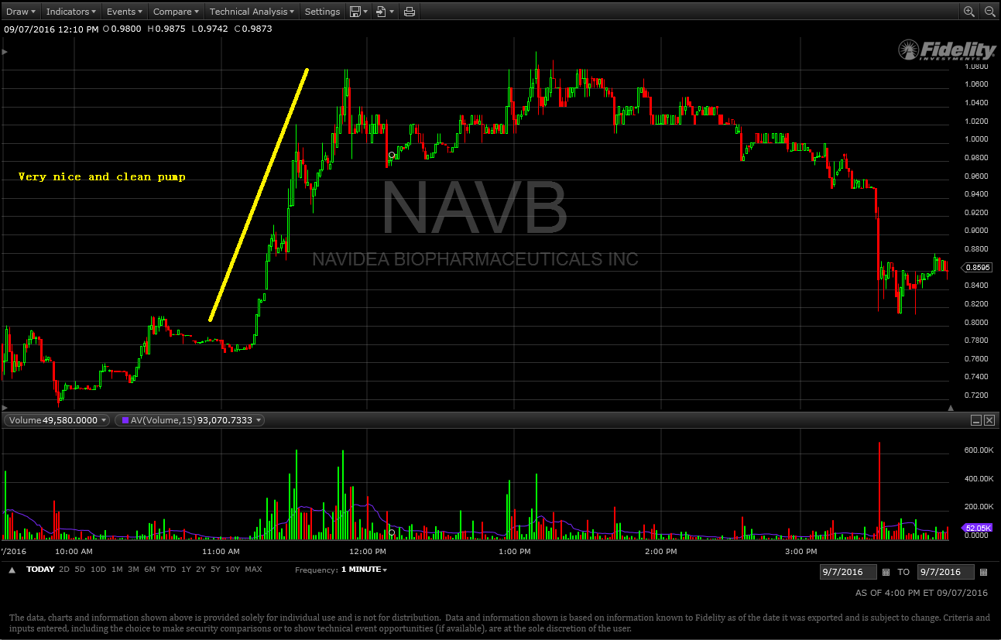
- MGT fake-out exit without using stop.
- Trading momentum, do not use stop, not going up in 3 mins , EXIT
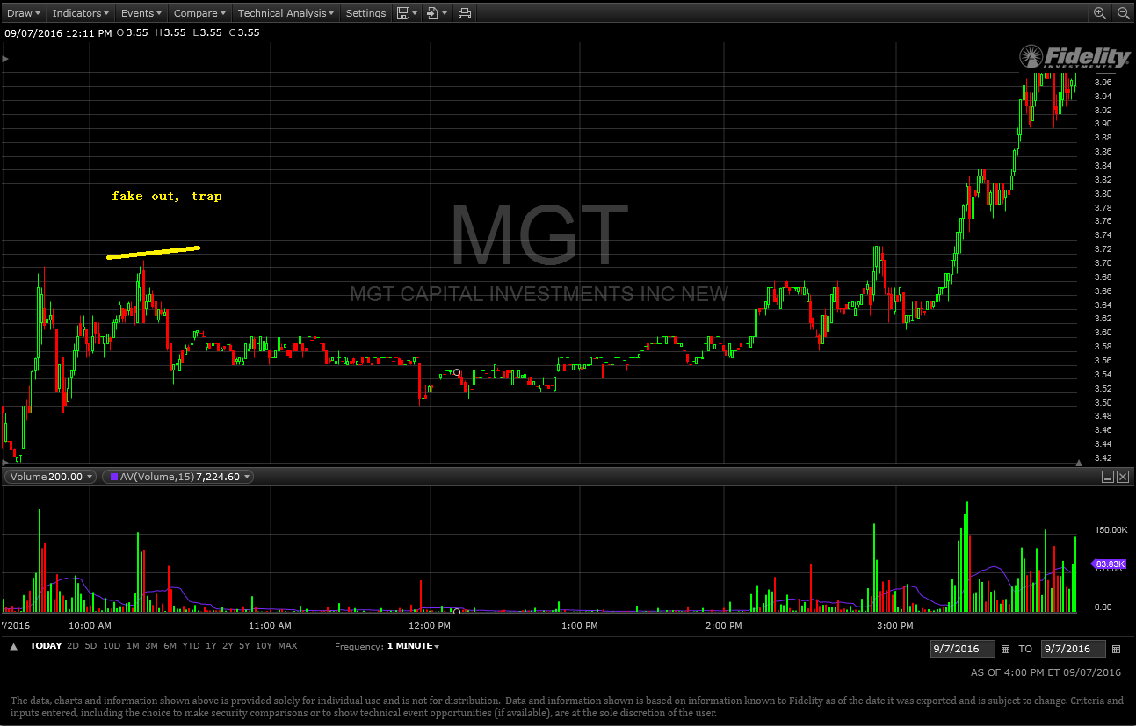

10-18
