Brandon Campbell

CPTS 460

Dr. K.C. Wang

September 9, 2019

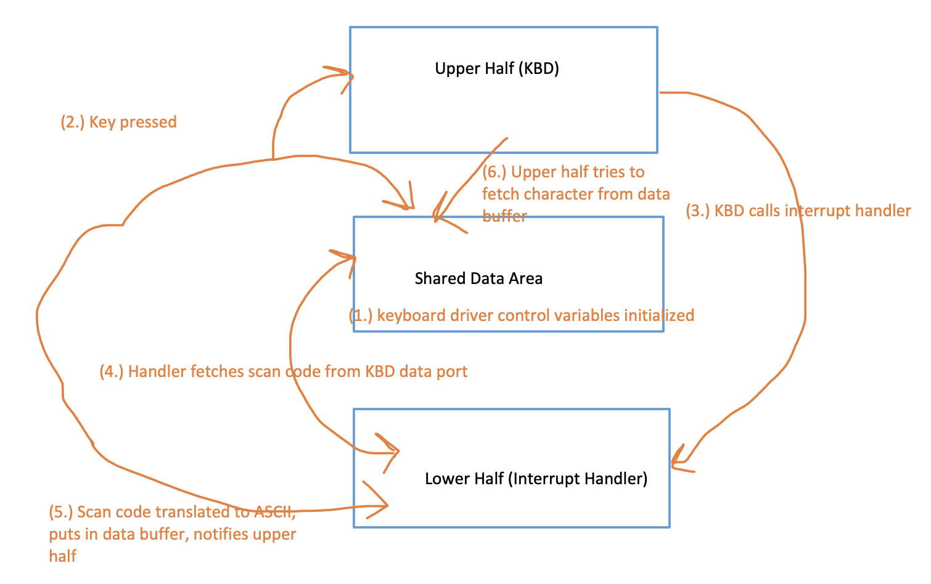Pre-lab 3 part 3 (diagram):