**CENG454 - FINAL REPORT**

**BURCU ECE SARIKAYA190444032**

**Game:**

My game consists of 4 scenes in total, including 3 main scenes and 1 congratulatory scene. The player can walk with the right and left arrow keys, jump once by pressing the Space key, and double jump by pressing it twice. The player has a health bar that contains 100 health points.

**Scenes:**

**Scene 1:**

To pass this level, you need to collect 100 points. The objects used for scoring are as follows:

* Fruits: 20 points
* Fire: -100 health

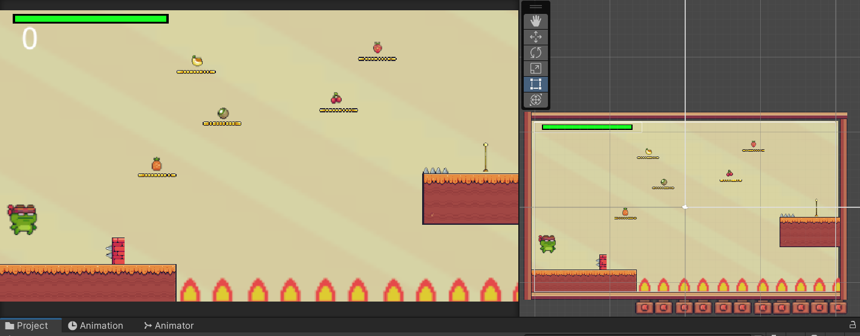

**Scene 2 :**

To pass this level, you must collect a total of 100 points. The scoring system is as follows:

**Objects that Award Points:**

* **Fruits:** 20 points
* **Small Diamonds:** 10 points
* **Large Diamond:** 40 points

**Actions that Award Points:**

* **Completing the level:** 50 points

**Objects that Deduct Points:**

* **Fire:** -100 health (Instant death)
* **Spikehead:** -70 health
* **Small Saw:** -50 health
* **Large Saw:** -100 health
* **Spikes:** -2 health

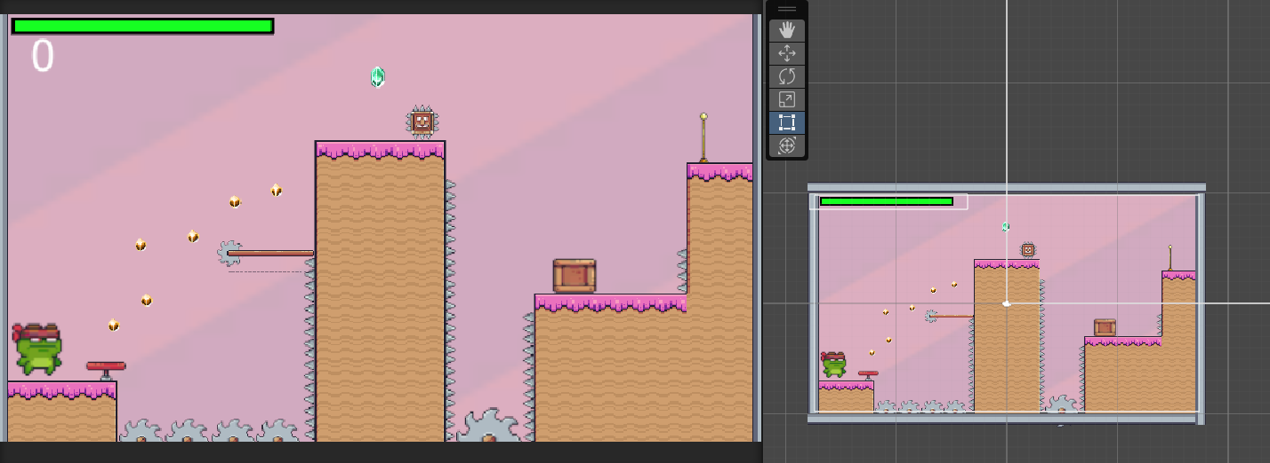

**Scene 3: The Final Scene**

Scene 3 can be considered the final scene of the game. In this scene, the player must collect a total of 1000 points to progress to the congratulatory scene. The scoring system for this scene is as follows:

**Objects that Award Points:**

* **Fruits:** 20 points
* **Small Diamonds:** 10 points
* **Large Diamonds:** 40 points
* **Elixir Bottle:** 500 points

**Objects that Deduct Points:**

* **Spiked Balls:** -10 health

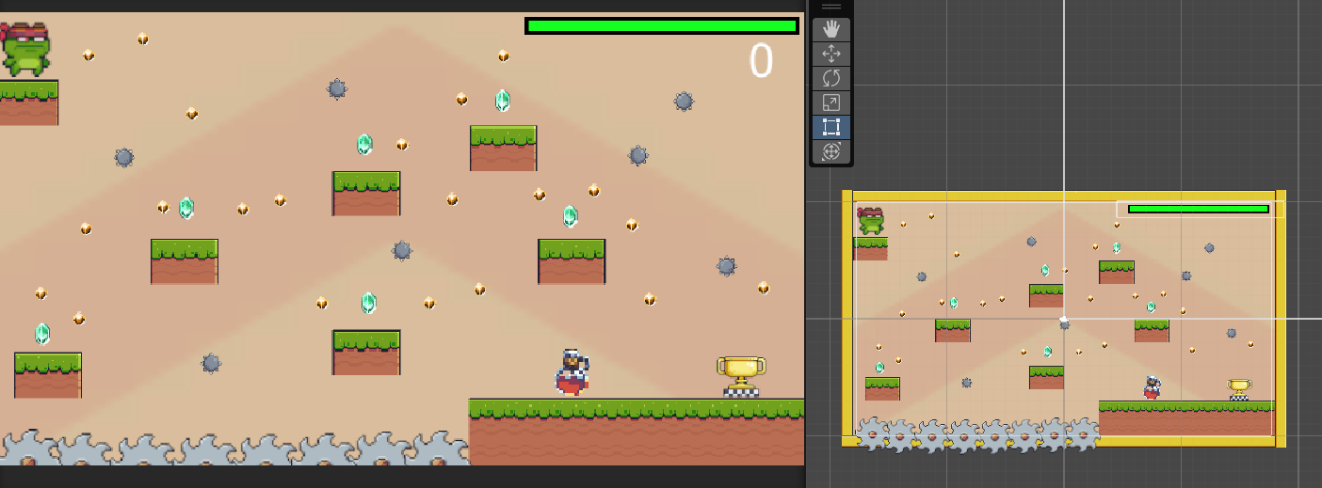

**Scene 4: The Congratulatory Scene**

Scene 4 is the congratulatory scene that appears after the player successfully completes Scene 3 and the game.

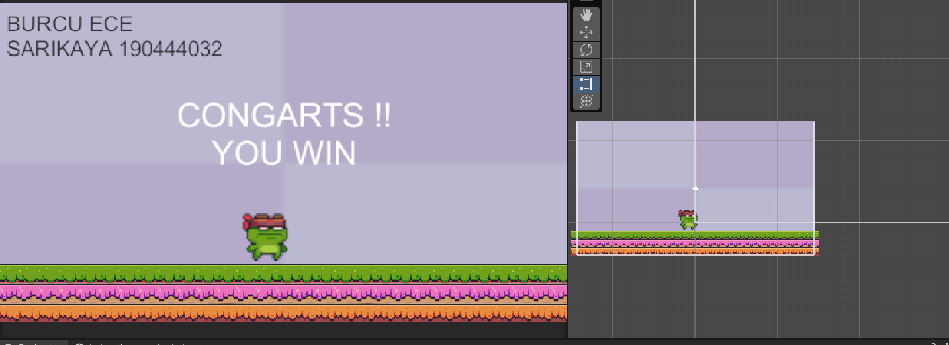

**Bug Report and Fixes**

**Bug:**

The game appears to have a minor bug that can cause the player to get stuck if they perform too many double jumps in rapid succession. This issue seems to resolve itself after a short period of time.

Drive : https://drive.google.com/drive/folders/1aaVNtfRUZjgHNHFeOdPXLeoKanoo2x91?usp=sharing