Group A 1

Homelessness in Little Rock

Emily Arnold, Mackenzi Browning, Carah Buescher, and Brandon Crawford

University of Arkansas at Little Rock

Writing for the Workplace 3316

Prepared for: Mayor of Little Rock, Arkansas- Mark Stodola

August 5, 2018

Group A

2

**Table of Contents**

List of illustrations………………………………………………………………………… 2

Abstract……………………………………………………………………………………. 3

Introduction………………………………………………………………………………...3

Background…………………………………………………………………..……. 3

Problem……………………………………………………………………………. 3

Purpose……………………………………………………………………………. 4

Scope…………………………………………………………………………….... 4

Discussion……………………………………………………………………………….... 4

People at risk ……………………………………………………………………… 4

Different housing options…………………………………………………………. 4

Lack of housing…………………………………………………………………… 5

Healthcare ………………………………………………………………………… 6

Food insecurity……………………………………………………………………. 6

Clothing and hygiene………………………………………………………………. 6

Conclusion………………………………………………………………………………… 7

Recommendations………………………………………………………………………… 7

Citations………………………………………………………………………………….. 8

**List of Illustrations**

Figure 1 Reasons for Homelessness Separated by Generation…………………………… 3

Figure 2 Percentage of homeless in Little Rock…………………………………………… 5

Group A

3

**Abstract**

It is easier to become homeless than one might think, many Americans live paycheck to paycheck and one major disaster can leave them on the streets without food, shelter, or money to get back on their feet. This article shows the problems within Little Rock in concern to our homeless citizens and attempts to show reasons as to why it is such a struggle to be without a home in this city. As well as emphasizing the lack of care given to the homeless this article will also take a look at possible solutions to the problems stated below in an attempt to find a better way of life for those struggling to survive each day on the street. Regardless of how one becomes homeless it shouldn’t be the end of the road and our goal is to educate people on the severity of the issue in hopes of finding a solution.

**Introduction**

**Background**

Homelessness at different ages have different risk factors. The generation ages according to Brown et al. (2016) are young adulthood, middle adulthood, and late adulthood. Figure 1 table illustrates the reasons for homelessness.

|  |  |  |  |  |
| --- | --- | --- | --- | --- |
| **Homeless** | **Young Adulthood** | **Middle Adulthood** | **Late Adulthood** |  |
| **People** |  |  |  |  |
| **Generations** |  |  |  |  |
|  |  |  |  |  |
| **Reasons for** | Breakdown of family | Death of parent | Death of spouse |  |
| **Homelessness** | home | Breakdown of | Retirement |  |
|  |  |  |
|  | Mental health or | relationship |  |  |
|  | substance abuse |  | Loss of house |  |
|  | problems | Loss of work | Worsen mental or cognitive |  |
|  |  |  |  |
|  | Childhood problems |  | health |  |
|  |  |  |  |  |

Figure 1: Reasons for homelessness separated by generations (Brown et al., 2016)

**Problem**

50 percent of the single homeless people today are 50 years old or older, but in 1990, the percentage was only 11 percent (Brown et al., 2016). Homelessness in 50 years old and older have increased in 28 years alone. This does not include the other ages. When this age group are homeless then they are at risk of having medical issues that does not occur until they are usually

Group A

4

70 years old or older including: falls, memory loss, and functional impairment (Brown et al.,

2016).

**Purpose**

The purpose of this proposal is to evaluate homelessness, discussed the problem at hand, and to provide measures to help homelessness in Little Rock, Arkansas. Evaluating homelessness and proposing solutions will help educate the Mayor of Little Rock: Mark Stodola.

**Scope**

Within the Little Rock metro area alone more than 1000 citizens are homeless, many of whom live in third world conditions. The lack of facilities and programs focused on helping the homeless they struggle to survive each day they live on the streets.

**Discussion**

**People at risk**

The older generation, 50 years old and older, have been established as a major percentage for homelessness. One of the main ways to help prevent homelessness is to recognize which people in that generation are at risk of losing their home or income (Brown et al., 2016). If we can find people that are late in their life and have a high risk of homelessness, we have a responsibility as citizens to try to prevent before it occurs. Risk factors include reduction of income, loss of income, or any factors that can cause the lost of a home (Brown et al., 2016).

**Different housing options**

Housing First Permanent Supportive Housing (PSH) is a housing option that does not have many barriers to enrolling, has several on-site services, and is nationally recognized to ending homelessness (Brown et al., 2016). As it states in the name, this option offers permanent housing for homeless people. The on-site services offered are case management, mental health, medical, vocational, and substance abuse services (Brown et al., 2016). PSH offers a way of life for someone versus short-term shelter. Some homeless people may prefer a different housing option, but this is one option.

Another option for housing similar to PSH is Our House, and they are located in Little Rock (“Our House,” 2018). This home was incorporated in 1987, and have since grown into the service they are now (“Our House,” 2018). This is not a federal type of housing. People work with Our House to help the people in Little Rock and make their community better. They offer job training, free child care, launched Potluck Food Rescue, and founded Harmony Health Clinic (“Our House,” 2018).

Group A

5

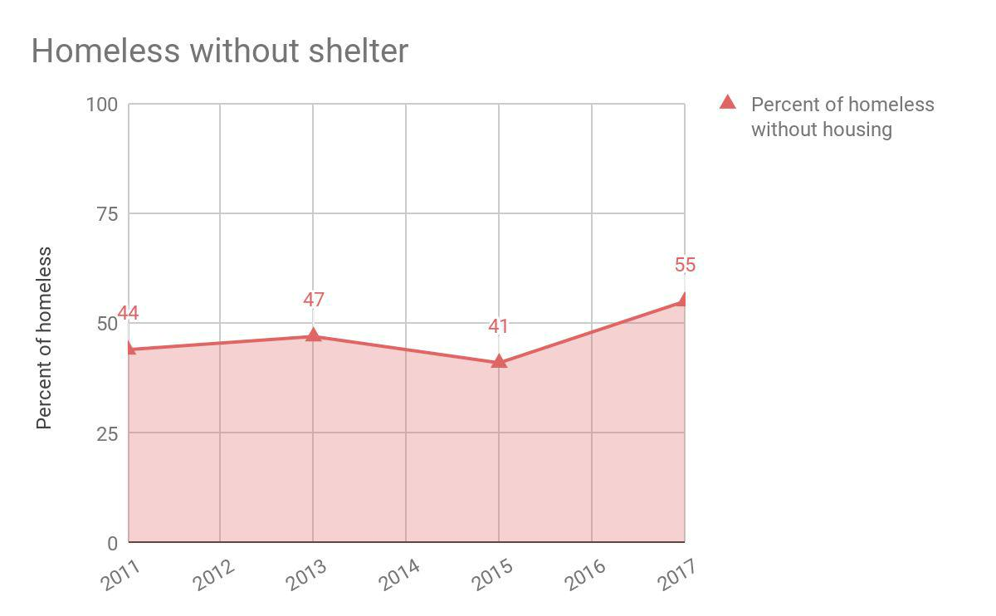

Figure 2: Percentage of homeless in Little Rock (Monk, G. 2017)

**Lack of housing**

There are roughly a 1000 beds spread throughout Pulaski County (ADHS, 2017) to help those in need and yet the needs still are not being met. One of the major challenges the homeless face when attempting to claim one of these beds are the prerequisites around whom may use them and for how long. Many of these beds are meant for smaller subgroups of people in need, such as veterans, drug rehabilitation patients, or abused women. For those not falling into these categories the amount of suitable housing rapidly dwindles from 1000 beds to 600. While this may still seem like a large number those beds are spread throughout Pulaski County and not just the Little Rock metro area, where there are over 960 homeless alone. The numbers in Little Rock continue to grow as homeless come to Little Rock from more rurals areas of the state in hopes of finding help. With this continual influx of citizens the schism between homeless and homeless with proper housing and help continues to grow wider, leaving the majority of those in need without options.

The lack of housing options available to those in need doesn’t measure up, forcing many to sleep outside and in rough conditions. According to a recent poll more than 55% of Little Rock’s homeless are forced to sleep in homeless camps, which are constantly being combated by the Little Rock Police Department, or worse being forced to find shelter wherever they can throughout the city (Monk G., 2017). The living conditions of the homeless have been described

Group A

6

as “Hell on Earth” by those unfortunate enough not to find themselves on one of the rare beds at a shelter. Without safe and clean housing facilities those living on the streets of Little Rock must fight to survive, often going without proper clothing or food, which leads to overall poor health.

**Healthcare**

Homelessness can cause people to not seek help even though they may need medical help. Our House (2018) founded Harmony Health Clinic in 2006, and it is a free clinic for people unable to seek care otherwise, low-income people. This free clinic can help homeless people and people close to homelessness stay healthy instead of continually getting sick. Homeless people are on the streets, exposed to everything, and exposing other people as well. This service is across the street from Our House in Little Rock on Roosevelt Street (“Our House,” 2018). This free clinic should be encouraged to use.

The Stewpot is also a local organization that can help the homeless with healthcare. Every Friday from 12:00 pm to 1:00 pm the Baptist Health Community Clinic is held at the First Presbyterian Church in Little Rock, Arkansas (Stewpot, 2018). Two volunteer nurses, two volunteer pharmacist, and one physician donate their time to volunteer and provide medical at no cost for the homeless.

**Food Insecurity**

Many of the homeless population often wonder where their next meal will come from. They often go days without eating. One local organization, known as, the Stewpot has a primary mission to feed the hungry. They help feed the homeless by making meals and serving them Monday through Friday from 12:00 pm to 1:00 pm each week. Since they opened in 1972, they have fed over 1.5 million meals to the needy (Stewpot, 2018).

Canvas Community Church helps feed the homeless on Sundays and Wednesdays. It is open to everyone who can use a meal. They do not deny anyone a meal and even the pets get a chance to eat too (Gatewood, 2018). The Majors Youth Council also helps by volunteering at Canvas Community Church in helping with preparing and serving food. They also help with making PB&J sandwiches for The Van at least once a month if not more. They also help serve at the Salvation Army. They help feed anyone who needs it (Scholl, 2018).

**Clothing and Hygiene**

A majority of the homeless population only have what is on their back or what they are caring with them. They rely on the kindness of strangers and different organization to help with them with the simple necessities. The Stewpot Organization helps provide clothing and hygiene products every week to the needy. Every Thursday from 12:00 pm to 1:00 pm they open their clothes closet to distribute hygiene products and clothing.

Canvas Community Church has a room of donated clothes that people can go in and pick out what they need, they offer help in picking out outfits for interviews when needed. They also

Group A

7

accept donations for feminine and baby supplies and give them out when possible (Gatewood, 2018). The Mayor's Youth Council takes donations for the Salvation Army, and even for certain people who have asked for help. People donate to them and they help by distributing it out to those that need it, they take food, clothes, shoes, feminine products, pet products, ect. (Scholl, 2018).

**Conclusion**

In conclusion the homeless of Little Rock and Arkansas as a whole not only need more facilities and programs, but better ones. We as a community cannot continue to ignore the problem and shuffle people in need off to the dark corners where we no longer have to worry about them. Everyone has a right to food, shelter, and simple comforts of life and the state has an obligation to deliver on this. Though it may be a long hard road towards helping Little Rock’s homeless it needs to be treated as top priority and not looked upon as a nuisance. Inscribed on the Statue of Liberty is a famous quote that sums up American ideology, “​Give me your tired, your poor, Your huddled masses yearning to breathe free,” shouldn’t that pertain to the tired and poor of Little Rock as well?

**Recommendation**

The homeless population in Central Arkansas is growing at an alarming rate. One of the biggest recommendations for the homeless community is to avoid stereotyping. This has become one of the biggest problems and leads to the homeless population being misunderstood. Remember that each person has their own unique story and it is important to learn their individual story. It is also helpful to pray. Pray for them and pray for guidance to be shown in ways that can help you help the homeless population. Inviting them to church helps them feel connected with society and most churches are able to help out someone in need (Reaching out and Helping the Homeless, 2018).

Homelessness brings a sense of loneliness to a human being. It breaks down their self-value. People who are homeless or at risk for being homeless need to be acknowledged. Giving them a simple smile or starting a conversation can really change their day around. Taking the time to learn about them and their story, shows them that you care. It is important to be ready to help the homeless. Often times, they need help just getting through day to day life. Providing them with a meal or showing them where a food pantry is located can help them get the nutrients they need to keep pushing through this hard patch in their life. It is important to carry extra water bottles, especially during the summer time to be able to give them. This will help them stay hydrated and decrease their chances of falling ill. During the winter, carrying an extra pair of gloves, warm socks, or an old coat can help them stay warm and avoid frostbite or other injuries

related to the cold (Reaching out and Helping the Homeless, 2018).

Group A

8

**Citations**

Arkansas Department of Human Services. (2017). ​*State of Arkansas Homeless Shelters* *Directory.​*Little Rock, AR: Division of County Operations.

Brown, R. T., Goodman, L., Guzman, D., Tieu, L., Ponath, C., & Kushel, M. B. (2016). Pathways to homelessness among older homeless adults: Results from the hope home study. ​*PLoS One, 11​*(5), e0155065. doi: 10.1371/journal.pone.0155065

Gatewood, Bobby (2018, August 4​th​). Personal Interview

Monk, G. & VISTA, C. (2017, June 16). Homeless in the Rough. Retrieved August 4, 2018,

from

http://ourhouseshelter.org/2017/06/16/2017-tally-finds-55-of-little-rock-area-homeless-li

ve-out-in-the-rough/

Our House (2018). ​*Our history.* *​*Retrieved from http://ourhouseshelter.org/history/

“Reaching out and Helping the Homeless.” ​*The Bowery Mission. Rebuilding Lives Since 1879.,* Retrieved from http://www.bowery.org/homelessness/tips-help-homless/

Scholl, Jan (2018, August 3rd). Personal Interview.

Stewpot Little Rock.(2018). Retrieved from http://www.stewpot-littlerock.org/