# CS 340 README Template

## About the Project/Project Title

*This project takes information from a mongo database and presents it in a cell table with filter functionality.*

## Motivation

This project exists to provide a clean user experience with mongo databases. The integration between Python and MongoDB provide a wide variety of tools for database manipulation.

## Getting Started

To run the program, open terminal and run “mongod_ctl start-noauth”, then run all cells in Jupyter.

## Installation

*Python and Mongo are required to run this program, as well as the AnimalShelter.py file.*

## Usage

This project does not contain a GUI way to change the database it reads from.

This project allows the user to filter the database results. To do so, run the program and click any of the “rescue” buttons above the graph. You can also set priority by selecting any of the titles in the graph, such as “age_upon_outcome”.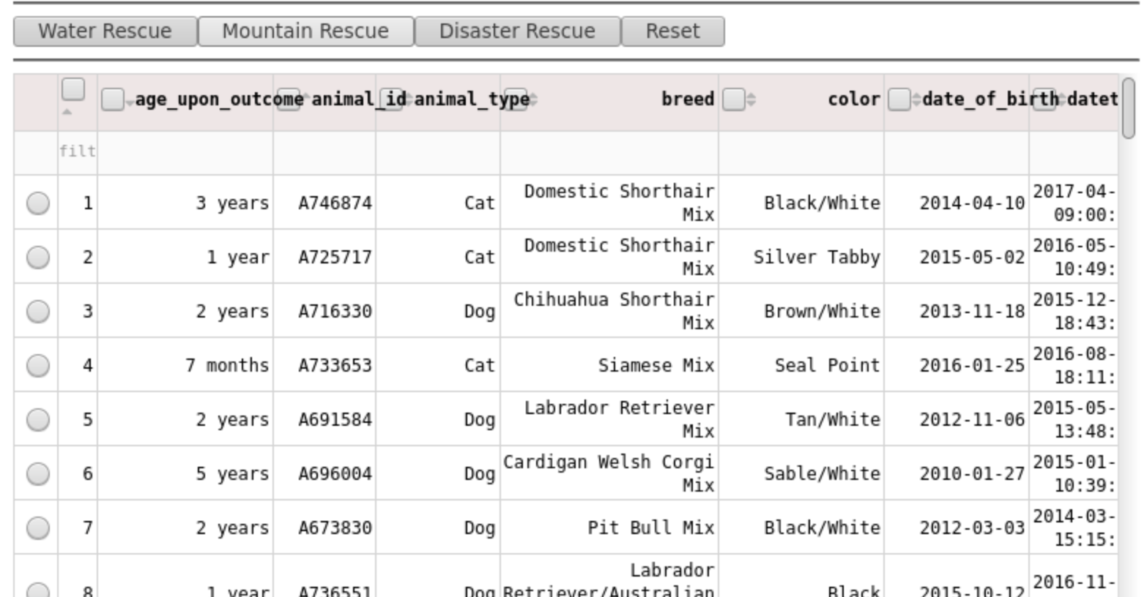

*No filter*

*Priority listed for “age_upon_outcome”*

## Roadmap/Features (Optional)

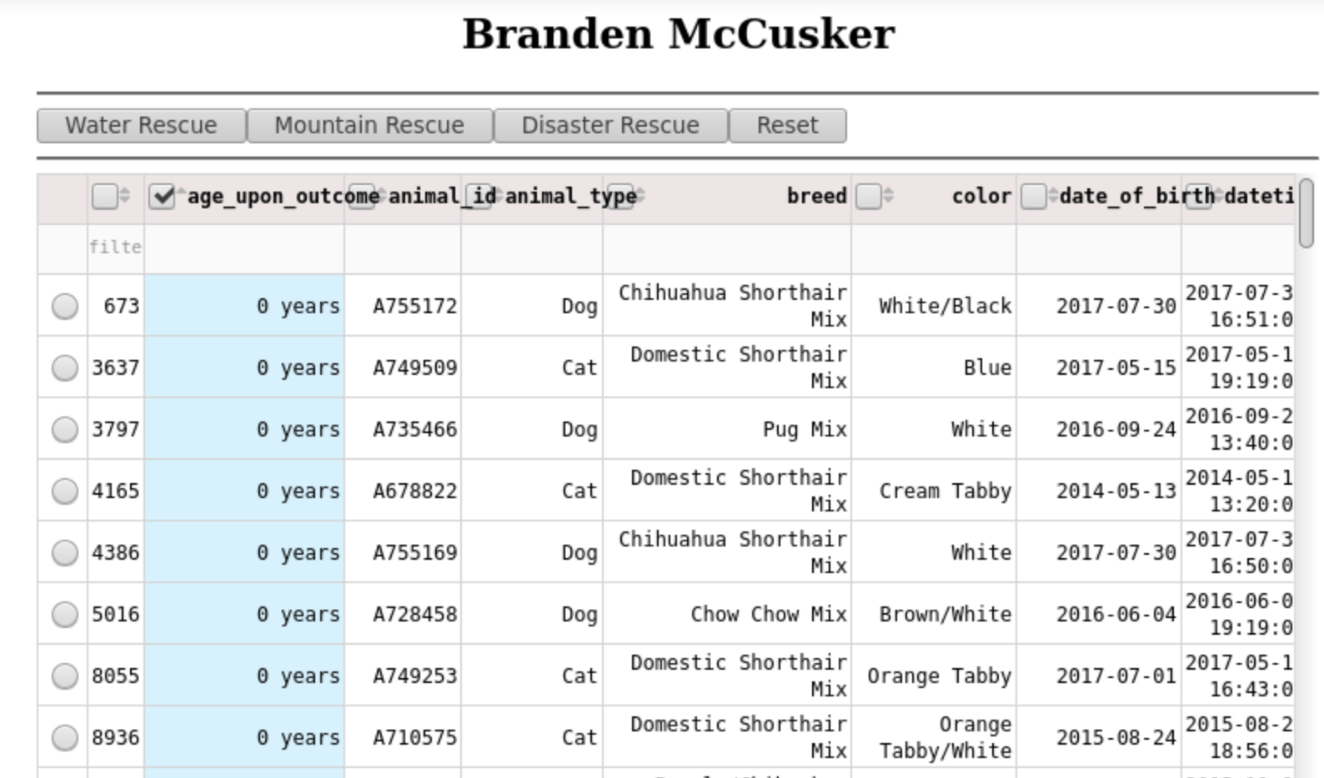*The Rescue buttons do not seem to be working.*

## Contact

Your name: Branden McCusker