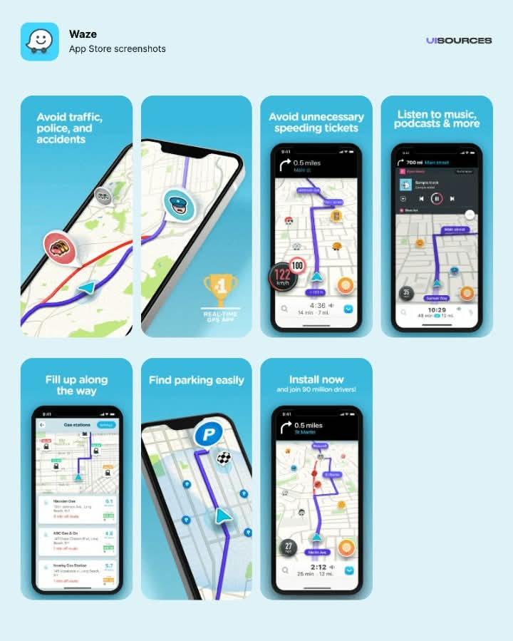
Similar applications/systems that is related to “SerbisYo” features, scope and objectives.

Waze

Waze helps drivers avoid traffic by using reports from other drivers.

- Objective: Fastest route using live, crowdsourced traffic.
- Key features: Road closure, hazard, and police reports; live rerouting; gas price info.
- Platforms: Android and iPhone, with Android Auto and CarPlay support.
- Known issues: Recent reviews mention a CarPlay map bug and the back button minimizing the app instead of closing it.

2. Apple Maps
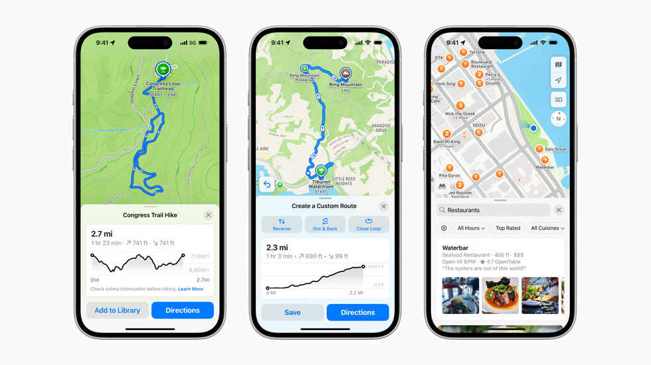

Apple Maps is the built-in navigation app on iPhone, built around privacy.
- Objective: Everyday navigation and place discovery with user privacy protected.
- Key features: Offline maps for iPhone and Apple Watch, incident reports, parked-car finder, place info with hours, photos, ratings, and Apple Pay support, plus topographic maps.
- Platforms: Apple devices only.

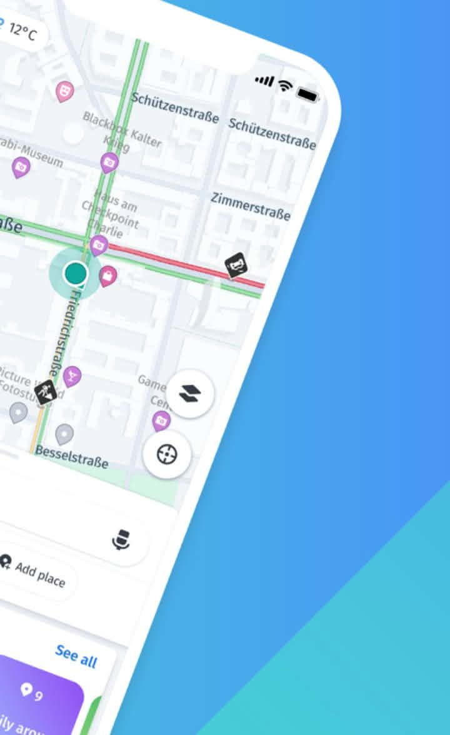
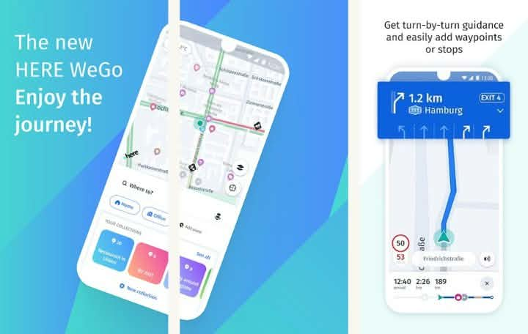
3. HERE WeGo

HERE WeGo guides travelers by car, on foot, or on public transport, including offline.
- Objective: Free navigation for local and global travelers.
- Key features: Public transport in more than 1,900 cities, walking guidance, parking finder, waypoints, saved collections, and downloadable offline maps.
- Platforms: Android and iPhone, with Apple CarPlay support on iOS.
- Gaps versus Google Maps: No Street View and no biking routes, according to one review.

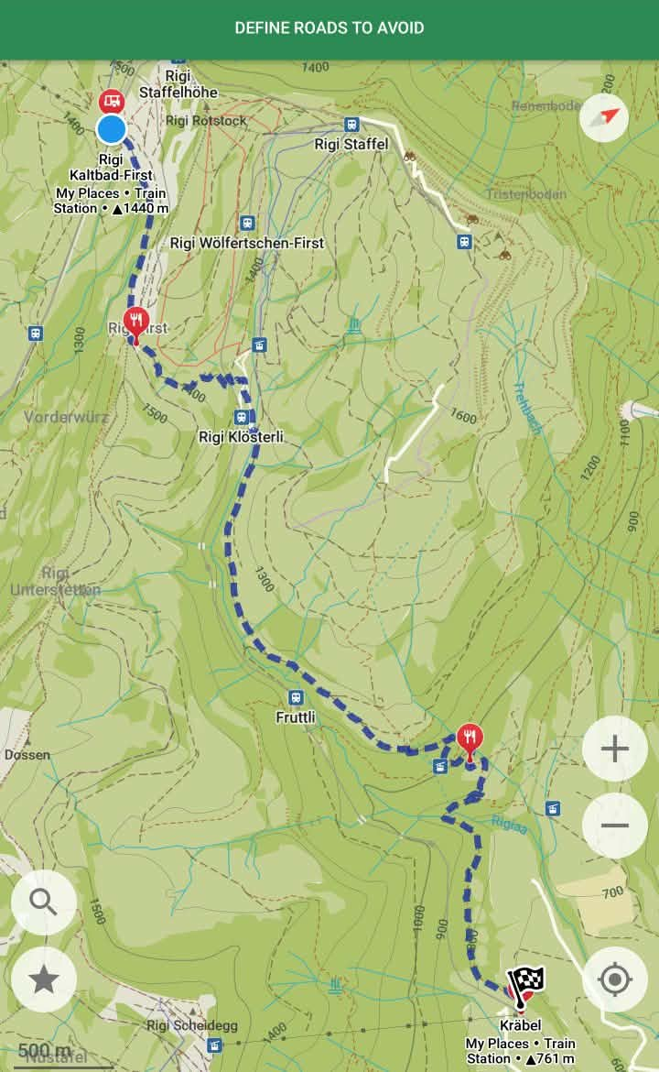
4. Organic Maps
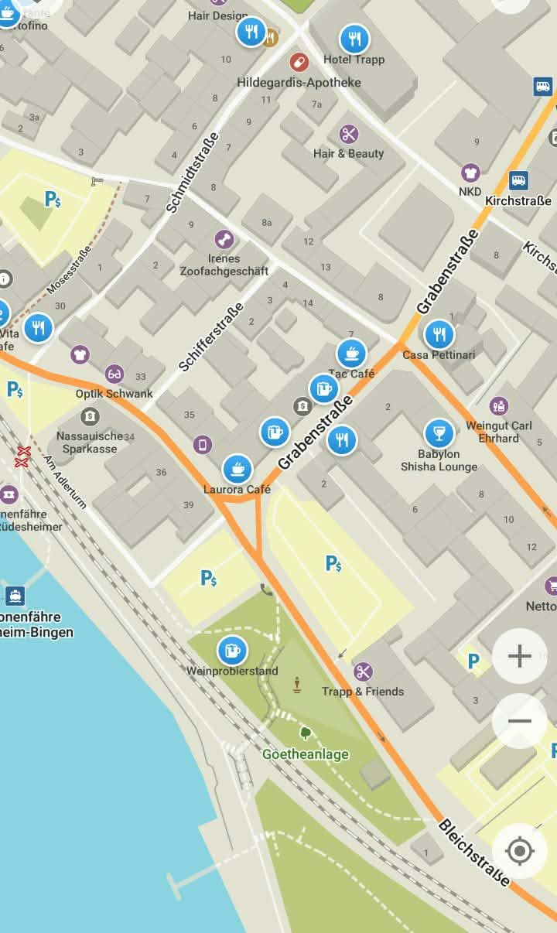

Organic Maps is a free offline map app for travel and outdoor use.
- Objective: Fast, detailed offline maps and GPS for travel, hiking, trekking, and cycling.
- Key features: Unlimited map downloads, and map data from OpenStreetMap refreshed every two weeks.
- Platforms: Android (also on F-Droid) and iPhone.
- Price: Free, with no in-app purchases.

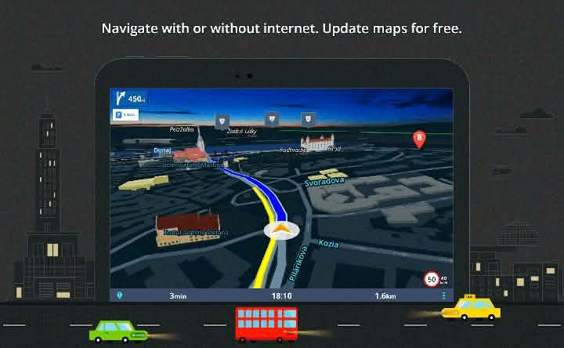
5. Sygic GPS Navigation
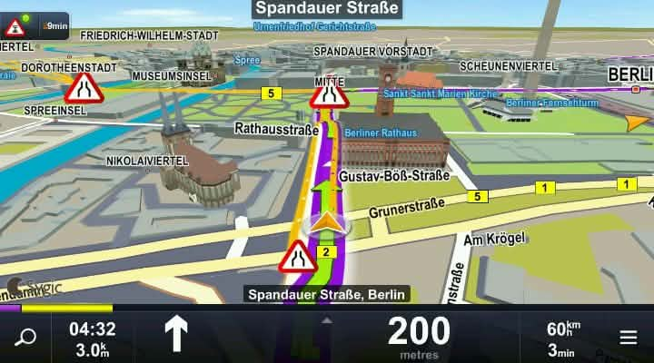

Sygic is a navigation app that works without an internet connection.
- Objective: Reliable voice-guided navigation anywhere, including with no signal.
- Key features: 3D offline maps from TomTom and other providers, free map updates several times a year, live traffic, speed camera alerts, walking directions, and millions of places of interest.
- Platforms: Android and iPhone.
- Price: Free to download, with in-app purchases and a Premium+ free trial.

Ratings and quick picks
Waze has the highest ratings on both stores, while Apple Maps scores lowest. Figures come from store-listing trackers and change by date and region.
App | Google Play (out of 5) | App Store (out of 5) | Best for
Waze | 4.31 (about 8.9M ratings) | 4.84 (about 3.2M ratings) | Live traffic
Organic Maps | 4.5 (about 16.5K reviews); another tracker shows 4.30 | Not checked | Offline hiking and cycling
Sygic GPS Navigation | 4.2 (about 1.9M reviews) | Not checked | Offline driving
HERE WeGo | 3.3 (about 501K reviews) | 3.69 (about 1.5K ratings) | Public transport and offline maps
Apple Maps | iPhone only | 2.55 (about 125K ratings) | iPhone users who value privacy
The low Apple Maps score looks odd for such a widely used app, so treat it with caution.
Quick picks
- Traffic: Waze.
- No internet: Organic Maps or Sygic.
- Public transport: HERE WeGo.

