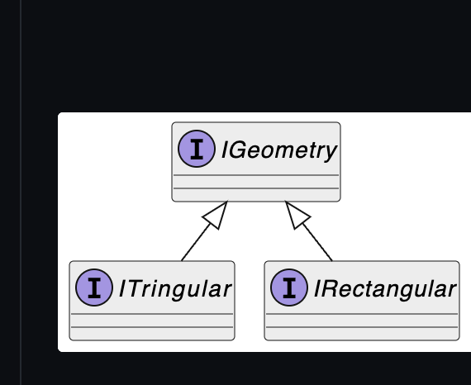 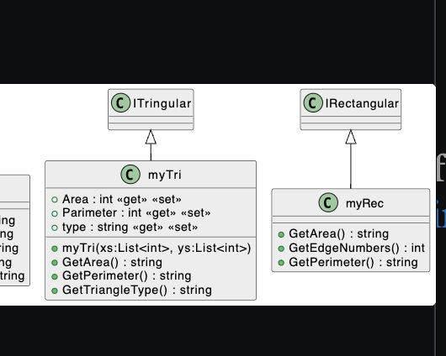

var tir=new myTri();  
var rect=new myRec();  
System.Console.WriteLine(tir.GetArea());  
System.Console.WriteLine(rect.GetArea());  
System.Console.WriteLine(tir.GetPerimeter());  
System.Console.WriteLine(rect.GetEdgeNumbers());

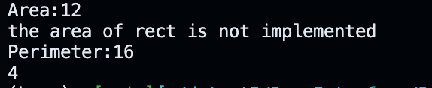

Alt text

public class myTri : ITringular  
{  
 public int Area { get; set; }  
 public int Parimeter { get; set; }  
 public string type { get; set; }  
 static double CalculateDistance(double x1, double y1, double x2, double y2)  
 {  
 return Math.Sqrt(Math.Pow(x2 - x1, 2) + Math.Pow(y2 - y1, 2));  
 }  
  
 public myTri(List<int> xs,List<int> ys){  
   
   
 double x1 = 1.0;  
 double y1 = 2.0;  
 double x2 = 4.0;  
 double y2 = 6.0;  
 double x3 = 7.0;  
 double y3 = 2.0;  
  
 double distance1 = CalculateDistance(x1, y1, x2, y2);  
 double distance2 = CalculateDistance(x2, y2, x3, y3);  
 double distance3 = CalculateDistance(x3, y3, x1, y1);  
  
 double Perimeter = distance1 + distance2 + distance3;  
 double s = Perimeter / 2; // Semi-perimeter  
 double Area = Math.Sqrt(s \* (s - distance1) \* (s - distance2) \* (s - distance3));  
  
 }  
 public string GetArea()  
 {  
 return Area.ToString();  
 }  
  
 public string GetPerimeter()  
 {  
 return Parimeter.ToString();  
 }  
  
 public string GetTriangleType()  
 {  
 return "obtuse angle";  
 }  
}  
public class myRec : IRectangular  
{  
 public string GetArea()  
 {  
 return "the area";  
 }  
  
 public int GetEdgeNumbers()  
 {  
 return 4;  
 }  
  
 public string GetPerimeter()  
 {  
 return "the perimeter";  
 }  
}

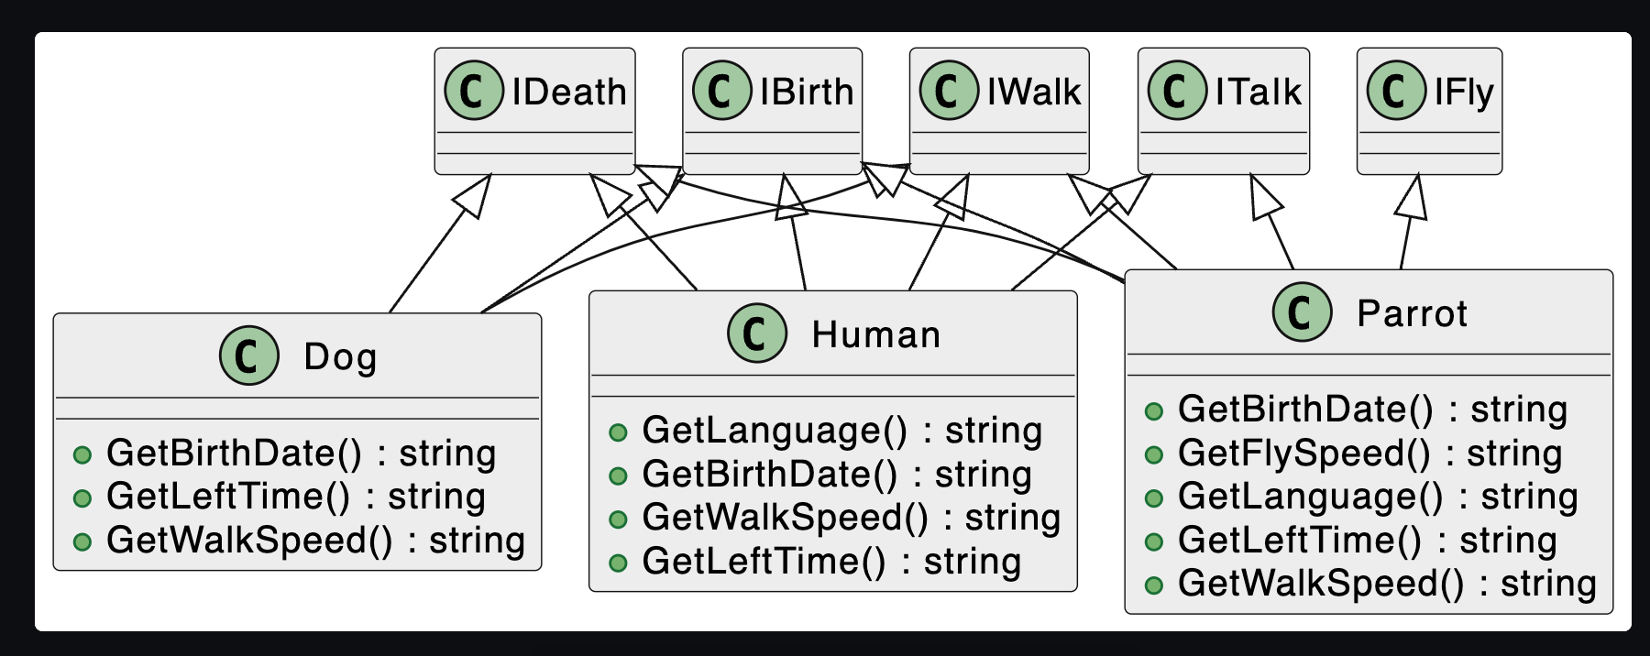

Alt text

using System;  
using System.Collections.Generic;  
using System.Linq;  
using System.Text;  
using System.Threading.Tasks;  
  
namespace DemoInterface  
{  
 public interface IBirth  
 {  
 string GetBirthDate();  
 }  
 public interface IWalk  
 {  
 string GetWalkSpeed();  
 }  
  
 public interface ITalk  
 {  
 string GetLanguage();  
 }  
 public interface IFly  
 {  
 string GetFlySpeed();  
 }  
 public interface IDeath  
 {  
 string GetLeftTime();  
 }  
  
  
  
}

using System.Runtime.InteropServices;  
using DemoInterface;  
  
Console.WriteLine("Hello, World!");  
Human human = new Human();  
Dog dog = new Dog();   
Parrot parrot = new Parrot();  
System.Console.WriteLine(human.GetLanguage());  
System.Console.WriteLine(dog.GetWalkSpeed());  
System.Console.WriteLine(parrot.GetFlySpeed());  
  
public class Human:ITalk,IWalk,IDeath,IBirth  
{  
 public string GetLanguage()  
 {  
 return "it's People's language";  
 }  
  
  
 public string GetBirthDate()  
 {  
 return "the birth Date is xxx";  
 }  
  
 public string GetWalkSpeed()  
 {  
 return "the walking speed is ";  
 }  
  
 public string GetLeftTime()  
 {  
 return "congrats, you dont have much time left";  
 }  
  
  
}  
public class Dog : IBirth, IWalk, IDeath  
{  
 public string GetBirthDate()  
 {  
 return "what? the dog was born a year ago";  
 }  
  
 public string GetLeftTime()  
 {  
 return "dog can really live long";  
 }  
  
 public string GetWalkSpeed()  
 {  
 return "the dog is walking, or more like running?";  
 }  
}  
public class Parrot : IBirth, IFly, ITalk, IDeath, IWalk  
{  
 public string GetBirthDate()  
 {  
 return "this P is born in 2020";  
 }  
  
 public string GetFlySpeed()  
 {  
 return "Parrot can fly, indeed";  
 }  
  
 public string GetLanguage()  
 {  
 return " you are just mocking people";  
 }  
  
 public string GetLeftTime()  
 {  
 return "Parrot can live for 80 years";  
 }  
  
 public string GetWalkSpeed()  
 {  
 return "Parrot can walk like 80mph";  
 }  
}