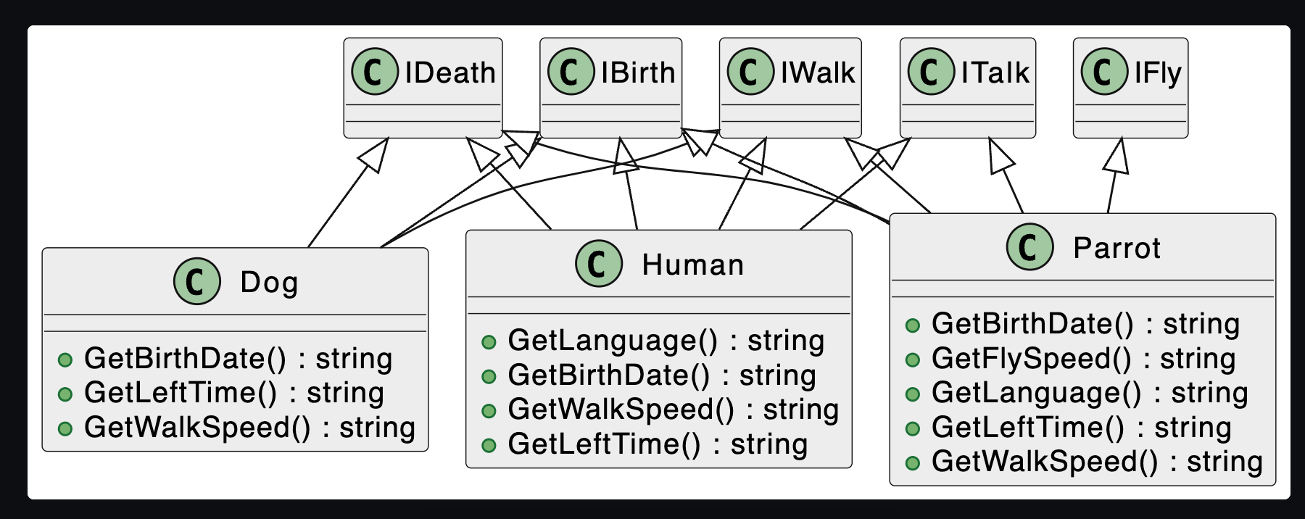

Alt text

using System;  
using System.Collections.Generic;  
using System.Linq;  
using System.Text;  
using System.Threading.Tasks;  
  
namespace DemoInterface  
{  
 public interface IBirth  
 {  
 string GetBirthDate();  
 }  
 public interface IWalk  
 {  
 string GetWalkSpeed();  
 }  
  
 public interface ITalk  
 {  
 string GetLanguage();  
 }  
 public interface IFly  
 {  
 string GetFlySpeed();  
 }  
 public interface IDeath  
 {  
 string GetLeftTime();  
 }  
  
  
  
}

using System.Runtime.InteropServices;  
using DemoInterface;  
  
Console.WriteLine("Hello, World!");  
Human human = new Human();  
Dog dog = new Dog();   
Parrot parrot = new Parrot();  
System.Console.WriteLine(human.GetLanguage());  
System.Console.WriteLine(dog.GetWalkSpeed());  
System.Console.WriteLine(parrot.GetFlySpeed());  
  
public class Human:ITalk,IWalk,IDeath,IBirth  
{  
 public string GetLanguage()  
 {  
 return "it's People's language";  
 }  
  
  
 public string GetBirthDate()  
 {  
 return "the birth Date is xxx";  
 }  
  
 public string GetWalkSpeed()  
 {  
 return "the walking speed is ";  
 }  
  
 public string GetLeftTime()  
 {  
 return "congrats, you dont have much time left";  
 }  
  
  
}  
public class Dog : IBirth, IWalk, IDeath  
{  
 public string GetBirthDate()  
 {  
 return "what? the dog was born a year ago";  
 }  
  
 public string GetLeftTime()  
 {  
 return "dog can really live long";  
 }  
  
 public string GetWalkSpeed()  
 {  
 return "the dog is walking, or more like running?";  
 }  
}  
public class Parrot : IBirth, IFly, ITalk, IDeath, IWalk  
{  
 public string GetBirthDate()  
 {  
 return "this P is born in 2020";  
 }  
  
 public string GetFlySpeed()  
 {  
 return "Parrot can fly, indeed";  
 }  
  
 public string GetLanguage()  
 {  
 return " you are just mocking people";  
 }  
  
 public string GetLeftTime()  
 {  
 return "Parrot can live for 80 years";  
 }  
  
 public string GetWalkSpeed()  
 {  
 return "Parrot can walk like 80mph";  
 }  
}